**ProtParam-Based Protein Analysis Project**

**Overview**

This project demonstrates the use of the **ExPASy ProtParam tool** for analyzing protein sequences. ProtParam is a widely used bioinformatics tool that predicts various physicochemical properties of proteins based only on their amino acid sequence. It is extremely useful for research in **protein chemistry, structural biology, and bioinformatics**.

**Key Features of ProtParam**

ProtParam provides several important properties of proteins:

1. **Amino Acid Composition** – Counts and percentages of each amino acid.
2. **Molecular Weight** – Total mass of the protein.
3. **Theoretical Isoelectric Point (pI)** – The pH at which the protein carries no net charge.
4. **Atomic Composition** – Distribution of carbon, hydrogen, oxygen, nitrogen, and sulfur atoms.
5. **Extinction Coefficient** – Useful for estimating protein concentration in solution.
6. **Estimated Half-Life** – Prediction of how long the protein is stable in different organisms.
7. **Instability Index** – Predicts whether the protein is stable or unstable in vitro.
8. **Aliphatic Index** – Indicates protein thermostability.
9. **Grand Average of Hydropathicity (GRAVY)** – Represents the hydrophobic/hydrophilic nature of the protein.

**My Project Results**

In this project, I analyzed **two protein sequences (Normal vs Mutant)** using ProtParam. The results revealed differences in:

* **Molecular weight** (change due to amino acid substitution).
* **Isoelectric point (pI)** (shift in protein charge behavior).
* **Stability parameters** (instability index indicated that the mutant protein may be less stable).
* **Hydropathicity** (mutation altered hydrophobicity, which can affect protein folding).

These findings highlight how even a single mutation can influence protein properties significantly.

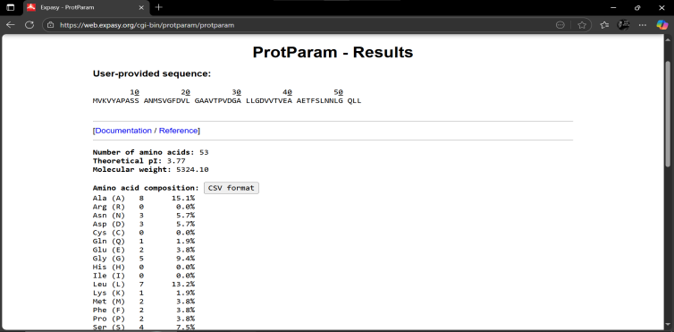 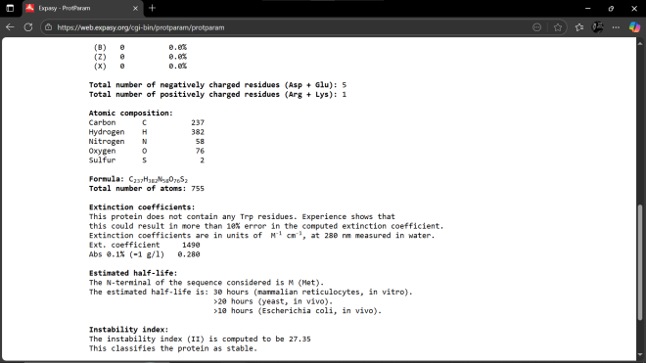 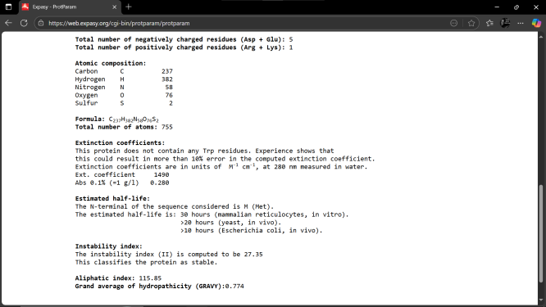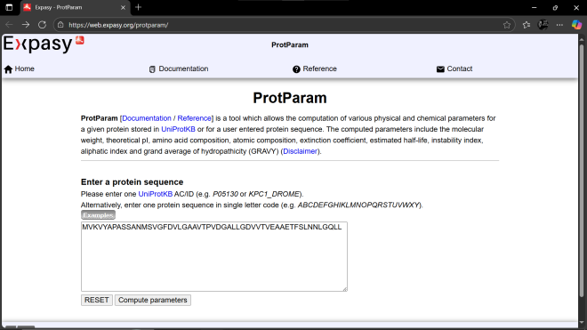  
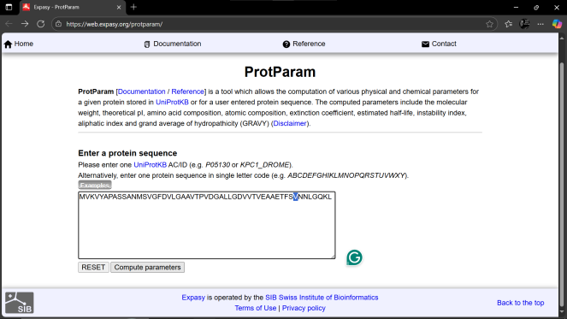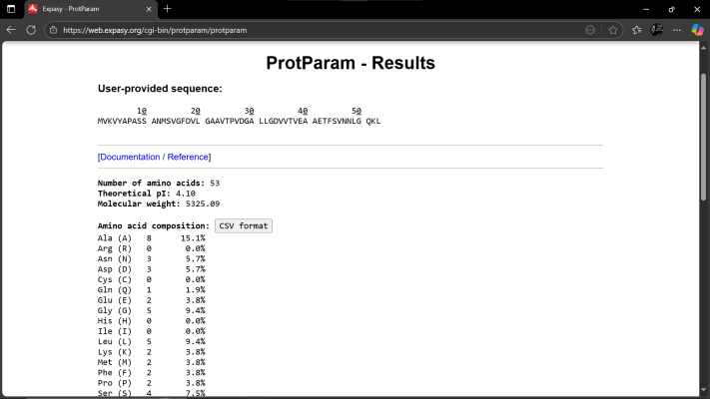

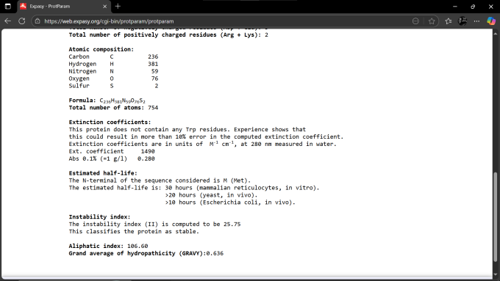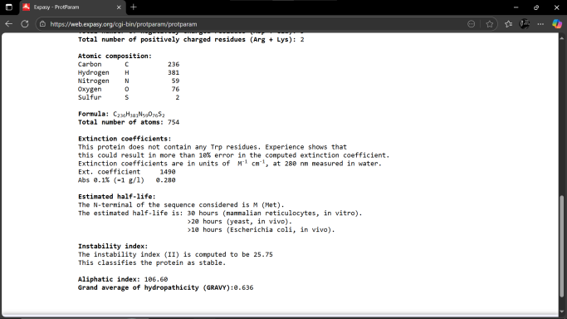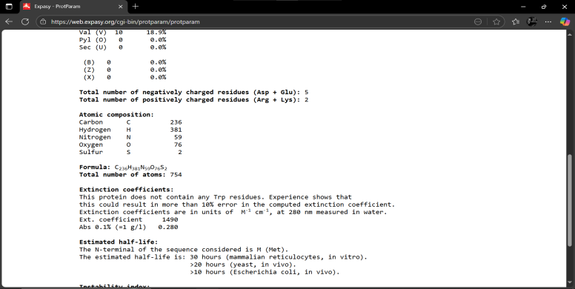

**Files in Repository**

* **ProtParam_Analysis_Project.docx →** Full detailed project report with explanations.
* **README.md** → Project summary and usage information (this file).

**How to Use**

1. Open the **Word file** for full details of the analysis.
2. Visit [**ExPASy ProtParam**](https://web.expasy.org/protparam/) to perform your own protein sequence analysis.
3. Compare your results with mine to see the effect of sequence variation.

**Applications**

ProtParam is widely used in:

* Protein structure prediction
* Mutation impact studies
* Recombinant protein design
* Biopharmaceutical research