Battleship Game report

Software Engineering class project
by Maryam Ismayilova
and Naila Ibrahimova

Within the BattleShip game project we have been able to implement the game version for console, and GUI version of the game on 1 machine with bot or second player.

The complete code can be found of GitHub repository https://github.com/maryamismailova/battleShipGame
The two main branches are “completeConsole” and “2Pl1GUI”
Release version are:
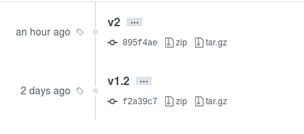
where v2 is GUI mode (though also has access to version 1 code)
and v1.2 is complete console version of the code

The basic idea to start the project with was to be able to implement the player interface, the game board and ships with their coordinates. The console version of the game is played sequentially, such that player1 initializes the board, then player2 initializes his own board, and then the game is started in startGame method, where players alternate till one of them wins.
The basic console interface can be seen in the screens below:
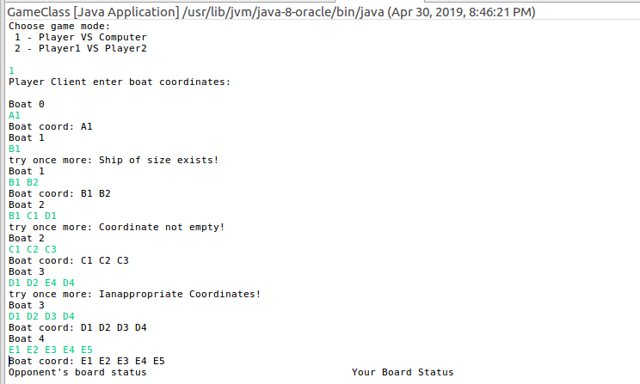
As you may see:
when starting player may choose between two game modes 1 or 2

Next step is to fill the board

From the example above, there is control over coordinates you push into the ships, which is implemented with Coordinate, Ship and Game class.
The format for coordinates in console mode is space separated [A-J][0-9] values for every coordinate of a ship.
To represent different errors when creating ships several Exceptions classes have been written, for inappropriate coordinates CoordinateOutOfBounds class (if values outside of the scope [A-J] and [0-9] are being provided), and for inappropriate ships UnavalableShipException (when one selects a cell that is already selected, or if the direction of the cells is inappropriate for a chip (not strictly vertical or horizontal) ), which carry more specific messages when they are thrown, thus enabling the player see what is wrong.

When all of the ships (5) are created successfully, the player can start the game.
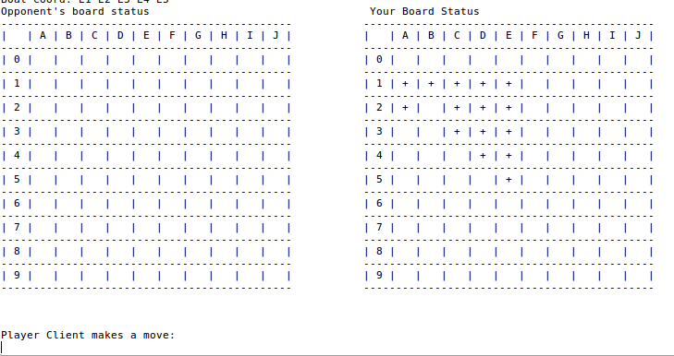
The typical game board looks like this.

On the right you can see your own board, while on the left is the board where you make moves against your opponent, and where you can see your success over the opponent.

When you fail to hit, to give turn to next player you must press any key.
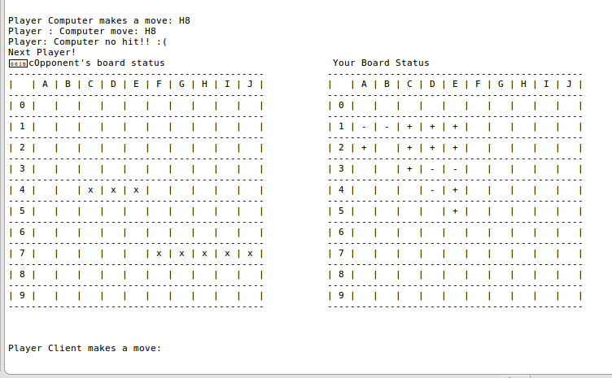
After several game iterations the game board may look like that.
The ‘+’ indicate that cell of a ship was not hit.
The ‘-’ indicate the hit ship coordinates.
And ‘x’ indicate those coordinate that you hit.

That is pretty everything for the console version of the game.

Both in console and GUI version to represent bot and simple player we wrote an abstract Player class which serves as a blueprint for bot and player. Therefor using Java polymorphism this made it easier to implement the console version of the game to switch between two game modes.

GUI VERSION

For GUI version of the code the task was more difficult, since using swing we were not able to achieve such sequentiality between two players as in console version.
For GUI version each player has his own panel with boards, which are placed within one BoardGUI, which serves as connector between the two players. When one player finishes his hits, board listens to actions and switches to second player and so on.
The game interface is simple but effective.
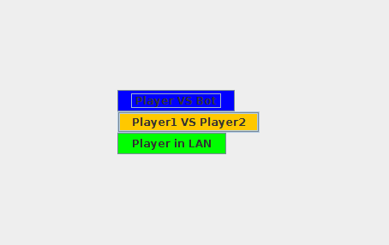
When the game is started, player can choose between two modes (Unfortunately due to scheduling and exams we were unable to finish LAN game mode).

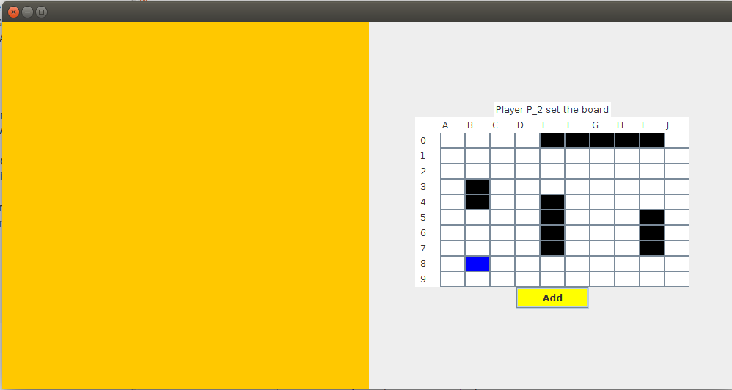

When one of players fills the board, the other player’s panel stay closed.
To add every ship click Add button.
Selected coordinates are in blue, and built ships are represented in black cells.
If ships coordinate are selected inappropriately error message is displaced just above the board.

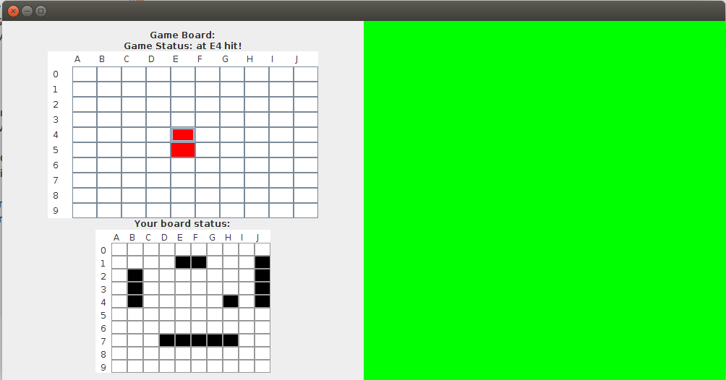

When the game is started each player has possibility to see his own board status and attack the ships of the opponent.
In GameBoard red cells represent the successfully hit ship coordinates of the opponent, while blue cells represent the coordinates that did not containt ships.

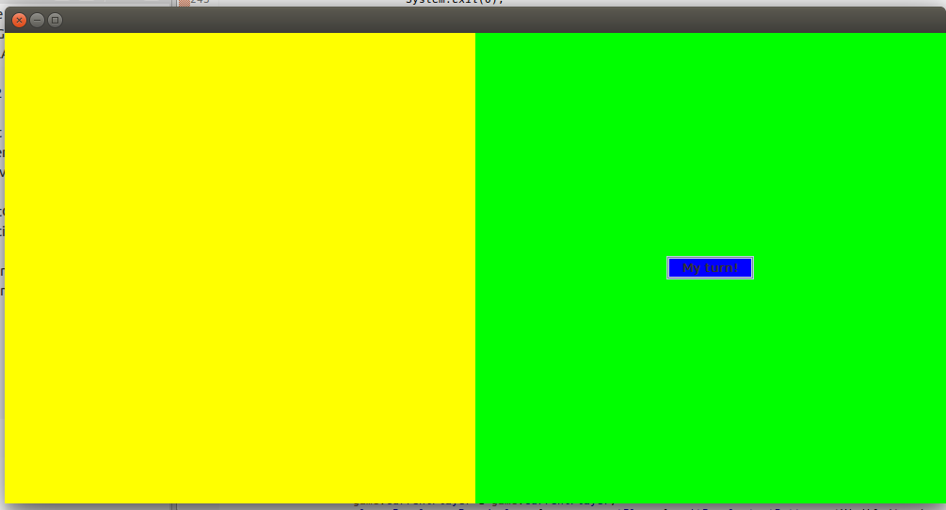
When one player fails to hit, his panel is automatically closed, and for the second player to start he has to press “My turn” button to set his board visible.

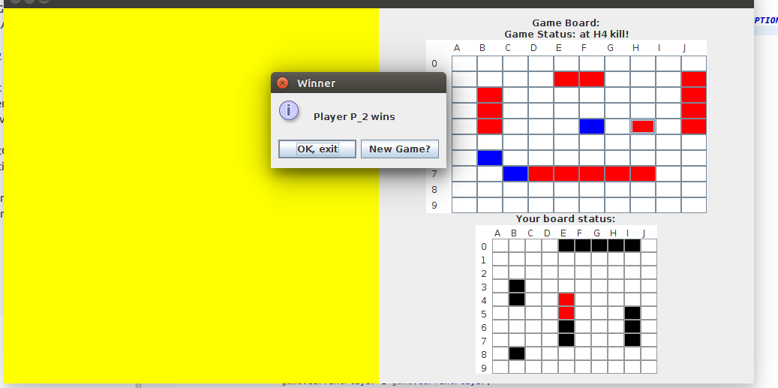
After several game iterations when one of the players wins option panel indicates his victory and proposes to start a new game or exit the game.

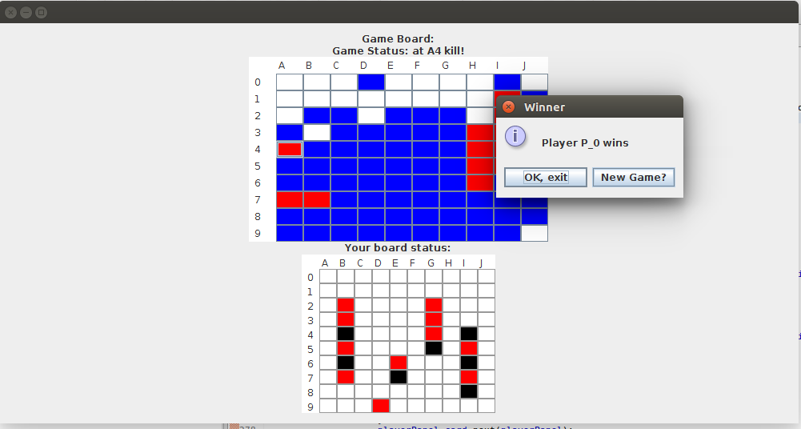
Player VS Bot
For this game mode only one panel was enough, where the player could see his own ships and attack the computer board.

We hope you will enjoy our game. Good luck!

