**Course Management**

**System**

**Design Document**

**University of Western Ontario - CS 2212**

**Team 7**

**Winter 2018**

**Instructor**

**Kostas Kontogiannis**

|  |  |
| --- | --- |
| Version: | 1.0 |
| Print Date: | 11/1/2005 8:54 AM |
| Release Date: |  |
| Release State: | Initial/Core/Final |
| Approval State: | Draft/Approved |
| Approved by: |  |
| Prepared by: |  |
| Reviewed by: |  |
| Path Name: |  |
| File Name: | sdd.docx |
| Document No: |  |

**Document Change Control**

|  |  |  |  |
| --- | --- | --- | --- |
| **Version** | **Date** | **Authors** | **Summary of Changes** |
| 0.2 | 1/4/2018 | Fatima | Tables for class diagrams added |
| 0.4 | 1/4/2018 | Fatima | Class diagrams added |
| 0.6 | 5/4/2018 | Jordan | Architecture diagram added |
| 0.8 | 3/4/2018 | Fatima | Intro and major design decisions added |
| 1.0 | 7/4/2018 | Maryam | more tables for class diagrams and class diagrams added |

**Document Sign-Off**

|  |  |  |
| --- | --- | --- |
| **Name (Position)** | **Signature** | **Date** |
| Maryam Karimi | MK | 8/4/2018 |
| Fatima Hasan | FH | 8/4/2018 |
| Jordan McInnis | JM | 8/4/2018 |
|  |  |  |

**Contents**

**1** **Introduction 4**

1.1 Overview 4

1.2 Resources - References 4

**2** **Major Design Decisions 5**

**3** **Architecture 5**

**4** **Detailed Class Diagrams 5**

4.1 UML Class Diagrams 5

# 1 Introduction

## 1.1 Overview

This software design document covers the architecture of core components in the system showcasing project structure and flow.

## 1.2 Resources - References

# 1. SRS for design decisions

# 2. Architecture Provided

# 2 Major Design Decisions

- Each user has his/her operations all in one class.

# 3 Architecture

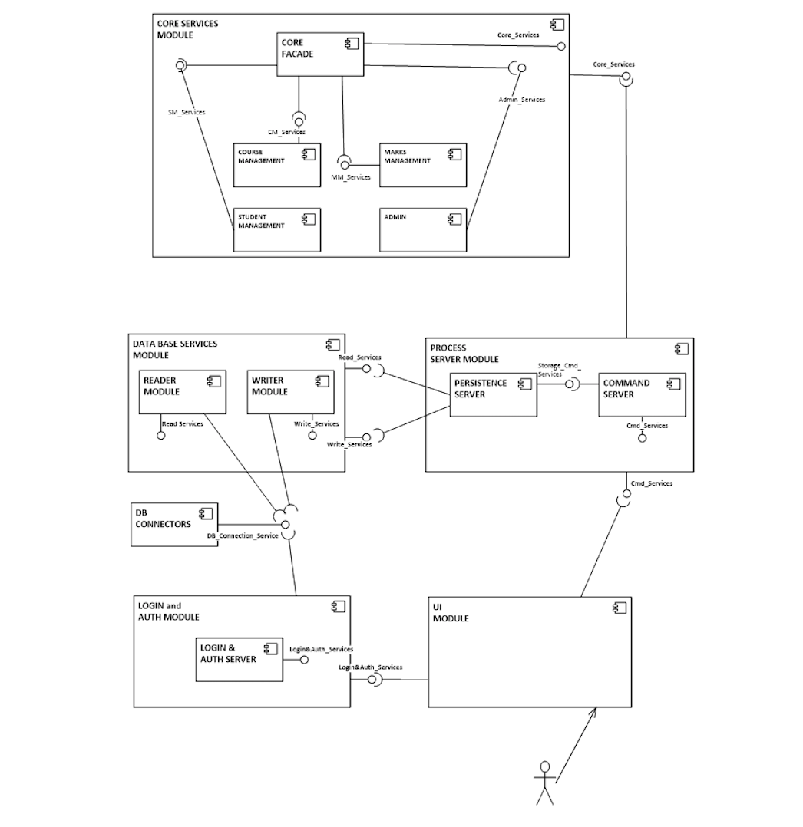

**CM_Services**

Offering Factory

Create Course Object

Attach evaluation entities for course

Attach evaluation strategies for course

Attach Instructor to Course

**SM_Services**

Enroll student in course

Print record for student

Select and change notification preference

**Marks_Services**

Add Mark

Final

Midtem

Assignments

Calculate Final Mark

**Admin_Services**

Start System

Stop System

Read course file

**Login&Auth_Services**

Login

Login Server

**Data_Base_Services**

Read from file

Write to file

**DB_Connection_Service**

Read from File

Write to file

# 4 Detailed Class Diagrams

## 4.1 UML Class Diagrams

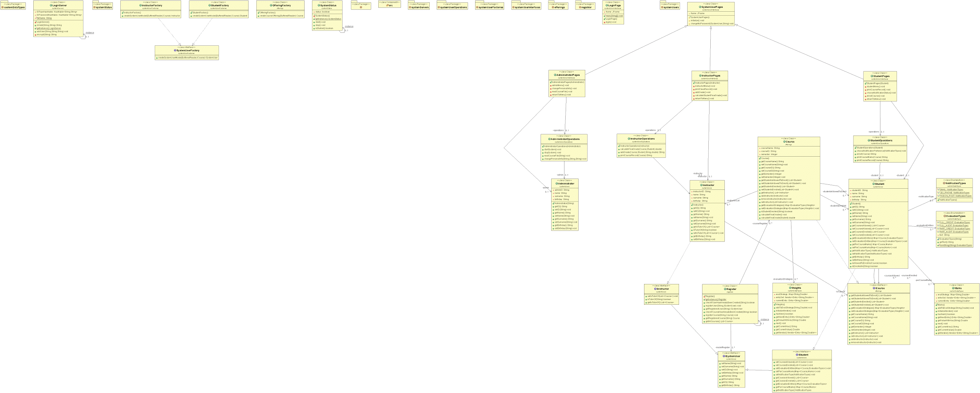

**Class: System Status**

|  |  |
| --- | --- |
| get Instance | returns an instance of this class. |
| Start | This method moves the system into the “running” state so that users other than administrators (students and instructors) can access their operations. |
| Stop | This method moves the system into the “stopped” state and thus prevents users other than the admin from accessing their operations. |
| Is Started | Checks if the system is started or terminated. |

**Class: Student Operation**

|  |  |
| --- | --- |
| Enroll | This method allows a logged in student to add a class to their record (enroll in a class), only if the student is allowed to enroll in that class. |
| Print course marks | This method lets a logged in student print the course marks when provided with a course id. |
| Print course record | This method lets a logged in student to choose between one of the courses he/she is enrolled in and print its record. |
| Choose Notification Preference | This method allows a logged in student choose their desired notification preference. |

**Class: Login Server**

|  |  |
| --- | --- |
| Add user | This method adds a user to the system database (userpass.txt file and hashtables). After being added to the system, the user can login and perform operations based on his/her user type (student/ administrator/ instructor). |
| Encrypt | This method is used so that when the students are being added to the system or when they are logging into the system, their passwords are encrypted. |
| Is Valid | This method takes an ID and a password as input and checks to see if they match. It returns “dontExist” if ID is not recognized and “dontMatch” if ID and password do not match. If the ID and password match, it returns either “a”, “s”, or “i” representing the type of user that signed in. |
| Get Instance | This method simply returns an instance of the class login server. |

**Class: Administrator Operation**

|  |  |
| --- | --- |
| Change personal info | This method when invoked by the administrator allows the admin to change his/her name, surname, and date of birth. |
| Start system | This method allows the administrator to start the system so that other user can use it |
| Stop system | This method allows the administrator to stop the system, and thus prevents anyone else from using the system |
| Read course file | This method allows an admin to read a course file which when a course file is read adds them to the system so that they are able to login to the system. |

**Class: Instructor Operation**

|  |  |
| --- | --- |
| Add Grade | This method allows an instructor to add a grade for a student when provided with a student id, course, evaluation entity, and a mark. |
| Calculate Final grade | This method allows an instructor to calculate the final grade for a student when provided with a course and a student. |
| Print Course Record | This method allows an instructor to view any course record he/she is teaching when provided with a course ID. |

**Class: Login Page (class for UI)**

|  |  |
| --- | --- |
| Login | This method allows any user to login to the system if they areallowed to. |

**Class: Administrator Pages (class for UI)**

|  |  |
| --- | --- |
| Admin menu | This method when invoked displays the operations that an admin can perform. |
| Change personal info | This method when invoked calls the change personal info method in the administrator operation class |
| Read course file | This method when invoked calls the read course file method in the administrator operation class. |
| Return to menu | This method displays the operations that an admin can perform again. |

**Class: Student Pages (class for UI)**

|  |  |
| --- | --- |
| Student menu | This method when invoked displays the operations that a student can perform. |
| Print course record | The print course record method when chosen by the student calls the print course record in the student operation class. |
| Choose notification status | The choose notification status method calls the choose notification preference in the student operation class to allow the student choose a notification preference. |
| Enroll course | The enroll course method calls the enroll method in the student operation class to allow the student logged in to enroll in a course if he/she is eligible to do so. |
| Return to menu | This method displays the operations that a student can perform again. |

**Class: Instructor Pages (class for UI)**

|  |  |
| --- | --- |
| Instructor menu | This method when invoked displays the operations that an instructor can perform. |
| Print class record | The print class record when invoked calls the print class record method in the instructor operation class to display the record of class he/she is teaching |
| Add grade | The add grade method when invoked calls the add grade method in the instructor operation class to let the instructor add a grade for a student. |
| Modify grade | This method when invoked checks first if there is a grade added under the entity chosen by the instructor, and if there isn’t it doesn’t allow the instructor to modify a grade that doesn’t exist, otherwise it lets the instructor modify the grade for a chosen entity and student. |
| Calculate student final grade | The calculate student final grade method calls the calculate final grade in the instructor operation class to let the instructor calculate the final grade if all the entities have submitted grades. |
| Return to menu | This method displays the operations that an instructor can perform again. |

**Class: System User Pages (Instructor Pages, Administrator Pages, and Student Pages extend this class)**

|  |  |
| --- | --- |
| Initialize | This method creates the frame of fixed size |
| Change my password | This method is the method that allows students, instructor or administrators to change their password through an interface |

**Class: Register (this is the same class as the one provided, but some return type names have been changed for the purposes of this project)**