**SOFTWARE DESIGN AND ARCHITECTURE**

**Submitted to: Sir Mukhtiar Zamin**



**ASSIGNMENT NO 2**

**Date: 26th June 2025**

DEPARTMENT OF SOFTWARE ENGINEERING

COMSATS UNIVERSITY ISLAMABAD

ABBOTTABAD CAMPUS

**Table of contents**

Contents

CHAPTER NO 1: INTRODUCTION 4

GROUP MEMBERS 4

CHAPTER NO 2: USE CASE DIAGRAM 5

FULL SYSTEM USECASE 5

USE CASE NAME: REGISTRATION 6

USE CASE NAME: LOGIN 8

USE CASE NAME: MANAGE BOOKING 8

USE CASE NAME: MANAGE BOOKING 9

USE CASE NAME: TRACK VEHICLE LOCATION 11

USE CASE NAME: FINANCE TRACKING 12

USE CASE NAME: FINANCE TRACKING 13

CHAPTER NO 3: FULLY DRESSED USE CASES 14

FULLY DRESSED USE CASE: REGISTRATION 14

FULLY DRESSED USE CASE : LOGIN 16

FULLY DRESSED USE CASE : MANAGE BOOKING 17

View Available Vehicles 17

View routes details 18

Book journey 19

Cancel Booking 20

FULLY DRESSED USE CASE : MANAGE BOOKING 21

Confirm Booking 21

Payment 22

Generate Receipt 22

FULLY DRESSED USE CASE: TRACK VEHICLE LOCATION 23

FULLY DRESSED USE CASE: FINANCE TRACKING 27

FULLY DRESSED USE CASE : FINANCE TRACKING 31

Track Defaulters 31

Refund Handling 31

Security and logs 31

CHAPTER NO 4: SYSTEM SEQUENCE DIAGRAM 33

SYSTEM SEQUENCE DIAGRAM : REGISTRATION 33

SYSTEM SEQUENCE DIAGRAM: LOGIN 35

SYSTEM SEQUENCE DIAGRAM: MANAGE BOOKING 36

SYSTEM SEQUENCE DIAGRAM: MANAGE BOOKING 37

SYSTEM SEQUENCE DIAGRAM: TRACK VEHICLE LOCATION 38

SYSTEM SEQUENCE DIAGRAM: FINANCE TRACKING 39

SYSTEM SEQUENCE DIAGRAM: FINANCE TRACKING 40

CHAPTER NO 5: PACKAGE DIAGRAM 41

PACKAGE DIAGRAM: REGISTRATION 41

PACKAGE DIAGRAM: LOGIN 42

PACKAGE DIAGRAM: MANAGE BOOKING 43

PACKAGE DIAGRAM: MANAGE BOOKING 44

PACKAGE DIAGRAM: TRACK VEHICLE LOCATION 45

PACKAGE DIAGRAM: FINANCE TRACKING 46

PACKAGE DIAGRAM: FINANCE TRACKING 47

CHAPTER NO 6: COMMUNICATION DIAGRAM 48

COMMUNICATION DIAGRAM: REGISTRATION 48

COMMUNICATION DIAGRAM : LOGIN 49

COMMUNICATION DIAGRAM: MANAGE BOOKING 50

COMMUNICATION DIAGRAM: MANAGE BOOKING 51

COMMUNICATION DIAGRAM: TRACK VEHICLE LOCATION 51

COMMUNICATION DIAGRAM: FINANCE TRACKING 53

SEQUENCE DIAGRAM: FINANCE TRACKING 54

CHAPTER NO 7: CLASS DIAGRAM 54

CLASS DIAGRAM: REGISTRATION 55

CLASS DIAGRAM: LOGIN 56

CLASS DIAGRAM: MANAGE BOOKING 57

CLASS DIAGRAM: MANAGE BOOKING 58

CLASS DIAGRAM: TRACK VEHICLE LOCATION 58

CLASS DIAGRAM: FINANCE TRACKING 60

CLASS DIAGRAM: FINANCE TRACKING 61

CHAPTER NO 8: STATE TRANSITION DIAGRAM 62

STATE TRANSITION DIAGRAM: LOGIN & REGISTER 62

STATE TRANSITION DIAGRAM: MANAGE BOOKING 62

STATE TRANSITION DIAGRAM: MANAGE BOOKING 62

STATE TRANSITION DIAGRAM: TRACK VEHICLE LOCATION 62

STATE TRANSITION DIAGRAM: FINANCE TRACKING 62

STATE TRANSITION DIAGRAM: FINANCE TRACKING 62

STATE TRANSITION DIAGRAM: 62

CHAPTER NO 9: ENTITY RELATIONSHIP DIAGRAM 63

ENTITY RELATIONSHIP DIAGRAM: LOGIN & REGISTER 63

ENTITY RELATIONSHIP DIAGRAM: MANAGE BOOKING 63

ENTITY RELATIONSHIP DIAGRAM: MANAGE BOOKING 63

ENTITY RELATIONSHIP DIAGRAM: TRACK VEHICLE LOCATION 63

ENTITY RELATIONSHIP DIAGRAM: FINANCE TRACKING 63

ENTITY RELATIONSHIP DIAGRAM: FINANCE TRACKING 63

ENTITY RELATIONSHIP DIAGRAM: 63

CHAPTER NO 10: CODING STANDARDS 63

# CHAPTER NO 1: INTRODUCTION

The Transport Management System is a comprehensive platform designed to streamline and optimize the planning, execution, and tracking of transportation operations. It facilitates efficient route planning, vehicle and driver management, real-time tracking, and delivery scheduling. The system aims to reduce operational costs, improve delivery timelines, and enhance overall logistics visibility, making transport operations more reliable and data-driven.

## GROUP MEMBERS

1. Maryam Khan (SP23-BSE-066) - Track Vehicle Location
2. Fatima Khan (SP23-BSE-102) - Manage Booking (Confirm Booking, Payment, Generate Receipt)
3. Alaina Khan (SP23-BSE-069) - Manage Booking (View Available Vehicles, view routes details, Book journey)
4. Warda Yousaf (SP23-BSE-042) - Login
5. Kashmala Zeb (SP23-BSE-048) - Finance (Manage fee structure, Generate Fee challan, Collect Payment, User Dashboard)
6. Tehreem Jilani (SP23-BSE-041) - Finance (Track Defaulters, Refund Handling, Security and logs)
7. Sarina Amjad (SP22-BSE-095) - Register

# CHAPTER NO 2: USE CASE DIAGRAM

## FULL SYSTEM USECASE

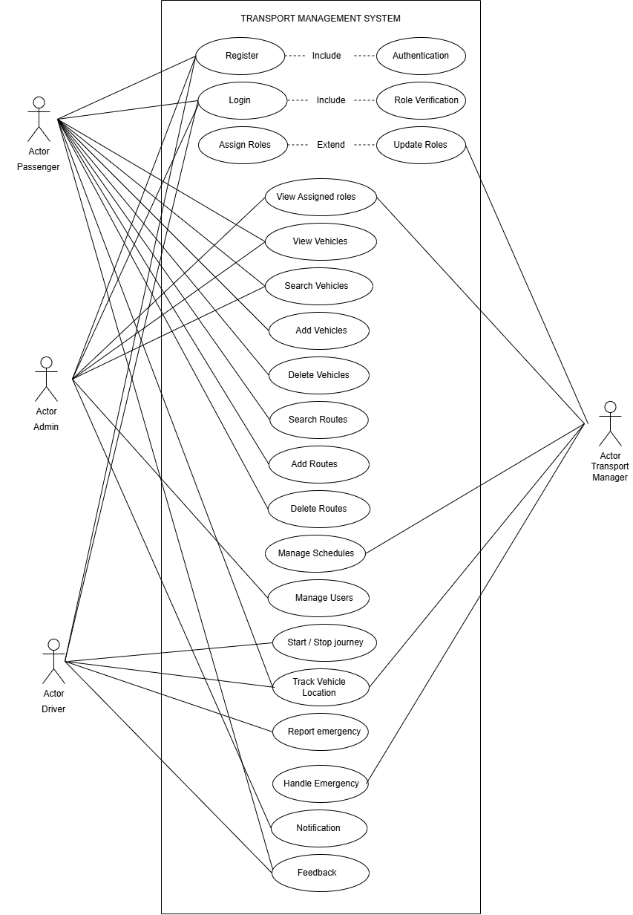

Sarina Amjad SP22-BSE-095

### USE CASE NAME: REGISTRATION

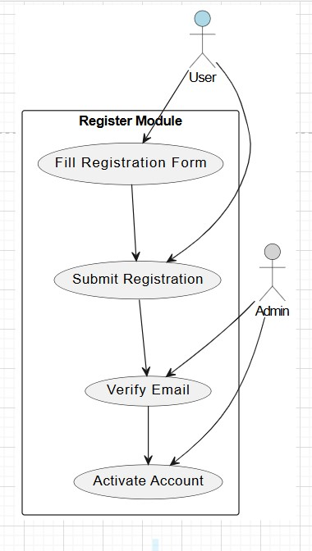

Warda Yousaf SP23-BSE-042

### USE CASE NAME: LOGIN

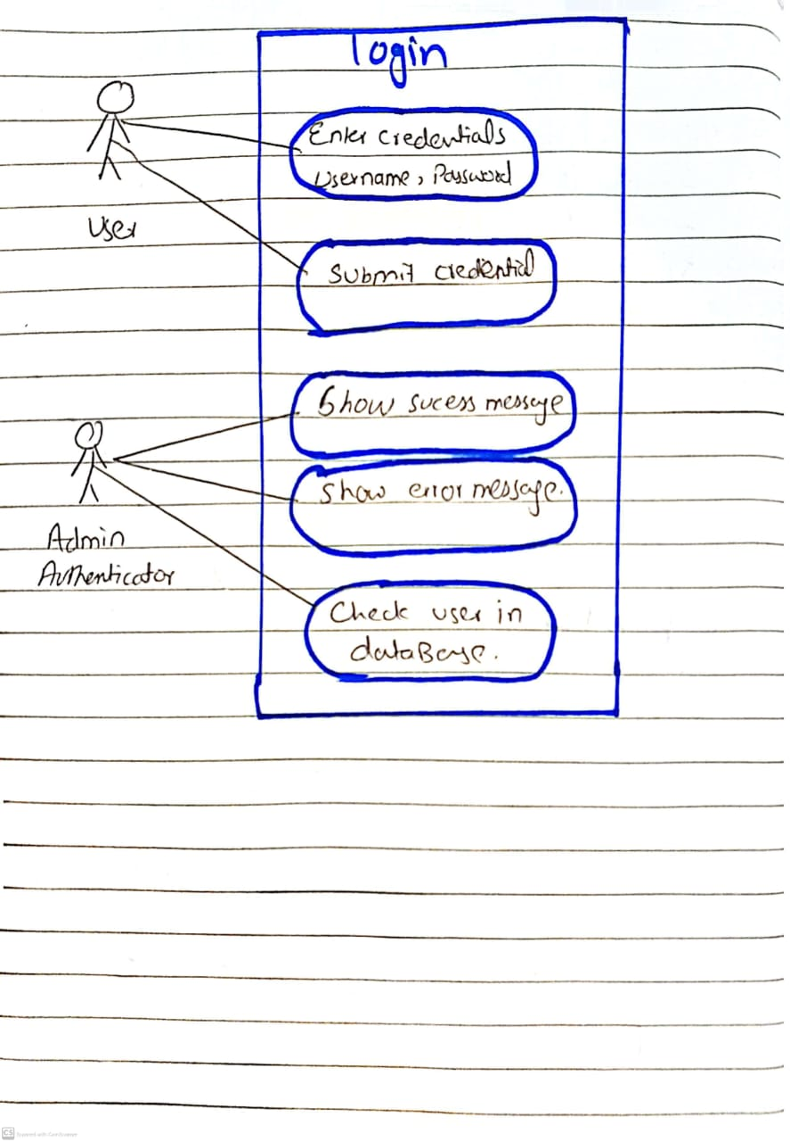

Alaina Khan SP23-BSE-069

### USE CASE NAME: MANAGE BOOKING

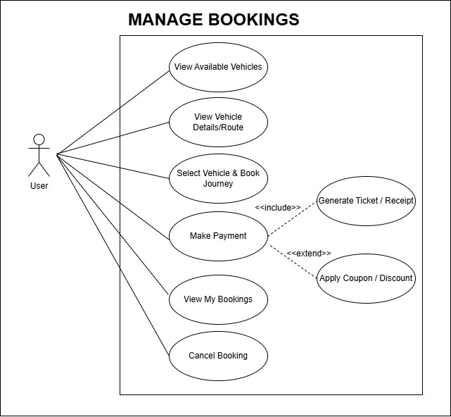

Fatima Khan SP23-BSE-102

### USE CASE NAME: MANAGE BOOKING

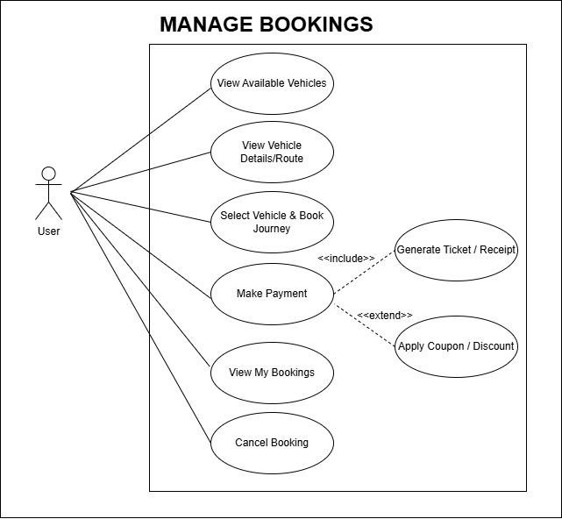

Maryam khan SP23-BSE-066

### USE CASE NAME: TRACK VEHICLE LOCATION

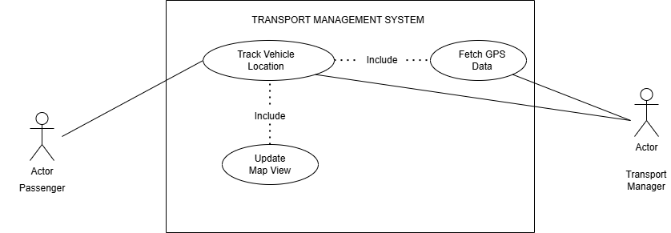

Kashmala Zeb SP23-BSE-048

### USE CASE NAME: FINANCE TRACKING

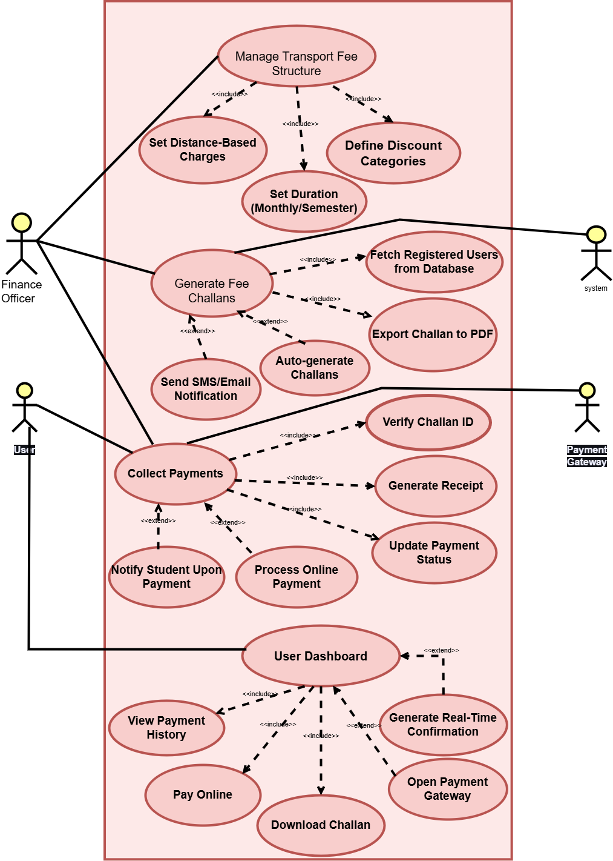

Tehreema Jilani SP23-BSE-041

### USE CASE NAME: FINANCE TRACKING

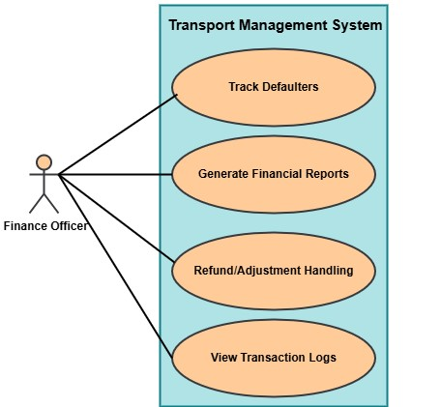

# CHAPTER NO 3: FULLY DRESSED USE CASES

Sarina Amjad SP22-BSE-095

### FULLY DRESSED USE CASE: REGISTRATION

|  |  |
| --- | --- |
| **Category** | **Details** |
| **Use Case ID** | UC-001 |
| **Use Case Name** | User Registration |
| **Primary Actor** | User |
| **Secondary Actors** | System, Admin |
| **Preconditions** | User has access to the registration page; system is online |
| **Postconditions** | User account is created but inactive until verified and activated |
| **Trigger** | User selects "Register" or "Sign Up" option |
| **Description** | The User fills the registration form, submits it, receives a verification email, and waits for account activation. Admin verifies and activates the account. |
| **Basic Flow** | 1. User navigates to registration page. 2. User enters details. 3. User submits form. 4. System validates and saves data. 5. System sends verification email. 6. User clicks verification link. 7. System marks account as verified. 8. Admin reviews registration. 9. Admin activates account. 10. User receives confirmation. |
| **Alternative Flows** | A1: Invalid data - System requests correction. A2: Verification email not received - User requests resend. A3: Admin rejects registration - User notified with reason. |
| **Exceptions** | System error during registration, connectivity issues |
| **Assumptions** | Email service functional, Admin available for timely verification |
| **Priority** | High |
| **Frequency of Use** | Frequent |
| **Business Rules** | Password security policy, unique email, verification before activation |
| **Special**  **Requirements** | Secure data storage, verification email expiration (24 hours), compliance with data protection laws |

Warda Yousaf SP23-BSE-042

### FULLY DRESSED USE CASE : LOGIN

|  |  |  |  |  |  |  |
| --- | --- | --- | --- | --- | --- | --- |
| |  |  | | --- | --- | |  |  |  |  |  | | --- | --- | | **User Login** | | |  | | UC-2 |
| |  |  | | --- | --- | | **Use Case Name** |  | | |  | | --- | |  |  |  | | --- | | User Login | |
| |  | | --- | | **Actor** |  |  | | --- | |  | | |  | | --- | |  |  |  | | --- | | End User (Customer) | |
| |  | | --- | | **Trigger** |  |  | | --- | |  | | |  | | --- | |  |  |  | | --- | | User navigates to the login page and clicks the login button after entering credentials | |
| **Description** | This use case allows a registered user to log into the Transport Management System using valid credentials. |
| **Preconditions** | * User must be registered in the system * User has valid login credentials (email/username and password) |
| **Postconditions** | * **Success**: User is logged in and redirected to their dashboard. * **Failure**: User remains on the login page and receives an error message |
| |  | | --- | | **Normal Flow** |  |  | | --- | |  | | 1. User navigates to the login page. 2. System displays the login form. 3. User enters email/username and password. 4. User clicks the “Login” button. 5. System validates the credentials. 6. If valid, system logs in the user and redirects to the dashboard. |
| **Alternative Flow** | **A1: Forgot Password** 1. User clicks on “Forgot Password”. 2. System prompts for the registered email. 3. User enters email. 4. System sends password reset link. 5. User resets password and logs in with the new one |
| |  | | --- | | **Exception Flow**  **Baseness Rules** |  |  | | --- | |  | | |  | | --- | |  |  |  | | --- | | **E1: Invalid Credentials** 1. User enters incorrect email or password. 2. System displays: "Invalid username or password."  **E2: Account Locked** 1. User fails login 3 times. 2. System locks account for 15 minutes and displays: Account temporarily locked due to multiple failed login attempts.  BR-01 Password must be at least 8 characters, contain letters and at least 1 digit.  BR-02 Aafter 5 failed login attempts, account is locked for 15 minutes  BR-03 Only registered users can access login functionality. | |
| **Assumptions** | |  | | --- | |  |  |  | | --- | | * User has stable internet connection. * User is using a supported browser. * User is already registered in the system. | |

Alaina Khan SP23-BSE-069

### FULLY DRESSED USE CASE : MANAGE BOOKING

#### View Available Vehicles

|  |  |
| --- | --- |
| **USE CASE ID** | **UC-03** |
| **USE CASE NAME** | View Available Vehicles |
| **ACTOR** | Registered User |
| **DESCRIPTION** | This use case allows a registered user to view a list of vehicles available for booking. The list is filtered based on input criteria such as location, vehicle type, and availability date. |
| **TRIGGER** | User selects “Book Vehicle” from the dashboard and then chooses the option to view available vehicles. |
| **PRE-CONDITION** | User must be logged into the system.  System must have vehicle data available. |
| **POST**  **CONDITION** | List of available vehicles is displayed based on selected criteria. |
| **NORMAL FLOW** | 1. User logs into the system. 2. User selects "Book Vehicle" from dashboard. 3. System displays filter options (date, location, type). 4. User selects filters and submits. 5. System queries available vehicles. 6. List of available vehicles is shown to the user. |
| **ALTERNATIVE FLOW** | 3a. User does not apply any filters → System displays all available vehicles. |
| **EXCEPTIONS** | 1. No vehicles available → System displays “No vehicles available for selected criteria.” 2. System error during fetch → Show error message. |
| **BUSINESS RULES** | * Only available vehicles should be shown. * User can only view vehicles available in the selected location/date. * Unregistered or logged-out users cannot access this page. |
| **ASSUMPTIONS** | * Vehicle data is regularly updated. * User has stable internet access. * Vehicles are tagged properly with status and location in the database. |

#### View routes details

|  |  |
| --- | --- |
| **USE CASE ID** | **UC-04** |
| **USE CASE NAME** | View Vehicle Details / Routes |
| **ACTOR** | Registered User |
| **DESCRIPTION** | After viewing the list of available vehicles, the user can select a vehicle to view more detailed information including its route, schedule, seat layout, and estimated timings. |
| **TRIGGER** | User clicks on a specific vehicle from the list of available vehicles. |
| **PRE-**  **CONDITION** | - User must be logged in. - List of available vehicles must already be displayed. |
| **POST**  **CONDITION** | Vehicle details, including route map and related info, are displayed to the user. |
| **NORMAL FLOW** | 1. User views list of available vehicles.2. User selects a vehicle.3. System fetches vehicle information and route details.4. System displays vehicle details (type, number, features).5. System shows route map, stops, timings, and estimated travel time.6. Seat layout and availability are optionally shown. |
| **ALTERNATIVE FLOW** | 4a. If route data is not available, system only displays basic vehicle info.6a. If seat layout is not supported, show general availability count. |
| **EXCEPTIONS** | - Selected vehicle no longer available → Show warning message. - Database timeout or error → Display technical error. |
| **BUSINESS RULES** | - User can only view details of available vehicles. - Routes must be displayed using map or list format. - Only valid and scheduled routes should be shown. |
| **ASSUMPTIONS** | - Route and vehicle data are pre-entered and accurate. - User interface supports map or route display features. - Internet connection is stable for map rendering. |

#### Book journey

|  |  |
| --- | --- |
| **Use Case ID** | UC-005 |
| **Use Case Name** | Select Vehicle & Book Journey |
| **Actor** | **Primary Actor:** Customer  **Secondary Actor:** Vehicle System  **Supporting Actor:** Payment System |
| **Description** | This use case allows a customer to select a vehicle for their journey, review available options, confirm the booking, and complete the payment process. |
| **Trigger** | The customer initiates the vehicle selection and booking process by selecting the "Select Vehicle & Book Journey" option on the dashboard. |
| **Preconditions** | * The customer is logged into the system. * The customer has entered the destination and journey details. * The system has a list of available vehicles. * The customer has a valid payment method. |
| **Postconditions** | * The customer has successfully booked a vehicle for the specified journey. * The system has reserved the selected vehicle. * Payment has been processed and confirmed. |
| **Normal Flow** | 1. Customer selects "Select Vehicle & Book Journey" from the dashboard. 2. The system displays available vehicles. 3. Customer reviews available vehicles and selects one. 4. System shows booking details (vehicle type, journey time, cost). 5. Customer confirms the booking. 6. The system processes the payment. 7. The system confirms the booking and sends a confirmation notification. |
| **Alternative Flow** | **A1: No Available Vehicles**: If no vehicles are available, the system will notify the customer. The customer can change preferences or try again later. **A2: Payment Failure**: If payment fails, the system notifies the customer, and they can retry with a different payment method. |
|  | **A3: Customer Cancels Booking**: If the customer cancels, the system returns to the vehicle selection page. |
| **Exception** | **E1: Payment Gateway Unavailable**: If the payment gateway fails, the system notifies the customer and allows them to retry later.  **E2: Technical Issue in Vehicle Selection**: If there's a technical issue, the system asks the customer to retry or contact support.  **E3: Invalid Payment Information**: The system asks the customer to reenter valid payment details. |
| **Business Rules** | * BR1: Vehicle must be available for the entire duration of the journey. * BR2: Booking is confirmed only after successful payment. * BR3: Vehicle prices may fluctuate based on demand and availability. |
| **Assumptions** | * The customer has a pre-registered account. * The customer knows the desired journey details (time, destination). * The system has access to up-to-date vehicle availability. |

#### Cancel Booking

|  |  |
| --- | --- |
| **Use Case ID** | **UC-006** |
| Use Case Name | Cancel Booking |
| Primary Actor | Customer |
| Secondary Actor | Vehicle System |
| Supporting Actor | Payment System (for refund processing) |
| Description | Allows a customer to cancel an existing booking. The system updates the booking status, adjusts vehicle availability, and processes refunds if necessary. |
| Trigger | Customer selects “Cancel Booking” from the dashboard. |
| Preconditions | - Customer is logged in - Customer has at least one active booking - System can access booking and vehicle data |
| Postconditions | - Booking status is updated to “Cancelled” - Booking is moved to cancelled_bookings table - Seats are restored to vehicle availability - Refund is initiated (if paid) |
| Normal Flow | 1. Customer selects “Cancel Booking” from dashboard 2. System displays user’s active bookings 3. Customer selects booking to cancel 4. System displays booking details and asks for confirmation 5. Customer confirms cancellation 6. System marks booking as cancelled, removes it from active list 7. Refund is initiated if applicable 8. Vehicle’s available seat count is updated 9. System confirms cancellation |
| Alternative Flows | A1: No Active Bookings → system shows “no bookings” A2: Customer aborts cancellation → system returns to booking list A3: Unpaid booking → no refund triggered |
| Exceptions | E1: Database or system error during cancellation → show error and retry option E2: Refund gateway failure → notify user and queue refund E3: Booking already cancelled or updated → show error and refresh list |
| Business Rules | BR1: Only “Pending” or “Confirmed” bookings may be cancelled BR2: Refunds issued only for paid bookings BR3: Cancelled seats must be restored to vehicle availability immediately |
| Assumptions | - Customer has valid bookings - System distinguishes paid vs unpaid bookings - Refund system is accessible or has fallback queue |

Fatima Khan SP23-BSE-102

### FULLY DRESSED USE CASE : MANAGE BOOKING

#### Confirm Booking

|  |  |
| --- | --- |
| **Use case ID** | UC- 6 |
| **Use case name** | Confirm booking |
| **Actors** | **Primary**: user, customer **secondary**: Transport Management System (TMS), Payment Gateway, Admin |
| **Description** | This use case describes the process by which a customer confirms a transport service booking (such as a seat on a bus, a cargo shipment, or a taxi), after selecting transport details and entering required information. |
| **Trigger** | The customer has completed selecting transport details and clicks the "Confirm Booking" button. |
| **Pre-conditions** | **Pre-1**: The user is logged in or has provided necessary personal details.  **Pre-2** The user has selected a valid transport route/service.  **Pre-3**: The system shows the availability of the selected service.  **Pre-4**: All required fields are completed. |

#### Payment

|  |  |
| --- | --- |
| **Use case ID** | UC-7 |
| **Use case name** | Make payment |
| **Actors** | **Primary**: user, customer **secondary**: Payment Gateway (e.g., Stripe, PayPal, etc.), Bank System (for verifying and processing transactions), admin. |
| **Description** | This use case describes the process by which a customer completes payment for a transportation-related service, such as booking a shipment, purchasing a ticket, or scheduling a delivery. The system verifies payment details, processes the transaction, and confirms the service booking. |
| **Trigger** | The customer initiates payment after selecting a transportation service (e.g., delivery, freight booking, ticket reservation). |
| **Pre-conditions** | **Pre-1**: Customer is registered and logged into the TMS platform  **Pre-2**: A valid service (shipment, route, vehicle, delivery schedule) has been selected  **Pre-3**: The system has calculated total charges including taxes and any additional fees.  **Pre-4**: A payment method is available and supported by the system. |

#### Generate Receipt

|  |  |
| --- | --- |
| **Use case ID** | UC-8 |
| **Use case name** | Generate receipt |
| **Actors** | **Primary**: system **secondary**: Customer (initiates or receives the receipt), Admin or Transport Operator (may request receipt generation), Payment Gateway (provides transaction reference) |
| **Description** | This use case allows the system to automatically or manually generate a receipt after a successful payment for transport services. The receipt includes transaction details, customer information, service summary, and a unique receipt number. |
| **Trigger** |  |
| **Pre-conditions** | **Pre-1**: Payment has been successfully completed.  **Pre-2**: A booking or service order exists in the system.  **Pre-3**: Customer and transaction data are stored. |
| **Post conditions:** | **Post-1:** A digital receipt (PDF or email format) is generated.  **Post-2:** The receipt is saved in the system for future reference.  **Post-3:**. A receipt and confirmation details are sent to the customer.  **Post-4:**. The customer receives a copy via email or downloads it from their dashboard. |

Maryam khan SP23-BSE-066

### FULLY DRESSED USE CASE: TRACK VEHICLE LOCATION

|  |  |
| --- | --- |
| USE CASE 1D | UC-9 |
|  |  |
| USE CASE NAME | Track Vehicle Location in a Transport Management System |
| Actor | Primary Actor: Passenger, Transport Manager Secondary Actor: System |
| Description | This use case allows Transport managers and users to view a vehicle's real-time location on a map using GPS data, helping with monitoring, route tracking, and arrival updates. |
| Trigger | The user (Transport Manager or passenger) selects the option to track a vehicle's location from the system dashboard or mobile app. |
| Pre-Condition | PRE-1: The vehicle has a GPS tracking device installed inside it.  PRE-2: The device has a GPS module, microprocessor, 4G SIM, and power source.  PRE-3: Server application is running on the correct protocol and port.  PRE-4: Frontend is built and is able to call backend. |
| Post Condition | POST-1: Location of vehicle is accurately measured by the tracker.  POST-2: The location is send to the server via 4G network.  POST-3: Server receives the data and store it in the database. POST-4: Real-time position is displayed to authorized users on a map UI. |
| Normal Flow | 13.0 Track Vehicle Location   1. When the user clicks on the GPS tracking button the satellites start sending signals to the GPS module inside the tracker. 2. Inside the module the antenna receives the signals and cleans and amplifies it. Then the GPS processor decodes the signals and gives output in the form of location. 3. 4G SIM installed in the tracker takes the signals to the server IP through the custom port using TCP or UDP protocol. 4. Server receives the data and stores it in database. 5. When accessed through the Web or mobile, server queries the database and gives the exact location. 6. The location is then displayed on the Google map where markers displays the location of vehicle. |

|  |  |
| --- | --- |
| Alternative Flow | **1a. No GPS Signals**  4a1. GPS is not able to get the signals from the satellite and displays on the screen “Location unavailable” **2a. GPS module not working**  2a1. There is a problem in the hardware of the module.  2a2. Displays a warning: Vehicle not connected. Last update at timestamp. **3a. No Internet**  3a1. Location is buffered in device memory  3a2. Shows message: Send later when the signal is back.  **4a. Server not available**  4a1. Server is not responding so the system displays message  “Resend message”.  4a2. If retries fail, device may switch to a backup server (if configured).  **5a. Privacy mode**  5a1. User has enabled the privacy mode.  5a2. Location can be viewed inside the car but not on other people devices. |
| Exceptions | * **Vehicle Not Connected:** * GPS device is offline or not transmitting data. * System displays the last known location with a warning. • **Map API Fails:** * If the map fails to load, show fallback coordinates or an error message. • **Unauthorized Access:** * A user tries to access tracking without proper permissions. System denies access. * **Vehicle Not Found:** * The selected vehicle ID doesn't exist or has been removed from the system. |
| Business Rules | * Vehicle location data must refresh at regular intervals (e.g., every 10 seconds). * Only authorized users (Transport managers or assigned users) can access tracking information. * Users can only track vehicles assigned to their specific trip or booking. * All tracking actions should be logged for audit and security purposes. * The system should store vehicle location history for reporting and analysis. |
|  | * Map display must be consistent and accurate based on the GPS coordinates received. * If a vehicle stops transmitting location, the system must indicate it with the last known location timestamp. • Users must not be able to spoof or modify location data manually. |
| Assumptions | 1. All vehicles are equipped with functioning GPS tracking devices. 2. There is a reliable internet connection for both GPS and user devices. 3. Passengers are informed of which vehicle they are linked to (e.g., via booking ID). 4. Map API integration is properly configured and available. 5. Users are familiar with basic map interaction (zoom, pan, select vehicle). |

Kashmala Zeb SP23-BSE-048

### FULLY DRESSED USE CASE: FINANCE TRACKING

**Manage Transport Fee Structure**

|  |  |
| --- | --- |
| **Use Case ID** | **UC-10** |
| **Use Case Name** | Manage Transport Fee  Structure |
| **Actors** | Primary: Finance Officer |
| **Trigger** | Admin/Officer wants to define or update transport fee structure |
| **Description** | Allows defining fee slabs based on user type, location, distance, and applicable discounts |
| **Preconditions** | Finance Officer must be logged in with permission |

|  |  |
| --- | --- |
| **Postconditions** | Fee slabs saved and reflected in challan generation |
| **Main Flow** | 1. Officer logs in 2. Navigates to fee config  3. Enters user-type, route, and slab details 4. Adds discounts if needed  5. Saves structure |
| **Alternative Flow** | Officer edits existing structure |
| **Includes** | * Admin authentication * User category validation |
| **Extends** | - N/A |
| **Exceptions** | Fields missing Invalid input |
| **Business Rules** | Only Admin/Finance roles can change fee structure |
| **Assumptions** | All fees are defined at  the start of each semester |

**Generate Fee Challans**

|  |  |
| --- | --- |
| **Use Case ID** | **UC-11** |
| **Use Case Name** | Generate Fee Challans |
| **Actors** | Primary: Finance  Officer, Students/Staff  (receive challan)  Secondary: system |

|  |  |
| --- | --- |
| **Trigger** | Start of semester/month triggers challan generation |
| **Description** | Generates transport challans  (manually/automatically  ), sends to students/staff |
| **Preconditions** | Fee structure must exist User must be registered |
| **Postcondition** | Challan PDF generated, sent via SMS/email, and saved in system |
| **Main Flow** | 1. Officer logs in 2. Selects user/batch 3. System fetches fees 4. Challan generated 5. Sent to users |
| **Alternative Flow** | Users download challan manually |
| **Includes** | * Generate PDF * Send Notification |
| **Extends** | - Manual download option |
| **Exceptions** | SMS/email failure Data not found |
| **Business Rules** | Must follow correct fee mapping rules |
| **Assumptions** | Internet/email system is functional |

**Collect Payments (Online & Offline)**

|  |  |
| --- | --- |
| **Use Case ID** | **UC-12** |
| **Use Case Name** | Collect Payments (Online & Offline) |
| **Actors** | Primary: Finance  Officer, Students/Staff  (FOR ONLINE), |

|  |  |
| --- | --- |
|  | Secondary: payment gateway |
| **Trigger** | User submits payment manually or via portal |
| **Description** | Allows both manual collection at office and online payment through gateway |
| **Preconditions** | Valid challan must exist System must be online |
| **Postconditions** | Payment status updated  Receipt generated |
| **Main Flow** | **Offline:**  1. User pays at office 2. Officer enters transaction 3. Receipt printed **Online:**  1. User logs in |
|  | 1. Clicks “Pay Now” 2. Redirects to gateway 3. Completes payment 4. Receipt saved |
| **Alternative Flow** | Online payment fails →  user retries or pays manually |
| **Includes** | * Payment Gateway API * Generate Receipt |
| **Extends** | - Online payment  (optional extension) |
| **Exceptions** | Payment timeout Bank server failure |
| **Business Rules** | System must sync with payment gateway securely |
| **Assumptions** | User has stable  connection for online payment |

**User Dashboard**

|  |  |
| --- | --- |
| **Use Case ID** | **UC-13** |
| **Use Case Name** | User Dashboard |
| **Actors** | Primary: user |
| **Trigger** | User logs into portal |
| **Description** | Enables users to view payment history, download challans, and make online payments |
| **Preconditions** | User must be registered and logged in |
| **Postconditions** | User actions recorded and system reflects updated views |
| **Main Flow** | 1. User logs in 2. Views fee status 3. Downloads challan 4. Pays online if needed 5. Views receipts/history |
| **Alternative Flow** | User has no previous payment history |
| **Includes** | * View Payment History * Download Challan |
| **Extends** | - Initiate Online  Payment |
| **Exceptions** | User not registered Invalid session |
| **Business Rules** | Only registered users can access dashboards |
| **Assumptions** | Assumes stable user login and account mapping |

Tehreema Jilani SP23-BSE-041

### FULLY DRESSED USE CASE : FINANCE TRACKING

#### Track Defaulters

#### Refund Handling

#### Security and logs

|  |  |  |  |  |
| --- | --- | --- | --- | --- |
| **Field** | **Track**  **Defaulters** | **Generate**  **Financial**  **Reports** | **Refund/Adjustment**  **Handling** | **View**  **Transaction**  **Logs** |
| **Use Case ID** | UC-FIN-14 | UC-FIN-15 | UC-FIN-16 | UC-FIN-17 |
| **Primary Actor** | Finance Officer | Finance  Officer | Finance Officer | Finance  Officer |
| **Trigger** | Officer clicks  "Track  Defaulters" | Officer requests report | Officer initiates refund | Officer selects  "View Logs" |
| **Preconditions** | Officer is logged in | Officer is logged in and authorized | Refund request exists | Log records exist |
| **Post conditions** | List of defaulters is shown | Report is generated and shown | Refund is handled | Logs are displayed |
| **Normal Flow** | 1. Officer selects2.  System queries  DB3. Show list | 1. Officer requests2. System queries data3. Show report | 1. Officer opens refund2. Fetch request3. Approve/Reject | 1. Officer clicks logs2. Fetch logs3.  Show logs |
| **Alternative**  **Flow** | 3a. No defaulters → Show message | 3a. No records → Show "No data" | 3a. Officer rejects request | 2a. No logs found |
| **Exceptions** | DB  unreachable →  Error | Report fail →  Error shown | Invalid request → Error | Log system down → Error |
| **Business**  **Rules** | Only finance officers access | Authorized users only | Refunds must be valid | Logs are viewonly |
| **Assumptions** | DB is updated regularly | Format is predefined | Requests are authentic | Logs are properly maintained |

# 

# CHAPTER NO 4: SYSTEM SEQUENCE DIAGRAM

Sarina Amjad SP22-BSE-095

### SYSTEM SEQUENCE DIAGRAM : REGISTRATION

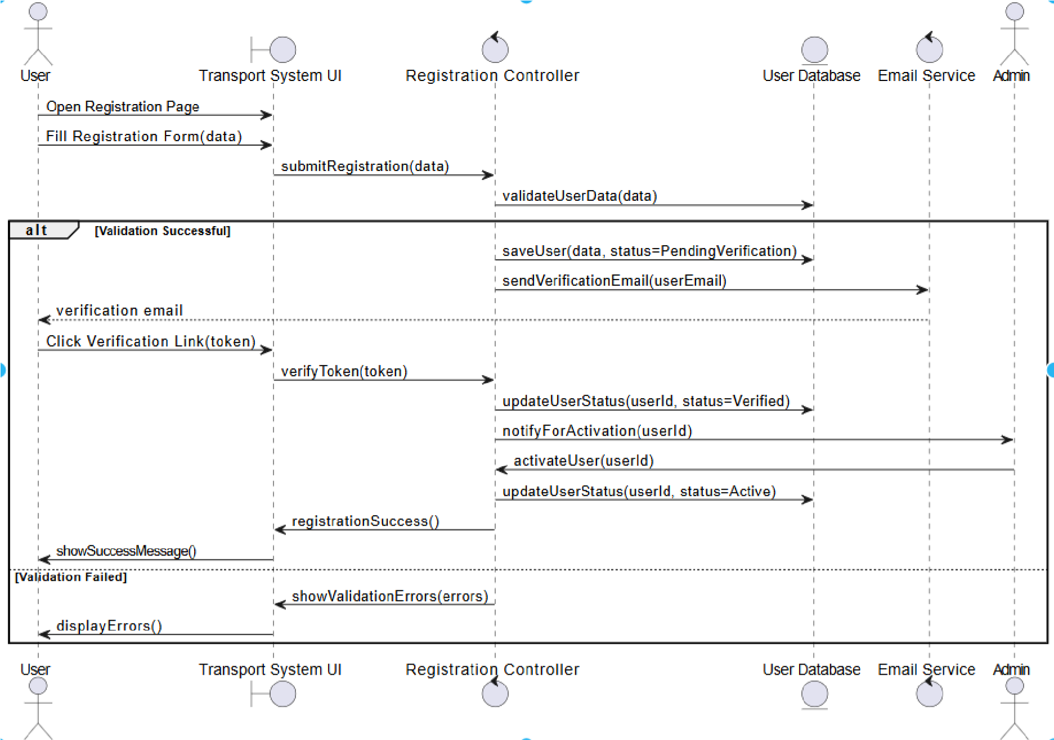

Warda Yousaf SP23-BSE-042

### SYSTEM SEQUENCE DIAGRAM: LOGIN

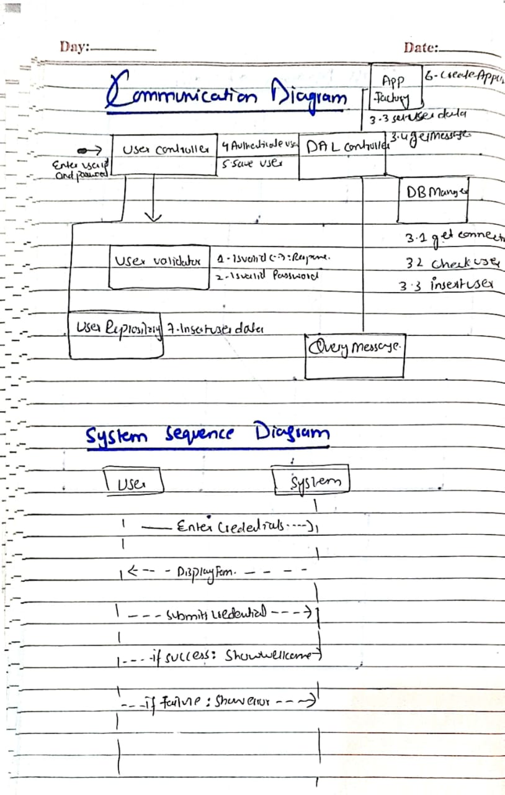

Alaina Khan SP23-BSE-069

### SYSTEM SEQUENCE DIAGRAM: MANAGE BOOKING

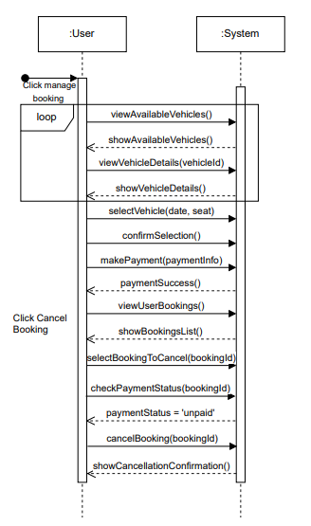

Fatima Khan SP23-BSE-102

### SYSTEM SEQUENCE DIAGRAM: MANAGE BOOKING

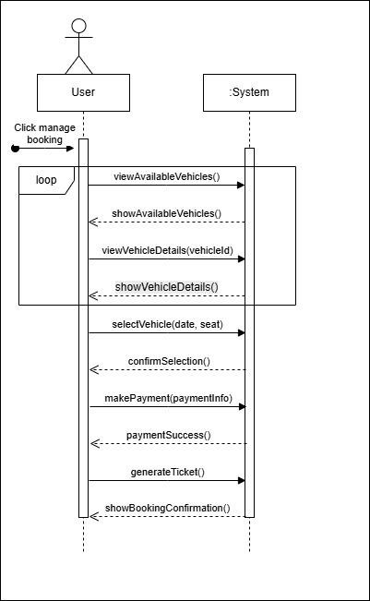

Maryam khan SP23-BSE-066

### SYSTEM SEQUENCE DIAGRAM: TRACK VEHICLE LOCATION

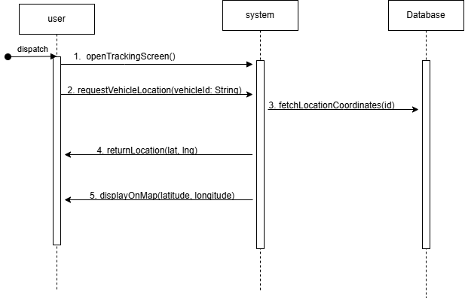

Kashmala Zeb SP23-BSE-048

### SYSTEM SEQUENCE DIAGRAM: FINANCE TRACKING

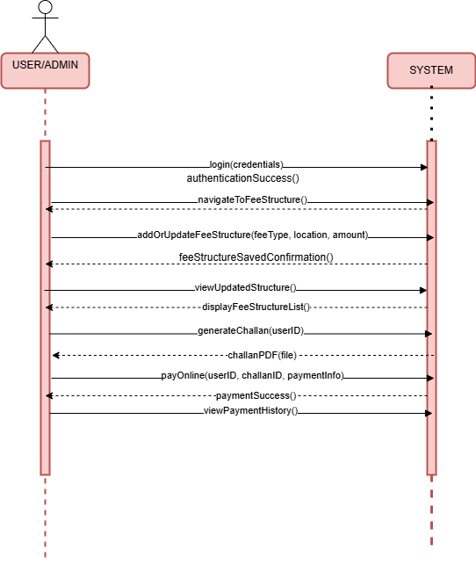

Tehreema Jilani SP23-BSE-041

### SYSTEM SEQUENCE DIAGRAM: FINANCE TRACKING

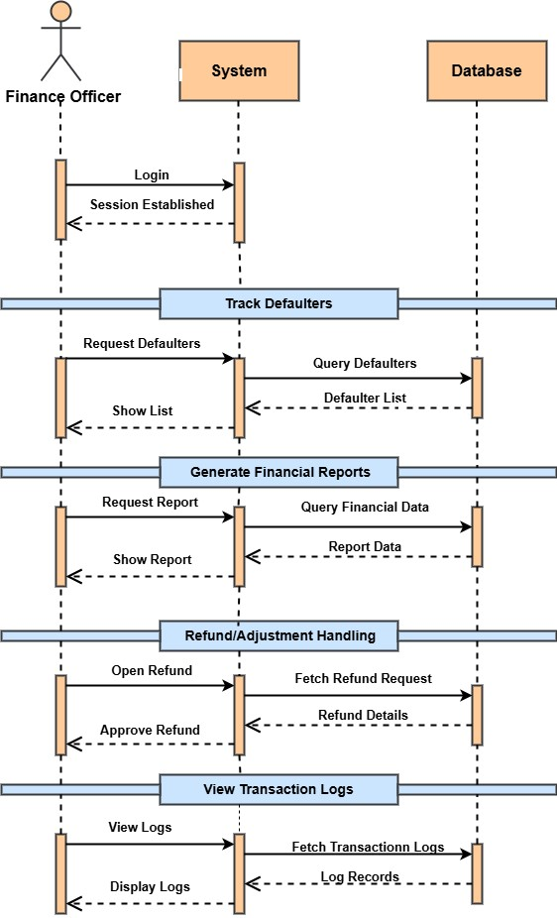

# CHAPTER NO 5: PACKAGE DIAGRAM

Sarina Amjad SP22-BSE-095

### PACKAGE DIAGRAM: REGISTRATION

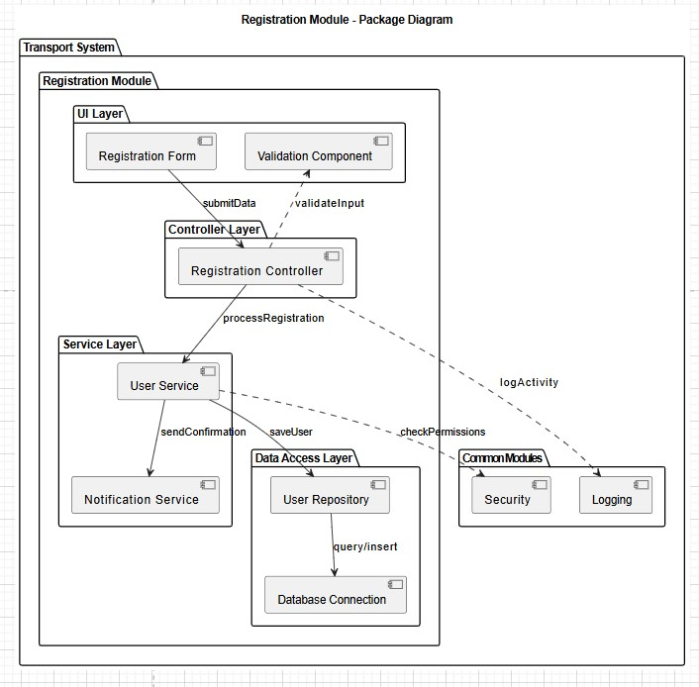

Warda Yousaf SP23-BSE-042

### PACKAGE DIAGRAM: LOGIN

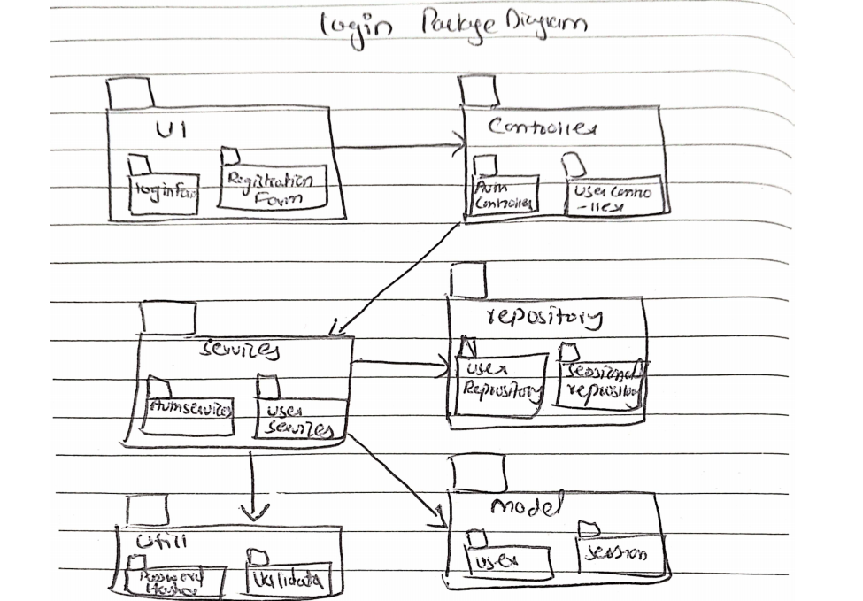

Alaina Khan SP23-BSE-069

### PACKAGE DIAGRAM: MANAGE BOOKING

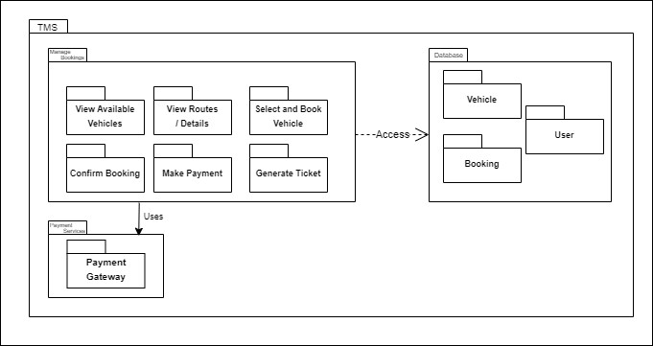

Fatima Khan SP23-BSE-102

### PACKAGE DIAGRAM: MANAGE BOOKING

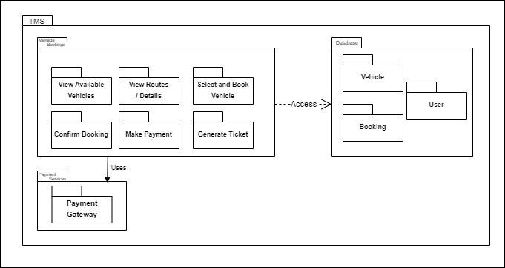

Maryam khan SP23-BSE-066

### PACKAGE DIAGRAM: TRACK VEHICLE LOCATION

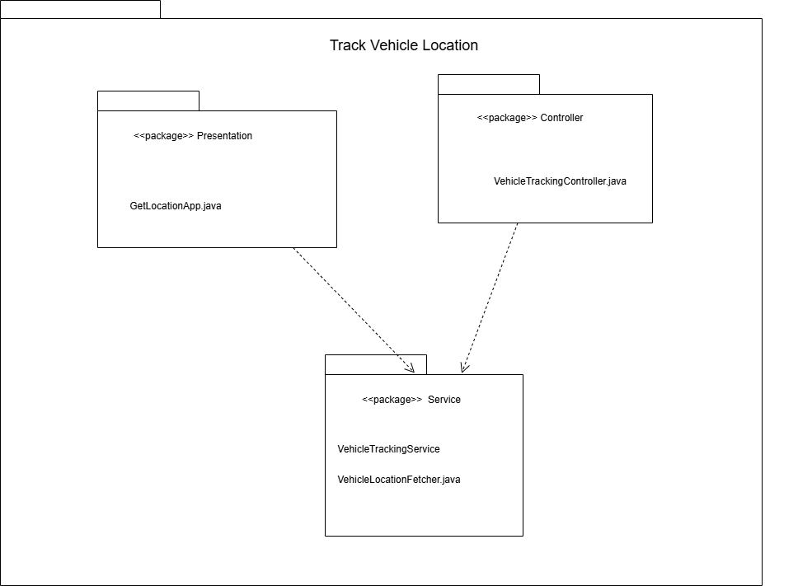

Kashmala Zeb SP23-BSE-048

### PACKAGE DIAGRAM: FINANCE TRACKING

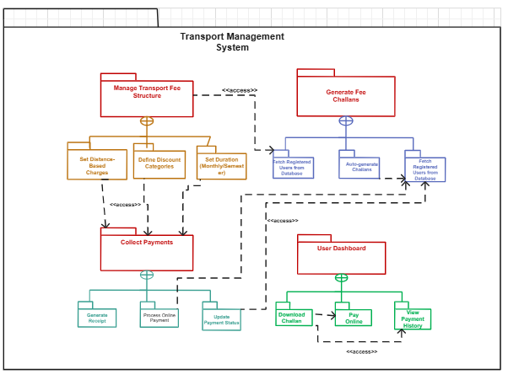

Tehreema Jilani SP23-BSE-041

### PACKAGE DIAGRAM: FINANCE TRACKING

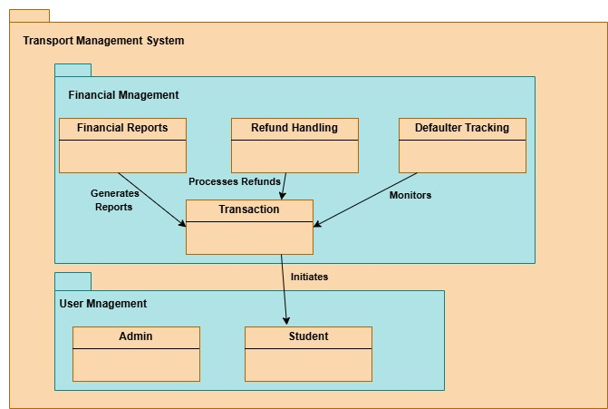

# CHAPTER NO 6: COMMUNICATION DIAGRAM

Sarina Amjad SP22-BSE-095

### COMMUNICATION DIAGRAM: REGISTRATION

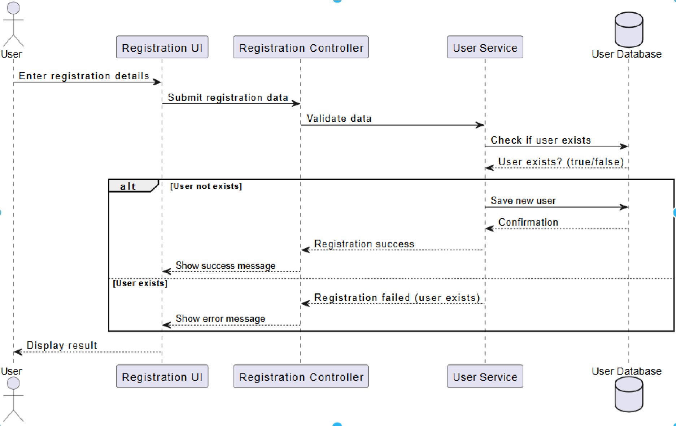

Warda Yousaf SP23-BSE-042

### COMMUNICATION DIAGRAM : LOGIN



Alaina Khan SP23-BSE-069

### COMMUNICATION DIAGRAM: MANAGE BOOKING

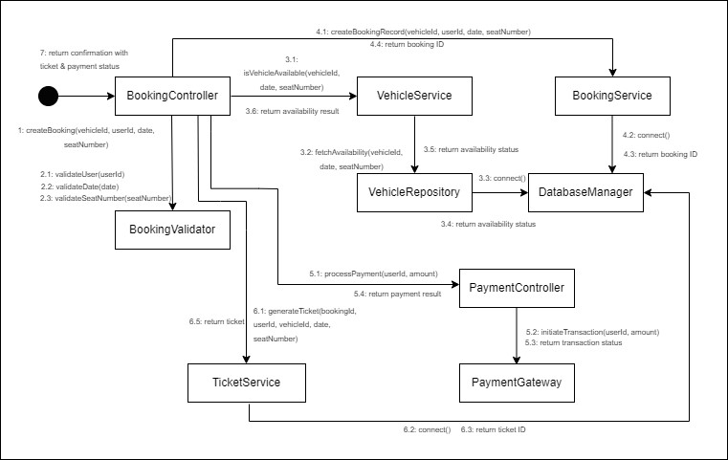

Fatima Khan SP23-BSE-102

### COMMUNICATION DIAGRAM: MANAGE BOOKING

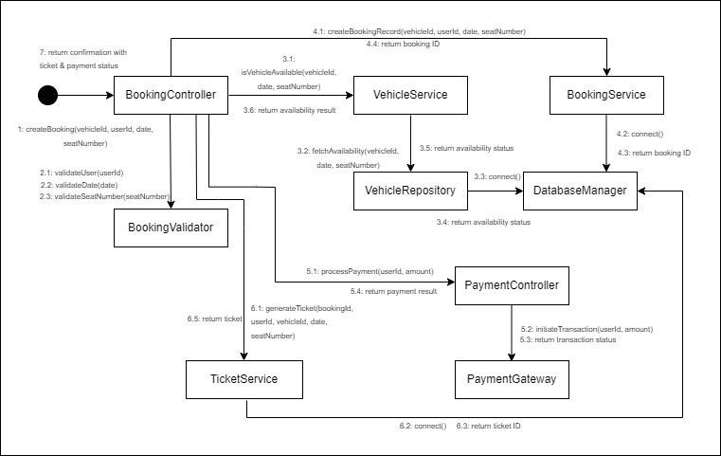

Maryam khan SP23-BSE-066

### COMMUNICATION DIAGRAM: TRACK VEHICLE LOCATION

**SET LOCATION**

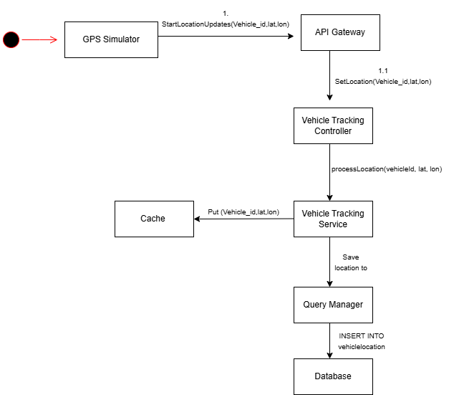

**GET LOCATION**

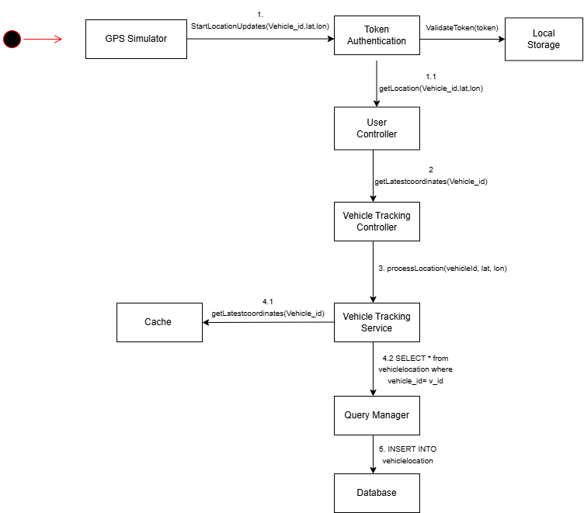

Kashmala Zeb SP23-BSE-048

### COMMUNICATION DIAGRAM: FINANCE TRACKING

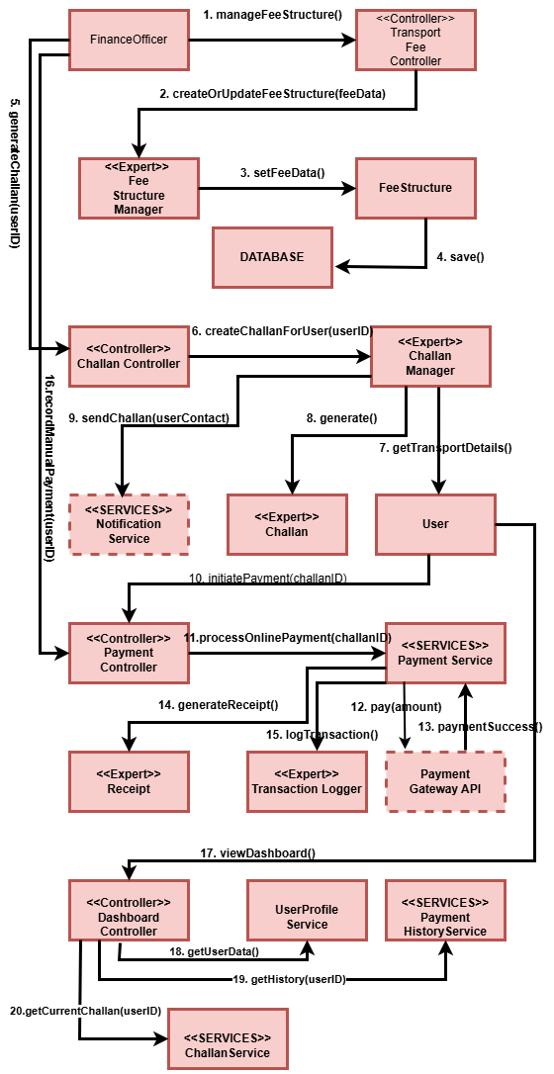

Tehreema Jilani SP23-BSE-041

### SEQUENCE DIAGRAM: FINANCE TRACKING

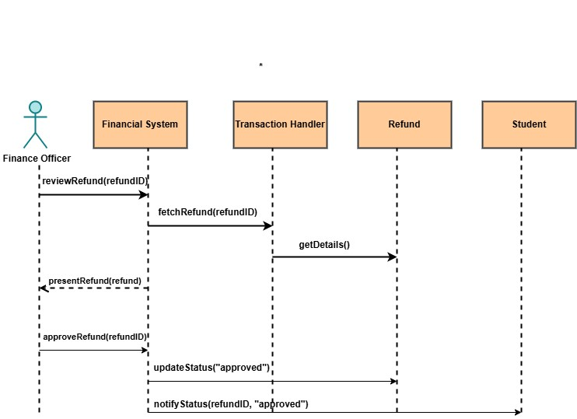

# CHAPTER NO 7: CLASS DIAGRAM

Sarina Amjad SP22-BSE-095

### CLASS DIAGRAM: REGISTRATION

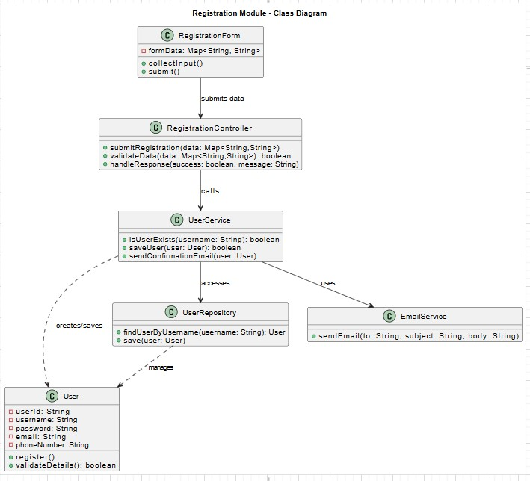

Warda Yousaf SP23-BSE-042

### CLASS DIAGRAM: LOGIN

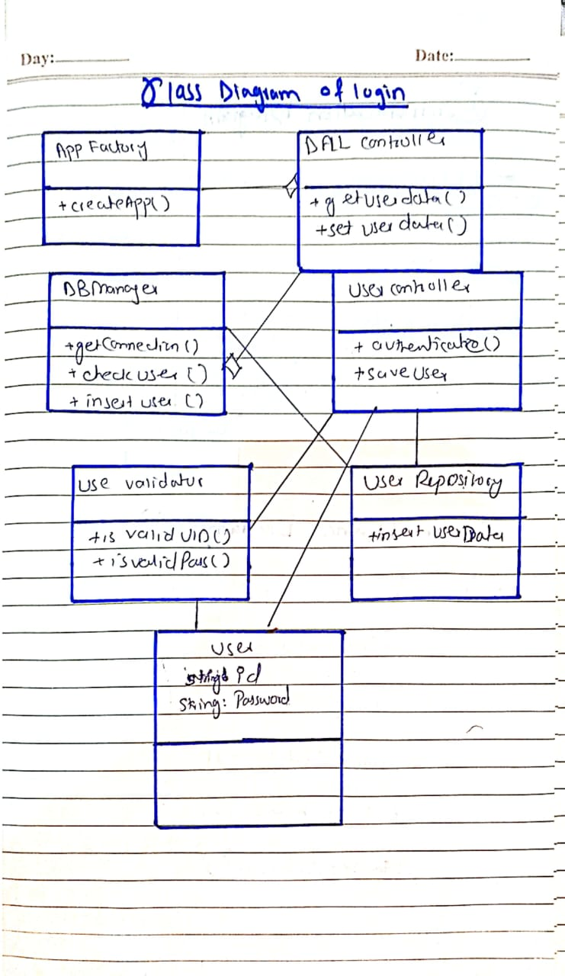

Alaina Khan SP23-BSE-069

### CLASS DIAGRAM: MANAGE BOOKING

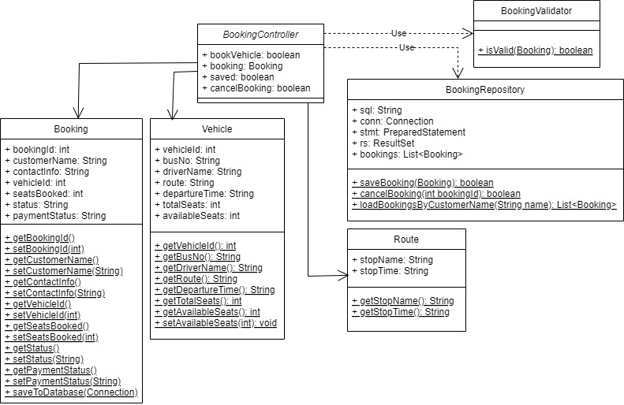

Fatima Khan SP23-BSE-102

### CLASS DIAGRAM: MANAGE BOOKING

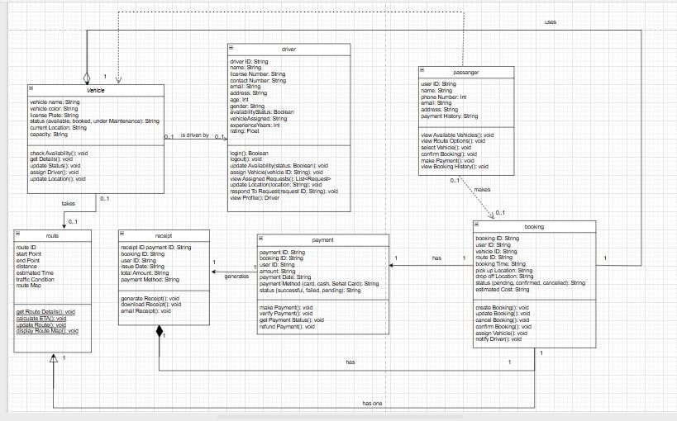

Maryam khan SP23-BSE-066

### CLASS DIAGRAM: TRACK VEHICLE LOCATION

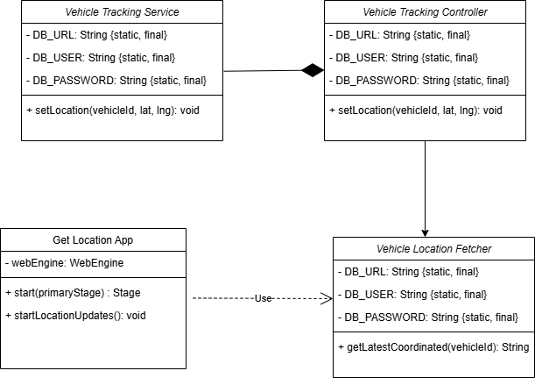

Kashmala Zeb SP23-BSE-048

### CLASS DIAGRAM: FINANCE TRACKING

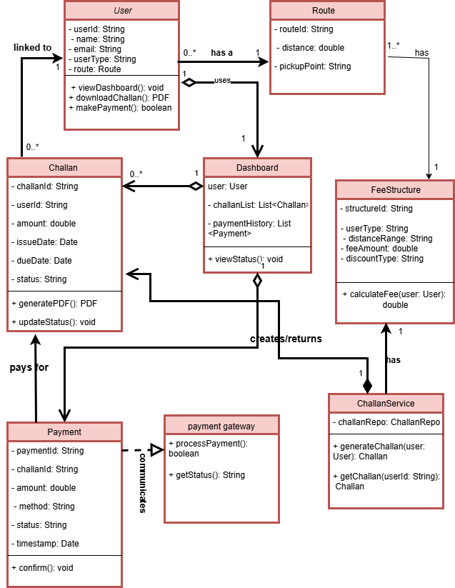

Tehreema Jilani SP23-BSE-041

### CLASS DIAGRAM: FINANCE TRACKING

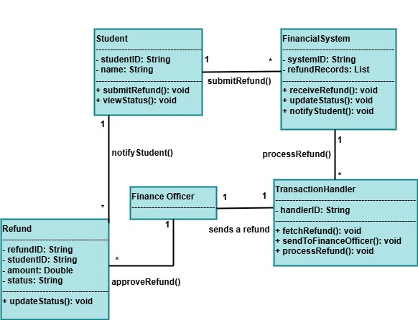

# CHAPTER NO 8: STATE TRANSITION DIAGRAM

Warda Yousaf SP23-BSE-042

### STATE TRANSITION DIAGRAM: LOGIN & REGISTER

Alaina Khan SP23-BSE-069

### STATE TRANSITION DIAGRAM: MANAGE BOOKING

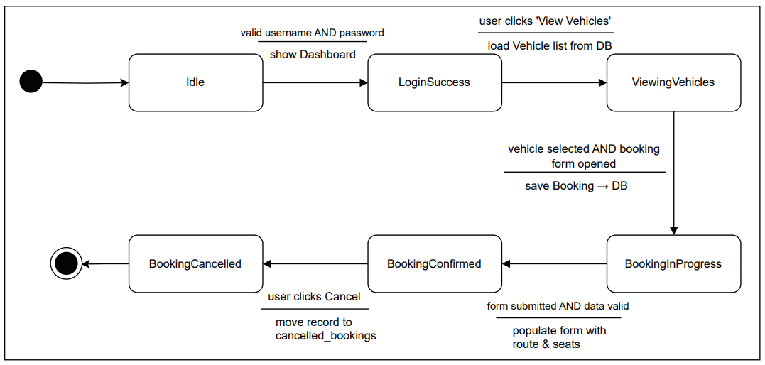

Fatima Khan SP23-BSE-102

### STATE TRANSITION DIAGRAM: MANAGE BOOKING

Maryam khan SP23-BSE-066

### STATE TRANSITION DIAGRAM: TRACK VEHICLE LOCATION

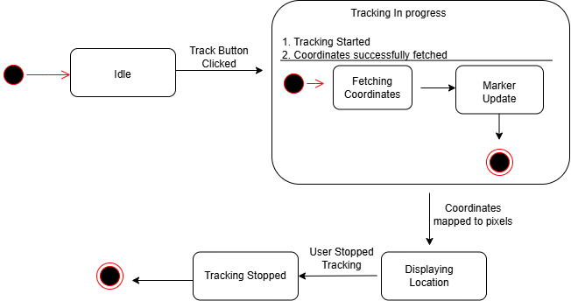

Kashmala Zeb SP23-BSE-048

### STATE TRANSITION DIAGRAM: FINANCE TRACKING

Tehreema Jilani SP23-BSE-041

### STATE TRANSITION DIAGRAM: FINANCE TRACKING

Sarina Amjad SP22-BSE-095

### STATE TRANSITION DIAGRAM:

# 

# CHAPTER NO 9: ENTITY RELATIONSHIP DIAGRAM

Warda Yousaf SP23-BSE-042

### ENTITY RELATIONSHIP DIAGRAM: LOGIN & REGISTER

Alaina Khan SP23-BSE-069

### ENTITY RELATIONSHIP DIAGRAM: MANAGE BOOKING

Fatima Khan SP23-BSE-102

### ENTITY RELATIONSHIP DIAGRAM: MANAGE BOOKING

Maryam khan SP23-BSE-066

### ENTITY RELATIONSHIP DIAGRAM: TRACK VEHICLE LOCATION

### 

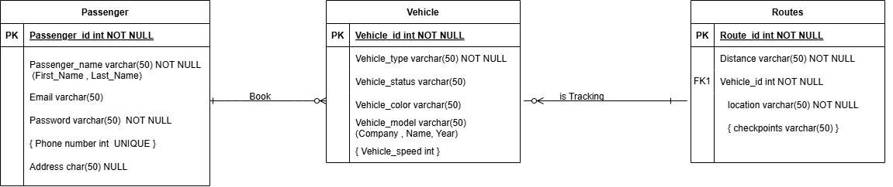

Kashmala Zeb SP23-BSE-048

### ENTITY RELATIONSHIP DIAGRAM: FINANCE TRACKING

Tehreema Jilani SP23-BSE-041

### ENTITY RELATIONSHIP DIAGRAM: FINANCE TRACKING

Sarina Amjad SP22-BSE-095

### ENTITY RELATIONSHIP DIAGRAM:

# 

# CHAPTER NO 10: CODING STANDARDS

**Coding Standards for TMS Manage Bookings Project**

We intend to follow a set of basic, consistent coding standards while developing the TMS (Transport Management System). These standards are aimed at making the code clear, readable, maintainable, and logically organized for both ourself and others who may review it.

Since this is a learning exercise, we will focus on fundamental conventions and practices suitable for beginner to intermediate-level projects.

1. **Naming Conventions** 
   * **Class Names:**

Class names will be written in **PascalCase** (each word starting with a capital letter).

Example: BookingController, VehicleService.

* + **Variables and Function Names:**

Variable and function names will be written in **camelCase** (the first word lowercase, each subsequent word capitalized).

Example: availableVehicles, validateBookingDetails().

* + **File Names:**

File names will be meaningful and consistent with the class or component they contain.

For React components, the file name will match the component name.

Example: ManageBookings.js, VehicleList.js.

1. **Indentation and Formatting** 
   * Code will be consistently indented using **4 spaces** per indentation level.
   * Each logical block of code (functions, conditionals, loops) will be separated by one blank line to enhance readability.
   * Opening braces { will be placed on the **same line** as the control structure or function declaration.

**Example:**

if (isAvailable) { confirmBooking();

}

1. **Commenting** 
   * Simple, clear comments will be included above functions and important code sections to describe their purpose.
   * Comments will also be added for any non-obvious logic or processes.
   * Comments will follow the single-line // format in JavaScript and React.

1. **Function Design** 
   * Functions will be **small and single-purpose**, focusing on doing one specific task.
   * Where applicable, reusable utility functions will be placed in a separate utility file.

1. **Error Handling** 
   * Basic error checking will be implemented where required, such as validating input values before processing them.
   * Error messages will be meaningful and assist in debugging.

1. **Code Structure and Organization** 
   * The codebase will follow a **modular structure**:
     + Components for UI elements.
     + Services for handling data and business logic.
     + Pages for complete views.
   * Related files and classes will be grouped logically in folders.

**Example Folder Structure:**

/src

/components

/services

/pages

/assets App.js index.js

1. **Consistency in Syntax and Practices** 
   * Consistent use of **const** and **let** for variable declarations in JavaScript.
   * Consistent arrow function syntax where appropriate.
   * Removal of any unused code or variables during cleanup.
   * Keeping code aligned with modern JavaScript (ES6+) and React conventions.

1. **Object-Oriented Practices** 
   * The project will implement **object-oriented programming (OOP) concepts** in JavaScript where suitable, particularly for services and controllers.
   * Classes will have clearly defined attributes (properties) and methods (functions) based on their responsibilities.