LAB AUTOMATION / PRODUCT TESTING
MANAGEMENT SYSTEM
DESIGNER GUIDE

Goup Members:
Student1613939 | MARYAM
Student1644851 | OKASHA BUKHARI
Student1645249 | MUHAMMAD HASHIM FARAZ
Student1649373 | MUHAMMAD ABID

Curriculum: ACCP AI
Semester: DISM
Faculty: Sir Tasbeel Jawed

Certificate of Recognition
This certificate is proudly presented to the development team of the
Lab Automation / Product Testing Management System
in recognition of their outstanding effort, dedication, and innovative approach in automating laboratory testing and product management processes.
The successful development of this system demonstrates excellence in system design, functionality, and teamwork. By digitizing the product testing workflow, the project contributes significantly to improving accuracy, efficiency, and traceability in industrial product testing.
This recognition stands as a testament to the hard work, commitment, and technical skills of the project team and highlights their role in advancing automation and digital transformation in laboratory environments.
Presented On: ____________________
Authorized By: ____________________

Acknowledgement
We would like to express our sincere gratitude to all those who contributed to the successful completion of the Lab Automation / Product Testing Management System.
First and foremost, we extend our heartfelt thanks to our respected instructor for continuous guidance, valuable feedback, and encouragement throughout the project development. His support and expertise played a crucial role in shaping the system according to real-world requirements and academic standards.
We are also thankful to our faculty members for providing us with the technical knowledge, resources, and learning environment necessary to complete this project effectively.
A special note of appreciation goes to our team members for their cooperation, dedication, and collaborative efforts. Their commitment and problem-solving skills were instrumental in the successful design and implementation of this system.
Finally, we would like to thank our families and friends for their constant support, motivation, and patience throughout this journey.

Synopsis
The Lab Automation / Product Testing Management System is a web-based application designed to automate and digitize the product testing and record-keeping process in an industrial laboratory environment.
In the existing manual system, product testing records are maintained on paper, which leads to errors, inefficiency, data loss, and difficulty in tracking products that undergo multiple testing stages. The proposed system addresses these issues by providing a centralized digital platform for managing product details, testing records, results, and reports.
The system assigns a unique 10-digit Product ID for each manufactured product and a 12-digit Test ID for every testing process, ensuring accurate tracking and traceability. It supports role-based access for Admin, Tester, and Supervisor users, enabling secure data entry, monitoring, and decision-making.
Key features of the system include product registration, testing management, advanced search, result evaluation, report generation, and audit logging. Products that pass testing are forwarded for CPRI approval, while failed products are sent for re-manufacturing and re-testing.
This project enhances operational efficiency, reduces human errors, supports informed decision-making, and demonstrates the practical application of software engineering principles in industrial automation.
1. Introduction:
This Designer Guide provides a detailed overview of the design aspects of the Lab Automation / Product Testing Management System. The guide focuses on system layout, user interface standards, module design, navigation flow, and validation rules based on the Software Requirement Specification (SRS).
2. System Architecture Design:
The system follows a web-based, modular architecture consisting of:
• Presentation Layer (User Interface)
• Application Layer (Business Logic)
• Database Layer (Product, Test, User, and Report Data)
This layered architecture ensures security, maintainability, and scalability.
3. User Interface Design Standards:
The user interface is designed to be simple, consistent, and role-based.
Design Guidelines:
• Clean layout with minimal clutter.
• Consistent color scheme and typography.
• Clearly labeled forms and buttons.
• Responsive design for desktop and tablet usage.
• Validation messages displayed clearly to users.
4. Color Scheme and Typography:
Color Scheme:
• Primary Color: Dark Blue (Professional & Trustworthy)
• Secondary Color: Light Gray (Background)
• Status Colors:
- Green: Passed
- Red: Failed
- Orange: Pending
Typography:
• Headings: Sans-serif, Bold
• Body Text: Sans-serif, Regular
• Font Size: Readable and consistent across screens
5. Navigation Design:
The system uses a top navigation bar with role-based access.
Main Navigation Items:
• Dashboard
• Product Module
• Testing Module
• Search Module
• Reports
• User Management (Admin only)
• Logout
- Problem Statement:
Problem Statement
1. Manual record-keeping is slow and prone to mistakes.
2. Each product may undergo multiple testing types in different departments.
3. Misplacement of records or products is common.
4. Difficulty in generating status reports for decision-making.
5. Tracking which products need re-manufacturing or CPRI testing is cumbersome.
- Requirement Specification:
1. Product Registration:
Enter product details (name, type, batch, revision).
Auto-generate 10-digit Product ID.
2. Testing Entry:
Enter test type and test results.
Add detailed remarks and tester names.
Auto-generate 12-digit Test ID.
Update status: Pending, Passed, Failed.
3. Advanced Search:
Search by Product ID, Test ID, test type, or status.
Filter based on date, product type, or batch number.
4. Status Tracking:
View which products are in testing, re-manufacturing, or approved by CPRI.
5. Reporting:
Generate reports of products tested, failed, passed, or pending.
Maintain logs for auditing.

- Designer:
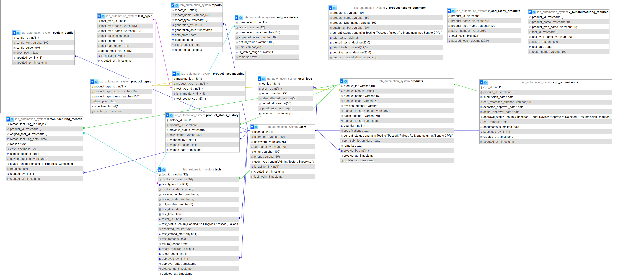

- Checklist For Validation:
Option | Validation
Do all text links lead to appropriate web pages? | YES
Do all image links lead to the appropriate web pages? | YES
Are all images and links clearly visible in web pages? | YES
Is web page opening properly in all tested web browsers? | YES
Are animations loading well? | YES
Is the website responsive? | YES
Is website taking too long to load? | NO
Is the navigation sequence correct through all the web pages on the site? | YES
Is the JavaScript code working as expected in all click events | YES

