LAB AUTOMATION / PRODUCT TESTING
MANAGEMENT SYSTEM
USER GUIDE

Goup Members:
Student1613939 | MARYAM
Student1644851 | OKASHA BUKHARI
Student1645249 | MUHAMMAD HASHIM FARAZ
Student1649373 | MUHAMMAD ABID

Curriculum: ACCP AI
Semester: DISM
Faculty: Sir Tasbeel Jawed

Certificate of Recognition
This certificate is proudly presented to the development team of the
Lab Automation / Product Testing Management System
in recognition of their outstanding effort, dedication, and innovative approach in automating laboratory testing and product management processes.
The successful development of this system demonstrates excellence in system design, functionality, and teamwork. By digitizing the product testing workflow, the project contributes significantly to improving accuracy, efficiency, and traceability in industrial product testing.
This recognition stands as a testament to the hard work, commitment, and technical skills of the project team and highlights their role in advancing automation and digital transformation in laboratory environments.
Presented On: ____________________
Authorized By: ____________________

Acknowledgement
We would like to express our sincere gratitude to all those who contributed to the successful completion of the Lab Automation / Product Testing Management System.
First and foremost, we extend our heartfelt thanks to our respected instructor for continuous guidance, valuable feedback, and encouragement throughout the project development. His support and expertise played a crucial role in shaping the system according to real-world requirements and academic standards.
We are also thankful to our faculty members for providing us with the technical knowledge, resources, and learning environment necessary to complete this project effectively.
A special note of appreciation goes to our team members for their cooperation, dedication, and collaborative efforts. Their commitment and problem-solving skills were instrumental in the successful design and implementation of this system.
Finally, we would like to thank our families and friends for their constant support, motivation, and patience throughout this journey.

Synopsis
The Lab Automation / Product Testing Management System is a web-based application designed to automate and digitize the product testing and record-keeping process in an industrial laboratory environment.
In the existing manual system, product testing records are maintained on paper, which leads to errors, inefficiency, data loss, and difficulty in tracking products that undergo multiple testing stages. The proposed system addresses these issues by providing a centralized digital platform for managing product details, testing records, results, and reports.
The system assigns a unique 10-digit Product ID for each manufactured product and a 12-digit Test ID for every testing process, ensuring accurate tracking and traceability. It supports role-based access for Admin, Tester, and Supervisor users, enabling secure data entry, monitoring, and decision-making.
Key features of the system include product registration, testing management, advanced search, result evaluation, report generation, and audit logging. Products that pass testing are forwarded for CPRI approval, while failed products are sent for re-manufacturing and re-testing.
This project enhances operational efficiency, reduces human errors, supports informed decision-making, and demonstrates the practical application of software engineering principles in industrial automation.

System Overview:
The Lab Automation / Product Testing Management System is designed to provide users with an efficient and user-friendly interface for managing laboratory testing activities. The system enables users to register products, record test details, monitor testing progress, and generate reports. By replacing manual record-keeping with an automated system, it significantly reduces human errors, improves operational efficiency, and ensures better control over testing workflows.

Product Management:
The system allows users to register newly manufactured products by entering essential details such as product name, type, batch number, and revision information. Once registered, the system automatically generates a unique ten-digit Product ID for each product. Users can view, update, and search product records at any time, making it easy to track products throughout the testing lifecycle.

Testing Management:
The testing module enables laboratory staff to enter detailed test information for registered products. Users can record test types, testing criteria, observed results, remarks, and tester names. For every test entry, the system automatically generates a unique twelve-digit Test ID. Based on the test results, the product status can be updated as pending, passed, or failed. Products that pass testing are marked for CPRI submission, while failed products are sent back for re-manufacturing and re-testing.

Search and Reporting:
The system provides advanced search functionality that allows users to quickly retrieve product and testing information using Product ID, Test ID, test type, product type, batch number, date, or status. Additionally, the reporting feature enables users to generate detailed reports related to testing progress, pass and fail rates, re-manufacturing requirements, and overall system performance. These reports assist management in decision-making and auditing processes.

User Roles and Security:
The Lab Automation / Product Testing Management System implements role-based access control to ensure system security and data integrity. Administrators are responsible for managing users, products, tests, and reports. Testers are authorized to enter and update testing information, while supervisors can view reports and approve products for further processing. Secure login authentication, activity logging, and data backup mechanisms are implemented to protect system data and ensure reliability.
Images:
Header

Footer
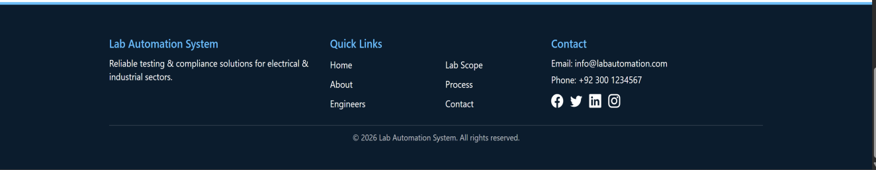

Home Page


About Us


Engineering Team


Lab Scope
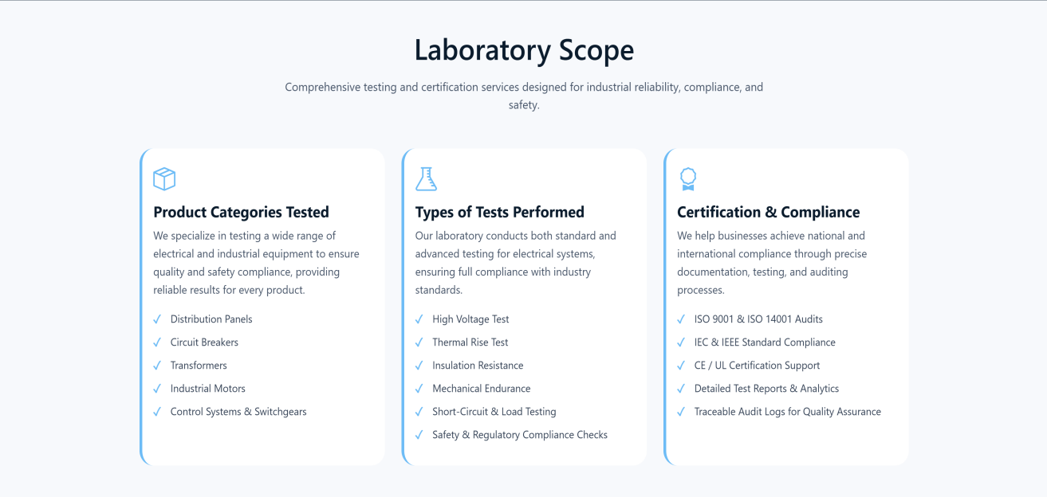

Process
