Idea Management System

Team members:

Maryam Naji

Zohreh Karim Zadeh

Idea management is the ability to capture feedback or insights from internal and external stakeholders for the purpose of adding this feedback into future products or product releases.

Every organization wants better ideas. But it is often too tough to capture them in a manageable way. And product teams need a way to quickly capture, categorize, and prioritize ideas. The best solution is to practice ideation -- the creative process of generating, developing, and curating new ideas.

Better ideas lead to innovation, and innovation leads to market leadership. Ideation software provides an integrated means to capture and respond to customer feedback, recommendations, and questions within the context of submitted ideas. Ideation software also allows product teams to quickly answer ideas submitters once those ideas are prioritized and scheduled for future releases.

This web application helps organizations to gather ideas from all employees,

evaluate them and bring them to market faster than ever before.

.

These new Web-based applications enable companies to solicit targeted ideas from all

employees — regardless of their geographic location — and gather them into a centralized online database.

Idea management systems also provide structured processes for evaluating and sharing ideas,

so managers can quickly zero in on those with the greatest potential.

Technologies used:

* Bootstrap
* Blob
* Ajax
* JQuery
* Facebook login

**Features:**

* User can sign up with email or facebook account
* Submit an idea
* Leave a comment foe an idea
* Upload image
* Search
* Sort

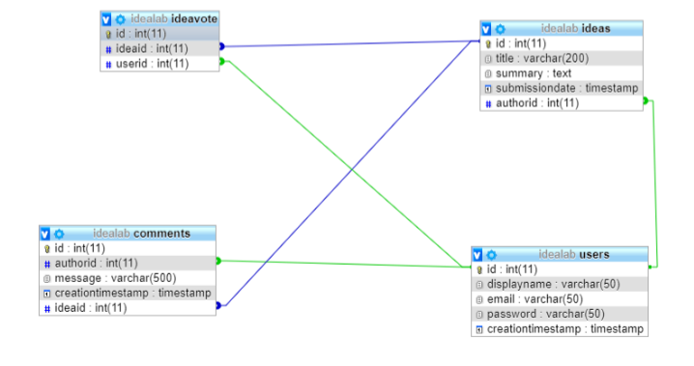

Pages Url:

<http://localhost:8008/register>

h[ttp://localhost:8008/login](http://localhost:8008/register)

http://localhost:8008/IdeaSubmision

<http://localhost:8008/IdeaList>

http://localhost:8008/IdeaDetail

