**RESEARCH TITLE:**

GCANet: A Guided Cascaded Attention Network with Preprocessing for Robust Thyroid Nodule Segmentation in Ultrasound Images

**RESEARCH QUESTION:**

Can we improve the accuracy, generalizability, and robustness of thyroid nodule segmentation in ultrasound images by using a guided, gated attention mechanism, along with preprocessing and cascaded refinement, instead of static attention like in DPAM-PSPNet?

**What Problem Are We Trying to Solve?**

DPAM-PSPNet uses static attention — both edge and global attention are applied equally to all images and regions.

In practice, not every image needs attention everywhere. Sometimes attention overfits or even adds noise.

DPAM is also a single-stage model with limited flexibility and relies heavily on one architecture.

We aim to build a smarter, more adaptive model that decides when and where attention is needed using a guided attention gate, and improves results through two-stage refinement and preprocessing.

**What Makes GCANet Unique & Different:**

|  |  |  |
| --- | --- | --- |
| **Feature** | **DPAM-PSPNet** | **GCANet (Ours)** |
| Attention | Static (always-on) | ✅ Adaptive (guided gating) |
| Segmentation Approach | Single-stage | ✅ Two-stage cascaded |
| Preprocessing | None or basic | ✅ CLAHE + edge enhancement |
| Decision Controller | ❌ None | ✅ Gated Attention Controller |
| Generalization (e.g., DDTI) | May overfit | ✅ Tunable, modular, flexible |
| Modularity | Locked to Mobile Net | ✅ Any backbone (e.g., Deep Lab) |
| Optional Diagnosis Prediction | ❌ No | ✅ Possible (classification head) |

**GCANet: Schematic Diagram**  
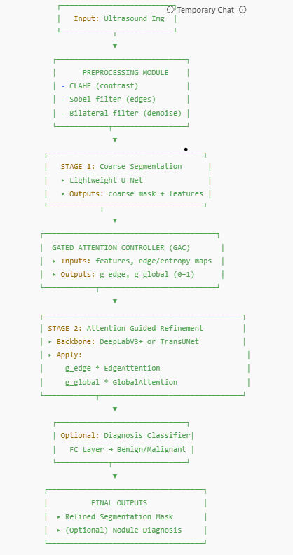

# What If GCANet Doesn't Outperform?

Even then — it is still useful because:

|  |  |
| --- | --- |
| **Value** | **Why It Matters** |
| 💡 Proves when attention should/shouldn't be used | Helps future models avoid unnecessary complexity |
| 🔎 Visualizes attention decisions | Adds interpretability (clinically valuable) |
| 🧪 Generalizes architecture (plug-and-play) | Works with multiple backbones |
| 📉 May outperform on hard or noisy cases | Even if overall Dice is same |
| 📦 Modular, reusable design | Future researchers can build on it |