COSY AIRCONDITIONERS
Premium Climate Control

TECHNICAL MANUAL
Complete Developer & Architecture Reference
Version 1.0 | 2026 | For Internal / Developer Use

Table of Contents
1. | Project Architecture Overview | 4
1.1 | Technology Stack | 4
1.2 | Project File Structure | 5
2. | HTML Pages Reference | 6
2.1 | index.html — Homepage | 6
2.2 | brand.html — Brand Catalog | 6
2.3 | compare.html — Comparison Tool | 7
2.4 | cart.html — Shopping Cart | 7
2.5 | Contact.html — Contact Form | 7
2.6 | docs/*.html — Product Detail Pages | 7
3. | JavaScript Architecture — app.js | 8
3.1 | Initialization Flow | 8
3.2 | All Functions Reference | 8
4. | Product Data Schema | 10
4.1 | Product Object Properties | 10
4.2 | Adding a New Product | 11
5. | Cart System — Technical Details | 12
5.1 | localStorage Keys | 12
5.2 | Price Parsing Logic | 12
5.3 | Cart Flow Diagram | 12
6. | CSS & Styling Guide | 13
6.1 | Design Tokens & Custom Classes | 13
6.2 | Adding a New Brand | 14
7. | Troubleshooting & Known Limitations | 15
8. | Future Development Recommendations | 16
9. | Glossary | 17

1. Project Architecture Overview
COSY AIRCONDITIONERS is a fully static, front-end web application with no backend server, database, or server-side rendering. All logic is implemented in plain HTML, CSS, and vanilla JavaScript. Data persistence is handled exclusively through the browser's localStorage API.
The application follows a single-file-per-page architecture where each HTML page is independent, sharing one CSS file (css/style.css) and one JavaScript file (js/app.js).

1.1 Technology Stack
Technology | Purpose
HTML5 | Semantic page structure and markup for all pages
CSS3 — css/style.css | Custom dark-themed styling, glow effects, scroll animations
Bootstrap 5.3.2 (CDN) | Responsive grid, navbar, dropdowns, modals, form controls
Bootstrap Icons 1.11.0 (CDN) | Icon library used throughout the UI
Google Fonts (CDN) | Orbitron (headings/brand text) and Rajdhani (body text)
Vanilla JavaScript — js/app.js | All interactivity: product rendering, cart, compare, animations
localStorage (Browser API) | Cart data persistence across page navigations
IntersectionObserver API | Scroll-triggered card reveal animations

NOTE: Because all libraries are loaded from CDN, an internet connection is required for Bootstrap, Bootstrap Icons, and Google Fonts to render correctly. The core application logic in app.js does not require internet access.

1.2 Project File Structure
File / Folder | Location | Purpose
index.html | Root | Main homepage — entry point of the application
brand.html | Root | Brand-filtered product listing page
compare.html | Root | Product side-by-side comparison page
cart.html | Root | Shopping cart and checkout page
Contact.html | Root | Contact form and company info page
css/style.css | css/ | All custom CSS — dark theme, animations, glow effects
js/app.js | js/ | All JavaScript — products data, cart, compare, animations
docs/samsung-windfree-elite.html | docs/ | Samsung WindFree Elite detail page
docs/samsung-classic.html | docs/ | Samsung Wind-Free Classic detail page
docs/lg-dual-inverter-pro.html | docs/ | LG Dual Inverter Pro detail page
docs/daikin-streamer.html | docs/ | Daikin Streamer X-Series detail page
docs/whirlpool-magicool.html | docs/ | Whirlpool Magicool Pro detail page
docs/haier-cleancool.html | docs/ | Haier CleanCool Ultra detail page
docs/gree-fairy.html | docs/ | Gree Fairy Series detail page
Image/Sumsung/ | Image/ | Samsung product images (.png)
Image/LG/ | Image/ | LG product images (.png)
Image/Daikin/ | Image/ | Daikin product images (.png)
Image/Whirlpool/ | Image/ | Whirlpool product images (.png)
Image/haier/ | Image/ | Haier product images (.png)
Image/Gree/ | Image/ | Gree product images (.png)

2. HTML Pages Reference

2.1 index.html — Homepage
The main entry point of the application. Contains:
- Fixed top navbar with scroll-opacity effect
- Hero section with animated temperature display (#heroTemp element)
- Brand showcase with 6 clickable brand logo cards (each has data-brand attribute for filter integration)
- #productGrid div — dynamically populated by displayProducts() in app.js
The productGrid is empty in the HTML. Products are injected via JavaScript on page load.

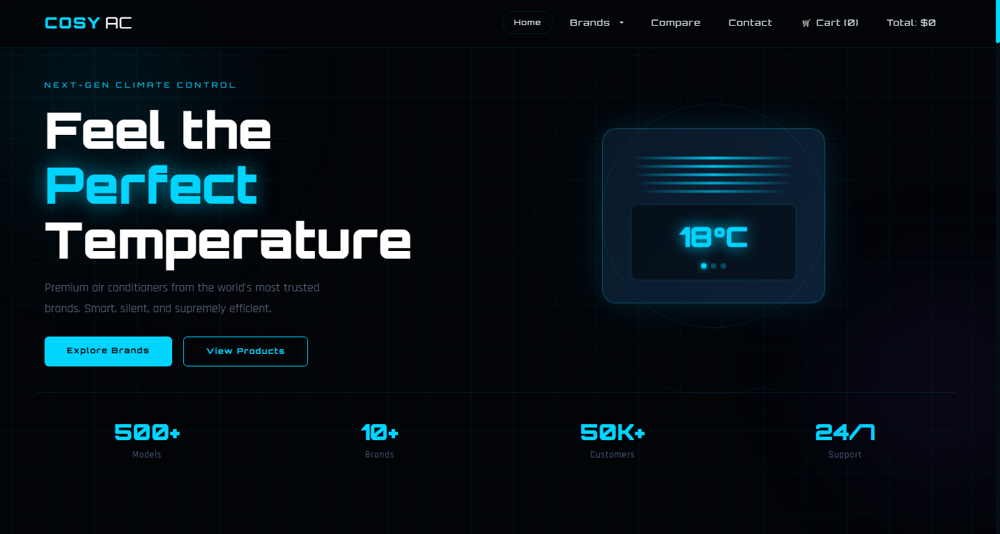

2.2 brand.html — Brand Catalog
Identical page structure to index.html with the addition of:
- #brandFilters — a row of filter buttons, each with a data-brand attribute matching brand names
- Products grid populated by displayProducts()
- initBrandFilter() is called on DOMContentLoaded to bind all filter events
Filter logic hides/shows .product-item elements by comparing their data-brand attribute to the clicked button's data-brand value.

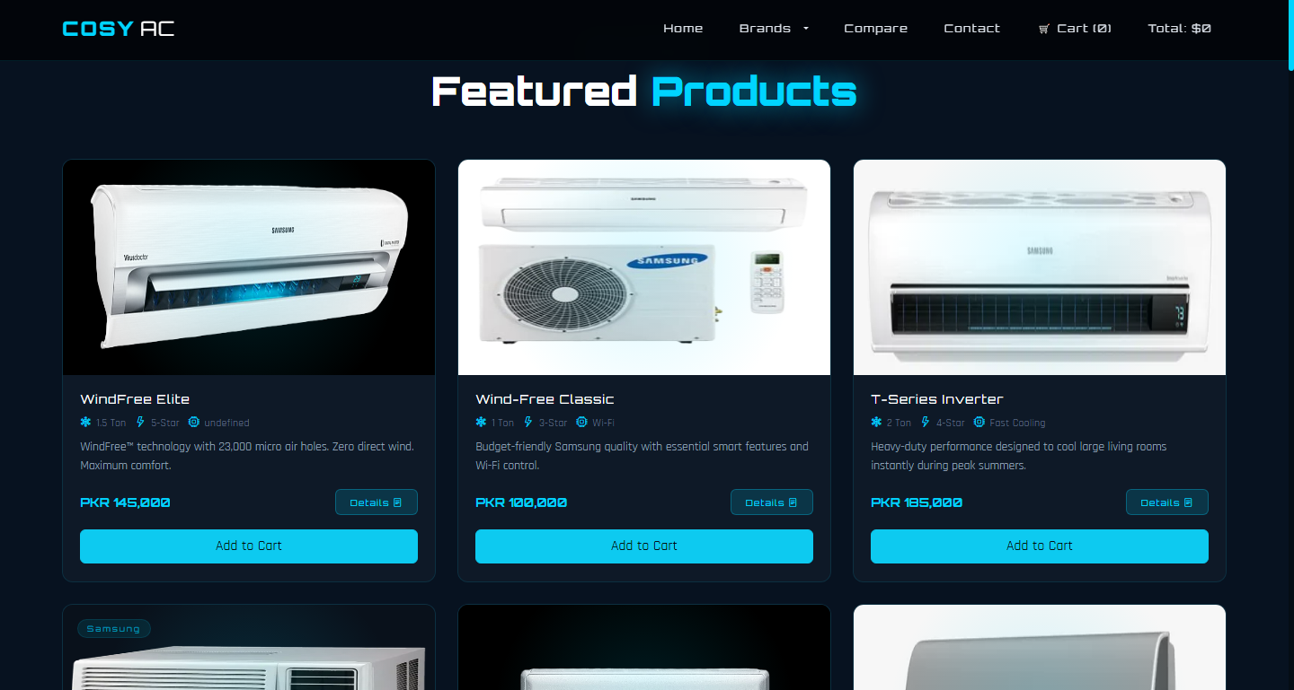

2.3 compare.html — Comparison Tool
Contains two <select> elements (#compareA, #compareB) pre-populated with all 7 product options. The compareProducts() function:
- Reads selected product IDs from both dropdowns
- Looks up full product objects from the products array using Array.find()
- Dynamically builds a <tr> per field from the compareFields array
- Injects rows into #compareBody and reveals #compareResult

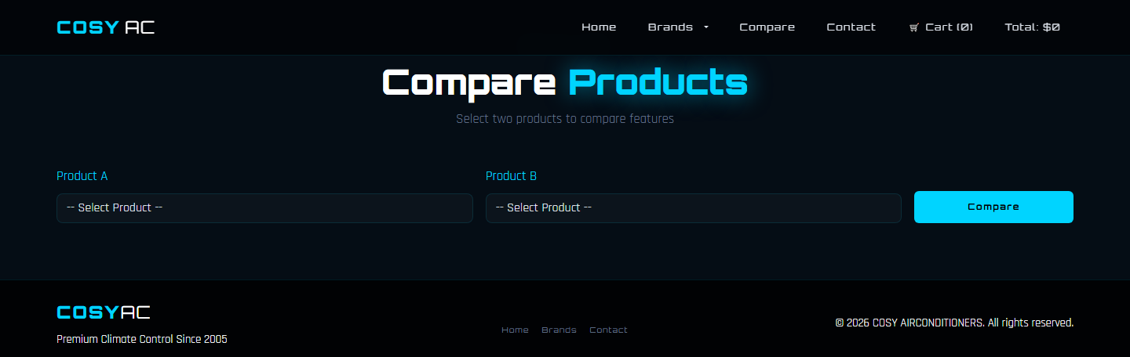

2.4 cart.html — Shopping Cart
Contains the cart table structure with #cart-table-body (tbody) and #cart-page-total. The renderCart() function handles all dynamic rendering. Key IDs:
- #cart-table-body — tbody where cart rows are injected
- #cart-page-total — span displaying the total amount
- #empty-msg — shown when cart is empty
- #cart-content — hidden when cart is empty

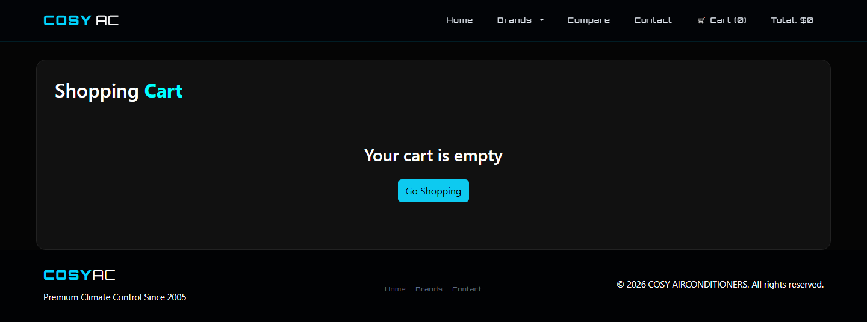

2.5 Contact.html — Contact Form
Static contact form with four inputs: Name (text), Email (email), Subject (select), Message (textarea). The sendMsg() function is called onclick of the submit button and shows #msgSuccess for 5 seconds.
NOTE: No form validation and no backend submission. Suitable for demo purposes only.

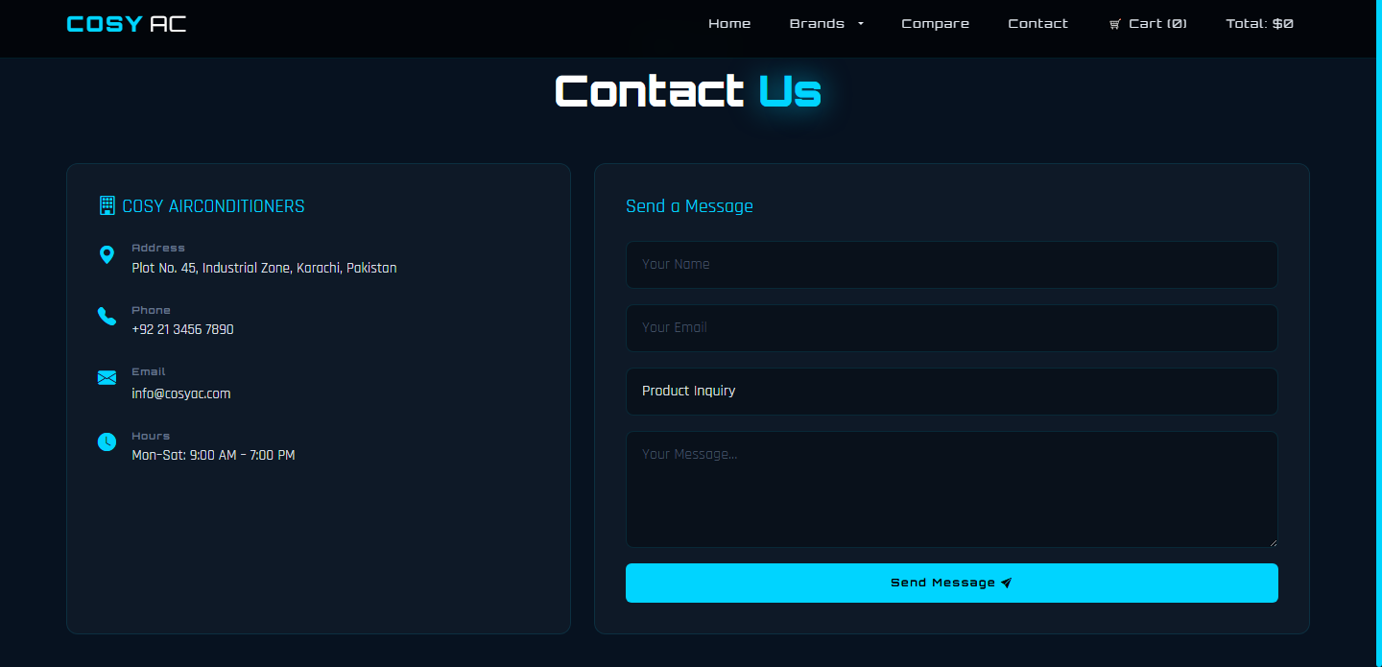

2.6 docs/*.html — Product Detail Pages
Seven individual static HTML pages, one per product. Each contains brand-specific specifications, feature lists, and styling. They are opened as new tabs via the Details button on product cards (target='_blank').

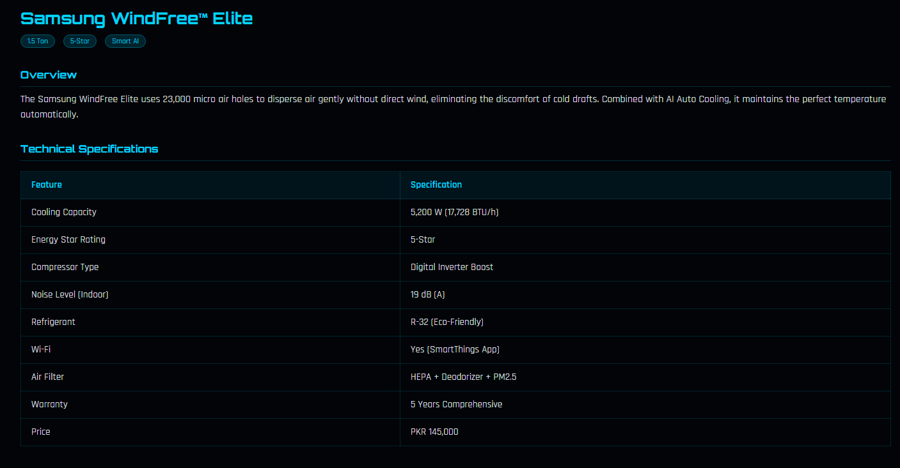

3. JavaScript Architecture — app.js
All application logic resides in a single file: js/app.js. This file is loaded at the bottom of the <body> tag in all HTML pages, ensuring the DOM is ready before any script executes.

3.1 Initialization Flow
Two DOMContentLoaded listeners exist in app.js — one for cart initialization and one for all other features. The execution order on page load is:
- Try to read userCart and cartTotal from localStorage into the cart array and total variable
- On DOMContentLoaded — renderCart() is called (updates navbar count and renders cart.html table if on that page)
- Conditionally call initBrandFilter(), initNavbarScroll(), initTempAnimation(), initScrollReveal() if their functions are defined
- Separately (outside DOMContentLoaded) — if #productGrid exists in the DOM, displayProducts() is called immediately
NOTE: displayProducts() is called synchronously outside DOMContentLoaded because the <script> tag is placed at the bottom of <body>, so the DOM is already fully loaded by the time the script runs.

3.2 All Functions Reference
Function | Detailed Description
displayProducts() | Generates and injects HTML for all product cards into the #productGrid element
initBrandFilter() | Attaches click event listeners to brand filter buttons and brand logo cards
compareProducts() | Reads values from both compare dropdowns and builds a spec comparison table
sendMsg() | Simulates contact form submission — shows a success banner for 5 seconds
addToCart(productId) | Finds product by ID, increments quantity or pushes new entry, updates localStorage
removeItem(index) | Decrements quantity or splices item at given index, syncs localStorage and UI
processPurchase() | Clears cart array and localStorage, replaces page body with success confirmation
renderCart() | Reads cart state and updates navbar count/total + renders cart table on cart.html
updateStorage() | Writes current cart array and total integer to localStorage
initNavbarScroll() | Scroll listener — adjusts navbar background opacity based on window.scrollY
initTempAnimation() | setInterval that cycles temperature values in the hero section every 2 seconds
initScrollReveal() | IntersectionObserver that sets opacity:1 / transform:none when cards enter viewport

4. Product Data Schema
All product data is stored as a JavaScript array named products at the top of app.js. There are currently 7 product objects in the array.

4.1 Product Object Properties
Property | Type | Description & Notes
id | String | Unique slug ID (e.g., 'samsung-windfree'). Used as key for cart and compare lookups.
name | String | Display name shown on product cards and comparison table header
brand | String | Brand name — must match data-brand attribute values used for filtering (case-insensitive)
image | String | Relative path to product image (e.g., 'Image/Sumsung/Sumsung-product1.png')
detailsPage | String | Relative path to the product docs/*.html detail page
capacity | String | Cooling capacity — display string, e.g., '1.5 Ton'
star | String | Energy star rating string, e.g., '5-Star' or '3-Star'
tech | String | Technology label shown on the product card spec row
wifi | String | 'Yes' or 'No' — whether the unit has Wi-Fi/smart app control
filter | String | Air filter type description for the comparison table
warranty | String | Warranty duration string, e.g., '5 Years' or '10 Years'
price | String | Full price string including currency prefix, e.g., 'PKR 145,000'
noise | String | Noise level string in decibels, e.g., '19 dB'
cooling | String | Cooling power in Watts string, e.g., '5,200 W'
description | String | Short marketing description (1-2 sentences) displayed on product card

4.2 Adding a New Product — Step by Step
Follow these exact steps to add a new AC product to the website:
- Open js/app.js in a code editor
- Locate the products array (near the top of the file)
- Add a new product object following the schema above — ensure all 15 properties are present
- Place the product image in: Image/<BrandName>/<filename>.png
- Create a detail page at: docs/<product-id>.html (copy an existing docs/*.html file and update the content)
- Set detailsPage to 'docs/<product-id>.html' in the product object
- Add a new <option> to both #compareA and #compareB select elements in compare.html
- Save all files and hard-refresh the browser (Ctrl+Shift+R)
TIP: Use a descriptive, lowercase, hyphenated ID (e.g., 'panasonic-inverter'). The ID is used as the cart key and comparison identifier.
WARNING: The brand property must exactly match the brand name used in the filter buttons' data-brand attribute (comparison is done with .toLowerCase() so casing in the product object doesn't matter, but the string must otherwise match).

5. Cart System — Technical Details

5.1 localStorage Keys
The cart system uses two localStorage keys to persist state across page navigations:
localStorage Key | Value Type | Contents
userCart | JSON String | Serialized array of cart item objects: [{ id, name, price, quantity }]
cartTotal | String (Integer) | Cumulative total price as an integer (non-formatted). Recalculated on every add/remove.

5.2 Price Parsing Logic
Product prices are stored as formatted strings in the products array (e.g., 'PKR 145,000'). When a product is added to the cart, the numeric value is extracted using a regex replace:
numericPrice = parseInt(numericPrice.replace(/[^\d]/g, '')) || 0;
This strips all non-digit characters, leaving only the integer value (e.g., 145000). This integer is stored in the cart item's price property and used for all arithmetic operations.
NOTE: If a price string contains a decimal value (e.g., 'PKR 1,500.50'), the decimal portion will be truncated since parseInt is used. Use string-formatted prices without decimals to avoid any loss of precision.

5.3 Cart State Flow
The complete lifecycle of a cart operation:
- Page Load — localStorage.getItem('userCart') is parsed into cart array and total is read
- Add Item — product found by ID, quantity incremented or new entry pushed, updateStorage() called, renderCart() called
- Remove Item — item found by index, quantity decremented or spliced, updateStorage() called, renderCart() called
- Checkout — localStorage.clear() called, cart = [], total = 0, page body replaced with success message
- Subsequent Page Load — cart is re-read from localStorage (empty after checkout)

6. CSS & Styling Guide

6.1 Design Tokens & Custom Classes
The project uses a consistent set of CSS design decisions encoded in css/style.css. The key design tokens and custom utility classes are:
Token / Class | Value | Usage
Background (primary) | #020408, #050505 | Nearly black dark backgrounds for main sections
Accent / Glow Color | #00B4D8 (Cyan) | Used for borders, button glows, link highlights, temperature display
Secondary Accent | #48CAE4, #0077B6 | Lighter cyan variants for gradient effects
Heading Font | Orbitron | Futuristic geometric sans-serif for brand name and section headings
Body Font | Rajdhani | Semi-condensed modern sans-serif for body text and specs
.btn-glow | Custom class | Primary call-to-action button with cyan box-shadow glow animation
.btn-glow-sm | Custom class | Smaller variant of the glow button (used in product cards)
.glow-text | Custom class | Text with cyan glow text-shadow effect
.product-card | Custom class | Dark card with border, hover glow, and transform transition
.section-dark / .section-darker | Custom class | Section background variants for alternating dark tones
.select-glow / .input-glow | Custom class | Form inputs with cyan border focus effect
.brand-logo-card | Custom class | Hoverable brand logo cards with glow and scale animation

TIP: To rebrand the accent color: open css/style.css, search for #00B4D8, and replace all occurrences with your new hex color. Also update the secondary variants #48CAE4 and #90E0EF.

6.2 Adding a New Brand
To extend the website with an additional AC brand, the following files must all be updated:

Step 1 — app.js
- Add all new brand products to the products array with correct brand property value

Step 2 — index.html
- Add a new brand logo card <div> in the brand showcase section
- Set data-brand attribute to the new brand name (lowercase)
- Add a new brand filter button with matching data-brand attribute in the #brandFilters section

Step 3 — brand.html
- Add the same brand filter button as added in index.html

Step 4 — All HTML files (navbar)
- Add a new <li> in the Brands dropdown menu in the navbar across all 5 HTML pages: index.html, brand.html, compare.html, cart.html, Contact.html

Step 5 — compare.html
- Add new <option> elements for each new product to both #compareA and #compareB dropdowns

Step 6 — Images & Docs
- Create Image/<NewBrand>/ folder and add product image files
- Create docs/<product-id>.html for each new product

7. Troubleshooting & Known Limitations
Issue | Root Cause | Solution
Fonts/styles not loading | CDN libraries not reachable | Connect to the internet. Google Fonts and Bootstrap are loaded from CDN.
Product images not showing | Wrong image path in app.js product data or missing file | Verify image file exists in Image/<Brand>/ and the path in app.js matches exactly.
Cart count not updating | JavaScript disabled or localStorage blocked | Enable JavaScript in browser settings. Check browser console for errors.
Cart items lost on reload | localStorage manually cleared or private/incognito mode | Use a normal browser session. Cart relies on localStorage.
Compare table not showing | Same product selected in both dropdowns | Select two different products. Same product selection triggers an alert.
Brand filter not working | Mismatch between data-brand attribute and brand property string | Check that the brand property in app.js matches data-brand values in HTML (case-insensitive comparison used).
New product not appearing | app.js not saved, or displayProducts() not triggered | Save app.js, hard-refresh browser (Ctrl+Shift+R / Cmd+Shift+R).
Contact form not emailing | Form is front-end demo only — no backend integration | Integrate FormSpree, EmailJS, or a backend endpoint for real email sending.
Layout broken on mobile | Missing viewport meta tag in an HTML file | Add: <meta name='viewport' content='width=device-width, initial-scale=1.0'> to the <head>.
Checkout doesn't process payment | Checkout is a demo — no payment gateway integrated | Integrate Stripe, PayFast, or another payment gateway for real transactions.

7.1 Known Limitations
- No form validation — the contact form and any input fields have no client-side validation logic
- No authentication — there is no user login, session management, or protected routes
- No backend — no server, no database, no API. All data is hardcoded in app.js
- No real payment — checkout is purely a UI simulation
- LocalStorage limitations — cart data can be lost if the user clears browser data or uses private browsing mode
- Single currency — prices are fixed in PKR with no currency conversion
- No search functionality — users cannot search for products by name or specification

8. Future Development Recommendations
The following enhancements are recommended for future iterations of the COSY AC platform:

8.1 Backend Integration
- Replace the static products array with a REST API or CMS (e.g., Strapi, Sanity, or a custom Node.js/PHP backend)
- Move product images to a cloud storage service (AWS S3, Cloudinary) for scalability
- Implement a real database (MySQL / MongoDB) for order and customer management

8.2 Authentication & User Accounts
- Add user registration and login (JWT-based or OAuth via Google/Facebook)
- Enable order history and wishlists per user account

8.3 Payment Integration
- Integrate a Pakistani payment gateway such as PayFast, Easypaisa, JazzCash, or international options like Stripe
- Implement proper checkout flow with order confirmation emails

8.4 Contact Form
- Integrate EmailJS or FormSpree for real email delivery from the contact form
- Add client-side form validation for all required fields

8.5 UX Improvements
- Add a product search bar with real-time filtering
- Add product ratings and customer reviews
- Add wishlist / save for later functionality
- Add a multi-step comparison supporting more than 2 products
- Add filter by price range, capacity, and star rating

8.6 Performance
- Convert to a framework (React, Vue, or Next.js) for component reuse and better state management
- Implement lazy loading for product images
- Bundle and minify CSS and JavaScript for production deployment

9. Glossary
Term | Definition
Static Website | A website with no server-side processing — all content is pre-written HTML/CSS/JS files served directly to the browser
Vanilla JavaScript | Plain JavaScript with no frameworks or libraries — no React, Vue, Angular, etc.
DOM | Document Object Model — the browser's live tree representation of the HTML page that JavaScript reads and manipulates
localStorage | A browser-native key-value storage API that persists string data with no expiry across sessions on the same domain
CDN | Content Delivery Network — a globally distributed server network that delivers static assets (CSS, JS, fonts) with low latency
IntersectionObserver | A browser API that fires a callback when a target element enters or exits the viewport — used for scroll-reveal animations
Bootstrap 5 | Open-source CSS/JS framework providing a responsive 12-column grid, pre-built UI components, and utility classes
DOMContentLoaded | A browser event that fires when the HTML document has been fully parsed and all scripts and stylesheets are loaded
setInterval | A JavaScript function that repeatedly executes a callback at a specified time interval (used for temperature animation)
Array.find() | JavaScript method that returns the first element in an array satisfying the provided testing function — used for cart and compare product lookups
Array.splice() | JavaScript method that removes or replaces elements in an array in-place — used to remove cart items
JSON.stringify / parse | JavaScript methods to serialize an object to a JSON string (for localStorage) and deserialize it back to an object
Regex replace | A technique using regular expressions to find and replace patterns in strings — used for price string parsing
data-* attribute | Custom HTML attributes used to store application-specific data (e.g., data-brand='samsung') accessible via JavaScript
Inverter AC | An air conditioner with a variable-speed compressor that adjusts cooling output continuously, saving energy compared to fixed-speed units

End of Technical Manual — COSY AIRCONDITIONERS v1.0 | © 2026 | For Developer Use Only

