**EFFECT OF GAMMA RADAITION ON THE MORPHOLOGY OF CONCRETE IN RADIOACTIVE WASTE DISPOSAL SITE**

R. S. Zaky1, Ahmed A.Abdel- Khalek2 , F.Shahin3 , N.S. Mahmoud1and K. El-Adham1

1.Nuclear and Radiological Regulatory Authority, Nasr City, Cairo 11762, Egypt1

2. Chemistry Department, Faculty of Science, Beni- Suef University , Egypt2

3. Physis Department, Faculty of Science, Beni- Suef University, Egypt2

**ABSTRACT:** Cement is an important material in radioactive waste management. It is used as a solidifying agent for the concentrated wastes resulting from the treatment process. The solidification process results in immobilized wastes. To protect the human and the environment for long periods of time, the solidified waste forms should withstand the operation and storage conditions. Hence, the cement blocks should have proper mechanical and chemical properties. Moreover, the effect of radiation on the blocks should be studied to assure the retention of radionuclides by the cement matrix under radiation fields. To carry out the study, cement blocks were irradiated by Gamma radiation at doses 40, 120 and 240 KGy. The morphology of the blocks was studied before and after irradiation using X-ray Diffraction Patterns (XRD), and Scanning Electron Microscopy (SEM). The results of morphology studies are presented. The morphology studies indicated an improvement in the fixation of radionuclides on the cement matrix after irradiation.

**Keywords:** Gamma radiation, XRD, SEM, cement blocks and Disposal site.

**I- Introduction:**

Cementation is one of the most common methods of radioactive waste management, as waste immobilization matrix, engineering barriers or structural material in repositories. In each case, the cement has performed as required for the period of the service life in the installation. This period can range from hundreds to thousands of years; it depends on the characteristics of the waste to be disposed [1]. Concrete is macroscopically consisting of two stages: cement paste and aggregate. Cement paste includes hydration products of Portland cement. Cement reacts with water to form hydration products. Unhydrated cementinvolves five constituents of which alite(3CaO·SiO2) and belite(2CaO·SiO2), which are responsible for the strength of the cement block. Both of them formed(C-SH), which have a complex internal pore structure with a high specific surface area [2].

Large amounts of water subsist in the cement in different conditions. They can be divided into three kinds according to how bound to the hydration products. Free water subsist in pores, it has behavior like bulk water [2].

From the chemical reaction wateris bound strongly with hydration products. The description of water chemical bound with the hydration products is still under discussion. The dehydration at 105°C under CO2-free conditions is normally used to differentiate between chemical bound and non-evaporable water [3]. Both of gel water and capillary water are dehydrated below 105°C as evaporable water [2].Also there is access of water, which cement contains it by immersing the cement blocks in distilled water to simulate water infiltration from the surrounding environment causing penetration of harmful ions into the cement blocks, and leaching of cement blocks compounds [5-10]. So after the cement blocks are irradiated there are two reactions occur as an effect of gamma radiation:

1. **Reaction between gamma rays and water**

Under gamma radiation, the pore water present in cement blocks undergoes radiolysis and there are some products can be produce more reactive, such as electrons, hydroxyl radicals and hydrogen peroxide. The products of radiolysis will interact with cement blocks components and its hydration products to form large numbers of compounds [11-13].

**b- Reaction between gamma rays and cement blocks components**

Interaction of gamma rays with cement blocks can be lead to the photoelectric effects, Compton scattering, or pair production, which may be the reason of electrons ejected and positron is occasionally involved. The produced or ejected electrons collide with cement blocks compounds to eject more electrons, so that the number of ejected electrons (secondary electrons) an increase until the energies of the secondary electrons become lower than the ionization energies of the cement blocks compounds. When the mass of the secondary electrons is very low, they do not directly eject atoms composing the cement blocks. Gamma radiation has very little effect on the solid cement blocks, which consist of rather isotropic, ionic and metallic bonds [2].

Gamma rays affect cement blocks through electronic excitations. When the secondary electrons collide with cement blocks electronic excitations occur. At the excited states the electrons loose their excess electronic energies to the vibrational energies of atoms composing the cement blocks producing a damage of anisotropic chemical bonds such as covalent bonds. Siliceous minerals are decomposed by gamma rays because the Si-O bond is covalent [14]. Water existing in cement blocks as one of the main components, is decomposed by the effect of radiolysis into hydrogen, oxygen and hydrogen peroxide [15].

The present work aims to investigate the effect ofgamma radiation on the cement morphology and the immobilization of elements in the cement blocks. The scanning electron microscopy and XRD are good tools to study the influence of gamma radiation on cement microstructure and mineralogy of each component in non-irradiated and irradiated concretes.

**II-Materials and Methods:**

1. **Preparations of Cement blocks**

The cement material is mixed with different elements to form blocks. All experiments used cement blocks with water to cement ratio 0.6. The mixture (cement and solution (water+ salts)) is stirred for 1 minute and casted in cubicmoulds of dimensions 0.8 cm× 0.8 cm× 0.8 cm. The blocks are removed after one day and left for curing time28 days. The cement blocks are exposed to gamma rays with different doses as the following; 40, 120, and 240 KGy.

1. **Methods:**
2. Leaching tests:

The tests were carried out on cement blocks containing Sr, Fe, Co individually and a mixture of them. The used concentrations are 0.01, 0.02, 0.1, and 0.15 M/L. the tests were carried out as the following:

1. The cement blocks were immersed in 300 ml of distilled water.
2. Leachnate is collected and key elements are determined after 90 days using ICP.
3. The cement blocks are crushed (non irradiated and irradiated cement blocks).
4. Energy Dispersive X-Ray Spectroscopy (EDS) (Oxford ISIS attached to Scanning Electron Microscope(SEM)Jeol 5400).
5. The samples analysis by X-Ray Diffraction (XRD) patterns were recorded by using PHILIPS X-ray unit (PW 1830), with diffractometer (PW 3710/31), scintillation counter (PW 2563/00).Samples were irradiated with monochromatized Cu Kα radiation (n=1.542 Å) and analyzed between 2 and 60° (2θ). The voltage and current used were 30 kV and 30 mA.

**III- Results**

1. **Chemical analysis of leachate**

The chemical analysis was performed for the key elements (Na, Ca, Al, and Si) of the cement in the non irradiated and irradiated cement blocks by ICP tool. This analysis shows the effect of radiation on the release of concerned ions from the cement blocks.

Table (1) illustrates the chemical analysis of leachate for non irradiated and irradiated cement blocks. The results indicatethat there is a decrease in the release of most of ions such as Na, Si, and Al, and an increase in the Ca ions under radiation. This may be attributed, as observed in all the samples, to a depletion of Portlandite and an increase of Calcite quantity in the surface of the specimens. This process, called carbonation, can be explained by the reaction of Portlandite with the Carbon Dioxide present in the atmosphere, as shown in the equation below [1]

Ca(OH)2+ CO2 CaCO3 + H2O (Eq. 01)

This calcite formation was less pronounced in the specimen’s core. It occurs probably due to the fact that the calcite can block the cement pores and prevent the Carbon Dioxide penetration to the inner part of the specimen [1].Also, there is a decrease in the release of the concerned ions from the cement blocks, it may be due to the effect of radiation, which blocks the cement pores and immobilizes the concerned ions in the cement blocks.

The results indicate that the carbonation results in immobilization of heavy-metals in cementitious blocks [16-21]. A wide review on the carbonation of waste immobilization was given by Fernandez Bertos et al. [17]. Carbonation of cement waste blocks modifies the microstructure, and may inhibit the leaching of elements from cement blocks. Therefore, the result of carbonation may result in the precipitation of calcium di ionized and formation of metal-silicate complexes [17].Carbonation has double effect the first some heavy metals from either hydroxy carbonate or carbonate precipitates on calcium silicates.Additionally, the decrease of pH reduces metal mobility for some elements briefly discussed by R.S.Zaky et al. [22].Carbonation of waste; it seems as a best process for immobilization of elements in cement blocks. However, the behavior can be different according to the type of waste. So, for different types of waste and different cement materials, additional experiments should be performed.

**Table (1) The chemical Analysis of Leachate for Non Irradiated and Irradiated Cement Blocks after 90 Days.**

|  |  |  |  |  |  |  |  |  |
| --- | --- | --- | --- | --- | --- | --- | --- | --- |
| **Cement block** | | **Na**  **(mg/ml)** | **Ca**  **(mg/ml)** | **Si**  **(mg/ml)** | **Al**  **(mg/ml)** | **Fe**  **(mg/ml)** | **Sr**  **(mg/ml)** | **Co**  **(mg/ml)** |
| Cement+ water Non irradiated | | 11,25 | 4.00 | 35.00 | 3.500 | 0.001 | 0.000 | 0.000 |
| Cement+SrCl2 0.15 M/L  Non irradiated | | 7.427 | 61.00 | 26.0033 | 3.00 | 0.000 | 2.50 | 0.000 |
| Cement+FeCl3 0.15M/L  Non irradiated | | 6.40 | 23.00 | 23.00 | 3.00 | 0.005 | 0.000 | 0.000 |
| Cement+ CoCl2 0.15M/L Non irradiated | | 7.45 | 26.00 | 26.00 | 4.00 | 0.000 | 0.000 | 0.037 |
| Cement+ mixture 0.15 M/L Non irradiated | | 6.75 | 27.00 | 26.00 | 3.00 | 0.010 | 2.78 | 0.035 |
| Cement + water 40 KGy | | 2.924 | 19.606 | 27.875 | 0000 | 0000 | 0.000 | 0.000 |
| Cement+SrCl2 0.15 M/L 40 KGy | 3.152 | 12.055 | 16.560 | 0.1044 | 0.000 | 1.1255 | 0.000 |
| Cement+FeCl3 0.15 M/L 40 KGy | | 2.592 | 19.523 | 21.308 | 0.000 | 0.000 | 0.000 | 0.000 |
| Cement+CoCl2 0.15M/L 40 KGy | | 1.699 | 20.889 | 12.020 | 0.007 | 0.000 | 0.000 | 0.004 |
| Cement + mixture 0.15 M/L 40 KGy | | 3.651 | 21.612 | 23.658 | 0000 | 0.000 | 0.9153 | 0.040 |
| Cement + water 120KGy | | 2.896 | 22.141 | 24.623 | 0000 | 0000 | 0.000 | 0.000 |
| Cement + SrCl2  0.15 M/L 120 KGy | | 2.020 | 18.926 | 9.967 | 0.035 | 0.000 | 1.3381 | 0.000 |
| Cement+FeCl3  0.15 M/L 120 KGy | | 3.011 | 17.635 | 11.125 | 0.0191 | 0.000 | 0.000 | 0.000 |
| Cement + CoCl2 0.15M/L 120 KGy | | 2.155 | 23.320 | 13.032 | 0.009 | 0.000 | 0.000 | 0.042 |
| Cement + mixture 0.15 M/L 120 KGy | | 5.000 | 30.982 | 35.000 | 0.0017 | 0000 | 1.6236 | 0.040 |
| Cement + water  240 KGy | | 2.961 | 14.454 | 16.031 | 0.024 | 0000 | 0.000 | 0.000 |
| Cement + SrCl2 0.15 M/L 240 KGy | | 2.475 | 14.263 | 5.930 | 0.061 | 0.000 | 1.4495 | 0.000 |
| Cement + FeCl3  0.15 M/L 240 KGy | | 1.602 | 24.187 | 11.651 | 0.0197 | 0.000 | 0.000 | 0.000 |
| Cement+CoCl2 0.15M/L 240 KGy | | 1.698 | 20.898 | 11.581 | 0.017 | 0.000 | 0.000 | 0.003 |
| Cement+mixture 0.15 M/L 240 KGy | | 4.010 | 16.73 | 26.054 | 0.090 | 0000 | 1.313 | 0.004 |

**Scanning Electron Microscopy (SEM):**

Figure (1) shows cement blocks with different radiation doses. The results show that non irradiatedcement blocks surface has very tiny pores. The gamma rays lead to changes in cement structure, and there are new crystals, (needle (CaCO3)) in all the different doses. This may be explained by a reaction of Calcium Hydroxide (CH) with CO2can cause changes of chemo-mechanical in the microstructure [16]. The reaction of Carbon Dioxide with dissolved (CH) may precipitate sparingly soluble Calcium Carbonate in the cement blocks pore space [23-25] as in eq. (1).

Carbonation of Calcium Hydroxideincludes three steps [24]: (1) dissolution of (CH); (2) absorption of CO2and formation of Co3+2 ions; and (3) chemical reaction and precipitation.

Calcium Carbonate results from the chemical reaction of Carbon Dioxide with Calcium Hydroxide [26]. In the first step of carbonation, Carbon Dioxidediffusion through the carbonated layer (second step), isa controlling step for carbonation of Calcium Hydroxide [23, 27]. Although Carbon Dioxide diffusivity is considerably higher in gas filled cement blocks pores, compared to cement blocks water filled pores, the presence of moistureis essential for the reaction of Carbon Dioxide with Calcium Hydroxide[28]. In the limiting step of the carbonation process the changes result as the rate of Calcium Hydroxide carbonation decreases due to the formation of Calcium Carbonate thin layer on the surface of CHcrystals [25, 27, 22, 29-31]. (Ca (CO3)2) crystals form at the Calcium Hydroxide surfacerandom on Figure (1,a-d). Finally the cement blocks surface covers as the nucleation sites grow and coalesce [29]. This is made possible by the small surface areas of portlandite crystals in comparison with calcium-silicatehydrates [32].

|  |
| --- |
| **H:\EDX 2\1_04.jpg**   1. **0 KGy b- 40 KGy**   **H:\EDX 2\9_21.jpgH:\EDX 2\17_38.jpg**  **c-120 KGy d- 240 KGy** |

**Fig (1) the SEM of Cement Blocks with Different Doses.**

Figure (2) shows SEM of cement blocks containing Srand irradiated with different doses.The results illustrate the effect of gamma ray on the morphology structure of the cement blocks. In case of non irradiated cement block the surface of cement blocks shows Sr+2 incorporation into the hydrated cement resulting in a poor crystalline structure. For the different doses 40, 120 and 240 KGy the structure of cement is changed to crystals. It may be due to the generation of hydrogen gas under radiation, and a partially Calcium Sulphoaluminate particles reacted with surrounding formed mostly by Strontium Aluminate. In these cement blocks ettringite is detected as smaller but needle shaped crystals; the presence of SrAl2O4inhibits the formation of ettringite crystals [33]. Also, as a result of carbonation, the cement blocks may undergo changes in the porosity of cement blocks. These changes may lead to a decrease in the porosity for the different doses [17, 20, 34, 35-40]. The dissolution of cement phases lead to the changes in the Porosity. Carbonation of cement leads to an increase in the volume and precipitation of Calcium Carbonate in the cement pore.

So, the decrease of cement blocks pore volume is associated with CaCO3 precipitation. Precipitation of calcium carbonates takes place in smaller cement pores[41]. It leadsto a shiftin thecement blocks pore size distribution curve towards smaller cement pore diameters and total volume of cement pores per gram of cement blocks [41]. On the other side, the cement blocks pore structure may be associated with the formation of additional silica gel due to the decomposition of C-S-H [55]. Additionally, apparently cement reacts in a similar way, the carbonation delays the formation of bilite (2CaO·SiO2): Rimmelé et al. [17] noticed that the cement blocks porosity decreases by radiation. In fact, the C-S-H carbonation is the key factors in the variation of cement blocks porosity. This was found by some authors[42].

|  |
| --- |
| **H:\EDX 2\6_15.jpg**   1. **0 KGy b- 40 KGy**   **H:\EDX 2\14_30.jpgF:\EDX 2\22_02.jpg**  **c-120 KGy d- 240 KGy** |

**Fig (2) the SEM Of Cement Blocks containing Sr with Different Doses**

Figure (3) illustrates SEM of cement blocks containing Fe and irradiated with different doses.The results demonstrate that for the non irradiated cement the surface is covered by Fe+2ions. It can be said that the hydration of cement may be modified by Fe+2ions due to coating the cement grains [18]. For irradiated cement blocks thereare crystal and some needle shape (CaCO3) appearingin the morphology of cement under radiation with different doses. It may be due to immobilization of Fe ions on the surface of cement resulting in blocking the pores of the cement as confirmed by in the chemical analysis.

The reaction can be illustrated by forming Calcium carbonate due to carbonation. It has a very low leaching rate and solubility thus lead to block the cement pores, at least in the first stage of carbonation [17, 19]. Houst and Wittmann [43] noted that uncarbonated cement blocks have a high absorption compared to carbonation of cement blocks. Ngala and Page [38] found that the transport properties of the elements have a large effect by the carbonation.

|  |
| --- |
| F:\EDX 2\7_17.jpg  **a- 0 KGy b- 40 KGy**  **F:\EDX 2\15_32.jpgF:\EDX 2\23_53.jpg**  **c-120 KGy d- 240 KGy** |

**Fig (3) the SEM Of Cement Blocks Containing Fe with Different Doses**

Figure (4) illustrates SEM of cement blocks containing Coand irradiated with different doses. The results demonstrate that in case of non irradiated cement, there is a precipitation of Co+2. Under radiation the structure is changed asthe crystalline and the needle shape appear due to the effect of the gamma rays on the morphology of cement, which can significantly improvethe immobilization of Co ions and most of the elements on the cement blocks by carbonation. This relates to the decrease of porosity of cement blocks and possibly also to structural changes of the C-S-H gel as the main binding component in cement [44].

|  |
| --- |
| F:\EDX 2\8_19.jpg  **a- 0 KGy b- 40 KGy**  F:\EDX 2\24_58.jpgF:\EDX 2\16_34.jpg  **c-120 KGy d- 240 KGy** |

**Fig (4) The SEM Of Cement Blocks Containing Co with Different Doses**

Figure (5) illustrates SEM of cement blocks containing mixture and irradiated with different doses.The surface of cement blocks in case of non irradiated cement after addition of a mixture of (Sr+2, Fe+3, and Co+2) salts**.** The results indicate the precipitation of mixture of salts on cement. This phenomenon reveals a new bulky structure on the surface of cement with the tiny pores.Under radiation, the structure of cement changes.The pores may be blocked and the crystalline and the needle shape of the Calcium Carbonate appear. Ions are immobilized on the cement surface.

|  |
| --- |
| **H:\EDX 2\5_12.jpg**   1. **0 KGy b- 40 KGy**   **H:\EDX 2\14_31.jpgH:\EDX 2\51_03.jpg**  **c-120 KGy d- 240 KGy** |

**Fig (5) The SEM Of Cement Blocks Containing Mixture with Different Doses**

**X-Ray Diffraction (XRD):**

Figure (6) illustrates XRD of cement blocks irradiated with different doses. The results indicate that there is a decrease in the number and size of unhydrated cement particles. Carbonation of cement blocks results from the reactions of (C3S) and (C2S) with Carbon Dioxide. These reactions resultin formation of CaCO3 and silica gel, as follows [21, 33]:

3*CaO**SiO*2 3*CO*2  *nH*2*O**SiO*2  *nH*2*O*3*CaCO*3 (3)

2*CaO**SiO*  2*CO*  *nHO**SiO* *nH O*3*CaCO* (4)

**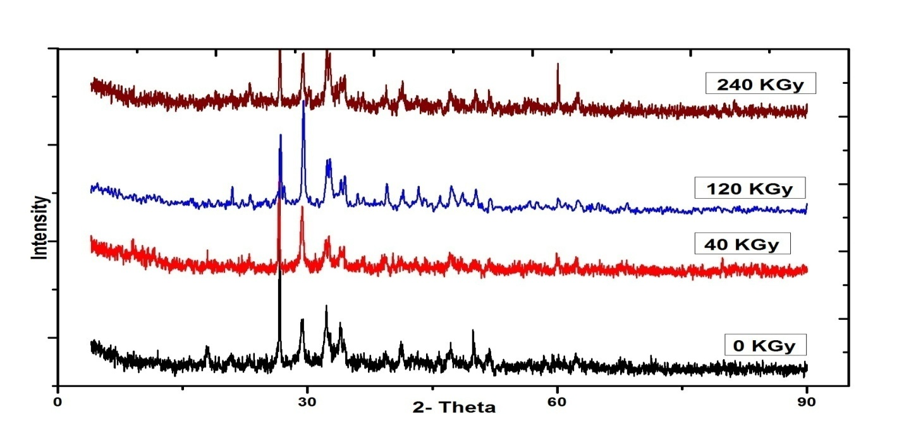**

**Fig (6) The XRD Of Cement Blocks with Different Doses**

Figure (7) illustrates XRD of cement blocks containing Sr and irradiated with different doses.The results show that under radiation there is an increase in the intensity of some peaks and a decrease in others, some peaks are broadened, and new peaks appear. It may be due to carbonation.

**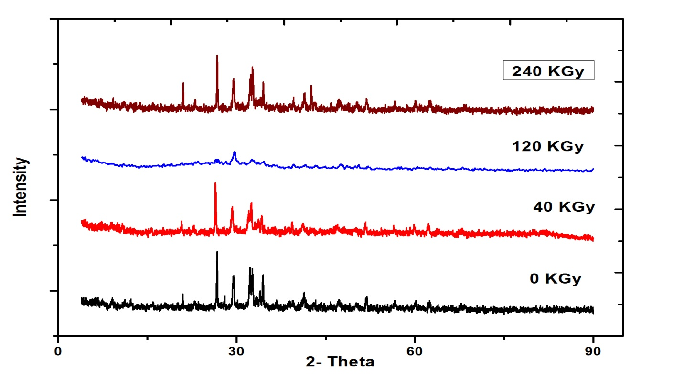**

**Fig (7) The XRD Of Cement Blocks Containing Srwith Different Doses**

Figure (8) illustrates XRD of cement blocks containing Fe and irradiated with different doses.The results demonstrate that the precipitation of Fe ions on the surface of cement. In case of irradiated cement blocks there are new peaks appear and others disappear; the intensity of the peaks increases.

**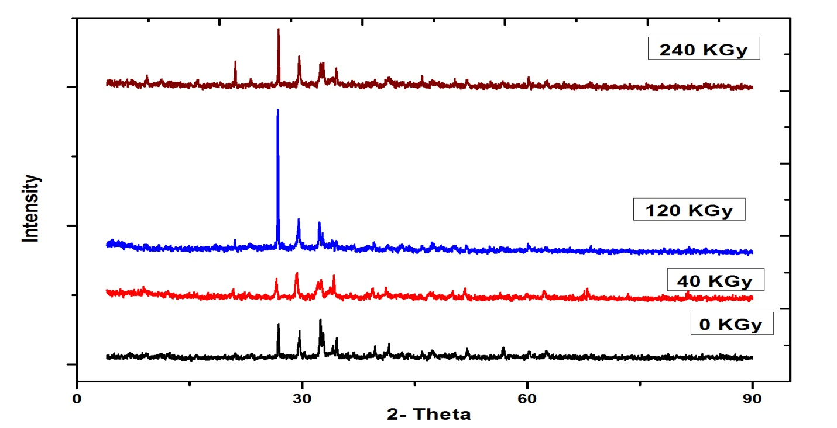**

**Fig (8) The XRD Of Cement Blocks Containing Fe with Different Doses**

Figure (9) illustrates XRD of cement blocks containing Co and irradiated with different doses. The results indicatean appreciable change in diffraction intensity under radiation, and new peaks appeared. Also the results show a decrease in the intensity and in the number of peaks.

**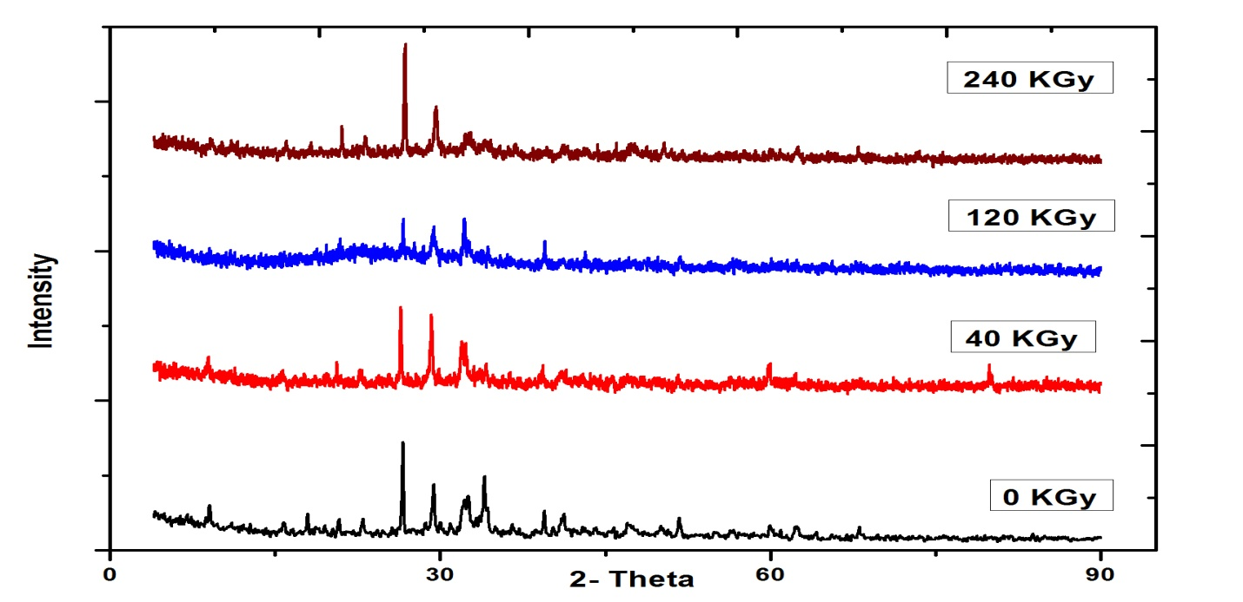**

**Fig (9) The XRD Of Cement Blocks Containing Co with Different Doses**

Figure (10) illustrates XRD of cement blocks containing mixture and irradiated with different doses. The results show a decrease in the intensity and number of the peaks. There in a shift in the basal spacing of the cement. This can be attributed to the energy transferred from the gamma rays to the molecules of water and the cement components. The energy transfer leads to water hydrolysis resulting in hydrogen, oxygen and hydrogen peroxide [15]. Also the energy transfer leads to damage in the weak chemical bond (covalent bonds) between silicon and oxygen. Si-O bond is covalent [45]. The hydrogen, oxygen and hydrogen peroxide formations and damage of silicon- oxygen bond are manifested in the intensity is a decrease and the number of peaks, and there is a shifting in basal spacing.

**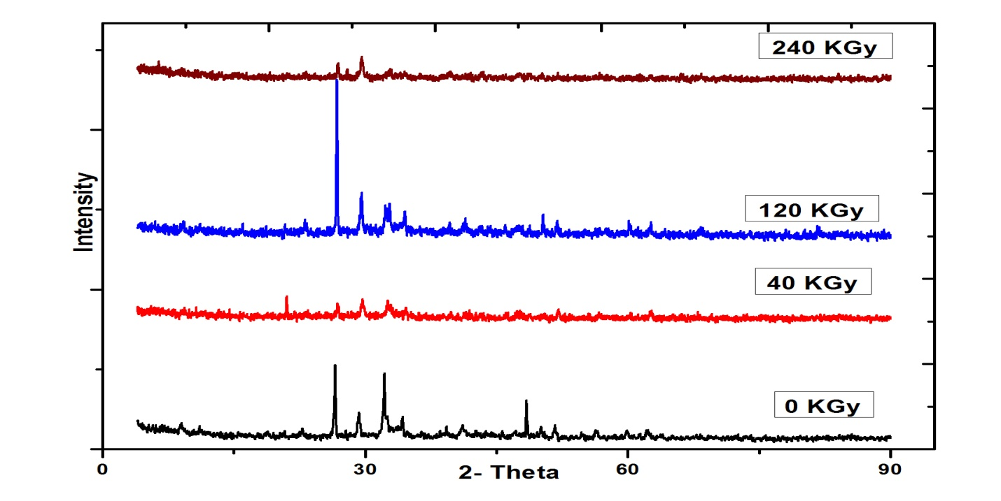**

**Fig (10) The XRD Of Cement Blocks Containing Mixture with Different Doses**

**Conclusions**

From the results of the present work it can be concluded that the presence ratio of Calcium Hydroxide(Ca(OH)2) and Calcite (CaCO3) are directly affected by irradiation. In the environment of a repository for radioactive waste, the carbonation reaction can be influenced by the presence of bicarbonate ions in the groundwater, or due to the presence of other factors (as presence of sulfate and chloride, temperature difference, pressure, etc.).

The results of the chemical analysis of leachate indicate that there is a decrease in the release of the key elements except Calcium under radiation.

From results of the SEM it is clear that the effect of radiation on the pure cement structure, crystals and pores change. This may be due to carbonation.

The XRD of pure cement illustrates that decrease in the number and size of anhydrated cement particles carbonation of cement blocks which may result from the reaction of C3s and C2s with CO2.

In case of Sr and Fe additives the results under radiation show an increase in the intensity of some peaks, a decrease in others appearance of new peaks. But in case of Co and mixture there is a decrease in the intensity and number of peaks.

More studies need to be carried outto evaluate the chemistry and mineralogy of the cementitious materials in the repository environment. Furthermore, more analysis on the specimens exposed to the irradiation needs to be done, for instance, thermogravimetric analysis and imaging analysis.

**Reference:**

1. Eduardo Ferreira, Roberto Vicente, XabierTurrillas, FabianoYokaichiya, Margareth Franco, Luis Gallego Martinez, AlexandreCarvalho, JúlioTakehiroMarumoEffects of Gamma Radiation on Cementitious Materials in Repository Environment – 16300,. WM2016 Conference, March 6 – 10, 2016, Phoenix, Arizona, USA
2. I. Maruyamaa, O. Kontanib, A. Ishizawab, M. Takizawac, O. SatocDevelopment of System for Evaluating Concrete Strength Deterioration Due to Radiation and Resultant Heat, , IAEA-CN-194-093.
3. Taylor, H. F. W. “ Cement Chemistry”, 2nd edn., Academic Press, p. 121, 1990.
4. E. Adamopoulou, P. Pipilikaki, M.S. Katsiotis, M. Chaniotakis and M. Katsioti, “How sulfates and increased temperature affect delayed ettringite formation (DEF) in white cement mortars” Construction and Building Materials, 25, 3583–3590 (2011).
5. J.W. Bullard, B. Lothenbach, P. E. Stutzman, and K.A. Snyder, “Coupling thermodynamics and digital image models to simulate hydration and microstructure development of portland cement pastes” Journal of Materials Research, 26, 609–622 (2011).
6. F. Deby, M. Carcassès, and A. Sellier, “Probabilistic approach for durability design of reinforced concrete in marine environment” Cement and Concrete Research, 39, 466–471 (2009).
7. R. Kaminskas, and I. Barauskas, “Influence of carbonated additives on Portland cement hydration in chloride environment” Advances in Cement Research, 24, 365–372 (2012).
8. R. Loser, B. Lothenbach, A. Leemann, and M. Tuchschmid, “Chloride resistance of concrete and its binding capacity – Comparison between experimental results and thermodynamic modeling” Cement and Concrete Composites, 32, 34–42 (2010).
9. B. Lothenbach, B. Bary, P. Le Bescop, T. Schmidt, and N. Leterrier, “Sulfate ingress in Portland cement” Cement and Concrete Research, 40, 1211–1225 (2010).
10. N. Ukrainczyk, N. Vrbos, and J. Šipušić, “Influence of metal chloride salts on calcium aluminate cement hydration” Advances in Cement Research, 24, 249–262 (2012).
11. P. Bouniol, “The influence of iron on water radiolysis in cement-based materials” Journal of Nuclear Materials, 403, 167–183 (2010).
12. P. Bouniol, and E. Bjergbakke, “A comprehensive model to describe radiolytic processes in cement medium” Journal of Nuclear Materials, 372, 1–15 (2008).
13. J.L. GarcíaCalvo, A. Hidalgo, C. Alonso, and L. FernándezLuco, “Development of low-pH cementitious materials for HLRW repositories: Resistance against ground waters aggression” Cement and Concrete Research, 40, 1290–1297 (2010).
14. Kaplan, M. F.,”Concrete Radiation Shielding,” Longman Scientific & Technical, 1989
15. Bouniol, P. and Aspart, A., “Disappearance of Oxygen in Concrete under Irradiation : The roleof Peroxides in Radiolysis,” Cement and concrete research, Vol.28, No.11, pp.1669-1681, 1998
16. Savija, B., &Lukovi, M. Carbonation of cement paste: Understanding, challenges, and opportunities.Construction and Building Materials, 117(August), 285-301. DOI: 10.1016/j.conbuildmat.2016.04.138.
17. Fernandez Bertos M, Simons S, Hills C, Carey P. A review of accelerated carbonation technologyin the treatment of cement-based materials and sequestration of CO2. Journal of hazardous materials.2004;112(3):193-205.
18. Valls S, Vazquez E. Accelerated carbonatation of sewage sludge–cement–sand mortars and itsenvironmental impact. Cement and concrete research. 2001;31(9):1271-6.
19. Macias A, Kindness A, Glasser F. Impact of carbon dioxide on the immobilization potential ofcemented wastes: chromium. Cement and concrete research. 1997;27(2):215-25.
20. Venhuis MA, Reardon EJ. Vacuum method for carbonation of cementitious wasteforms.Environmental science & technology. 2001;35(20):4120-5.
21. Lange L, Hills C, Poole A. The influence of mix parameters and binder choice on the carbonationof cement solidified wastes. Waste Management. 1996;16(8):749-56.
22. R. S. Zaky1, Ahmed A.Abdel- Khalek2 , F.Shahin3 , N.S. Mahmoud1, K. El-Adham1Study of The Leachability and Solubility of Some Radionuclides in The Waste Repository "
23. Castellote M, Andrade C. Modelling the carbonation of cementitious matrixes by means of theunreacted-core model, UR-CORE. Cement and concrete research. 2008;38(12):1374-84.
24. García-González CA, Hidalgo A, Andrade C, Alonso MC, Fraile J, López-Periago AM, et al.Modification of composition and microstructure of Portland cement pastes as a result of natural andsupercritical carbonation procedures. Industrial & engineering chemistry research. 2006;45(14):4985-92.
25. Peter M, Muntean A, Meier S, Böhm M. Competition of several carbonation reactions in concrete:A parametric study. Cement and concrete research. 2008;38(12):1385-93.
26. Cizer Ö, Van Balen K, Elsen J, Van Gemert D. Real-time investigation of reaction rate and mineralphase modifications of lime carbonation. Construction and Building Materials. 2012;35:741-51.
27. Parrott L. Carbonation, moisture and empty pores. Advances in Cement Research. 1992;4(15):111-8.
28. Yang T, Keller B, Magyari E, Hametner K, Günther D. Direct observation of the carbonationprocess on the surface of calcium hydroxide crystals in hardened cement paste using an Atomic ForceMicroscope. Journal of Materials Science. 2003;38(9):1909-16.
29. Galan I, Glasser F, Baza D, Andrade C. Assessment of the protective effect of carbonation onportlandite crystals. Cement and concrete research. 2015;74:68-77.
30. Hidalgo A, Domingo C, Garcia C, Petit S, Andrade C, Alonso C. Microstructural changes inducedin Portland cement-based materials due to natural and supercritical carbonation. Journal of MaterialsScience. 2008;43(9):3101-11.
31. Richardson I, Groves G, Brough A, Dobson C. The carbonation of OPC and OPC/silica fumehardened cement pastes in air under conditions of fixed humidity. Advances in Cement Research.1993;5(18):81-6.
32. Groves G, Rodway D, Richardson I. The carbonation of hardened cement pastes. Advances inCement Research. 1990;3(11):117-25.
33. G. Velazco\*, J.M. Almanza, D.A. Cortés, J.C. Escobedo, J.I. Effect of the strontium aluminate and hemihydrate contents on the properties of a calcium sulphoaluminate based cement, Escalante-Garcia, Materiales de Construcc iَn, Vol. 64, Issue 315, July–September 2014, e024, ISSN-L: 0465-2746.
34. Borges PH, Costa JO, Milestone NB, Lynsdale CJ, Streatfield RE. Carbonation of CH and C–S–H incomposite cement pastes containing high amounts of BFS. Cement and concrete research.2010;40(2):284-92.
35. Han J, Liang Y, Sun W, Liu W, Wang S. Microstructure Modification of Carbonated Cement Pastewith Six Kinds of Modern Microscopic Instruments. Journal of Materials in Civil Engineering. 2014.
36. De Belie N, Kratky J, Van Vlierberghe S. Influence of pozzolans and slag on the microstructure ofpartially carbonated cement paste by means of water vapour and nitrogen sorption experiments andBET calculations. Cement and concrete research. 2010;40(12):1723-33.
37. Chindaprasirt P, Rukzon S. Pore structure changes of blended cement pastes containing fly ash,rice husk ash, and palm oil fuel ash caused by carbonation. Journal of Materials in Civil Engineering.2009;21(11):666-71.
38. Ngala V, Page C. Effects of carbonation on pore structure and diffusional properties of hydratedcement pastes. Cement and concrete research. 1997;27(7):995-1007.
39. Fabbri A, Corvisier J, Schubnel A, Brunet F, Goffé B, Rimmele G, et al. Effect of carbonation on thehydro-mechanical properties of Portland cements. Cement and concrete research. 2009;39(12):1156-63.
40. Pihlajavaara S. Some results of the effect of carbonation on the porosity and pore size distributionof cement paste. Matériauxet Construction. 1968;1(6):521-7.
41. Arandigoyen M, Bicer-Simsir B, Alvarez JI, Lange DA. Variation of microstructure withcarbonation in lime and blended pastes. Applied surface science. 2006;252(20):7562-71.
42. Shen Q, Bao B, Pan G. Influence of CSH carbonation on the porosity of cement paste. Magazine ofConcrete Research. 2015.
43. Houst YF, Wittmann FH. Influence of porosity and water content on the diffusivity of CO 2 and O2 through hydrated cement paste. Cement and concrete research. 1994;24(6):1165-76.
44. Purnell P, Short N, Page C. Super-critical carbonation of glass-fibre reinforced cement. Part 1:mechanical testing and chemical analysis. Composites Part A: Applied Science and Manufacturing.2001;32(12):1777-87.
45. Rahman A, Glasser F. Comparative studies of the carbonation of hydrated cements. Advances inCement Research. 1989;2(6):49-54.