

**EMBEDDED SYSTEM RESEARCH PROJECT**

**GROUP MEMBERS:**

* **MARYAM REHAN(IU05-0121-0135)**
* **ANISH KHAN (IU05-0220-0120)**
* **MUHAMMAD AHMED (IU05-0121-0054)**

**INSTRUCTOR:**

* **MAAM SANA IRSHAD**

**EMDEDDED SYSTEM FOR RECORDING AND CONTROLLING**

**HAND HYGIENE IN HEALTH CARE ENVIRONMENT**

**ABSTRACT:**

The study describes an embedded system to automate and improve the control of hand hygiene (HH) in hospitals. Emphasizing the importance of HH in the protection against healthcare-associated infections (HAIs), the study supports WHO and Brazilian health regulations regarding hand hygiene. Furthermore, the study demonstrates a present lack of technological solutions that accurately measure hygiene compliance. Proposed is a low-cost hardware-based system with IOT connectivity to allow real-time data monitoring and internal audits. The system effectiveness for supporting hygiene compliance and infection control was demonstrated when it was tested in a real hospital environment for 3 hours, recording HH events.

**1.INTRODUCTION:**

It demonstrated how the application of hand hygiene curtails the spread of infections in the environment where the COVID-19 pandemic has orchestrated hard battles. Proper hand hygiene is fundamental for healthcare workers to be able to cure and take care of patients because it prevents the transmission of harmful microorganisms. However, the regular monitoring of hand hygiene in hospitals is very tough, as it is normally done through periodic manual audit by the hospital infection control service, thereby rendering result unstandardized because manual ways with health surveillance teams often rely on sample data, thus misrepresenting actual hygiene practices.

Hospital auditing is also subject to the effects of what is commonly known as the Hawthorne effect. These effects imply that healthcare workers manipulate their behavior when being observed. Hence, the compliance data become unreliable. According to WHO's very recent evaluations, many settings, including very underdeveloped, still have ineffective monitoring and feedback provisions regarding HH compliance.  
  
  
  
An automated embedded system prototype that serves to improve HH monitoring and recording is the respondent to such gaps. The system adopted IOT and RFID technologies to augment the infection prevention strategies and better support patient-centered care. When deployed into real hospital environment system is made to give reliable data so that practices of hygiene

would be standardized to all different departments of the hospital.  
  
This innovation will not only improve the accuracy of HH data collection but also create awareness for healthcare teams. The article further explains the stages of designing, testing, and implementing the system.

**2.RELATED WORK AND PROBLEM STATEMENT:**

**2.1 RELATED LEGISLATION:**

In Brazil, NVS established by ANVISA an RDC number 42 of the year 2010, which acts as a guideline regarding hand hygiene among health services. According to ANVISA's RDC 50, 2002, there must be mandatory wash basins: (RDC50, 2002) (RDC42, 2010). The total time to perform hand hygiene according to the World Health Organization is from 40 to 60 seconds (Santos-Gago et al., 2021).

**2.2 RELATED WORK:**

Current regulations provide space for those technologies that automate the whole health hygiene (HH) process and enable continuous monitoring and assistance to healthcare facilities. Several of these studies in connection with the above problem indicated various ways involving embedded systems, RFID, IOT, and AI towards infection control enhancement.  
According to Queiroz et al. (2021), the research revealed that embedded systems of RFID IOT were effective to hospitals in tracking hygiene actions. The works of Li et al. (2018) dealt with the WristWash, which is a smart wearable IOT bracelet embedded with accelerometers to measure the performance of said hand hygiene movements against the standard techniques. Cherin et al. (2018) have described methods using machine learning and cameras to recognize different stages of HH. The work of Bal and Abrishambaf (2017) speaks about cloud-linked stations that detect HH events; however, they lack real-time reporting and wider opportunity coverage. Fagert et al. (2022) CleanVibes applied signal analysis (FFT) to track patterns of hand friction during washing. The work of Wu et al. (2020) proposed to use BLE wearables for identifying healthcare workers present near dispensers, but this is a hardware-intensive solution that is not designed to cover all bed entry scenarios.  
  
Within all these promising advances, an important gap remains in monitoring HH opportunities when entering or exiting patient areas, such as Intensive Therapy Units (ITUs) to have comprehensive information in clinical engineering with regard to hand hygiene practices. Most of the current systems track only handwashing actions, while opportunities for hygiene remain out of the loop.  
  
This research proposes a new, unique embedded system identifying who is actually accessing pertinent data areas through an internal and external application.

**3. Methodological Procedures:**

The study comprised evolutionary prototyping for modeling and evaluating an embedded hand hygiene (HH) system in healthcare settings. It is classified as applied qualitative, descriptive, and explanatory. To tackle the practical problem of ineffectiveness and manual HH auditing procedures in hospitals considered with the inaccuracy of the Hawthorne effect, the essentially methodological procedures were close collaboration with the Hospital Infection Control Service (HICS) in defining the system's requirements, such as requiring non-contact activation, prompting hygiene before and after bed access, and real-time calculation of HH rates. A prototype was developed that included an ESP32 microcontroller, infrared and ultrasonic sensors, an RFID reader for optional user identification, a visual orientation display of WHO's 11-step hygiene procedure, and a solenoid valve to control water flow. The programming logic was developed using a modular, closed-loop control algorithm capable of real-time monitoring and transmitting data to the Losant IOT platform via the MQTT protocol.

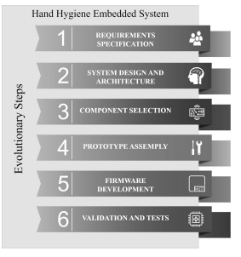

**4.Embedded System For Hand Hygiene:**

In the course of developing the embedded system, a needs and requirements survey was conducted with the Hospital Infection Control Service (HICS). It was found that there was a need to give guidance that is clear and easily understandable on the necessary steps for hand hygiene (HH) to the users.

**4.1 Requirement Specification:**

These embedded systems are designed with restrictions on any manual means of water activation, thereby providing for hand hygiene before and after ingress into bed; they also incorporate smooth surfaces in order to minimize bacterial dissemination. They additionally provide their own formal guidance based on WHO and HCI standards, calculate hand hygiene compliance indices while in use, and can identify the healthcare professional executing the hand hygiene.

**4.2 Embedded Systems Architecture And Components:**

The embedded system is defined by a well-organized interlinking of electronic and software components to incorporate an ESP32-Microcontroller. They interconnect for data visualization and monitoring on the Losant IOT Platform. It comprises four main portions: sense input (infrared sensors to detect bed entry/exit and ultrasonic sensor to detect presence near a tap), output devices (LCD display, orientation display, and water valve), processing unit (ESP32), and IOT monitoring platform. In addition; an RFID reader is optionally used to identify a person who enters the bed.

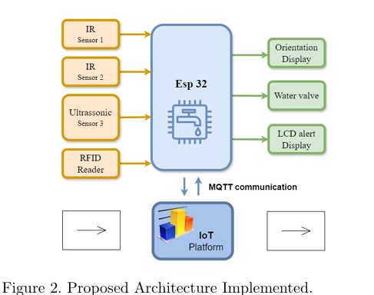

There are two different types of output device- the innovative orientation displays and the 16 x 2 LCD that display hand washing steps. The tap is controlled by a 12V solenoid valve. Uniquely, the system guides all through an 11-step WHO and HCI-compliant hand hygiene activities through a display with timed LED backlighting that illuminates each step as the user performs hand hygiene in front of the tap.

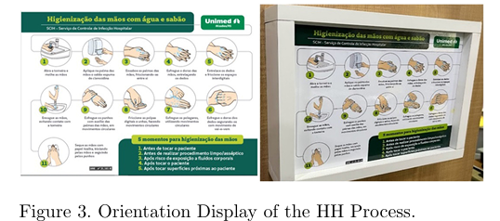

The system's electronics are housed within a cabinet made from smooth, easy-to-clean acrylic, appropriate for the healthcare environment. The ergonomic case-box houses the circuit board, LCD display, ultrasonic sensor, and RFID reader. The case-box and orientation display were mounted onto custom-designed furniture with a basin and a faucet, thereby integrating all electronics and controls into one unit.

**4.3 Prototype Assembly:**

Tests of sensor measurements were carried out while the prototype was assembled and calibrated in the laboratory. Infrared sensors were found to detect accurately at a minimum of one meter, while RFID cards were read successfully within the case-box designed. So it has been verified for the electronic circuit by embedding all system components. The electronic circuit (shown in Figure 2) was assembled onto the perforated plate for the better conduction of signal. The assembly and installation of this electronic circuit is shown in Figure 4.

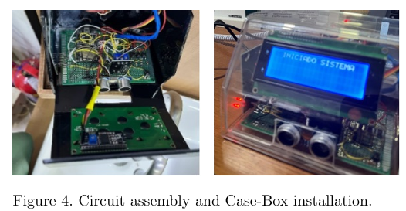

The methodology made it possible to fix and arrange all components within the Case-Box and the designed furniture. The setup has been finished with black adhesive coating providing a polished finish in the manner shown in Figure 5.

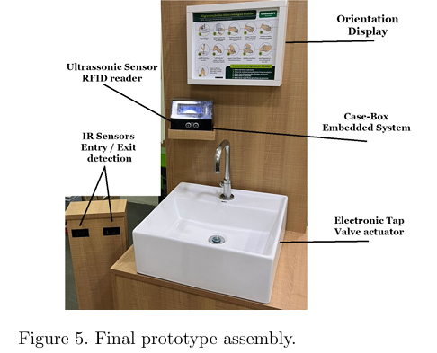

Functional tests were conducted after the prototype assembly to check the RFID communication for the accurate detection of people entering and leaving the washbasin placed at the bed entrance. These tests serve to fine-tune the algorithm of the system which will be discussed next.

**4.4 Firmware Development:**

This project was mainly focused towards building an embedded system that would act as a motivation for hand hygiene (HH) practice within the healthcare environment. Embedded system is composed of an ESP32 microcontroller and various other components like sensors, RFID reader, display, and communication with Losant IoT platform through WiFi employing MQTT protocol. The control system is based on a closed-loop logic, whereby it continuously receives data from infrared and ultrasonic sensors to detect if a person is approaching a hospital bed or leaving it, thus marking HH potential opportunities.  
  
A unique educational aspect of the system includes an 11-step HH procedure according to WHO and HCI guidelines shown on the orientation screen, only moving to the next step if the user remained present through the entire process. This system also offers optional identification of the user using an RFID card. The control logic of algorithm modules has been one of the considerations for easy management and updating. It captures variables such as the number of people entering/exiting, HH opportunities, and hygiene rate, and sends the information to the IOT platform in real time for monitoring.   
  
The setup takes into account real-life constraints such as different walking speeds of users and accurate detection to instigate relevant hygiene action. Essentially, the system represents an intelligent, contactless, and educative way of advancing hand hygiene protocol compliance within hospitals to meet infection control needs.

**5. Hospital Validation and Results:**

The embedded system was evaluated for a period of 3 hours in a bed entrance of hospital, where it was able to monitor hand hygiene (HH) compliance in real-time. The system was validated in a clinical scenario by the hospital management team. The system knew if bedside care staff entered and exited the bed using infrared sensors, and whether care staff were in attendance or performing HH using an RFID badge to identify them.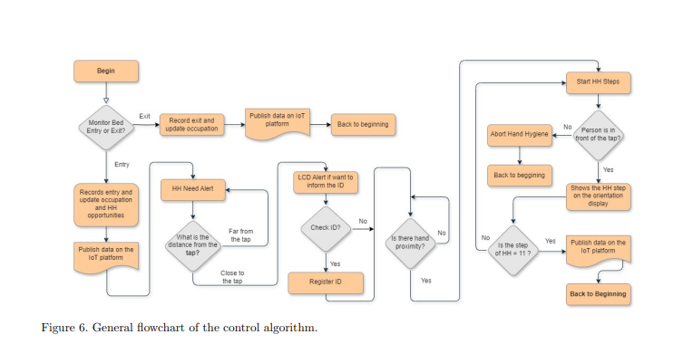

The key performance indicators included: accesses (12); exits (10); opportunities for hand hygiene (24); completed hand sanitization (13); and bed occupancy (2). The overall hand hygiene rate during the assessment, as per guidelines, was 54.17%. Hygiene data were captured and compiled as "data points," and then forwarded to the Losant IOT platform, however, with the intent that they later be visualized as event entries on the dashboard specifically created for the bed application.

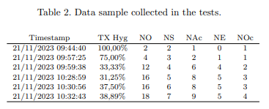

The dashboard had eight blocks showing: number of accesses, exits, HH opportunities, completed sanitizations, HH rate over time, number of occupants, just the HH rate graph, and HH detailed timestamps with the identification of the professional's use of RFID codes.

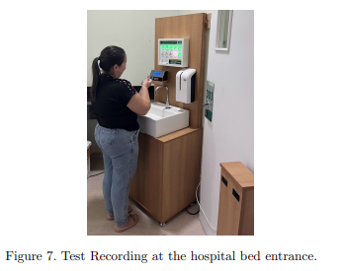

While there were intermittent interrupts in functionality due to internet dropped connections, the system continued to function seamlessly when the internet reconnection occurred. Overall, an uninterrupted highly regulated and maintained internet connection is very specific for success and durability as the next step would be implementing a local storage device (e.g., SD card) and increasing the capability to allow staff to persist data review when the internet was not stable.

The system provided a valuable resource to monitor and increase HH.

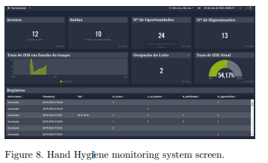

**6.Coclusion:**

The modernized embedded system enables to monitor, continually, and provide accurate record keeping for hand hygiene (HH) activities. This system diminishes the effect of Hawthorne. It has synchronized instruments of attendance with immediate visualizations for managers in hospitals through IOT Losant from a distance The applicable zones would include ICUs and Surgical centers, and reports from the staff indicated that the personnel system worked to set specifications and hygiene standards.   
  
The innovation centers around the Hospital 4.0 idea as it puts healthcare at the epicenter of Industry 4.0, including automation and robotics. Future enhancements include camera machine learning for supervision of hand factors utilizing a camera, proprietary IOT platforms, and offline data preservation away from internet connectivity.