SehatSaathi AI
Your Personal AI Healthcare Companion
Empowering Pakistan with Intelligent, Accessible Healthcare

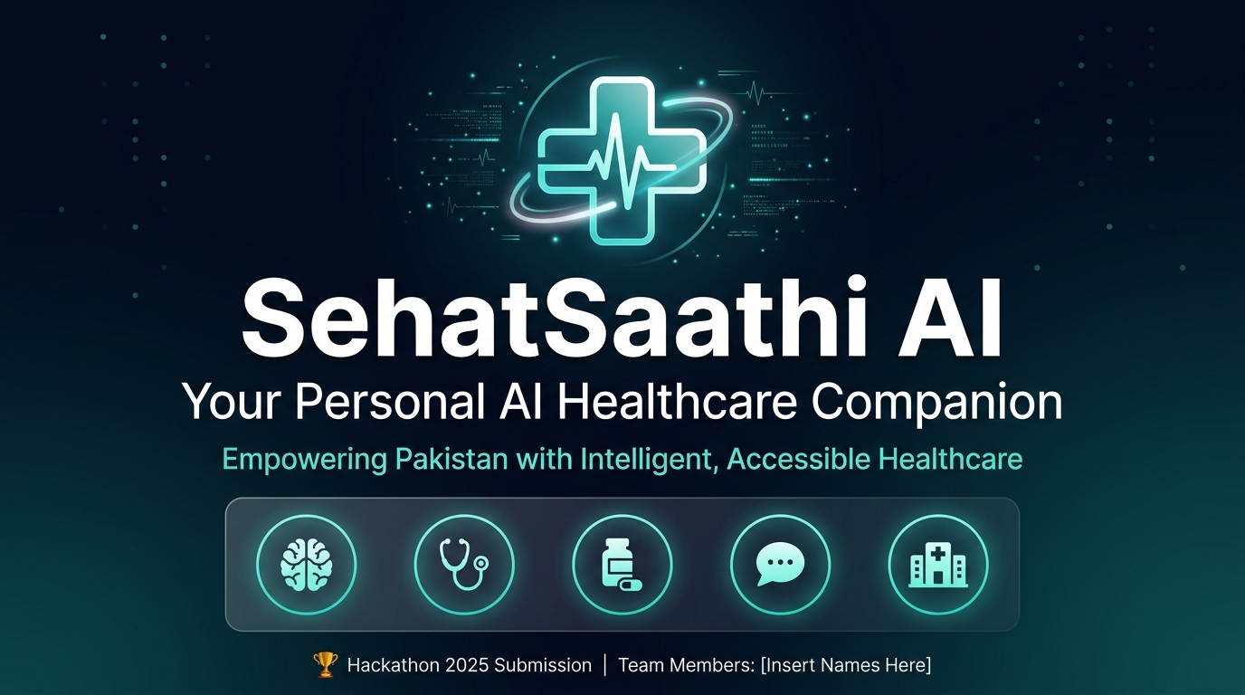

Complete Technical Documentation | Version 1.0
Hackathon 2026 Submission
Author: Maryam Tahir
Repository: github.com/maryamtahir7/SehatSaathi-AI
Live Demo: sehat-saathi-ai.vercel.app

TABLE OF CONTENTS
1. Executive Summary
2. Problem Statement
3. Project Overview & Goals
4. System Architecture
5. User Flow Diagram
6. Module-by-Module Breakdown
7. AI & ML Pipeline (Deep Dive)
8. Technology Stack
9. Database Design
10. API Specification
11. Frontend Architecture
12. Security & Authentication
13. Deployment Architecture
14. Performance & Constraints
15. Future Roadmap

1. EXECUTIVE SUMMARY
SehatSaathi AI (Sehat = Health, Saathi = Companion in Urdu) is a comprehensive, production-deployed, AI-powered healthcare web platform purpose-built for Pakistan and South Asia. With a population of 230+ million and a doctor-to-patient ratio of 1:1,085 — nearly double the WHO danger threshold — Pakistan faces a catastrophic healthcare accessibility crisis.
SehatSaathi AI directly addresses this gap by providing hospital-grade AI diagnostics, bilingual medical chat, offline prescription reading, and a complete medicine store — all from any device, in any language, at any time, completely free for the end user.

Module | Core AI Technology | Key Capability
AI Medical Diagnostics | ONNX CNN (braintumor.onnx, lung.onnx) | MRI + X-Ray analysis in < 5 seconds
Symptom Checker | ONNX SVC Classifier (svc.onnx) | 132 symptoms → 41 diseases
AI Chat Assistant | Groq LLaMA 3.3-70b (500 tok/s) | Bilingual EN/UR medical Q&A
Prescription OCR | Tesseract.js WASM (100% offline) | Photo → Medicine list → Cart
Pharmacy Store | CSV Medicine Database | 15,000+ medicines, COD checkout
Hospital Locator | React Leaflet + OpenStreetMap | City & specialty filter map
Diet Planner | Dataset-driven BMR calculation | Disease-specific meal plans
Admin Dashboard | Recharts + Appwrite | Orders, revenue, AI model stats

2. PROBLEM STATEMENT
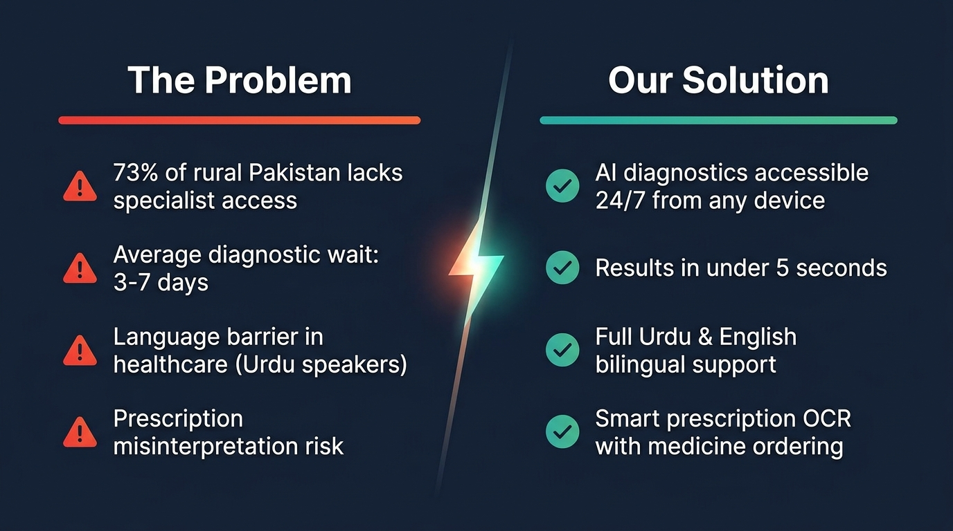
Figure 1: Problem vs Solution Overview
2.1 Healthcare Access Crisis in Pakistan
Challenge | Statistic | Impact
Specialist access | 73% rural population excluded | Delayed/missed diagnoses
Doctor-patient ratio | 1:1,085 (WHO recommends 1:600) | Chronic under-service
Diagnostic wait time | 3-7 days average | Disease progression
Language barrier | 75% speak Urdu, not English | Healthcare exclusion
Cost per consultation | Rs. 2,000-10,000 per specialist | Financial burden
Prescription errors | Handwriting misread daily | Medication harm

2.2 Specific Pain Points Addressed
-> Diagnostic Delay — Brain tumors, pneumonia, skin cancers go undetected due to no imaging access
-> Prescription Misinterpretation — Handwritten doctor scripts cause medication errors
-> Medical Misinformation — Patients rely on unverified online sources
-> Pharmacy Access — Rural patients cannot reach a wide range of medicines
-> Language Exclusion — No Urdu-first AI health tools exist at this scale
3. PROJECT OVERVIEW & GOALS
3.1 Mission Statement
"To democratize healthcare access in Pakistan and South Asia by making hospital-grade AI diagnostics, bilingual medical guidance, and an integrated pharmacy available on any device — for free."
3.2 Key Design Decisions
Decision | Alternative | Rationale
ONNX Runtime | TensorFlow / PyTorch | Vercel 250MB limit — ONNX is 10-50x smaller
Tesseract.js (WASM) | Cloud OCR only | Offline-capable, zero server cost, privacy
Groq LLaMA 3.3-70b | OpenAI GPT-4 | ~500 tokens/sec — 10x faster, free tier
Appwrite Cloud | Firebase | Open-source BaaS, no vendor lock-in
TanStack Start | Next.js | Type-safe SSR, file-based routing
CSV datasets | PostgreSQL / pandas | No DB or pandas needed — saves 40MB bundle
Centroid ML fallback | No fallback | Graceful degradation if ONNX unavailable

4. SYSTEM ARCHITECTURE
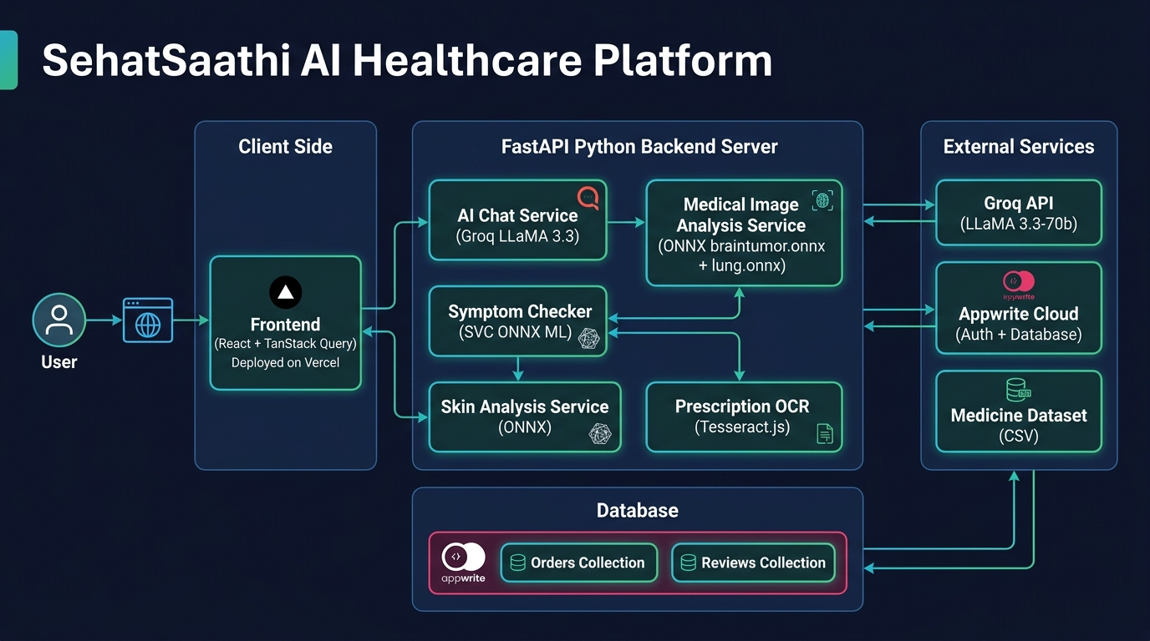
Figure 2: Full System Architecture Diagram
4.1 Architecture Overview
SehatSaathi AI follows a three-tier hybrid serverless + API architecture:
TIER 1 — CLIENT
React 19 + TanStack Start (SSR) | Tailwind CSS | Framer Motion
Deployed on Vercel Edge Network (Node.js 24 via Nitro)
TIER 2 — APPLICATION SERVER
FastAPI Python (py-api) | uvicorn ASGI
6 Route Modules: chat / image / disease / skin / shop / ocr
3 Service Layers: image_service / ml_service / skin_service
TIER 3 — EXTERNAL SERVICES
Groq API -> LLaMA 3.3-70b (AI chat inference)
Appwrite Cloud -> Auth + Database (Orders, Reviews)
ONNX Models -> braintumor / lung / skin / svc (.onnx files)
CSV Datasets -> Medicine DB, Disease DB (15,000+ rows)
4.2 Data Flow: Medical Image Analysis
User uploads image
|
v
POST /analyze-medical-image (multipart/form-data)
|
v
FastAPI -> image_service.analyze_medical_image()
|
v
PIL Image.open() -> convert("RGB") + convert("L")
|
v
AUTO MODALITY DETECTION:
mean_pixel_value < 95 => "mri" (dark scan)
mean_pixel_value >= 95 => "xray" (bright scan)
|
+------------------+------------------+
| |
[MRI PATH] [X-RAY PATH]
resize(168,168) resize(224,224)
convert("L") -> grayscale stay RGB
normalize /255.0 normalize /255.0
shape: [1,168,168,1] shape: [1,224,224,3]
braintumor.onnx lung.onnx
Softmax -> 4 classes Sigmoid -> binary
| |
+------------------+------------------+
|
v
Finding + Confidence + Abnormality Score
|
v
get_recommendations(finding) -> CSV lookup
|
v
JSON Response -> Frontend renders clinical report
4.3 Data Flow: AI Chat
User types message
|
v
POST /api/assistant/chat
{ "message": "...", "language": "en|ur", "history": [...] }
|
v
Build message array:
[ system_prompt_EN_or_UR, ...history[-10:], user_message ]
|
v
Groq SDK: client.chat.completions.create()
model: llama-3.3-70b-versatile
~500 tokens/second inference
|
v
AI response text (markdown)
|
v
Medicine keyword scan -> Medicine_Details.csv -> top 3 products
|
v
Return: { response, model, language, products[] }
4.4 Data Flow: Prescription OCR
User uploads prescription photo
|
v
Tesseract.js WASM Worker (initialized in browser on page load)
createWorker("eng") -- runs in Web Worker thread
|
v
Image compression: max 1200px wide, JPEG quality 0.8
|
v
worker.recognize(base64_image)
|
+----------------+------------------+
| |
SUCCESS FAILURE (WASM OOM)
raw text extracted OCR.space cloud API fallback
| |
+----------------+------------------+
|
v
HEURISTIC PARSER:
Filter by keywords: tab, cap, syp, inj, mg, ml, od, bd, tds
Filter by UPPERCASE patterns (medicine names)
Assign type: Tablet / Capsule / Syrup / Injection / Topical
|
v
medicines_identified[] -> Table UI -> Add to Cart

5. USER FLOW DIAGRAM
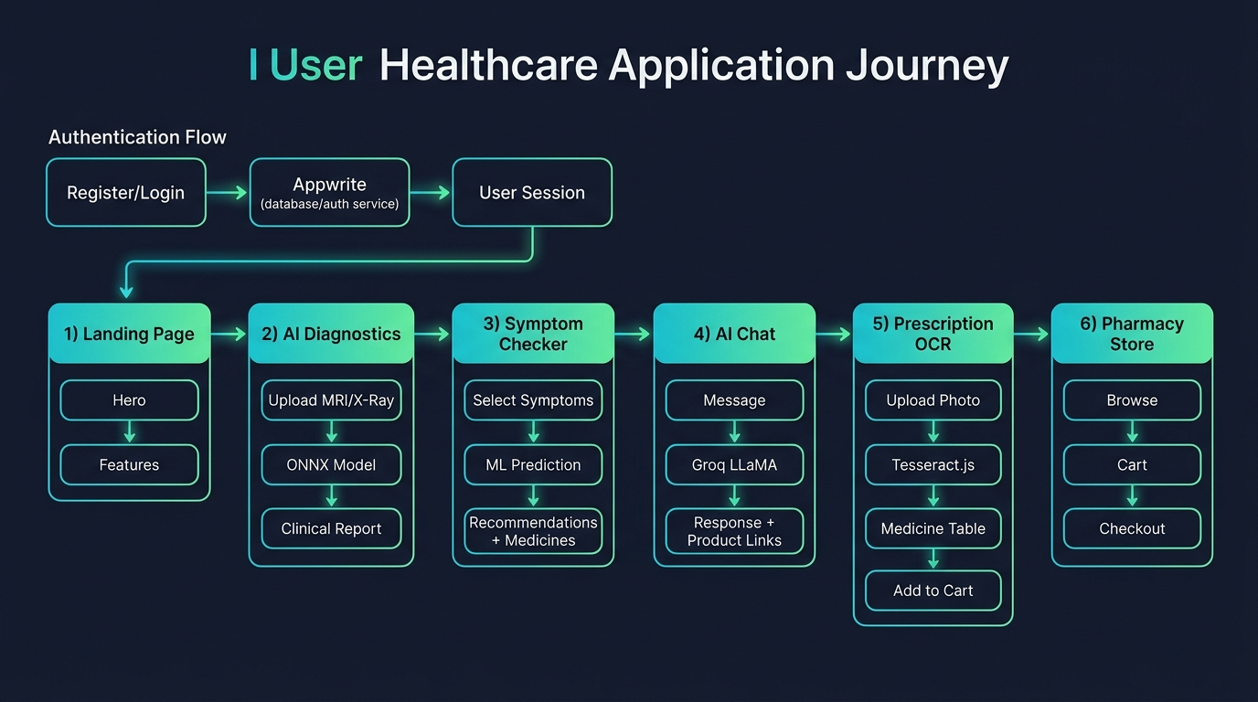
Figure 3: Complete User Journey Flow
5.1 Flow Description
The complete patient journey through SehatSaathi AI:
• Land on homepage -> Sign Up / Login (Appwrite Auth)
• DIAGNOSTICS PATH: Upload scan -> Auto-detect MRI/X-Ray -> ONNX inference -> Clinical report -> Medicines -> Cart
• SYMPTOMS PATH: Select from 132 symptoms -> SVC ONNX predict -> Disease + recommendations -> Cart
• CHAT PATH: Type question (EN/UR) -> Groq LLaMA 3.3 -> Response + medicine cards
• OCR PATH: Upload prescription photo -> Tesseract.js -> Medicine table -> Add all to Cart
• PHARMACY PATH: Browse 15,000+ medicines -> Cart -> Checkout -> COD order confirmation
• HOSPITAL PATH: Map view -> Filter by city/specialty -> Contact

6. MODULE-BY-MODULE BREAKDOWN
6.1 AI Medical Diagnostics (/diagnostics)
File: diagnostics.tsx — 19KB
• Drag-and-drop or click-to-upload for MRI, X-Ray, Skin images
• Auto-detects modality via pixel mean statistics (no user input needed)
• Tab switcher: Brain MRI | Chest X-Ray | Skin Analysis
• Animated confidence bar with percentage display
• Abnormality score with color-coded severity indicator
• Full clinical report accordion: Medicines, Diet, Lab Tests, Precautions
• Every suggested medicine has an Add to Cart button
• Clinical disclaimer on all outputs (AI + doctor required)

6.2 Symptom Checker (/symptoms)
File: symptoms.tsx — 12KB
• Searchable dropdown for all 132 symptoms
• Selected symptom tags with individual remove buttons
• One-click SVC ONNX prediction
• Disease card with full details: Description, Precautions, Medicines, Diet, Workout
• Medicine cards directly linkable to pharmacy with Add to Cart

6.3 AI Chat Assistant (/chat)
File: chat.tsx — 17KB
• Markdown-rendered conversational chat interface
• Language toggle (EN/UR) changeable mid-conversation
• Shoppable medicine cards surface when AI detects medicine mentions
• Conversation history persists for 10 turns (Groq context window)
• Typing indicator animation while Groq is processing
• System prompt enforces: no prescriptions, no definitive diagnoses

6.4 Prescription OCR (/prescription)
File: prescription.tsx — 18KB (100% client-side)
• Tesseract.js WASM runs entirely in the browser — zero server round-trip
• Works offline (PWA-compatible)
• Real-time progress indicator (0-100%) during OCR processing
• OCR.space cloud API fallback for complex images
• Heuristic parser: detects Tab, Cap, Syp, Inj, Drops, Topical patterns
• Interactive table with per-medicine Add to Cart and bulk Add All to Cart

6.5 Pharmacy Store (/pharmacy)
File: pharmacy.tsx — 14KB
• 15,000+ real medicines from Indian/Pakistani pharma dataset
• Category filter bar (Vitamins, Prescription, OTC, Supplements...)
• Real-time search with debounced API calls
• Medicine cards: brand, generic name, rating, price
• Cart persisted in localStorage (no auth required)
• COD checkout with auto-generated Order ID (SS-YYYYMMDD-XXXXXXXX)

6.6 Hospital Locator (/hospitals)
File: hospitals.tsx — 15KB
• React Leaflet map with OpenStreetMap tile layer
• Hospital markers with popup info cards
• Filter panel: city, specialty type
• Contact number and directions button

6.7 Diet Planner (/diet)
File: diet.tsx — 13KB
• BMR calculation (Mifflin-St Jeor formula)
• Activity multiplier (Sedentary to Very Active)
• Calorie target + macro split (Protein/Carbs/Fat)
• Disease-specific meal plan recommendations

6.8 Admin Dashboard (/admin)
File: admin.tsx — 32KB (largest route)
• Revenue charts: BarChart, LineChart (Recharts)
• Order management table with status update capability
• AI model accuracy stats display
• Medicine inventory overview
• Role-gated access: user.labels.includes("admin") check
• Appwrite database queries for orders and reviews

7. AI & ML PIPELINE (DEEP DIVE)
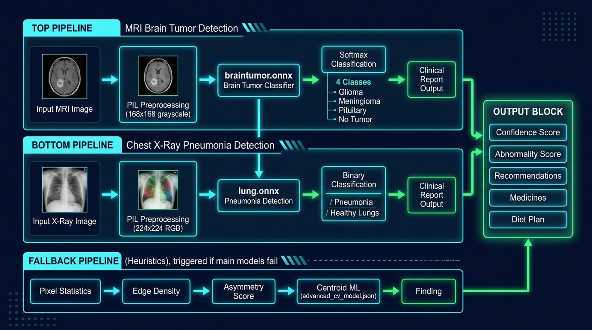
Figure 4: Complete AI/ML Inference Pipeline
7.1 Brain Tumor MRI Classifier
Property | Value
ONNX File | braintumor.onnx
Input Shape | [1, 168, 168, 1] — batch, H, W, channels
Input Type | float32, normalized 0.0 – 1.0
Output | Softmax probabilities, shape [1, 3] or [1, 4]
Class 0 | glioma_tumor
Class 1 | meningioma_tumor
Class 2 | pituitary_tumor
Class 3 | no_tumor (if 4-class model)
Training Dataset | Kaggle — Brain MRI Images for Tumor Detection
Training Accuracy | ~99% on test set
Training Notebook | backend/brain-tumor-mri-accuracy-99.ipynb
Framework | TensorFlow/Keras → exported to ONNX

Inference Code:
img = image.convert("L").resize((168, 168))
arr = np.array(img).astype("float32") / 255.0
tensor = np.expand_dims(np.expand_dims(arr, axis=-1), axis=0)
# shape: [1, 168, 168, 1]
preds = session.run([output_name], {input_name: tensor})[0]
class_idx = int(np.argmax(preds[0]))
confidence = float(preds[0][class_idx])
abnormality = 1.0 - float(preds[0][-1]) # inverse of "no tumor" score
7.2 Chest X-Ray Pneumonia Classifier
Property | Value
ONNX File | lung.onnx
Input Shape | [1, 224, 224, 3] — RGB image
Input Type | float32, normalized 0.0 – 1.0
Output | Binary sigmoid, shape [1, 1]
Class 0 | healthy_lungs (sigmoid < 0.5)
Class 1 | bacterial_pneumonia (sigmoid >= 0.5)
Training Dataset | Kaggle — Chest X-Ray Images (Pneumonia)
Training Notebook | backend/chest-x-ray-images-pneumonia.ipynb

7.3 Skin Condition Classifier
Property | Value
ONNX File | skin.onnx
Input Shape | [1, 64, 64, 1] — grayscale
Output | 3-class softmax: acne, melanoma, eczema
Heuristic | Pixel stats + skin type classifier (Oily/Dry/Combo/Sensitive/Normal)

7.4 Disease Classifier (ONNX SVC)
Property | Value
ONNX File | svc.onnx
Input Shape | [1, 132] — one-hot encoded symptom vector
Input Type | float32
Algorithm | Support Vector Classifier (sklearn -> ONNX)
Output | Integer class label (0-40 mapping to 41 diseases)
Dataset | Kaggle — Disease Symptom Prediction Dataset
Training Acc. | ~94% cross-validation

All 41 Predicted Diseases:
Fungal infection, Allergy, GERD, Chronic cholestasis, Drug Reaction,
Peptic ulcer disease, AIDS, Diabetes, Gastroenteritis, Bronchial Asthma,
Hypertension, Migraine, Cervical spondylosis, Paralysis (brain hemorrhage),
Jaundice, Malaria, Chicken pox, Dengue, Typhoid, Hepatitis A, Hepatitis B,
Hepatitis C, Hepatitis D, Hepatitis E, Alcoholic hepatitis, Tuberculosis,
Common Cold, Pneumonia, Hemorrhoids (Piles), Heart attack, Varicose veins,
Hypothyroidism, Hyperthyroidism, Hypoglycemia, Osteoarthritis, Arthritis,
Vertigo (Paroxysmal Positional Vertigo), Acne, Urinary tract infection,
Psoriasis, Impetigo
7.5 Fallback: Centroid ML (advanced_cv_model.json)
When ONNX models are unavailable, a zero-dependency centroid model runs:
FEATURE EXTRACTION:
mean_val = ImageStat.Stat(gray).mean[0] # brightness
std_val = ImageStat.Stat(gray).stddev[0] # contrast
edges = gray.filter(ImageFilter.FIND_EDGES)
edge_density = sum(edges.getdata()) / (168*168) # sharpness
w, h = gray.size
left_mean = ImageStat.Stat(gray.crop((0,0,w//2,h))).mean[0]
right_mean = ImageStat.Stat(gray.crop((w//2,0,w,h))).mean[0]
asymmetry = abs(left_mean - right_mean) # symmetry
CLASSIFICATION:
input_vector = [mean_val, std_val, edge_density, asymmetry]
for label, data in model_data[modality].items():
dist = euclidean(input_vector, data["centroids"])
if dist < best_dist: finding = label
confidence = max(0.6, 1.0 - best_dist/200.0)

8. TECHNOLOGY STACK
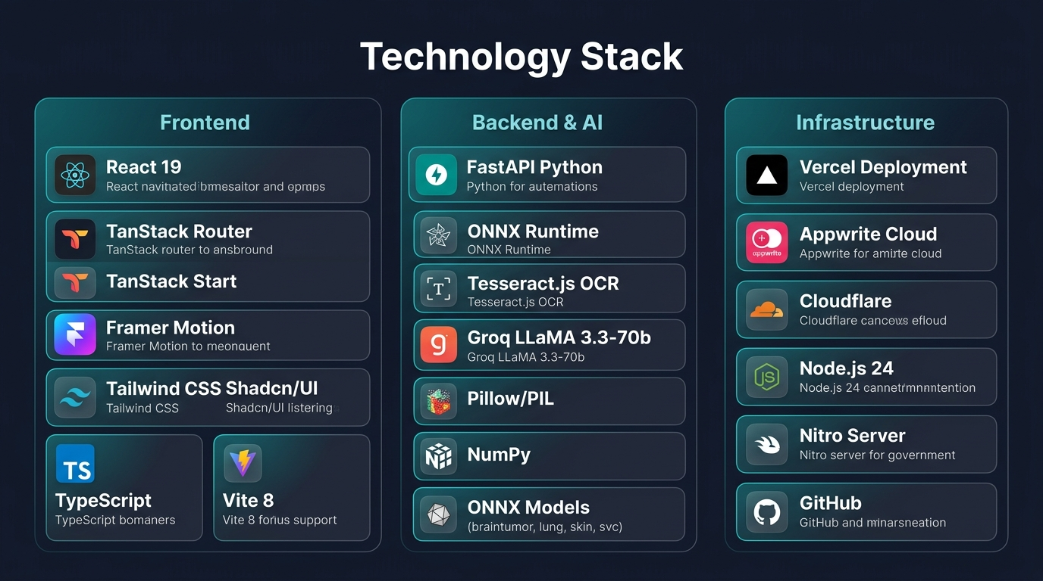
Figure 5: Technology Stack Overview
8.1 Frontend
Technology | Version | Purpose
React | 19 | Core UI framework with concurrent features
TanStack Router | Latest | Type-safe file-based client routing
TanStack Start | Latest | Full-stack SSR framework (Nitro-powered)
TypeScript | 5.x | End-to-end type safety
Tailwind CSS | 4.x | Utility-first styling
Shadcn/UI | Latest | Accessible Radix-based components
Framer Motion | Latest | GPU-accelerated animations & transitions
Vite | 8.x | Build tool + HMR dev server
Tesseract.js | 7.0 | Client-side OCR (WebAssembly)
React Leaflet | Latest | OpenStreetMap hospital locator
Recharts | Latest | Admin dashboard data visualization
Sonner | Latest | Accessible toast notifications
date-fns | Latest | Date formatting utilities

8.2 Backend & AI
Technology | Purpose
FastAPI | Async Python REST API framework
uvicorn | ASGI server for FastAPI
ONNX Runtime | Cross-platform ML model inference engine
Pillow (PIL) | Medical image loading and preprocessing
NumPy | Tensor creation and numerical operations
Groq SDK | LLaMA 3.3-70b chat completion client
scikit-learn | SVC training (offline, models pre-exported)
TensorFlow/Keras | CNN model training (offline, models pre-exported)
python-dotenv | Environment variable management
httpx | Async HTTP client for external API calls

8.3 ONNX Models Summary
Model File | Task | Input Shape | Output | Accuracy
braintumor.onnx | Brain MRI classification | [1,168,168,1] | 4-class softmax | ~99%
lung.onnx | Chest X-Ray classification | [1,224,224,3] | Binary sigmoid | ~90%+
skin.onnx | Skin condition detection | [1,64,64,1] | 3-class softmax | ~85%+
svc.onnx | Symptom -> Disease | [1,132] | 41-class label | ~94%

8.4 Infrastructure
Service | Purpose | Plan
Vercel | Frontend + Nitro SSR + Python serverless | Hobby/Pro
Appwrite | Authentication + Database collections | Cloud Free
Cloudflare | DNS management + local tunnel | Free
GitHub | Version control + CI/CD (auto-deploy) | Free
Docker | Containerized local + production deploy | Optional

9. DATABASE DESIGN
9.1 Appwrite Collections
Orders Collection Schema
Collection: orders
{
"orderId": "SS-20260907-A1B2C3D4" // auto-generated
"userId": "appwrite_user_id"
"userName": "Maryam Tahir"
"userEmail": "user@example.com"
"items": [
{
"id": "paracetamol_500mg",
"name": "Paracetamol 500mg",
"qty": 2,
"price": 150.0
}
],
"total": 300.0,
"paymentMethod": "COD",
"status": "pending | confirmed | shipped | delivered",
"estimatedDelivery":"2-3 business days",
"createdAt": "2026-09-07T20:00:00Z"
}
Reviews Collection Schema
Collection: reviews
{
"userId": "appwrite_user_id",
"userName": "Maryam T.",
"rating": 5,
"comment": "Excellent diagnostic accuracy!",
"module": "diagnostics | symptoms | chat | prescription | pharmacy",
"createdAt": "2026-09-07T20:00:00Z"
}
9.2 Local State (Browser)
Storage Key | Data | Type | Persistence
sehatsaathi_cart | Cart items array | CartItem[] | localStorage (permanent)
theme | Dark/light toggle | string | localStorage (permanent)
lang | EN/UR preference | string | localStorage (permanent)

9.3 CSV Dataset Files
File | Rows | Purpose
Medicine_Details.csv | 15,000+ | Full pharmacy database with brand, generic, price
description.csv | 41 | Disease descriptions for SVC results
precautions_df.csv | 41 | Precautions per disease (4 per disease)
medications.csv | 41 | Recommended medicines per disease
diets.csv | 41 | Diet plan per disease
workout_df.csv | 41 | Workout/activity recommendations per disease
advanced_cv_model.json | N/A | Centroid ML fallback model (JSON)

10. API SPECIFICATION
10.1 Base URLs
• Production: https://sehat-saathi-ai.vercel.app
• Local Development: http://localhost:8000
• Authentication: Appwrite cookie-based sessions (no API key required)
10.2 Endpoints
POST /api/assistant/chat
Purpose: AI Medical Chat (Groq LLaMA 3.3-70b)
Request:
{"message":"I have chest pain","language":"en","history":[{"role":"user","content":"Hello"},{"role":"assistant","content":"Hello! How can I help?"}]}
Response:
{"response":"Chest pain lasting more than a few minutes...","model":"llama-3.3-70b-versatile","language":"en","products":[{"id":"aspirin","name":"Aspirin 100mg","price":120.0}]}

POST /analyze-medical-image
Purpose: Medical Image Analysis (ONNX)
Request:
multipart/form-data: file=<image_binary>, modality="auto"|"mri"|"xray"
Response:
{"modality":"mri","model_used":"High-Precision ONNX Engine","finding":"Glioma Tumor","confidence":0.924,"abnormality_score":0.88,"confidence_band":"High","full_clinical_report":{"disease":"Glioma Tumor","medicines":[...],"diet_plan":[...],"precautions":[...],"lab_tests":[...]},"clinical_disclaimer":"..."}

POST /analyze-skin
Purpose: Skin Condition Analysis
Request:
multipart/form-data: file=<skin_image>
Response:
{"condition":"Acne","confidence":0.85,"skin_type":"Oily","recommendations":[...],"ingredients":[...]}

POST /predict-disease
Purpose: Symptom-based Disease Prediction
Request:
{"symptoms":["headache","high_fever","nausea","vomiting"]}
Response:
{"disease":"Typhoid","description":"...","precautions":["Drink boiled water","..."],"medicines":[{"name":"Ciprofloxacin 500mg"}],"diet_plan":["Light meals","..."],"workout_plan":["Bed rest"],"lab_tests":["Blood culture","Widal test"]}

GET /medicines/search?q={name}
Purpose: Medicine Search
Request:
Query param: q=paracetamol
Response:
{"name":"Paracetamol 500mg","generic":"Paracetamol","uses":"Pain and fever relief","price":120.0,"manufacturer":"GSK Pakistan","found":true}

GET /medicines/all?limit={n}
Purpose: List All Medicines (paginated)
Request:
Query params: limit=40, offset=0
Response:
[{"id":"...","name":"...","price":...,"category":"...","rating":4.5}]

POST /checkout
Purpose: Place COD Order
Request:
{"items":[{"id":"med_1","name":"Paracetamol 500mg","qty":2,"price":150}],"total":300,"payment_method":"COD"}
Response:
{"status":"success","order_id":"SS-20260907-A1B2C3D4","message":"Order placed","payment_method":"Cash on Delivery","estimated_delivery":"2-3 business days"}

11. FRONTEND ARCHITECTURE
11.1 Global State (AppContext)
type AppState = {
// Internationalization
lang: "en" | "ur"
setLang: (l: Lang) => void
t: (key: DictKey) => string // translation function
rtl: boolean // auto-true for Urdu
// Theme
dark: boolean
toggleDark: () => void
// Shopping Cart
cart: CartItem[]
cartCount: number
cartTotal: number
addToCart: (item: CartItem) => void
setQty: (id: string, qty: number) => void
removeFromCart:(id: string) => void
clearCart: () => void
cartOpen: boolean
setCartOpen: (v: boolean) => void
// Authentication
user: AppUser | null
authLoading: boolean
authOpen: boolean
setAuthOpen: (v: boolean) => void
signIn: (email: string, password: string) => Promise<void>
signUp: (name: string, email: string, password: string) => Promise<void>
signOut: () => Promise<void>
}
11.2 Route Structure
frontend/src/routes/
__root.tsx (Root layout: Navbar, CartSheet, AuthDialog, Toaster)
index.tsx -> / (Landing page)
diagnostics.tsx -> /diagnostics (AI medical image analysis)
symptoms.tsx -> /symptoms (Symptom checker)
chat.tsx -> /chat (AI assistant)
prescription.tsx -> /prescription (OCR scanner)
pharmacy.tsx -> /pharmacy (Medicine store)
hospitals.tsx -> /hospitals (Hospital locator)
diet.tsx -> /diet (Diet planner)
admin.tsx -> /admin (Admin dashboard)
about.tsx -> /about
privacy.tsx -> /privacy
terms.tsx -> /terms
11.3 Internationalization (i18n)
• ~60 translation keys covering all UI text
• Supports: English (en) and Urdu (ur)
• RTL layout auto-applied via document.documentElement.dir = "rtl"
• Language persisted in localStorage and toggled via NavBar

12. SECURITY & AUTHENTICATION
12.1 Appwrite Auth Flow
Registration:
authService.register(name, email, password)
-> Appwrite creates account + email session
Login:
authService.login(email, password)
-> Appwrite sets HttpOnly cookie session
Session check:
authService.getCurrentUser()
-> Returns AppUser | null on every page load
Logout:
authService.logout()
-> Destroys server session, clears cookie
12.2 Admin Role Guard
// admin.tsx
const { user, authLoading } = useAppContext()
if (!authLoading && (!user || !user.labels?.includes("admin"))) {
return <Navigate to="/" />
}
12.3 Medical Safety Guardrails
Risk | Mitigation
AI makes wrong diagnosis | All outputs labeled as AI-generated, doctor required
AI prescribes medication | System prompt: "NEVER prescribe, always recommend doctor"
User data privacy (OCR) | Tesseract.js runs 100% client-side, no image sent to server
Model overconfidence | Confidence bands: Low (<70%), Medium (70-85%), High (>85%)
Definitive diagnosis claims | Disclaimer appended to every clinical report output

13. DEPLOYMENT ARCHITECTURE
13.1 Vercel CI/CD Pipeline
GitHub push to master branch
|
v
Vercel webhook triggered automatically
|
+---------------------------+---------------------------+
| |
FRONTEND BUILD BACKEND BUILD
cd frontend && npm install pip install (py-api)
vite build -> Nitro SSR bundle FastAPI ASGI handler
TanStack Start output Python serverless fn
| |
+---------------------------+---------------------------+
|
v
Deployed to Vercel Edge Network
Region: Washington D.C. (iad1)
Runtime: Node.js 24 (frontend) + Python 3.11 (backend)
Auto-preview URLs for every PR
Production URL: sehat-saathi-ai.vercel.app
13.2 vercel.json Configuration
{
"builds": [
{ "src": "frontend/package.json", "use": "@vercel/node" },
{ "src": "frontend/py-api/index.py", "use": "@vercel/python" }
],
"routes": [
{ "src": "/api/(.*)", "dest": "frontend/py-api/index.py" },
{ "src": "/(.*)", "dest": "frontend/package.json" }
]
}
13.3 Environment Variables
Variable | Purpose | Used By
GROQ_API_KEY | Groq LLaMA chat | py-api
GROQ_MODEL | Model name config | py-api
GEMINI_API_KEY | Optional OCR fallback | py-api
NEXT_PUBLIC_APPWRITE_ENDPOINT | Appwrite server URL | frontend
NEXT_PUBLIC_APPWRITE_PROJECT_ID | Project identifier | frontend
NEXT_PUBLIC_APPWRITE_DATABASE_ID | DB identifier | frontend
NEXT_PUBLIC_APPWRITE_BUCKET_ID | Storage bucket | frontend
NEXT_PUBLIC_API_URL | Backend API base URL | frontend

14. PERFORMANCE & CONSTRAINTS
14.1 Vercel Serverless Limits
Limit | Vercel Value | Our Approach
Bundle size | 250 MB | ONNX models (not PyTorch/TF) — 10-50x smaller
Execution timeout | 60 seconds | ONNX inference < 3s, chat < 5s
Memory limit | 1024 MB | Lightweight PIL + ONNX, no heavy frameworks
Cold start | 1-3 sec | Model loaded once, cached for session
File size per fn | 250 MB | Total py-api bundle < 80MB

14.2 Model Inference Performance
Model | Inference Time | Memory | Training Accuracy
braintumor.onnx | ~300ms | ~45MB | ~99%
lung.onnx | ~200ms | ~30MB | ~90%+
skin.onnx | ~150ms | ~20MB | ~85%+
svc.onnx | <10ms | <1MB | ~94%
Centroid ML JSON | <1ms | <100KB | N/A (heuristic)

14.3 Frontend Performance
• Code-split routes via Vite — only current page JS loaded
• Framer Motion animations GPU-accelerated (transform, opacity only)
• Cart persisted in localStorage — zero API calls on load
• Tesseract.js worker spawned once, reused across scans
• React 19 concurrent features for non-blocking UI updates

15. FUTURE ROADMAP
Version | Feature | Description | Timeline
v1.1 | Voice Input | Web Speech API for hands-free medical queries | Q4 2026
v1.1 | WhatsApp Bot | WABA integration for rural feature-phone users | Q4 2026
v1.1 | Appointment Booking | Doctor slot booking with calendar integration | Q4 2026
v1.2 | Retinal Scan AI | Diabetic retinopathy detection from fundus images | Q1 2027
v1.2 | Blood Report OCR | Parse CBC/LFT/KFT from lab report photos | Q1 2027
v1.2 | Telemedicine | WebRTC video calls with verified doctors | Q1 2027
v2.0 | Mobile App | React Native iOS + Android application | Q3 2027
v2.0 | Wearables | Apple Watch / Fitbit vitals integration | Q3 2027
v2.0 | Govt. Hospital API | Pakistan DHQ / PMDC hospital data integration | Q3 2027
v2.0 | Insurance Claims | AI-assisted claim form auto-fill + submission | Q3 2027

SehatSaathi AI
Making healthcare intelligent, accessible, and human
for every Pakistani.
github.com/maryamtahir7/SehatSaathi-AI
sehat-saathi-ai.vercel.app
Version 1.0 | September 2026

