SehatSaathi AI
Complete Project Documentation
Version 1.0 | September 2026 | Author: Maryam Tahir
Repository: github.com/maryamtahir7/SehatSaathi-AI
Live Demo: sehat-saathi-ai.vercel.app

1. Executive Summary
SehatSaathi AI (Sehat = Health, Saathi = Companion in Urdu) is a comprehensive, full-stack AI-powered healthcare web platform purpose-built for Pakistan and South Asia. The platform addresses a critical gap in healthcare access by providing hospital-grade AI tools directly on any device, in any language, at any time — completely free for the end user.

Platform Modules
Module | AI Technology | Capability
Medical Diagnostics | ONNX CNN Models | MRI Brain Tumor, Chest X-Ray, Skin
Symptom Checker | ONNX SVC Classifier | 132 symptoms → 41 diseases
AI Chat Assistant | Groq LLaMA 3.3-70b | Medical Q&A in English & Urdu
Prescription OCR | Tesseract.js WASM | Offline handwriting recognition
Pharmacy Store | CSV Medicine Database | 15,000+ medicines, COD checkout
Hospital Locator | React Leaflet | OpenStreetMap hospital finder
Diet Planner | Dataset-driven | Disease-specific nutrition plans
Admin Dashboard | Recharts analytics | Orders, revenue, model stats

2. Problem Statement

Healthcare Access Crisis in Pakistan
Challenge | Impact
73% of rural Pakistan lacks specialist access | Delayed or missed diagnoses
Average diagnostic wait: 3-7 days | Disease progression untreated
Language barrier (75% speak Urdu) | Healthcare exclusion
Rs. 2,000-10,000 per specialist visit | Financial burden on families
Prescription misinterpretation | Medication errors and harm

Specific Pain Points
- Diagnostic Delay — Brain tumors, pneumonia go undetected due to lack of imaging access
- Prescription Misinterpretation — Handwritten prescriptions are often unreadable
- Misinformation — Patients rely on unverified online sources for health advice
- Pharmacy Access — Rural patients cannot easily access a wide range of medicines

3. Project Overview

Architecture Philosophy
The platform uses a hybrid serverless + API architecture:
User Device
|
| HTTPS
v
Vercel Edge Network (CDN)
|
v
TanStack Start (React 19 SSR) — Nitro
|
| Internal proxy /api/* -> :8000
v
FastAPI Python Backend (py-api)
+-- ONNX Runtime (local ML inference)
+-- Groq API (cloud LLM chat)
+-- Appwrite Cloud (auth + database)
+-- CSV datasets (medicine, disease)

Key Design Decisions
Decision | Rationale
ONNX over TensorFlow | Vercel 250MB limit — ONNX 10-50x smaller
Tesseract.js (client-side) | Zero server cost, offline, privacy-preserving
Groq for chat | ~500 tokens/sec — fastest LLM inference globally
Appwrite | Open-source BaaS — no Firebase vendor lock-in
TanStack Start | SSR + type-safe file-based routing
CSV datasets | No pandas — saves 40MB serverless bundle

4. System Architecture
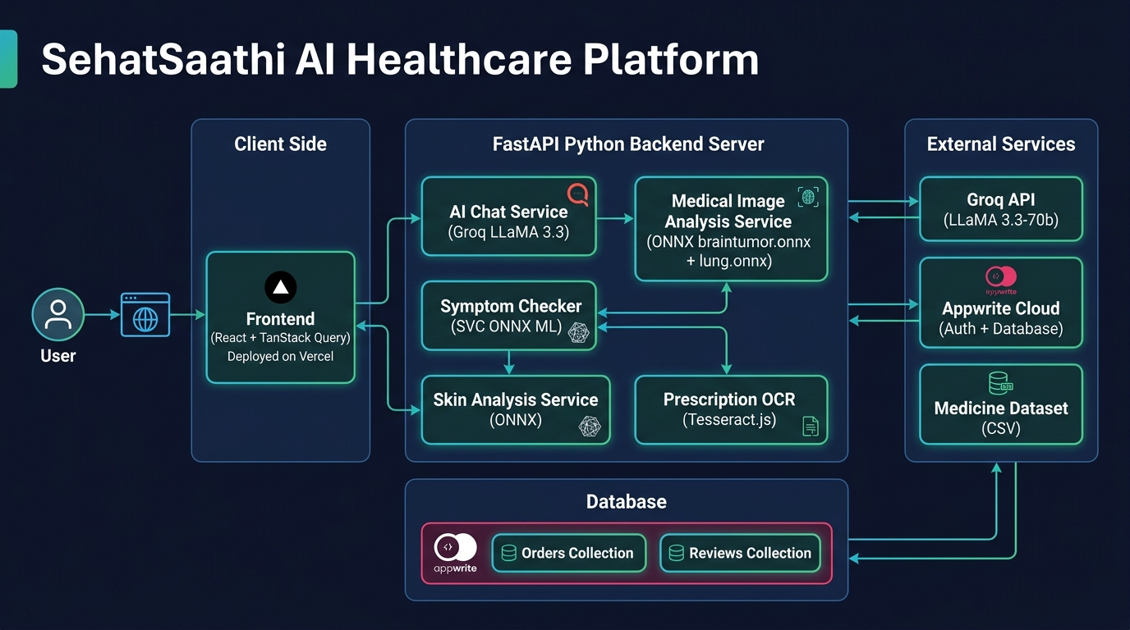

Data Flow: Medical Image Analysis
User uploads image
|
v
POST /analyze-medical-image
|
v
PIL: convert RGB + grayscale
Auto-modality: mean_px < 95 -> MRI, else X-Ray
|
+--------+--------+
| |
[X-Ray] [MRI]
lung.onnx braintumor.onnx
224x224x3 168x168x1
Binary sigmoid Softmax 4-class
|
v
Confidence + Abnormality Score + Clinical Report

Data Flow: Symptom Prediction
User selects symptoms
|
v
One-hot encode -> [0,0,1,0,1,...] (132-dim)
|
v
svc.onnx -> predicted class -> disease name
|
v
CSV lookup: description, precautions, medicines, diet

5. Module-by-Module Breakdown

5.1 AI Medical Diagnostics (/diagnostics)
File: diagnostics.tsx (19KB)
- Upload MRI, X-Ray, or Skin image via drag-and-drop
- Auto-detects modality via pixel mean statistics
- Tab switcher: Brain MRI | Chest X-Ray | Skin Analysis
- Confidence bar + Abnormality score visualization
- Full clinical report: medicines, diet, lab tests, precautions
- Add medicines directly to cart

5.2 Symptom Checker (/symptoms)
File: symptoms.tsx (12KB)
- Search + select from 132 symptoms
- SVC ONNX prediction on submit
- Full recommendation card: disease, medicines, diet, workout
- Medicine add-to-cart integration

5.3 AI Chat Assistant (/chat)
File: chat.tsx (17KB)
- Markdown-rendered real-time chat
- Language toggle (EN/UR) mid-conversation
- Product cards appear when medicines are mentioned
- Conversation history up to 10 turns
- Groq LLaMA 3.3-70b (~500 tokens/sec)

5.4 Prescription OCR (/prescription)
File: prescription.tsx (18KB) — 100% client-side
- Tesseract.js WASM worker initializes in browser
- Image compression to max 1200px
- Text extracted with real-time progress indicator
- Heuristic medicine detection (Tab, Cap, Syp, Inj...)
- OCR.space API fallback if WASM fails
- Bulk Add All to Cart button

5.5 Pharmacy Store (/pharmacy)
File: pharmacy.tsx (14KB)
- Grid of medicine cards with category filters
- Real-time search filtering
- Rating, brand, price display
- Cart integration with persistent localStorage
- COD checkout with order ID generation

5.6 Hospital Locator (/hospitals)
File: hospitals.tsx (15KB)
- React Leaflet map with OpenStreetMap tiles
- Hospital listing with city filter
- Specialty filter panel

5.7 Admin Dashboard (/admin)
File: admin.tsx (32KB)
- Revenue charts (Recharts BarChart, LineChart)
- Order management table
- AI model accuracy display
- Role-gated: requires Appwrite admin label

6. ML & AI Models
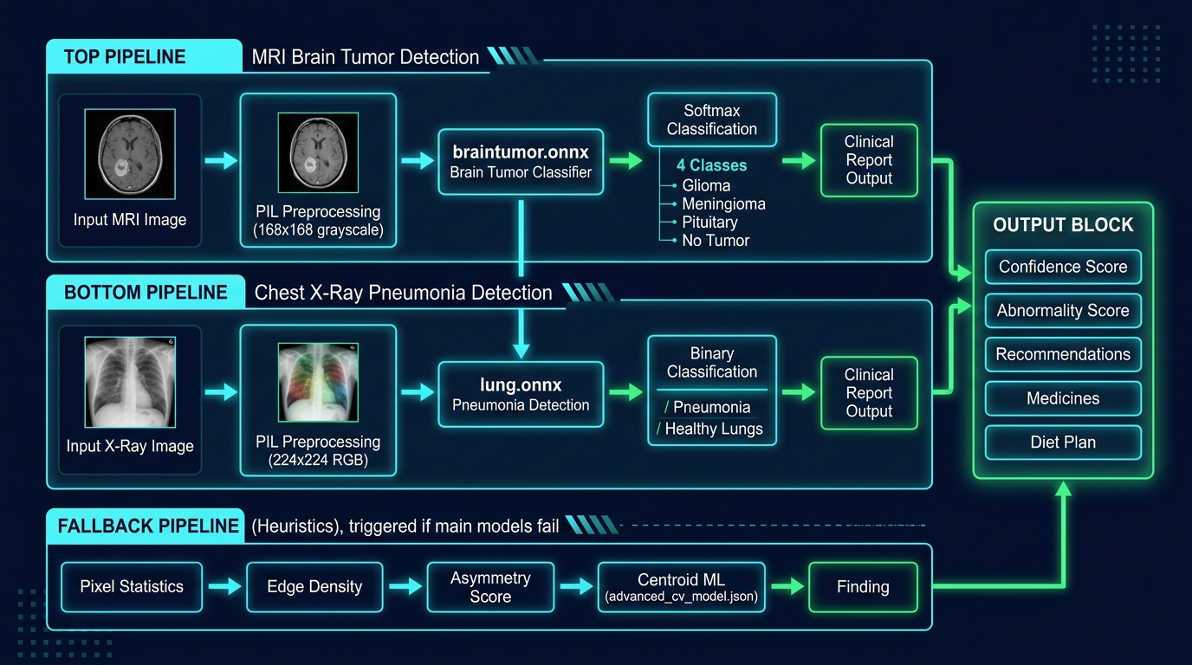

6.1 Brain Tumor MRI Classifier
Property | Value
File | braintumor.onnx
Input Shape | [1, 168, 168, 1] — batch, H, W, channels
Input Type | float32, normalized 0-1
Output | Softmax probabilities [1, 3] or [1, 4]
Classes | glioma_tumor, meningioma_tumor, pituitary_tumor, no_tumor
Training Accuracy | ~99%
Training Notebook | backend/brain-tumor-mri-accuracy-99.ipynb

6.2 Chest X-Ray Pneumonia Classifier
Property | Value
File | lung.onnx
Input Shape | [1, 224, 224, 3]
Input Type | float32, normalized 0-1
Output | Binary sigmoid [1, 1]
Classes | 0 = healthy_lungs, 1 = bacterial_pneumonia
Training Notebook | backend/chest-x-ray-images-pneumonia.ipynb

6.3 Skin Condition Classifier
Property | Value
File | skin.onnx
Input Shape | [1, 64, 64, 1]
Output | 3-class softmax
Classes | acne, melanoma, eczema

6.4 Disease Classifier (SVC ONNX)
Property | Value
File | svc.onnx
Input Shape | [1, 132] one-hot encoded symptoms
Algorithm | Support Vector Classifier
Output | Integer class label (41 diseases)
Dataset | Kaggle Medical Symptom Prediction Dataset

All 41 diseases covered:
- Fungal infection, Allergy, GERD, Chronic cholestasis, Drug Reaction
- Peptic ulcer disease, AIDS, Diabetes, Gastroenteritis, Bronchial Asthma
- Hypertension, Migraine, Cervical spondylosis, Paralysis, Jaundice
- Malaria, Chicken pox, Dengue, Typhoid, Hepatitis A/B/C/D/E
- Alcoholic hepatitis, Tuberculosis, Common Cold, Pneumonia, Piles
- Heart attack, Varicose veins, Hypothyroidism, Hyperthyroidism
- Hypoglycemia, Osteoarthritis, Arthritis, Vertigo, Acne, UTI, Psoriasis, Impetigo

6.5 Fallback: Centroid ML (advanced_cv_model.json)
When ONNX models are unavailable, a pure-JSON centroid model provides classification:
Feature vector: [mean_pixel, std_dev, edge_density, asymmetry]
Method: Euclidean distance to class centroids
Modality-filtered: separate MRI and X-Ray centroids
Confidence: max(0.6, 1.0 - best_dist/200.0)

7. Database Design

Appwrite Collections

Orders Collection
{
"orderId": "SS-20260907-ABC12345",
"userId": "appwrite_user_id",
"items": [{"id":"paracetamol_500","name":"Paracetamol 500mg","qty":2,"price":150}],
"total": 300,
"paymentMethod": "COD",
"status": "pending",
"createdAt": "2026-09-07T20:00:00Z"
}

Reviews Collection
{
"userId": "appwrite_user_id",
"userName": "Maryam T.",
"rating": 5,
"comment": "Excellent diagnostic accuracy!",
"module": "diagnostics",
"createdAt": "2026-09-07T20:00:00Z"
}

Local State (localStorage)
- Key: sehatsaathi_cart — Persistent cart array (CartItem[])
- Schema: { id, name, price, qty } per item

8. API Specification

Base URLs
- Production: https://sehat-saathi-ai.vercel.app
- Local Backend: http://localhost:8000

POST /api/assistant/chat
Purpose: AI Chat
Request:
{"message":"string","language":"en|ur","history":[]}
Response:
{"response":"string","model":"string","language":"string","products":[]}

POST /analyze-medical-image
Purpose: Medical Image Analysis
Request:
multipart/form-data: file + modality(auto|mri|xray)
Response:
{"modality":"mri","finding":"Glioma Tumor","confidence":0.924,"abnormality_score":0.88,...}

POST /predict-disease
Purpose: Symptom Disease Prediction
Request:
{"symptoms":["headache","fever","nausea"]}
Response:
{"disease":"Typhoid","description":"...","medicines":[...],"diet_plan":[...]}

GET /medicines/search?q=name
Purpose: Medicine Search
Request:
Query param: q=medicine_name
Response:
{"name":"Paracetamol 500mg","generic":"...","price":120.0,"found":true}

POST /checkout
Purpose: Place Order
Request:
{"items":[...],"total":300,"payment_method":"COD"}
Response:
{"status":"success","order_id":"SS-20260907-XXXX","estimated_delivery":"2-3 days"}

9. Technology Stack
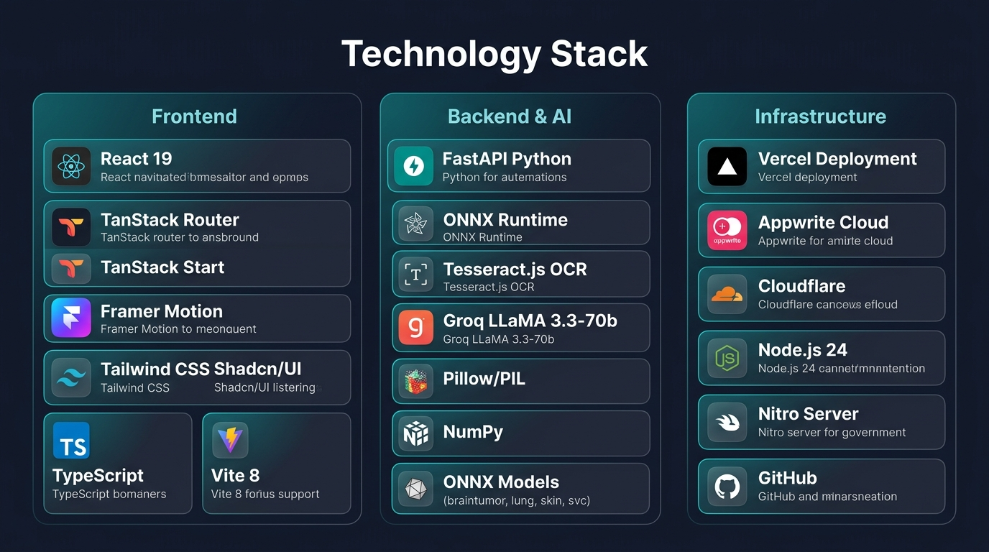

Frontend
Technology | Version | Purpose
React | 19 | UI Framework
TanStack Router | Latest | File-based type-safe routing
TanStack Start | Latest | SSR + full-stack framework
TypeScript | 5.x | Type safety
Tailwind CSS | 4.x | Utility-first styling
Shadcn/UI | Latest | Accessible component library
Framer Motion | Latest | Animations & micro-interactions
Vite | 8.x | Build tool
Tesseract.js | 7.0 | Client-side OCR (offline)
React Leaflet | Latest | Hospital map (OpenStreetMap)
Recharts | Latest | Admin dashboard charts
Sonner | Latest | Toast notifications

Backend & AI
Technology | Purpose
FastAPI | Python REST API framework (async)
ONNX Runtime | Production ML model inference
Pillow (PIL) | Medical image preprocessing
NumPy | Numerical computation
Groq SDK | LLaMA 3.3-70b chat inference
scikit-learn | SVC model training
TensorFlow/Keras | CNN model training

Infrastructure
Service | Purpose
Vercel | Frontend + Nitro SSR edge deployment
Appwrite Cloud | Authentication + Database
Cloudflare | DNS + tunnel for local dev
GitHub | Version control + CI/CD
Docker | Containerized deployment

10. Security & Authentication

Appwrite Auth
- Registration: authService.register(name, email, password)
- Login: authService.login(email, password) — cookie-based session
- Session persists across page refreshes via Appwrite server session
- Logout: authService.logout() — destroys server session

Admin Authorization
user.labels.includes('admin') — checked on every admin route render

Medical Safety
- All AI outputs include: "This report is AI-generated and must be validated by a clinical specialist"
- Chat system prompt: NEVER prescribe medication, NEVER make definitive diagnosis
- Always recommends consulting a qualified doctor for serious symptoms

11. Deployment Architecture

Vercel CI/CD Pipeline
GitHub push to master
|
v
Vercel CI/CD triggered automatically
|
+------------------+------------------+
| |
npm run build pip install (py-api)
Vite + Nitro SSR bundle FastAPI ASGI handler
| |
+------------------+------------------+
|
v
Deployed to Vercel Edge
Region: Washington D.C. (iad1)
Runtime: Node.js 24 (frontend) + Python (backend)

Getting Started (Local)
# 1. Clone
git clone https://github.com/maryamtahir7/SehatSaathi-AI.git
# 2. Environment
cp .env.example frontend/py-api/.env.local
# 3. Frontend
cd frontend && npm install && npm run dev
# 4. Backend
cd frontend/py-api
pip install fastapi uvicorn pillow onnxruntime numpy groq
uvicorn index:app --reload --port 8000

12. Future Roadmap
Version | Feature | Timeline
v1.1 | Voice input for AI chat (Web Speech API) | Q4 2026
v1.1 | WhatsApp Bot integration for rural users | Q4 2026
v1.1 | Appointment booking system | Q4 2026
v1.2 | Retinal scan analysis (diabetic retinopathy) | Q1 2027
v1.2 | Blood report OCR (CBC, liver function parsing) | Q1 2027
v1.2 | Doctor telemedicine video calls | Q1 2027
v2.0 | React Native mobile application | Q3 2027
v2.0 | Wearable device integration (heart rate, SpO2) | Q3 2027
v2.0 | Insurance claim automation | Q3 2027
v2.0 | Pakistan Govt. hospital API (DHQ integration) | Q3 2027

SehatSaathi AI v1.0.0 — September 2026
Making healthcare intelligent, accessible, and human.
github.com/maryamtahir7/SehatSaathi-AI

