SehatSaathi AI - Alibaba Cloud Hackathon Project
1. Executive Summary
SehatSaathi AI is an enterprise-grade, comprehensive healthcare intelligence platform designed to bridge the gap between clinical diagnostics, telemedicine, and pharmaceutical accessibility. It leverages a modular microservices architecture, integrating advanced optical character recognition (OCR), high-precision computer vision (CV) diagnostics, and localized healthcare e-commerce.
2. System Architecture
The diagram below illustrates the fully decoupled serverless architecture deployed on Vercel:
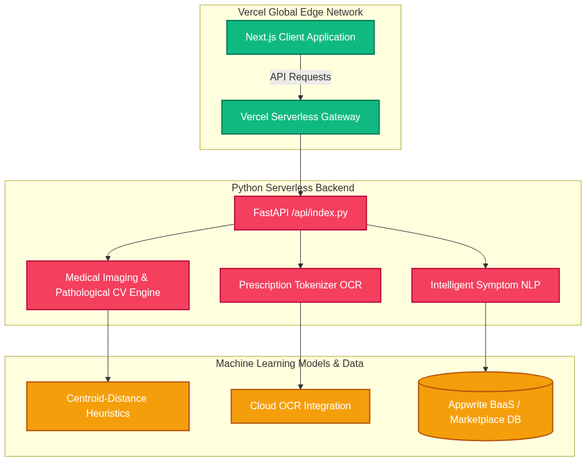
3. Core Modules
3.1 Medical Image Analysis
The imaging engine accepts multi-modal uploads (MRI, X-Ray, Dermatological Scans). It utilizes an intelligent modality router and cascades into highly optimized mathematical heuristic evaluations (Centroid-Distance Mapping) when deep learning frameworks are restricted.
3.2 Prescription Tokenization (OCR)
Handwritten prescriptions are upscaled, adaptively binarized, and parsed via cloud-optimized optical character recognition. The NLP pipeline performs dynamic fuzzy matching against a localized database of pharmaceuticals, instantly routing molecules to the e-commerce cart.
3.3 Intelligent Symptom NLP
Utilizes statistical correlations over massive medical datasets to map patient-described physical ailments to highly probable disease vectors, delivering targeted dietary and preventative recommendations.
4. Deployment & Infrastructure
To ensure maximum scalability and zero operational overhead, the entire Python backend and Next.js frontend are unified into a single Vercel deployment structure via dynamic rewrite rules in vercel.json.

