Background: Duke Kunshan University (DKU) is an interdisciplinary institution that grants dual undergraduate degrees, an MOE Chinese degree and a degree from Duke University in Durham, United States. The principal structure of DKU majors is robustly interdisciplinary. No student confines their study to a single discipline (for example, biology or economics). Instead, all students engage in broad inquiry related to a subject or question (for example, political economy or global health) and take a wide variety of courses related to that area (for example, in public policy, history, ethics, or economics). As a result, our graduates are prepared to engage in a wide variety of inquiries using multiple methodologies to address complex issues that require interdisciplinary approaches.
This has implications for our vision and expectations of undergraduate theses and design projects, which reflect this broad interdisciplinary training. At DKU, every student completes a two-year project known as signature work which consists of multiple interconnected parts including thematic courses, experiential learning, capstones, and a final product. It seeks to integrate students’ interdisciplinary educational experience and culminates in the creation of a product in a scholarly, creative, or applied nature in lieu of an undergraduate thesis or design required by JED. Because DKU encourages students to cultivate their independence and creativity as one of its institutional student learning outcomes, the student-led signature work projects often reflect students’ own particular interdisciplinary interests and training. In addition, signature work has an intensive emphasis on problem-solving and skill-development which is much needed for any interdisciplinary inquiry; thus, students’ final products are evidence of transferrable skills that students have acquired and demonstrated through the 2-year program, rather than content knowledge narrowly defined by disciplinary training.
In sum, while the Chinese major declared with any given student might be construed narrowly, the experience of our students is much broader—and intentionally so. This is a distinctive feature of our curriculum, and this distinctiveness results in broadly interdisciplinary submissions from our graduates’ submitting theses or design projects. We have designed this to prepare our students for a wide variety of graduate programs in China and the West, where interdisciplinary training is a competitive advantage.
EXPLORING 3D DEEP LEARNING-BASED CLASSIFICATION
OF HEAD CT SINOGRAMS TO BYPASS IMAGE RECONSTRUCTION

by
Maryana Malyushytska

Signature Work Product, in partial fulfillment of the Duke Kunshan University Undergraduate Degree Program

November 3rd, 2025

Signature Work Program
Duke Kunshan University

ABSTRACT
Computed tomography (CT) is essential in diagnostic imaging; however, conventional analysis relies upon the reconstruction of raw projection data (sinograms) into human-interpretable images. While vital for visualization purposes, reconstruction has the potential to introduce artifacts, distort quantitative biomarkers, and incur additional computational overhead. Advancements in deep and machine learning have now made it possible to use solely sinogram data for classification, eliminating the need for image reconstruction entirely. Reconstruction-free classification could reduce delays in emergency diagnostics, where every second counts. In field settings with suboptimal CT quality, this approach may be particularly applicable for triage in suspected intracranial hemorrhage and other disorders, especially when low radiation doses are desired. As such, this Signature Work investigates 3-dimensional deep learning-based classification using head CT sinograms to improve diagnostic efficiency. Using the Stanford-SinoCT dataset (9,779 labeled studies), convolutional neural network (CNN) architectures (ResNet3D, DenseNet3D, EfficientNet3D, and MobileNet3D) are trained, validated, and tested on normalized sinograms. Model performance is compared to image-based models through AUROC, AUPRC, accuracy, ECE, and related metrics. Threshold dependence and post-hoc calibration with temperature scaling are also evaluated. Initial results show that sinogram-only ResNet3D models perform similarly (AUROC = 0.7211) to reconstructed-volume models (AUROC = 0.7255), therefore implying reconstruction may be unnecessary for certain diagnostic tasks. These findings have implications for faster, lower-latency CT pipelines, reduced computational cost, and lower hardware demands, which in turn would greatly benefit hospitals with limited resources.

Keywords:
classification, computational efficiency, computed tomography, convolutional neural networks, deep learning, image reconstruction, sinogram

Abbreviations:
ADAM - adaptive moment estimation, AMP - automatic mixed-precision, AP - average precision, AUROC - area under receiver operating characteristic curve, AUPRC - area under precision-recall curve, CNN - convolution neural network, CT - computed tomography, DL - deep learning, ECE - expected calibration error

ACKNOWLEDGEMENTS
I’d like to express my gratitude toward the Stanford University School of Medicine for granting access to view and use their SinoCT Dataset for my personal, non-commercial research. Furthermore, I’d like to thank my mentor, Ming-Chun Huang, who graciously provided access to his laboratory’s GPU server, enabling me to download, access, and work with the entire dataset for my research, as well as being the individual educator who first sparked my interest in image processing as a field of study.

TABLE OF CONTENTS
ABSTRACT ii
Keywords iii
Abbreviations iii
ACKNOWLEDGEMENTS iv
TABLE OF CONTENTS v
LIST OF TABLES vi
TABLE OF FIGURES vii
1 INTRODUCTION 1
1.1 Background & Significance 1
1.2 Research Gap & Objectives 2
2 MATERIAL AND METHODS 4
2.1 Dataset 4
2.2 Preprocessing 4
2.3 Model Architectures 5
2.4 Training Procedure 6
2.5 Evaluation Metrics 6
2.6 Calibration 7
2.7 Computational Analysis 7
2.8 Reproducibility 7
2.9 Hardware & Software 8
3 RESULTS 9
3.1 Model Training and Convergence 9
3.2 Model Performance 10
3.3 Threshold and Confusion Analysis 14
3.6 Calibration 17
3.7 Computational Efficiency 19
4 DISCUSSION 20
4.1 Principal Findings 20
4.2 Implications 20
4.3 Limitations 21
4.4 Comparison to Prior Research 22
4.5 Future Research Directions 23
5 CONCLUSION 24
6 REFERENCES 26
A ADDITIONAL MATERIALS 32
A Appendix 32

LIST OF TABLES
Table 3.1: Test-set model performance parameters 10
Table 3.2: Model Pre- & Post-Calibration Metrics 17
Table 3.3: Model Computational Efficiency Summary 19
Table A.1: Sinogram ResNet3D Model Training Data 32
Table A.2: Sinogram DenseNet3D Model Training Data 33
Table A.3: Reconstructed CT Volume ResNet3D Model Training Data 34
Table A.4: Model Comparison for Sinogram Training 34

TABLE OF FIGURES
Figure 3.1: Training/validation accuracy & loss curves for 3D ResNet model trained on volume image data. 9
Figure 3.2: Training/validation accuracy & loss curves for 3D ResNet model trained on sinogram data. 10
Figure 3.3: Bar chart summarizing model performance with error bars 11
Figure 3.4: Radar plot comparing model performance 12
Figure 3.5: ROC Curve Comparison of Sinogram & Volume Models 13
Figure 3.6: PR Curve Comparison of Sinogram & Volume Models 14
Figure 3.7: Reconstructed CT Volume Training Model - F1 Score & Accuracy vs. Threshold 15
Figure 3.8: Sinogram Model - Confusion Matrix at best threshold = 0.30 16
Figure 3.9: Volume Model - Confusion Matrix at best threshold = 0.35 16
Figure 3.10: Calibrated Sinogram Model - Confusion Matrix at Best Threshold = 0.40 18
Figure 3.11: Calibrated Volume Model - Confusion Matrix at Best Threshold = 0.30 18
Figure A.1: Model Comparison for 7-Epoch Sinogram Training 35

1 INTRODUCTION

1.1 Background & Significance
Modern diagnostics rely heavily on medical imaging as a major contributing factor in medical decision-making, facilitating disease detection, guiding treatment plans, and assessing patient outcomes [6], [9], [14], [35]. Of the currently available medical imaging modalities, computed tomography (CT) plays a crucial role, due to its high-resolution visualization of internal anatomy [34], [35]. Head CT is especially important, allowing clinicians to identify life-threatening conditions such as intracranial hemorrhage, ischemic stroke, and traumatic brain injury. As the primary form of imaging that provides clear visualization of brain structures, it is an incredibly valuable diagnostic tool [20], [23], [25], [28], [29].
Despite its widespread clinical use, conventional CT imaging relies on a multi-step reconstruction pipeline that converts raw X-ray projection data, known as a sinogram, into interpretable cross-sectional images. This process involves a complex series of mathematical transformations, specifically designed for human visualization and interpretation. Although reconstruction is necessary for radiologists, it introduces computational latency, hardware demands, and potential artifacts [5], [13], [17], [18]. Even with modern GPU-accelerated methods, reconstructing a full CT study of 2048 slices requires 2-4 minutes and over 500 GB of memory bandwidth, assuming current clinical hardware [40], [43]. Pre-processing can also unintentionally modify quantitative characteristics, including but not limited to the introduction or amplification of noise contamination, which may limit what machine learning models could readily exploit directly from the raw data [7], [11], [12], [35]. These potential errors can reduce the reproducibility of quantitative biomarkers and the reliability of deep learning features extraction. Prior research has shown that reconstruction kernel variability alone can cause a drop of over 20% in radiomic feature consistency across scans [44].
Reconstruction may no longer be required for diagnostic purposes because deep learning models analyze numerical patterns rather than image readability. Since diagnostic information is inherently present in the raw projection data, reconstruction can be theoretically omitted prior to classification. Direct sinogram analysis could eliminate the aforementioned issues and inefficiencies, reducing latency, improving computational cost, and eventually improving real-time clinical triage [7], [9], [13], [26], [27].

1.2 Research Gap & Objectives
Recent developments in deep learning for the sinogram domain include Lee et al. (2019), who introduced a sinogram-specific CNN, SinoNet, suggesting diagnostic information is usable in its raw form [7]. Moreover, Sindhura et al. (2024) proposed a two-stage sinogram-based deep learning model for intracranial hemorrhage detection and subtype classification [10]. Subsequently, Varma et al. (2025) demonstrated that information-preserving representations could improve efficiency in large-scale medical imaging applications [8], [9]. However, despite progress in sinogram-based deep learning, the field remains largely unexplored and theoretical, especially with respect to 3D applications. Prior studies utilized 2D sinogram projections, which may fail to properly capture volumetric features and abnormalities. As such, this signature work project aims to utilize the Stanford-SinoCT dataset to perform a controlled comparison between the sinogram & reconstructed image domains for classification using identical 3D CNN architectures. Specifically, this paper hypothesizes that a ResNet3D model architecture trained directly on sinogram data will achieve classification performance on the same level as an image-domain model, defined quantitatively as an AUROC difference of ≤ 0.02 between domains, and will demonstrate equal to or lower average batch inference time (± 10%). This direct, controlled comparison hopes to address the efficiency gaps that exist in CT diagnostic pipelines.

2 MATERIAL AND METHODS

2.1 Dataset
This study used the Stanford-SinoCT dataset, containing 9,779 non-contrast head CT image studies collected on a GE scanner from 2001 and 2014, each with either 0.49 or 0.60 mm pixel spacing in the axial plane [1], [2]. Each study includes a paired high-quality stimulated sinogram and its corresponding reconstructed CT volume, labeled as normal or abnormal by board-certified radiologists during initial interpretation. The scan class distribution is 4380:5399 (normal:abnormal), with 20 conditions, including intracranial hemorrhage, considered as abnormalities [1], [2]. This pairing allows for direct comparison between deep learning classification models trained on the projection (sinogram) and image domains (reconstructed CT).
Sinograms were generated with GE’s CatSim software, a simulation environment for X-ray computer tomography [3]. Each sinogram has a resolution of 984 x 888 pixels and is stored as a NumPy array. Reconstructed CT images are stored within Stanford’s PACS, in the form of 512 x 512 pixel axial DICOM slices; the number of slices varies per scan. Labels for each head CT image study are provided in a corresponding CSV file, resulting in a total combined dataset of approximately 1.3 terabytes of imaging data.
Collecting data from a single institutional source using a standardized scanner and reconstruction protocol may introduce acquisition bias, limiting its broader application. This could also potentially hide the benefits of sinogram-based learning in lower-quality imaging environments with variable scanner calibration, reconstruction, or data acquisition, when reconstruction struggles.

2.2 Preprocessing
All data was preprocessed in Python 3.12 using the NumPy, TorchIO, and PyTorch libraries.
Sinogram and CT volume data were rescaled in order to maintain consistent spatial dimensions and dataset uniformity. Both were resized to (1 x 192 x 192 x 96) to meet deep learning model fixed input tensor dimension requirements and ensure fair comparison. The dimensions (192, 192, 96) were specifically chosen in order to balance image detail preservation with efficient GPU memory usage during the 3D convolutions.
The dataset was split into training (70%), validation (15%), and testing (15%) subsets. Patient-level separation was kept between the respective subsets, meaning that if a sinogram was allocated to the training set, its corresponding CT image reconstruction was also included. To address the class imbalance between normal and abnormal studies, a class-proportional weighted cross-entropy loss function was applied.

2.3 Model Architectures
Two identical 3D convolutional neural network (CNN) architectures based on ResNet3D-18 were implemented for a direct comparison of classification results between the sinogram and reconstructed volume domains. Each model incorporated organized sequential convolutional residual blocks, batch normalization, and ReLU layers with skip connections. After global average pooling, a two-unit fully connected linear head was used to provide normal and abnormal classifications.
ResNet3D was chosen as the comparative deep learning architecture due to its consistent outperformance of other CNN architectures in regard to CT Image classification [6]. The supporting literature shows that ResNet3D performs especially well in binary classification. However, if the study were expanded to include radiomic feature extraction, other CNN architectures and variants could prove better suited [6], [9], [23], [29], [32], [39]. To determine its suitability for sinogram data classification, several alternative architectures (EfficientNet3D, DenseNet3D, and MobileNet3D) were also initially evaluated on the sinogram subset of the dataset. Each model was trained for up to 7 epochs under identical conditions to assess convergence behavior, stability, runtime, and validation accuracy. Among these, both DenseNet3D and ResNet3D demonstrated strong performance and were therefore continued for training up to 20 epochs; however, ResNet3D showed higher stability, generalization, and accuracy in the sinogram domain. As such, ResNet3D model architecture was applied toward both sinogram and reconstructed-volume experiments to ensure a controlled comparison. ResNet3D-50 was considered as a deeper CNN variant, but it required significantly more training time and computational resources. As a compromise, the more light-weight ResNet3D-18 model was chosen.

2.4 Training Procedure
Training was conducted using the PyTorch 2.2.1 library. Both domain models were optimized using the Adam optimizer algorithm [4] with an initial learning rate of 1e-4, a batch size of 8, a weight decay of 1e-5, and a weighted cross-entropy loss (in order to address class imbalance). Each model was trained up to 20 epochs, with early stopping applied when the validation accuracy failed to improve for five consecutive epochs (patience = 5). Automatic mixed-precision training (AMP) was deployed as a means to accelerate training convergence and reduce memory usage.
For fair comparison purposes, the sinogram and reconstructed-volume models were trained under identical experimental conditions, including architecture, hyperparameter settings, data splits, and evaluation metrics. This standardization meant that any differences in model performance were due to domain-specific characteristics rather than differences in training strategy.
All training logs, loss/accuracy histories, and checkpoints were saved for post-training analysis and visualization purposes.

2.5 Evaluation Metrics
Model performance was evaluated on the test set using the following quantitative metrics: Area Under the Receiver Operating Characteristic Curve (AUROC), Area Under the Precision-Recall Curve (AUPRC), Accuracy, Precision, Recall, and F1-Score. ROC and PR curves were plotted to visualize the model’s performance. Additionally, a radar plot was used to visualize the relative performance of the sinogram and reconstructed-volume models across the aforementioned evaluation metrics, in which each metric was normalized to allow for direct visual comparison. Thresholds ranging between 0.1 to 0.9 were tested, with the optimal threshold for each model chosen based on the highest F1 score achieved. Statistical analyses included p-values for performance comparisons and 95% confidence intervals (CIs) to quantify uncertainty and assess the significance of any differences between models.

2.6 Calibration
Post-hoc temperature scaling was applied to the softmax outputs of the validation subset and then evaluated on the test subset in order to calibrate confidence scores [38]. Calibration quality was then analyzed via Expected Calibration Error (ECE) and Brier Score, ensuring that model confidence was consistent with the accuracy results.

2.7 Computational Analysis
Beyond the evaluation of classification metrics, computational analysis of both models was performed to analyze resource allocation efficiency. Trainable parameter count, floating-point operations (FLOPs), GPU memory utilization, and average inference time were gathered using both ptflops and torchinfo libraries, in addition to training time per epoch, inference time per batch, and peak GPU memory allocation using PyTorch.

2.8 Reproducibility
All experiments used fixed random seeds across NumPy, PyTorch, and CUDA to ensure deterministic behavior and reproducible results. Furthermore, the implemented 3D CNN architectures derived from the publicly available Torchvision model library, with minimal structural modifications to accommodate the medical imaging data. All code, including data preprocessing, model training, evaluation, and statistical analysis scripts, is publicly shared through the following GitHub repository:
https://github.com/maryana-malyushytska/Exploring-3D-Deep-Learning-Classification-of-Head-CT-Sinograms-DKU-Signature-Work
Moreover, the Stanford-SinoCT dataset used in this study is publicly available for non-commercial research through the Center for Artificial Intelligence in Medicine & Imaging (AIMI) at Stanford University for reference [1].

2.9 Hardware & Software
Experimentation was executed on the Duke GPU Medical Research Server, equipped with an NVIDIA A40 GPU (47.7 GB VRAM), a 34-core x86-64 architecture CPU, and 67.1 GB of system RAM. Implementation was written in Python 3.12 with PyTorch 2.2.1, along with supporting libraries such as NumPy, TorchIo, Matplotlib, and scikit-learn for pre-processing, visualization, and evaluation.

3 RESULTS
A total of 9,779 non-contrast head CT cases from the Stanford-SinoCT dataset were analyzed. Each labeled case study provided a stimulated sinogram and its corresponding CT volume. Data was split into training (70%), validation (15%), and test (15%) subsets. Two identical 3D ResNet architectures were trained separately on the sinogram and reconstructed image data using the Adam optimizer with cross-entropy loss [4]. From there, the best-performing epoch was selected using the highest validation accuracy. Each model was then applied to its respective test subset.

3.1 Model Training and Convergence
Both models successfully converged within their ResNet3D training: the reconstructed-volume model stabilized after 13 epochs, triggering early stopping by epoch 18, while the sinogram model peaked at 15 epochs. Training and validation metrics (loss, accuracy, balanced accuracy, and F1 score) for both models are shown in Figures 3.1 & 3.2, respectively. See Appendix A.1 for the per-epoch training metrics.

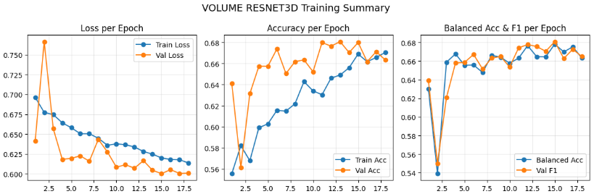

Figure 3.1: Training and validation accuracy and loss curves for 3D ResNet model trained on volume image data.

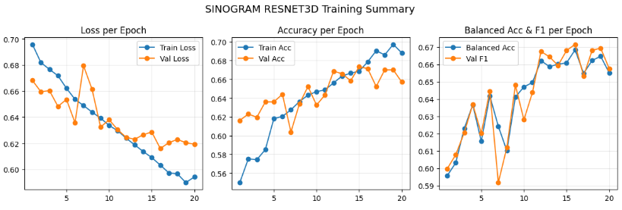

Figure 3.2: Training and validation accuracy and loss curves for 3D ResNet model trained on sinogram data.

3.2 Model Performance
Test-set results are summarized in Table 3.1. The sinogram model achieved a ROC AUC of 0.721 and AP of 0.661, while the volume model achieved an AUC of 0.726 and an AP of 0.647. AUC (0.890) and AP (0.680) p-values were both found to be much larger than 0.05. F1 scores were 0.671 and 0.654, respectively, with a corresponding p-value of 0.384. Figure 3.3 provides a visualization of this summary with error bars indicating the 95% confidence intervals.
 | AUC [95% CI] | AP [95% CI] | Accuracy [95% CI] | F1 [95% CI]
Sinogram Model | 0.721 [0.696-0.747] | 0.661 [0.621-0.700] | 0.615 [0.590-0.639] | 0.671 [0.645-0.697]
Volume Model | 0.726 [0.693-0.753] | 0.647 [0.600-0.694] | 0.627 [0.598-0.655] | 0.654 [0.621-0.684]
P-Value | 0.890 | 0.680 | 0.548 | 0.384

Table 3.1: Test-set model performance parameters

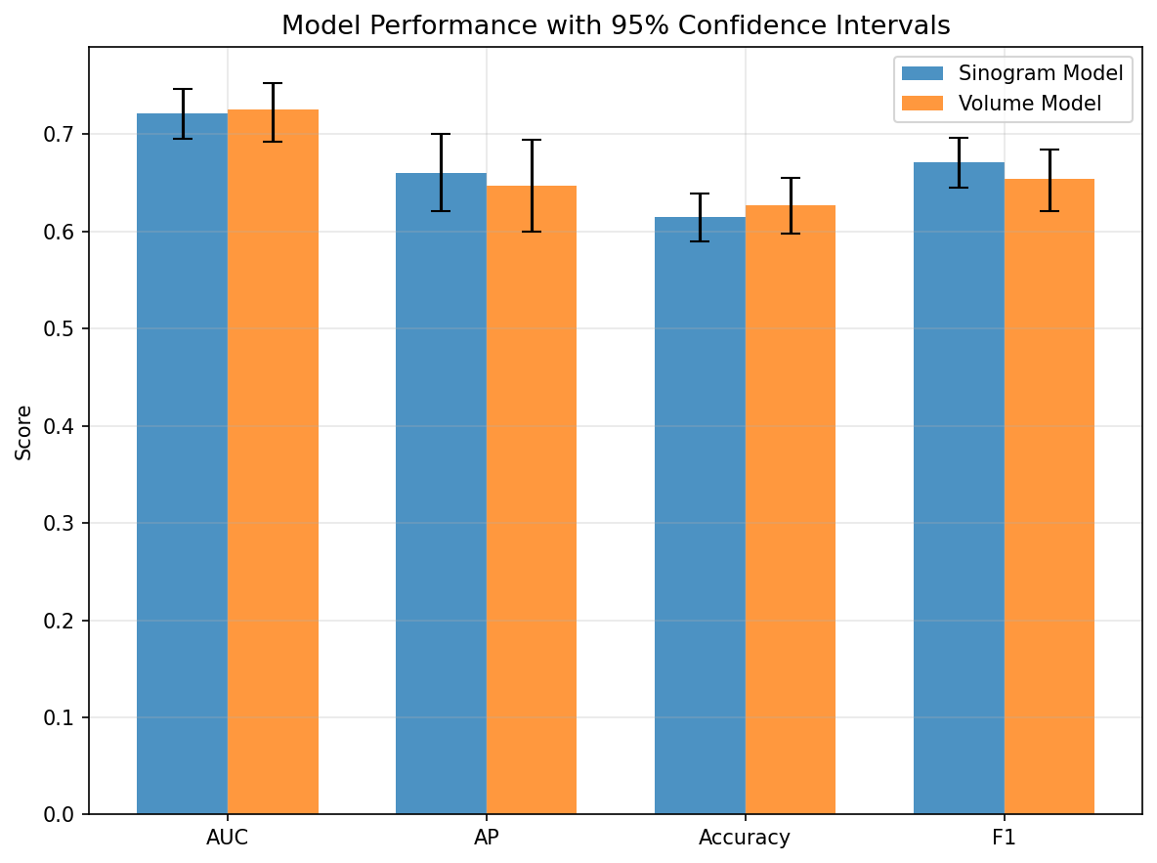

Figure 3.3: Bar chart summarizing model performance with error bars

Figure 3.4 is a radar plot comparing the sinogram-based and reconstructed-volume ResNet3D models across four key performance metrics (AP, ROC AUC, Accuracy, and F1-Score). The models appear balanced, with the sinogram model showing slightly higher F1-Scores and AP, while the volume model showed slightly higher AUC and general accuracy.
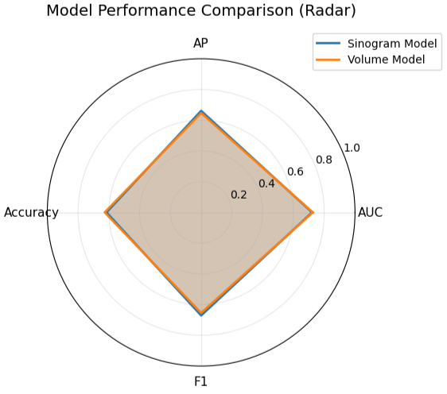

Figure 3.4: Radar plot comparing model performance

Through evaluation on the test subsets, both models show to have achieved similar classification performance, with the sinogram model producing an AUROC of 0.722 (95% CI 0.696–0.747) and the reconstructed-volume model achieving 0.725 (95% CI 0.693–0.753). Additionally, the precision-recall curves show a consistent pattern, with the sinogram model achieving an average precision of 0.662 (95% CI 0.623–0.702) compared to 0.649 (95% CI 0.604–0.696) for the volume model. The ROC and PR curve comparisons are shown in Figures 3.5 & 3.6 below, with the overlapping curves illustrating the minor trade-offs between both models.
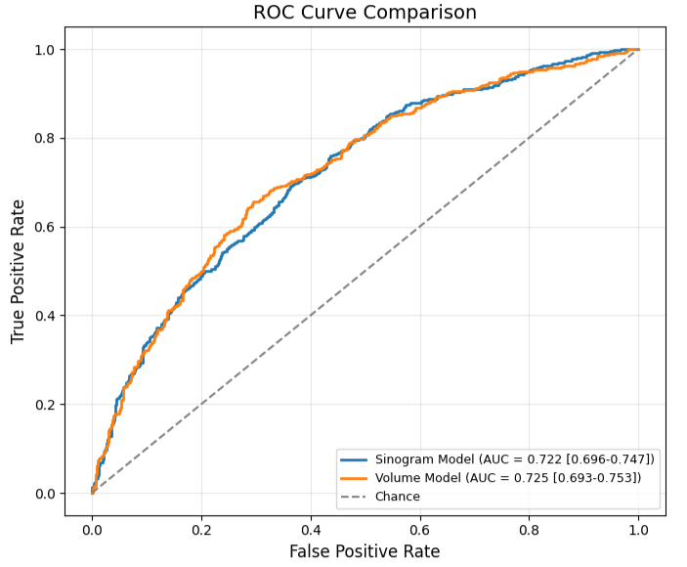

Figure 3.5: ROC Curve Comparison of Sinogram & Volume Models

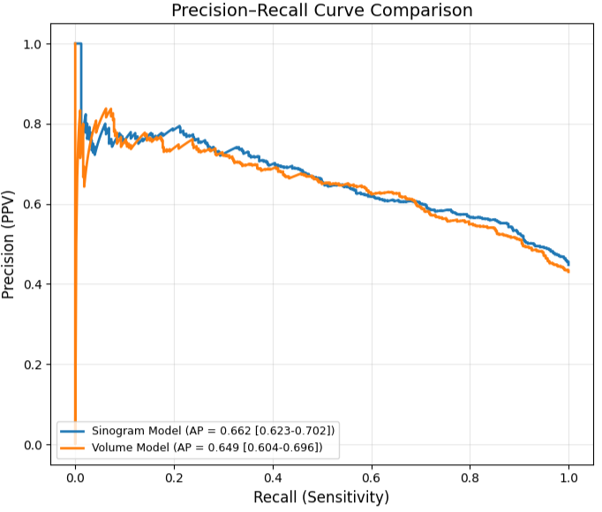

Figure 3.6: PR Curve Comparison of Sinogram & Volume Models

3.3 Threshold and Confusion Analysis
Decision thresholds were optimized based on the maximum F1 score for abnormal classification, as seen in Figures 3.6 & 3.7. The sinogram model achieved its best performance at a threshold of 0.30, while the volume model performed best at a threshold of 0.35.
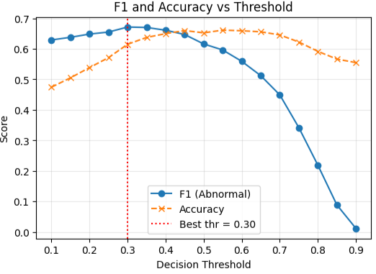
Figure 3.6: Sinogram Training Model - F1 Score & Accuracy vs. Threshold

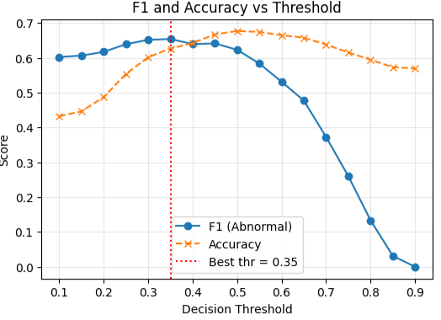

Figure 3.7: Reconstructed CT Volume Training Model - F1 Score & Accuracy vs. Threshold

As shown in Figures 3.8 and 3.9, respectively, the sinogram model correctly identified 325 abnormal and 577 normal cases, but produced more false negatives. In contrast, the volume model correctly identified 316 abnormal and 407 normal cases.
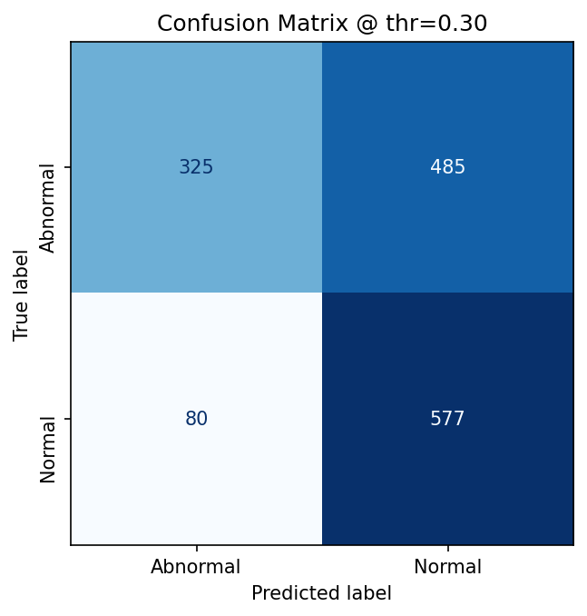

Figure 3.8: Sinogram Model - Confusion Matrix at best threshold = 0.30

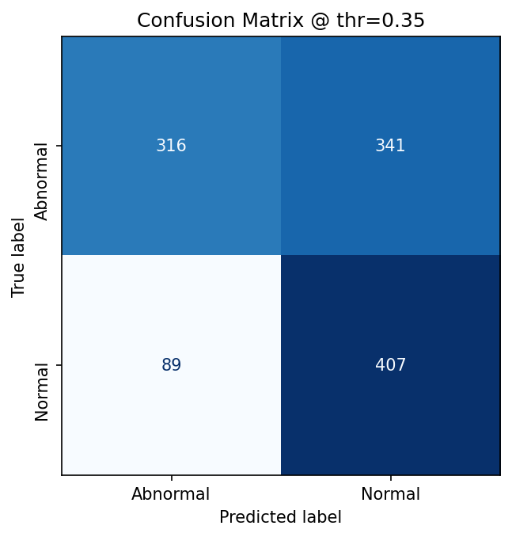

Figure 3.9: Volume Model - Confusion Matrix at best threshold = 0.35

3.6 Calibration
Model calibration was evaluated using temperature scaling on the validation set, as seen in Table 3.2.
 | Calibration Stage | ECE | Brier Score
Sinogram - Pre | Before Temperature Scaling | 0.0468 | 0.2130
Sinogram - Post | After Temperature Scaling | 0.0467 | 0.2119
Volume - Pre | Before Scaling | 0.0419 | 0.2093
Volume - Post | After Scaling | 0.0382 | 0.2094

Table 3.2: Model Pre- & Post-Calibration Metrics
Post-calibration, the sinogram model’s ECE decreased from 0.0468 to 0.0467, and the Brier score improved from 0.2130 to 0.2119. The volume model’s ECE decreased from 0.0419 to 0.0382, and the Brier score increased slightly from 0.2093 to 0.2094.
After temperature scaling and threshold optimization, the calibrated models produced the following results (Figures 3.10 & 3.11).
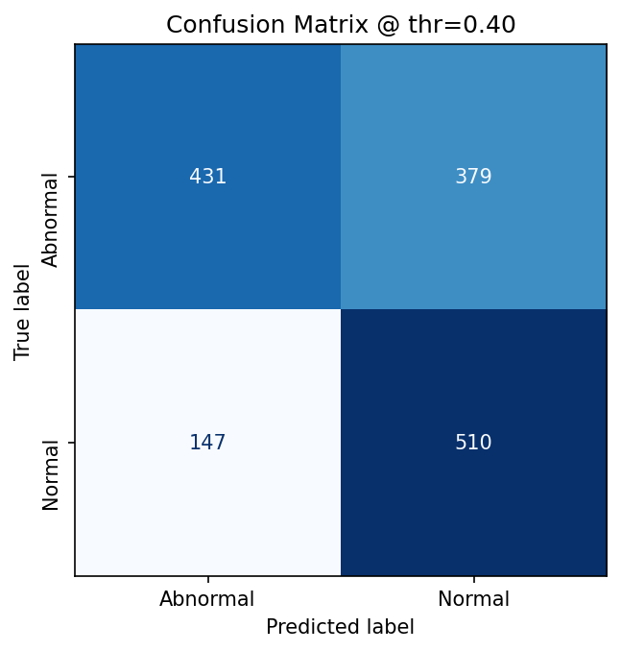

Figure 3.10: Calibrated Sinogram Model - Confusion Matrix at Best Threshold = 0.40

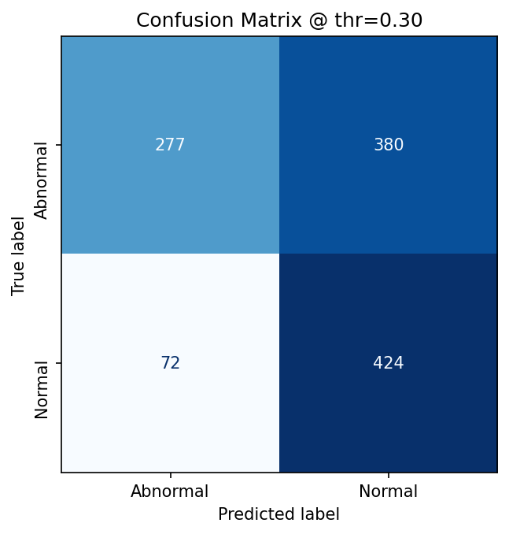

Figure 3.11: Calibrated Volume Model - Confusion Matrix at Best Threshold = 0.30

3.7 Computational Efficiency
Both 3D ResNet model architectures showed similar computational profiles (Table 3.3), with both the sinogram and volume-based models having approximately the same number of FLOPS. The sinogram model achieves a slightly faster average inference time (0.0032s vs. 0.0033s), albeit at the cost of higher memory consumption, approximately 1.280 GB vs. 1.197 GB. In real-time, however, these results are negligible.
Model | Input | Parameters (M) | FLOPs  (G) | Avg Time (s) | Memory (MB) | Relative Speed (%) | Relative FLOPs (%)
Sinogram 3D ResNet | 1×192×192×96 | 33.15 | 11.38 | 0.0032 | 1279.6 | 100 | 100
Volume 3D ResNet | 1×192×192×96 | 33.15 | 11.38 | 0.0033 | 1197.2 | 97 | 100

Table 3.3: Model Computational Efficiency Summary

4 DISCUSSION

4.1 Principal Findings
These results demonstrate that direct classification of head CT sinogram data using a 3D ResNet architecture can achieve the same level of diagnostic performance as that of reconstructed image-domain models. The sinogram-based network architecture achieved an ROC AUC of 0.721 and AP of 0.661, which is fairly close to that of the volume model (AUC = 0.726, AP = 0.647). This suggests that the information for diagnosis is present and accessible within the projection domain. Although the sinogram model displayed slightly more sensitivity and precision, the volume model was marginally more balanced overall, likely due to pre-processing that occurred during the reconstruction phase. Although, p-values being greater than 0.5 for both metrics indicate that the difference is statistically insignificant. Furthermore, both models reflect stable thresholds and probabilities after temperature scaling, as indicated in the relatively consistent ECE and Brier scores across predictions. From a computational efficiency standpoint, neither the sinogram nor image domain significantly introduced latency or memory penalties. While the sinogram model required more epochs for convergence, the pre-batch training and inference times were effectively equivalent, if not faster.

4.2 Implications
These results imply that reconstruction is not strictly necessary for classifying head CT abnormalities, indicating that sinogram data alone is sufficient for effective model training and interpretation by deep learning algorithms.
In terms of computational efficiency, while the per-scan inference differences (0.0032s vs. 0.0033s) and differences in overall memory utilization (approx. 12.80 GB vs. 11.97 GB) are negligible, they show that computation is not more expensive with sinogram-models than it is with reconstructed-image ones. Taking it a step further, these results identify the reconstruction stage as the clinically significant factor impacting pipeline efficiency, rather than the classification stage, since reconstruction typically adds several seconds of processing per slice, consuming substantial GPU and memory bandwidth [40]. Thus, the advantage of sinogram-based models lies not in the speed of the classification model, but in the increasingly simplified and accelerated workflow that results from skipping construction, particularly in high-throughput or time-sensitive environments.
Beyond efficiency, bypassing image reconstruction also reduces data manipulations prior to classification, therefore minimizing the potential propagation of occurring errors downstream into diagnostic models. Traditional CT projection-data reconstruction methods can introduce spatially correlated noise and streak artifacts, amongst others, that degrade overall image quality, particularly in low-dose or motion-affected scans [17], [41], [42]. Moreover, the resulting CT-images are often difficult to correct for scanning-related artifacts such as beam hardening, which can further compromise diagnostic accuracy [42], [43].
Clinically, these findings lead to possibly faster diagnostic triage, reduced hardware demands, potential avoidance of artifact development, and lower energy consumption by eliminating the reconstruction pipeline.

4.3 Limitations
This study is limited in part due to the fact that it solely references the Stanford-SinoCT dataset. Although it contains a relatively large quantity of case studies, the dataset represents scans from a single source and a standardized acquisition protocol. As a result, the generalizability of these results is not guaranteed; The trained CNN models may be learning scanner- or protocol-specific characteristics of abnormality rather than diagnostic features. Additionally, the binary nature of the study, classifying the scans as “normal” or “abnormal” likely masks certain abnormality-specific strengths and limitations in terms of classification and diagnosis. Abnormalities in the dataset encompass more than twenty different disorders, yet label all of them under a single class, which makes it difficult to evaluate the model’s true diagnostic sensitivity (e.g., the difference between hemorrhage & ischemia classification).

4.4 Comparison to Prior Research
Recent research developments, such as MedVAE (Varma et al., 2025), demonstrate how large-scale autoencoders can compress medical images with minimal information loss, thereby leveraging the efficiency of sinogram data downstream [8]. Still, these approaches rely on post-reconstruction data, whereas this work extends the upstream efficiency, placing the necessity of reconstruction itself into question.
Lee et al. (2019), originally established the feasibility of direct CT sinogram-space learning and interpretation via the development of their own sinogram-specific 2D classification CNN methodology, SinoNet [7]. As a baseline, their study used a separate CNN, Inception-v3, on the reconstructed CT images to perform the same classification tasks as SinoNet. However, the same architecture was never applied to both domains. On the other hand, this study builds upon these breakthroughs by extending to the 3D space and conducting a paired, architecture-controlled 3D comparison between sinogram- and image-domain models on the same dataset. While SinoNet demonstrated the 2D feasibility of direct-sinogram-based classification, this study’s approach differs by extending to volumetric inputs and conducting direct head-to-head tests of diagnostic parity (AUROC = 0.7211 vs. 0.7255), further solidifying the evidence that reconstruction may be unnecessary for CT-image classification tasks.
Similarly, Sindhura et al. (2024) proposed an automated approach for detecting and classifying intracranial hemorrhages (ICH) directly from sinograms using a combined CNN-RNN deep learning framework [22]. While their results achieved strong ICH-specific performance, it was limited to a single pathology and required an additional synthesis stage. By contrast, our model approaches a broader abnormal-vs-normal task encompassing multiple pathologies including ICH, and employs a simpler end-to-end 3D CNN, thereby making the results more generalizable and clinically applicable. Finally, this study’s analysis incorporates post-hoc calibration (ECE, Brier Score) and direct computational efficiency profiling, which are not present in prior works.

4.5 Future Research Directions
Further work should extend this study’s framework across multi-center datasets and more diverse classification protocols. Furthermore, deeper investigation into multi-class diagnostic categorization could reveal which abnormalities are best suited for sinogram-based interpretation. Building upon this study, research could also be extended to direct projection data radiomic feature extraction in order to evaluate how bypassing reconstruction might affect the preservation or distortion of quantitative image biomarkers.
For future clinical application, reconstruction-free triage implementation will require rigorous validation to ensure that the smoother workflow does not compromise diagnostic accuracy or require professional oversight. If proven reliable, projection-domain classification models could substantially speed up emergency triage, support telemedicine diagnostics, and make AI-assisted CT analysis accessible in resource-limited settings, where reconstruction hardware or bandwidth are constrained.

5 CONCLUSION
Through this study, direct 3D CNN sinogram-based classification of head CTs has been shown to maintain computational efficiency while achieving comparable classification accuracy to that of reconstructed volume image-domain-based deep learning. These results demonstrate that it is possible to extract diagnostic data features from projection data, which eliminates the need for image reconstruction and reduces the possibility of artifact distortion as well as computational overhead.
In terms of real-time patient triage or prioritization in situations such as stroke, traumatic brain injury, or intracranial hemorrhage, these findings imply that sinogram-domain models could expedite diagnostic workflow, where even a few minutes can mean the difference between life and death. Abnormal scans could be quickly flagged by applying the classification method directly to the CT sinogram data, allowing radiologists and/or emergency physicians to more effectively handle high volumes of critical caseloads.
Sinogram-based classification expands accessibility to AI-assisted diagnostics in low-resource settings, where computational infrastructure and reconstruction hardware are limited or of poor quality, by avoiding reconstruction requirements. Additionally, compared to large constructed volumes, transmitting sinogram data in telemedicine or remote care would shorten transfer times and quicken outside diagnostic help, especially where bandwidth and hardware capacity are a concern, such as in smaller or rural hospitals.
As an industry-based application, this study highlights a possible shift in how CT systems might handle data in the future. CT systems could be built with real-time deep learning classification on top of AI-ready sinogram outputs. In addition to allowing manufacturers to directly integrate AI-based triage into CT scanners, this approach may reduce latency, energy usage, and storage needs associated with reconstruction.
While these are promising results, further study is necessary to validate them across multiple institutions, datasets, and classification protocols, as well as to evaluate the effectiveness of sinogram-based models on specific diagnostic features and disorder subtypes. If the framework is expanded to include multi-class or radiomic analyses, it may clarify how reconstruction-free projection-domain learning can complement or even replace reconstructed-image domain learning in the future.

6 REFERENCES
[1] Stanford University Center for Artificial Intelligence in Medicine & Imaging. “SinoCT Dataset,” Stanford University, Stanford, CA, USA, 2023. [Online]. Available: https://aimi.stanford.edu/datasets/sinoct. DOI: 10.71718/6tfs-tm78.
[2] S. M. Hooper, J. A. Dunnmon, M. P. Lungren, D. Mastrodicasa, D. L. Rubin, C. Ré, A. Wang, and B. N. Patel, “Impact of upstream medical image processing on downstream performance of a head CT triage neural network,” Radiology: Artificial Intelligence, vol. 3, no. 4, e200229, 2021. DOI: 10.1148/ryai.2021200229.
[3] B. De Man, S. Basu, N. Chandra, B. Dunham, P. Edic, M. Iatrou, S. McOlash, P. Sainath, C. Shaughnessy, B. Tower, and E. Williams, “CatSim: A new computer assisted tomography simulation environment,” Proc. SPIE – Int. Soc. Opt. Eng., vol. 6510, 65102G, 2007. DOI: 10.1117/12.710713.
[4] D. P. Kingma and J. L. Ba, “Adam: A method for stochastic optimization,” Int. Conf. Learn. Representations (ICLR), 2015. DOI: 10.48550/arXiv.1412.6980.
[5] Y. Li, K. Li, C. Zhang, J. Montoya, and G. H. Chen, “Learning to reconstruct computed tomography images directly from sinogram data under a variety of data acquisition conditions,” IEEE Trans. Med. Imaging, vol. 38, no. 10, pp. 2469–2481, 2019. DOI: 10.1109/TMI.2019.2910760.
[6] C. Chen, N. A. M. Isa, and X. Liu, “A review of convolutional neural network-based methods for medical image classification,” Computers in Biology and Medicine, vol. 185, p. 109507, 2024. DOI: 10.1016/j.compbiomed.2024.109507.
[7] H. Lee, C. Huang, S. Yune, S. H. Tajmir, M. Kim, and S. Do, “Machine friendly machine learning: Interpretation of computed tomography without image reconstruction,” Scientific Reports, vol. 9, no. 1, 2019. DOI: 10.1038/s41598-019-51779-5.
[8] M. Varma, A. Kumar, R. Van der Sluijs, S. Ostmeier, L. Blankemeier, P. J. M. Chambon, et al., “MedVAE: Efficient automated interpretation of medical images with large-scale generalizable autoencoders,” in Medical Imaging with Deep Learning, 2025. [Online]. Available: https://openreview.net/pdf?id=jNmvKHniMe
[9] H. Lee, J. Lee, H. Kim, B. Cho, and S. Cho, “Deep-neural-network-based sinogram synthesis for sparse-view CT image reconstruction,” IEEE Transactions on Radiation and Plasma Medical Sciences, vol. 3, no. 2, pp. 109–119, 2018. DOI: 10.1109/TRPMS.2018.2882660.
[10] J. Coronado and G. Sheen, “Exploring deep learning methods for head CT triaging,” Stanford University, 2024. [Online]. Available: https://cs231n.stanford.edu/2024/papers/exploring-deep-learning-methods-for-head-ct-triaging.pdf
[11] S. Li, J. Liu, Z. Wang, Z. Cao, Y. Yang, B. Wang, S. Xu, L. Lu, M. I. Saripan, X. Zhang, X. Dong, and D. Wen, “Application of PET/CT-based deep learning radiomics in head and neck cancer prognosis: A systematic review,” Radiology Science, vol. 1, no. 1, 2022. DOI: 10.15212/radsci-2022-0006.
[12] S. Röhrich, J. Hofmanninger, F. Prayer, H. Müller, H. Prosch, and G. Langs, “Prospects and challenges of radiomics by using nononcologic routine chest CT,” Radiology: Cardiothoracic Imaging, vol. 2, no. 4, p. e190190, 2020.DOI: 10.1148/ryct.2020190190.
[13] S. Pai, I. Hadzic, D. Bontempi, K. Bressem, B. H. Kann, A. Fedorov, R. H. Mak, and H. J. W. L. Aerts, “Vision foundation models for computed tomography,” arXiv preprint, 2025. DOI: 10.48550/arxiv.2501.09001.
[14] D. R. Sarvamangala and R. V. Kulkarni, “Convolutional neural networks in medical image understanding: A survey,” Evolutionary Intelligence, vol. 15, no. 1, pp. 1–22, 2021. DOI: 10.1007/s12065-020-00540-3.
[15] K. H. Wu, K. Zeng, M. Y. Shalaginov, and T. H. Zeng, “Brain hemorrhage CT image detection and classification using deep learning methods,” in Proc. IEEE Int. Conf. Bioinformatics and Biomedicine (BIBM), 2024, pp. 5322–5326. DOI: 10.1109/bibm62325.2024.10822353.
[16] D. Zhang, J. Wang, J. H. Noble, and B. M. Dawant, “HeadLocNet: Deep convolutional neural networks for accurate classification and multi-landmark localization of head CTs,” Medical Image Analysis, vol. 61, p. 101659, 2020. DOI: 10.1016/j.media.2020.101659.
[17] L. R. Koetzier, D. Mastrodicasa, T. P. Szczykutowicz, N. R. van der Werf, A. S. Wang, V. Sandfort, et al., “Deep learning image reconstruction for CT: Technical principles and clinical prospects,” Radiology, vol. 306, no. 3, p. e221257, 2023. DOI: 10.1148/radiol.221257.
[18] L. Glaszner and M. Zach, “Bigger isn’t always better: Towards a general prior for medical image reconstruction,” in Proc. DAGM German Conf. Pattern Recognition, Cham, Switzerland: Springer Nature, 2024, pp. 275–291. DOI: 10.1007/978-3-031-85181-0_18.
[19] O. Ronneberger, P. Fischer, and T. Brox, “U-Net: Convolutional networks for biomedical image segmentation,” in Proc. Medical Image Computing and Computer-Assisted Intervention (MICCAI), Cham, Switzerland: Springer International Publishing, 2015, pp. 234–241. DOI: 10.1007/978-3-319-24574-4_28.
[20] M. Zach, E. Kobler, and T. Pock, “Computed tomography reconstruction using generative energy-based priors,” arXiv preprint, arXiv:2203.12658, 2022. [Online]. Available: https://arxiv.org/pdf/2203.12658
[21] S. Chilamkurthy, R. Ghosh, S. Tanamala, M. Biviji, N. G. Campeau, V. K. Venugopal, V. Mahajan, P. Rao, and P. Warier, “Development and validation of deep learning algorithms for detection of critical findings in head CT scans,” arXiv preprint, arXiv:1803.05854, 2018. [Online]. Available: https://arxiv.org/pdf/1803.0585
[22] C. Sindhura, M. Al Fahim, P. K. Yalavarthy, and S. Gorthi, “Fully automated sinogram-based deep learning model for detection and classification of intracranial hemorrhage,” Medical Physics, vol. 51, no. 3, pp. 1944–1956, 2024. DOI: 10.1002/mp.16714.
[23] S. Nizarudeen and G. R. Shanmughavel, “Comparative analysis of ResNet, ResNet-SE, and attention-based RaNet for hemorrhage classification in CT images using deep learning,” Biomedical Signal Processing and Control, vol. 88, p. 105672, 2024. DOI: 10.1016/j.bspc.2023.105672.
[24] A. M. Ceballos-Arroyo, J. Kim, C. H. Lin, L. Qin, G. S. Young, and H. Jiang, “Anatomically-guided masked autoencoder pre-training for aneurysm detection,” arXiv preprint, arXiv:2502.21244, 2025. [Online]. Available: https://arxiv.org/pdf/2502.21244
[25] Y. R. Chen, C. C. Chen, C. F. Kuo, and C. H. Lin, “An efficient deep neural network for automatic classification of acute intracranial hemorrhages in brain CT scans,” Computers in Biology and Medicine, vol. 176, p. 108587, 2024. DOI: 10.1016/j.compbiomed.2024.108587.
[26] S. Xie, X. Zheng, Y. Chen, L. Xie, J. Liu, Y. Zhang, et al., “Artifact removal using improved GoogLeNet for sparse-view CT reconstruction,” Scientific Reports, vol. 8, no. 1, p. 6700, 2018. DOI: 10.1038/s41598-018-25153-w.
[27] Z. Zhang, X. Liang, X. Dong, Y. Xie, and G. Cao, “A sparse-view CT reconstruction method based on combination of DenseNet and deconvolution,” IEEE Transactions on Medical Imaging, vol. 37, no. 6, pp. 1407–1417, 2018. DOI: 10.1109/TMI.2018.2806086.
[28] Q. Zhou, W. Zhu, F. Li, M. Yuan, L. Zheng, and X. Liu, “Transfer learning of the ResNet-18 and DenseNet-121 model used to diagnose intracranial hemorrhage in CT scanning,” Current Pharmaceutical Design, vol. 28, no. 4, pp. 287–295, 2022. DOI: 10.2174/1381612827666211213143357.
[29] M. F. Mushtaq, M. Shahroz, A. M. Aseere, H. Shah, R. Majeed, D. Shehzad, and A. Samad, “BHCNet: Neural network-based brain hemorrhage classification using head CT scan,” IEEE Access, vol. 9, pp. 113901–113916, 2021. DOI: 10.1109/ACCESS.2021.3102740.
[30] N. Anjum, A. N. M. Sakib, and S. M. M. Ahsan, “Classification of brain hemorrhage using deep learning from CT scan images,” in Proc. Int. Conf. Information and Communication Technology for Development (ICICTD 2022), Singapore: Springer Nature, 2023, pp. 181–193. DOI: 10.1007/978-981-19-7528-8_15.
[31] A. Elen, A. Diker, and A. Subasi, “Brain hemorrhage detection using computed tomography images and deep learning,” in Applications of Artificial Intelligence in Medical Imaging, Cambridge, MA: Academic Press, 2023, pp. 283–303. [Online]. Available: https://www.sciencedirect.com/science/article/abs/pii/B9780443184505000141
[32] M. Ammar, M. A. Lamri, S. Mahmoudi, and A. Laidi, “Deep learning models for intracranial hemorrhage recognition: A comparative study,” Procedia Computer Science, vol. 196, pp. 418–425, 2022. DOI: 10.1016/j.procs.2021.12.254.
[33] B. Zheng, C. Huang, X. Chen, and Y. Luo, “Toward head computed tomography image reconstruction standardization with deep-learning-assisted automatic detection,” IEEE Transactions on Instrumentation and Measurement, vol. 73, pp. 1–14, 2023. DOI: 10.1109/TIM.2023.3323395.
[34] H. Kang, A. Kiess, and C. H. Chung, “Emerging biomarkers in head and neck cancer in the era of genomics,” Nature Reviews Clinical Oncology, vol. 12, no. 1, pp. 11–26, 2015. DOI: 10.1038/nrclinonc.2014.192.
[35] M. Fallahpoor, S. Chakraborty, B. Pradhan, O. Faust, P. D. Barua, H. Chegeni, and R. Acharya, “Deep learning techniques in PET/CT imaging: A comprehensive review from sinogram to image space,” Computer Methods and Programs in Biomedicine, vol. 243, p. 107880, 2024. DOI: 10.1016/j.cmpb.2023.107880.
[36] H. Lee, J. Lee, H. Kim, B. Cho, and S. Cho, “Deep-neural-network-based sinogram synthesis for sparse-view CT image reconstruction,” IEEE Transactions on Radiation and Plasma Medical Sciences, vol. 3, no. 2, pp. 109–119, 2018. DOI: 10.1109/TRPMS.2018.2882660.
[37] L. Pei, T. Fang, L. Xu, and C. Ni, “A radiomics model based on CT images combined with multiple machine learning models to predict the prognosis of spontaneous intracerebral hemorrhage,” World Neurosurgery, vol. 181, pp. e856–e866, 2024. DOI: 10.1016/j.wneu.2023.11.065.
[38] C. Guo, G. Pleiss, Y. Sun, and K. Q. Weinberger, “On calibration of modern neural networks,” arXiv preprint, arXiv:1706.04599, 2017. DOI: 10.48550/arXiv.1706.04599.
[39] K. He, X. Zhang, S. Ren, and J. Sun, “Deep residual learning for image recognition,” in Proc. IEEE Conf. Computer Vision and Pattern Recognition (CVPR), Las Vegas, NV, USA, 2016, pp. 770–778. DOI: 10.1109/CVPR.2016.90.
[40] G. Quintana-Ortí, M. Chillarón, V. Vidal, and G. Verdú, “High-performance reconstruction of CT medical images by using out-of-core methods in GPU,” Computer Methods and Programs in Biomedicine, vol. 218, p. 106725, 2022. doi: 10.1016/j.cmpb.2022.106725.
[41] M. Abella, C. Martínez, M. Desco, J. J. Vaquero, and J. A. Fessler, “Simplified statistical image reconstruction for X-ray CT with beam-hardening artifact compensation,” IEEE Transactions on Medical Imaging, vol. 39, no. 1, pp. 111–118, Jun. 2019. doi: 10.1109/TMI.2019.2921929.
[42] Z. Zhang, C. Liu, S. Zhou, X. Yang, R. Loffroy, H. W. Kim, and L. Shan, “Comparative evaluation of deep learning-based and conventional reconstruction techniques for image quality enhancement in low-dose chest computed tomography,” Journal of Thoracic Disease, vol. 17, no. 5, pp. 3249–3258, May 2025, doi: 10.21037/jtd-2025-589.
[43] M. J. Willemink and P. B. Noël, “The evolution of image reconstruction for CT—from filtered back projection to artificial intelligence,” European Radiology, vol. 29, no. 5, pp. 2185–2195, 2019, doi: 10.1007/s00330-018-5810-7.
[44] M. Shafiq-ul-Hassan, G. G. Zhang, D. C. Hunt, K. Latifi, G. Ullah, R. J. Gillies, and E. G. Moros, “Accounting for reconstruction kernel–induced variability in CT radiomic features using noise power spectra,” Journal of Medical Imaging, vol. 5, no. 1, p. 011013, Dec. 2017, doi: 10.1117/1.JMI.5.1.011013.

A ADDITIONAL MATERIALS

A Appendix
epochs | train_loss | val_loss | train_acc | val_acc | val_balacc | val_f1
1 | 0.6957966101 | 0.6681732701 | 0.550036523 | 0.6162235855 | 0.5956874683 | 0.5997347003
2 | 0.6818408947 | 0.6594541611 | 0.5753104456 | 0.6230402181 | 0.6031540673 | 0.6077896429
3 | 0.6766407212 | 0.6603482089 | 0.5744338934 | 0.6196319018 | 0.6229240656 | 0.6205335935
4 | 0.671722461 | 0.6482432281 | 0.5852447042 | 0.63599182 | 0.636732623 | 0.63696646
5 | 0.6621215222 | 0.6535997158 | 0.6182615047 | 0.63599182 | 0.6156012177 | 0.6202360667
6 | 0.6536697068 | 0.6357307314 | 0.6204528853 | 0.6441717791 | 0.6418400135 | 0.6446521218
7 | 0.6488727607 | 0.6794114771 | 0.6276113952 | 0.6039536469 | 0.6242516489 | 0.5917558799
8 | 0.6438995224 | 0.6613293882 | 0.6363769175 | 0.6339468303 | 0.6101555894 | 0.6120643839
9 | 0.6392486371 | 0.6324010973 | 0.6432432432 | 0.6523517382 | 0.6411973617 | 0.6480191776
10 | 0.6336532429 | 0.6380279649 | 0.6468955442 | 0.6325835037 | 0.6470150516 | 0.6279973029
11 | 0.6296352783 | 0.630435455 | 0.6487947407 | 0.6434901159 | 0.6495602909 | 0.6438125149
12 | 0.6238867819 | 0.6245066065 | 0.6562454346 | 0.6687116564 | 0.662193472 | 0.6675023233
13 | 0.618762582 | 0.623069746 | 0.6635500365 | 0.6659850034 | 0.6587180788 | 0.6643789186
14 | 0.61368432 | 0.6265679341 | 0.6666179693 | 0.6584867076 | 0.6601217656 | 0.6594176713
15 | 0.6090627099 | 0.6286364076 | 0.6686632579 | 0.6734832993 | 0.6609081684 | 0.6680146141
16 | 0.6033138415 | 0.6160249809 | 0.6785975164 | 0.6714383095 | 0.6684001353 | 0.6716171551
17 | 0.597340099 | 0.62040497 | 0.6904309715 | 0.6523517382 | 0.6548537122 | 0.6532775641
18 | 0.5966234267 | 0.6229880371 | 0.6860482104 | 0.670074983 | 0.6622780315 | 0.6681592097
19 | 0.5898922581 | 0.6203980716 | 0.6972972973 | 0.670074983 | 0.6647217994 | 0.6694141248
20 | 0.5942548351 | 0.6193073046 | 0.6880934989 | 0.657123381 | 0.6551496702 | 0.6576371248

Table A.1: Sinogram ResNet3D Model Training Data

epochs | train_loss | val_loss | train_acc | val_acc | val_balacc | val_f1
1 | 0.689156274 | 0.6426516435 | 0.5525200877 | 0.6380368098 | 0.623634365 | 0.6304564564
2 | 0.665418311 | 0.6510932228 | 0.6062819576 | 0.6209952284 | 0.6346524607 | 0.6168285994
3 | 0.6517525204 | 0.6389631754 | 0.6243973703 | 0.6489434219 | 0.6523422966 | 0.6498012251
4 | 0.6422830629 | 0.623440899 | 0.6452885318 | 0.6632583504 | 0.6614239811 | 0.6637789224
5 | 0.6356475661 | 0.6343522557 | 0.6487947407 | 0.6632583504 | 0.6480551328 | 0.6550484981
6 | 0.6294931705 | 0.6432958137 | 0.6534696859 | 0.6475800954 | 0.6505327245 | 0.6484838098
7 | 0.6231838257 | 0.6256250383 | 0.6579985391 | 0.6414451261 | 0.6518772197 | 0.6398774033
8 | 0.6144693432 | 0.6224060803 | 0.6634039445 | 0.6762099523 | 0.6569085067 | 0.6631104528
9 | 0.6084403666 | 0.6215656057 | 0.6727538349 | 0.6591683708 | 0.6440639269 | 0.6510200565
10 | 0.5996814749 | 0.611433561 | 0.6860482104 | 0.654396728 | 0.6611618468 | 0.6545383705
11 | 0.5930073616 | 0.6089525943 | 0.6853177502 | 0.651670075 | 0.658836462 | 0.651670075
12 | 0.5798641759 | 0.6162883625 | 0.6929145362 | 0.6639400136 | 0.6722475901 | 0.6635748894
13 | 0.5684150674 | 0.6319826279 | 0.7032870709 | 0.670074983 | 0.6529342128 | 0.6596855784

Table A.2: Sinogram DenseNet3D Model Training Data

epochs | train_loss | val_loss | train_acc | val_acc | val_balacc | val_f1
1 | 0.6964934995 | 0.6414576946 | 0.5556774547 | 0.6410034602 | 0.629945122 | 0.6390300787
2 | 0.67728538 | 0.7666233197 | 0.5821905284 | 0.5614186851 | 0.5391341463 | 0.5500341779
3 | 0.674643396 | 0.6569181538 | 0.5679283233 | 0.6314878893 | 0.6588963415 | 0.6208659855
4 | 0.6642154325 | 0.6181646508 | 0.5991954654 | 0.6574394464 | 0.6677317073 | 0.658013765
5 | 0.6580131905 | 0.6194011904 | 0.602852441 | 0.6574394464 | 0.6556036585 | 0.6586009917
6 | 0.6504437887 | 0.6225375811 | 0.6156518559 | 0.6738754325 | 0.6558170732 | 0.6672114146
7 | 0.6504630683 | 0.6157913161 | 0.6149204608 | 0.6505190311 | 0.6478414634 | 0.6515688286
8 | 0.6447221442 | 0.643356037 | 0.6218687146 | 0.6617647059 | 0.6660731707 | 0.6632790668
9 | 0.6358748901 | 0.6275533049 | 0.6428963247 | 0.6634948097 | 0.6642682927 | 0.6649461474
10 | 0.6377031902 | 0.6082540197 | 0.6341195831 | 0.6522491349 | 0.6576890244 | 0.6537098347
11 | 0.6365712591 | 0.6113203797 | 0.6304626074 | 0.6799307958 | 0.6632926829 | 0.6743764605
12 | 0.6337596684 | 0.6070390975 | 0.6461876029 | 0.6764705882 | 0.676652439 | 0.6777905586
13 | 0.6280171002 | 0.6164999112 | 0.6491131834 | 0.6807958478 | 0.6647682927 | 0.6756803606
14 | 0.6247296812 | 0.604335884 | 0.6560614372 | 0.6704152249 | 0.6646585366 | 0.6705304479
15 | 0.6198874172 | 0.6001299304 | 0.6690437009 | 0.6799307958 | 0.6782743902 | 0.680976761
16 | 0.6180479249 | 0.6051176828 | 0.6617297495 | 0.6617647059 | 0.6698780488 | 0.6628375953
17 | 0.6176073144 | 0.600324023 | 0.6657524227 | 0.6712802768 | 0.6754085366 | 0.6727665613
18 | 0.6135197635 | 0.6007807243 | 0.6705064911 | 0.6634948097 | 0.6633170732 | 0.6648544795

Table A.3: Reconstructed CT Volume ResNet3D Model Training Data

Model | LastValACC | PredAinf | Slope
densenet3d | 0.6789366053 | 1 | 0.01465576005
resnet3d | 0.6646216769 | 0.9999999995 | 0.007327880027
mobilenet3d | 0.6632583504 | 0.6612017874 | 0.003919563736
efficientnet3d | 0.651670075 | 0.6005093125 | 0.03527607362

Table A.4: Model Comparison for Sinogram Training
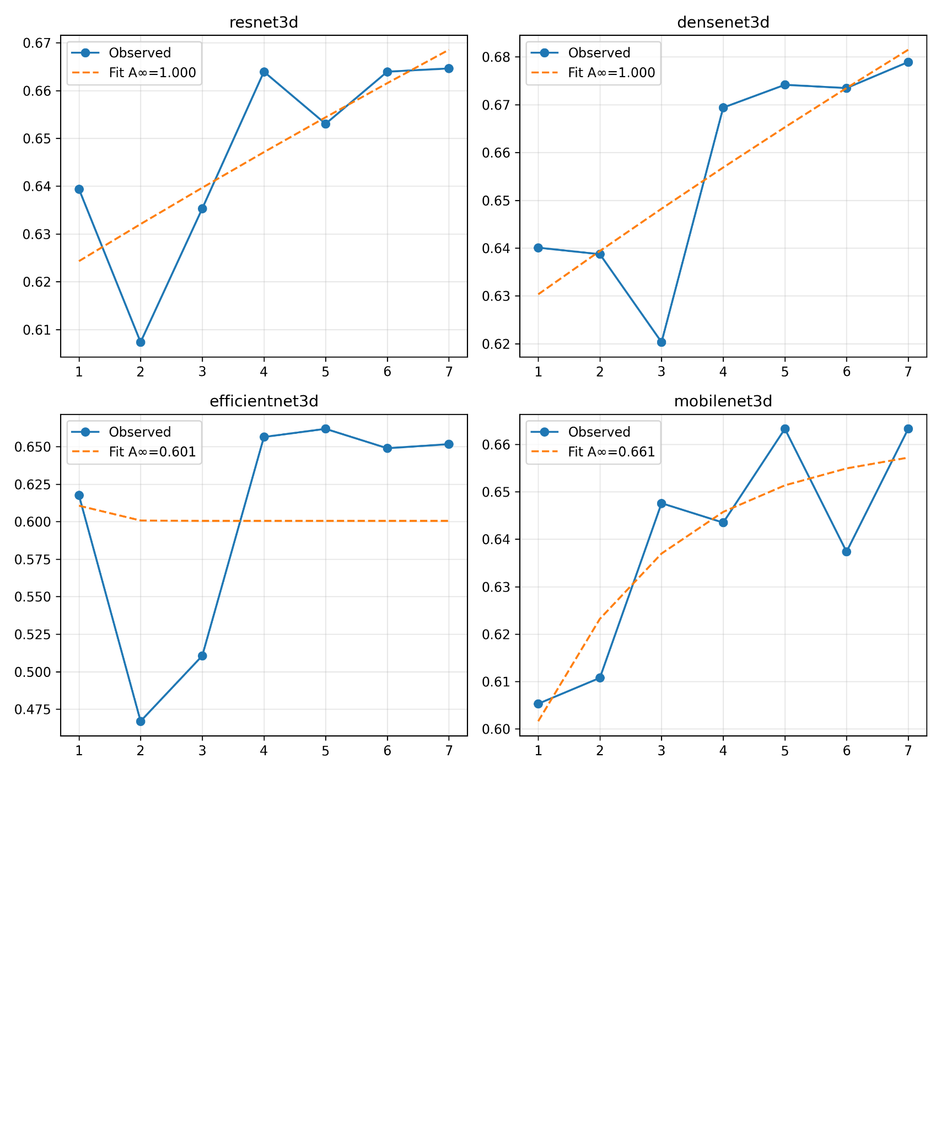

Figure A.1: Model Comparison for 7-Epoch Sinogram Training

