Maryan Mendoza

100512079

Table of contents

1.1 Purpose of the test plan document. 3

1.2 Description 3

2. Scope 3

3. Testing methodology 3

4. Test approach 3

5. Testing types. 4

6. Final test report 9

7. Debbugging 10

### 1.1 Purpose of the test plan document.

This document has the purpose of planning the testing of the functionality , the usability and the performance of the mobile app game **Three on a Row** basing on the requirements set in the assigment.

In order to identify the errors that this software may present to the user the method that is going to be used is the black box and white box testing .

### 1.2 Description

The three on a row mobile app is a game that is meant to allow the user to change the color of the tiles of a grid in a determined time. The main goal is to avoid having three of the same color in a row.

### 2. Scope

The testing will evaluate the performance of the software in the following aspects :

-Display and functionality of the settings activity

-Display and functionality of the help activity

-Display and functionality of the home screen

-Display and fucntionality of the game activity

### 3. Testing methodology

The testing methodology that is going to be used for this project is agile due that is planned to be performed in three phases of the project.

### 4. Test approach

The application will be tested three different emulators from Adroid studio.

|  |  |  |  |  |
| --- | --- | --- | --- | --- |
| Emulator | Licence | Platform | Android version | Requisites |
| Android sdk | Free | Mac os x | 4.1 Jelly Bean | -Java developmet kit  -android standard developmet kit  -Android virtual device  -Android –x86_64  -Minimun 8GB ram memory |
| Android sdk | Free | Mac os x | 5.0 lollipop | -Java developmet kit  -android standard developmet kit  -Android virtual device  -Android –x86_64  -Minimun 8GB ram memory |
| Android sdk | Free | Mac os x | 7.0 Nougat | -Java developmet kit  -android standard developmet kit  -Android virtual device  -Android –x86_64  - Minimun 8GB ram memory |

### 5. Testing types.

The types of testing that are going to be performed are :

**-Functionality**

in this part of the testing the aim is to test the basic functionality of the application like navigation between pages, functionality of the main menu, and the requirements defined by the client.

-**Usability**

The usability is going to test how the color schema, the messages display to the client when the user wins or losses the game, how helpfull is the help screen, how intuitive is the navigation.

-**Performance**

Taking into account that the performance of the app may vary in each phone depending on how many apps the user has running , the connectivity , the system that is runing on .The three in a row app performance is going to be tested in a normal working environment of a phone with no connectivity issues, only running one app, The apects of performance that are going to be tested are :

-memory leaks

-CPU memory usage

-Power comsumption

-Speed.

**Testing levels**

White box – static

Black box

**Roles and responsabilities**

Maryan Mendoza Developer

Jimmy Tresintis - Cient

|  |  |
| --- | --- |
| **Author** | Maryan Mendoza |
| **Software tested** | Three in a row |
| Testing type | Black box /functionality  White box/ logic, performance |
| Date |  |
| Tested By : |  |

|  |  |  |  |
| --- | --- | --- | --- |
| Test case id :TOR1 | | | |
| **Teste case description** | Test the navigation of the menu | | |
| **Related requirements** | Run the application | | |
| **Test procedure** | **Expected result** | **Result** | **Status** |
| Click the menu on the settings button of the first screen | Display the settings activity  Macintosh HD:Users:maryanmendozanunez:Desktop:settingsMenu.png |  |  |
| Being on the settings activity click on the home menu | Display the home activity | x | The menu does not work in the settings activity |
| Being on the settings activity click on the help menu | Display the help activity | x | The menu does not work in the settings activity |
| Click in the help menu of the first screen | Display the help activity  Macintosh HD:Users:maryanmendozanunez:Desktop:helpmenuScreen.png |  |  |
| Beign on the help activity click on the home menu | Display the home activity | x | The menu does not work in the help activity |
| Beign on the help activity click on the settings activity | Display the settings activity | x | The menu does not work in the help activity |

|  |  |  |  |
| --- | --- | --- | --- |
| Test case id :TOR2 | | | |
| **Teste case description** | Test navigation /functionality of the buttons and the result of the game activity of the application | | |
| **Related requirements** | Run the application | | |
| **Test procedure** | **Expected result** | **Result** | **Status** |
| Click on the start game button | Display the screen that contains a grid with grey squares, two white squares , two red squares and a button to reset the game.  Macintosh HD:Users:maryanmendozanunez:Desktop:Captura de pantalla 2016-11-27 a las 5.32.49 p.m..png |  | OK |
| Choose different levels. Selecting the difficulty on the settings menu.  Select 5x5 and difficult | The game displays an activity according to the level that the user selects. The user can select easy and difficult timer and change the grid from 4X4 to 5X5.  Selecting 5x5 and difficult a screen like the right screen must appear  Macintosh HD:Users:maryanmendozanunez:Desktop:difficulty.png |  |  |
| Play the game | The tiles change the color when the user clicks on them, the tiles can only change the color once, a message with the next color will appear every time a tile is clicked.  This screen shows the game at the second 42 and then the screen at the secont 33 after the user has clicked some tiles.  Macintosh HD:Users:maryanmendozanunez:Desktop:pantallaAntesYdespues.png |  |  |
| Click the reset button | Display the screen that contains a grid with grey squares , two white squares , two red squares and a button to reset the game. | * x | Partially working |

|  |  |  |  |
| --- | --- | --- | --- |
| Test case id :TOR3 | | | |
| **Teste case description** | Test usability in all the activities | | |
| **Related requirements** | Run the application | | |
| **Test procedure** | **Expected result** | **Result** | **Status** |
| Test the application logo, run the app | Display the app logo in the homescreen  Macintosh HD:Users:maryanmendozanunez:Desktop:Captura de pantalla 2016-11-27 a las 5.07.12 p.m..png |  |  |
| Test the message when the user fails | Display a message when the game is over  Macintosh HD:Users:maryanmendozanunez:Desktop:Captura de pantalla 2016-11-27 a las 5.09.40 p.m..png |  |  |
| Test the message when the user wins | Display a message when the user wins  Macintosh HD:Users:maryanmendozanunez:Desktop:Captura de pantalla 2016-11-27 a las 5.14.46 p.m..png |  |  |
| Click on the help screen | The help screen provides relevant information for the users on how to play the game.  Macintosh HD:Users:maryanmendozanunez:Desktop:Captura de pantalla 2016-11-27 a las 5.18.27 p.m..png |  |  |
| Start the game and click on a grey tile | When clicking each grid a message with the next color appears  Macintosh HD:Users:maryanmendozanunez:Desktop:Captura de pantalla 2016-11-27 a las 5.24.10 p.m..png |  |  |
| Check how intuitive is the navigation of the app | The user must not take more that three seconds in find the option that is looking for, the menu should be located in a position where is visible, the buttons are clear on the actions that they performe. | x |  |
| Check color usability | The color of the application should be according to the target of the application and the nature of the game. |  |  |

|  |  |  |  |
| --- | --- | --- | --- |
| Test case id :TOR4 | | | |
| **Teste case description** | Test the settings activity functionality/usability | | |
| **Related requirements** | Run the application /click on the settings menu | | |
| **Test procedure** | **Expected result** | **Result** | **Status** |
| Change the timer to difficult and play the game | The timer increases or decreases the amount of time acoording to the user selection.  In this case the timer will be set to 30 seconds    Macintosh HD:Users:maryanmendozanunez:Desktop:Captura de pantalla 2016-11-27 a las 7.45.37 p.m..png |  |  |
| Change the size of the grid to 5x5 and play the gamr | The app starts a new game with the new size of the grid.  Macintosh HD:Users:maryanmendozanunez:Desktop:Captura de pantalla 2016-11-27 a las 7.46.00 p.m..png |  |  |
| Change the color of the grid to blue and orange | The app starts a new game with the new color.  Macintosh HD:Users:maryanmendozanunez:Desktop:Captura de pantalla 2016-11-27 a las 7.46.19 p.m..png |  |  |

### 6. Final test report

|  |  |  |  |  |
| --- | --- | --- | --- | --- |
| **List of bugs** | | | | |
| Tester : | Maryan Mendoza | | | |
| Date : | 27-11-2016 | | | |
| Test case id : |  | | | |
| Test case | description | Error | Date Retested | Ok ? |
| TOR01 | Being on the settings activity click on the home menu | The menu is not displayed in the settings activity |  |  |
| TOR01 | Being on the settings activity click on the help menu | The menu is not displayed in the settings activity |  |  |
| TOR01 | Beign on the help activity click on the home menu | The menu is not displayed in the help activity |  |  |
| TOR01 | Beign on the help activity click on the settings activity | The menu is not displayed in the help activity |  |  |
| TOR2 | Test the reset button  Display the screen that contains a grid with grey squares , two white squares , two red squares and a button to reset the game. | When clicking the button sometimes does not generate the four color squares |  |  |
| TOR3 | Check how intuitive is the navigation of the app | The menu is not working in the game, settings and help activities |  |  |

### 7. Debbugging

#### Runtime errors and log info messages

1.This error occurs because there was not default grid assigned to the activity,so if the user did not select the grid size in the settings the app chushed. To fixed that a default grid was given to the app.

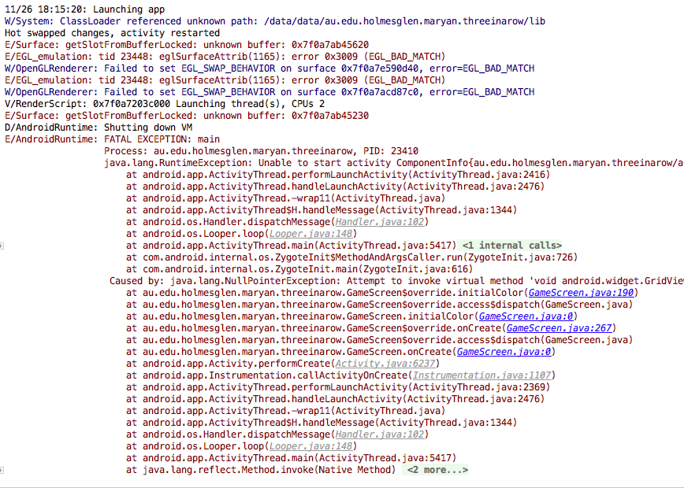

#### Performance

|  |  |
| --- | --- |
| Memory and cpu used running the application, loading the main screen. | |
| Version 2 | Version 3 |
| Macintosh HD:Users:maryanmendozanunez:Desktop:Captura de pantalla 2016-11-25 a las 8.22.42 p.m..png | Macintosh HD:Users:maryanmendozanunez:Desktop:Captura de pantalla 2016-11-27 a las 8.48.09 p.m..png |
| In comparison with the version two the version three takes more memory space. | |

|  |  |
| --- | --- |
| Memory and cpu playing the game and the user loses the game | |
| Version 2 | Version 3 |
| Macintosh HD:Users:maryanmendozanunez:Desktop:Captura de pantalla 2016-11-25 a las 8.23.44 p.m..png | Macintosh HD:Users:maryanmendozanunez:Desktop:Captura de pantalla 2016-11-27 a las 8.57.56 p.m..png |
| In version one the memory usage was less 2,87 | In version 3 the memory usage incremented 3,7 MB |

|  |  |
| --- | --- |
| Memory and cpu playing the game and wining the game | |
| Version 2 | Version 3 |
| Macintosh HD:Users:maryanmendozanunez:Desktop:Captura de pantalla 2016-11-25 a las 8.25.02 p.m..png | Macintosh HD:Users:maryanmendozanunez:Desktop:Captura de pantalla 2016-11-27 a las 9.02.47 p.m..png |
| The memory allocated in version 2 is 3,19 in version three it had an increment of 1,41MB | |

|  |  |
| --- | --- |
| Memory and cpu loading the help | |
| Version 2 | Version 3 |
| Macintosh HD:Users:maryanmendozanunez:Desktop:Captura de pantalla 2016-11-25 a las 8.26.22 p.m..png | Macintosh HD:Users:maryanmendozanunez:Desktop:Captura de pantalla 2016-11-27 a las 9.09.57 p.m..png |
| The memory allocated in version 2 is 3,26 in version three it had an decrease 0,12 MB to 3,14MB | |

|  |  |
| --- | --- |
| Memory and cpu changing the color and restarting the game | |
| Version2 | Version3 |
| Macintosh HD:Users:maryanmendozanunez:Desktop:Captura de pantalla 2016-11-25 a las 8.27.49 p.m..png | Macintosh HD:Users:maryanmendozanunez:Desktop:Captura de pantalla 2016-11-27 a las 9.13.00 p.m..png |
| The memory allocated in version 2 is 3,90 in version 3 it had an decrease 8 MB to 3,81MB | |