
Maryam
31-May
202509001

GitHub Link: https://github.com/maryanmudaffar/IT9201-Rain-Prediction
Table of Contents
TASK 1 PROBLEM DEFINITION, LITERATURE REVIEW & ENVIRONMENTAL SETUP 3
1.1 Problem Statement & Research Question 3
1.2 Literature Review — PRISMA Systematic Search 4
1.3 Environmental Setup 4
TASK 2 ML FRAMEWORK, DATA ACQUISITION & PRE-PROCESSING 5
2.1 Dataset Description 5
2.2 Pre-Processing Pipeline 7
2.3 Feature Engineering 7
TASK 3 FEATURE SELECTION, LEARNING METHODS & EVALUATION STRATEGIES 8
3.1 Feature Selection — Mutual Information 8
3.2 Machine Learning Algorithms 9
3.3 Evaluation Metrics & Strategy 9
TASK 4 HYPERPARAMETER OPTIMISATION & RESULTS 10
4.1 Baseline vs Tuned — Full Comparison 10
4.2 Decision Threshold Optimisation 11
4.3 Final Model Performance 11
TASK 5 DISCUSSION, EXPLAINABILITY, OPTIMISATION & FUTURE EXTENSIONS 14
5.1 Critical Analysis of Results 14
5.2 Explainable AI — SHAP: Global Feature Importance 14
5.3 Explainable AI — LIME: Local Explanation 15
5.4 SHAP vs LIME — Agreement Analysis 15
5.5 Optimisation — Learning Rate Analysis 16
5.6 Limitations & Future Extensions 17
5.7 No-Code Analysis — Orange Unsupervised K-Means 18
5.8 Use of Generative AI 19
Appendix 1: Weekly log 20
Appendix 2. Huwawi course certificate 21
REFERENCES 21

TASK 1 PROBLEM DEFINITION, LITERATURE REVIEW & ENVIRONMENTAL SETUP

1.1 Problem Statement & Research Question
Rainfall prediction is an important problem in meteorology because it affects many areas such as agriculture, aviation, emergency planning, urban development, and everyday life. This project focuses on predicting whether it will rain the next day in Australia using historical weather data. It is a supervised binary classification problem, where the target variable RainTomorrow is either Yes (1) or No (0), meaning the output is a category rather than a continuous value.
A major challenge in this dataset is class imbalance. About 77.6% of the data shows no rain, while only 22.4% shows rain. This means a simple model that always predicts “No Rain” could achieve over 77% accuracy but would fail to detect actual rain events. In practice, missing a real rain event (false negative) is more serious than giving a false alarm. Therefore, Recall and F1-score are used as the main evaluation metrics instead of accuracy. To handle the imbalance, techniques such as class_weight='balanced' and scale_pos_weight are applied.
The dataset includes 145,460 daily weather records from 49 Australian weather stations, covering the period from November 2007 to June 2017. After removing records with missing target values, 142,193 clean records remain. The data originally has 23 meteorological features (e.g., temperature, rainfall, wind speed, humidity, pressure, and cloud cover), which increase to 30 features after feature engineering.
The full workflow—from data preprocessing and feature engineering to model training, tuning, explainability, and optimization—is implemented in Python 3.13 using Jupyter Notebook.
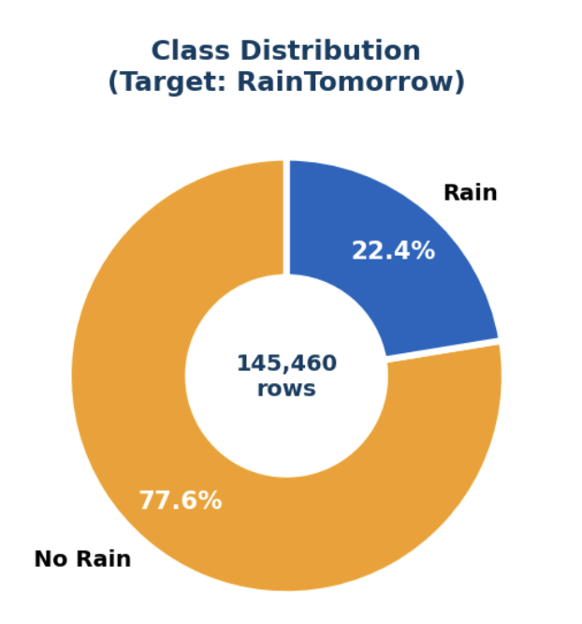
Figure 1. Class Distribution — RainTomorrow. No Rain = 77.6% (110,316), Rain = 22.4% (31,877).

1.2 Literature Review — PRISMA Systematic Search
A PRISMA-based literature review was conducted using Google Scholar, IEEE Xplore, and ResearchGate with relevant keywords, selecting studies published in English (2018–2024) that used supervised ML on weather data with reported metrics. From 130 records, 35 duplicates were removed (95 left), 65 were excluded after screening (30 full texts assessed), and 25 were removed (deep learning only, no metrics, or proprietary data), leaving 5 high-quality studies.
Key findings show that Random Forest and ensemble models perform best, Decision Trees improve with proper depth control, and Humidity3pm and Pressure3pm are consistently the strongest predictors. Prior work also highlights improved minority-class recall with ensembles and GridSearchCV optimisation. The main gap is the lack of XGBoost and the absence of a unified pipeline combining feature engineering, explainability (SHAP/LIME), and optimisation on the weatherAUS dataset — which this project addresses.

# | Author(s) | Year | Algorithm | Key Finding
1 | Kumari & Srivastava | 2021 | Random Forest | RF 92% accuracy; ensemble depth is key hyperparameter
2 | Ahmed et al. | 2022 | LR vs Decision Tree | DT outperforms LR on imbalanced weather data
3 | Navlani | 2019 | Multiple classifiers | Benchmark on weatherAUS — Humidity3pm top predictor
4 | Ortiz-Garcia et al. | 2020 | SVM + Ensemble | Ensemble improves minority-class recall significantly
5 | Dutta et al. | 2021 | LR, DT, RF, KNN | RF + GridSearchCV best F1 on rainfall datasets
Table 1. PRISMA Literature Review — 5 Selected Studies

1.3 Environmental Setup
Component | Library / Tool | Purpose
Language | Python | Core programming environment
Environment | Jupyter Notebook | Interactive development
ML Framework | Scikit-learn | All 4 classifiers, preprocessing, metrics
Boosting | XGBoost | Gradient boosting classifier
Explainability | SHAP | Exact Shapley values — global + local
Explainability | LIME | Local linear surrogate explanations
Visualisation | Matplotlib / Seaborn | All charts and figures
No-Code | Orange 3 | Unsupervised K-Means clustering
Dataset | weatherAUS.csv (Kaggle) | Rain in Australia — 145,460 rows
Table 2. Environmental Setup — Libraries, Tools and Versions

TASK 2 ML FRAMEWORK, DATA ACQUISITION & PRE-PROCESSING

2.1 Dataset Description
GitHub Link: https://github.com/maryanmudaffar/IT9201-Rain-Prediction
The Rain in Australia dataset (weatherAUS.csv) comes from Kaggle and was originally collected by the Australian Bureau of Meteorology. It includes 145,460 daily records from 49 weather stations over 10 years with 23 weather-related features and the target variable RainTomorrow.
After removing rows with missing target values, 142,193 clean records remained, with all other missing values handled through imputation. The data is split into 80% training and 20% testing using stratified sampling to preserve the class distribution.
A key challenge is the class imbalance (77.6% No Rain vs. 22.4% Rain), which makes rain harder to detect. To address this, imbalance handling methods such as class_weight='balanced' and scale_pos_weight are applied in the models
Property | Value
Source | Kaggle — Rain in Australia (weatherAUS.csv)
Origin | Australian Bureau of Meteorology
Raw records | 145,460 daily observations
After cleaning | 142,193 rows | 0 missing values
Train set | 113,754 samples (80%) — stratified
Test set | 28,439 samples (20%) — stratified
Raw features | 23 meteorological variables
After engineering | 30 features (+ 7 engineered + Month + Season)
Class distribution | No Rain: 77.6% (110,316) | Rain: 22.4% (31,877)
Problem type | Supervised Binary Classification
Date range | 10 years
Weather stations | 49 locations across Australia
Table 3. Dataset Properties Summary. Highlighted rows indicate the two key characteristics: class imbalance and problem type.
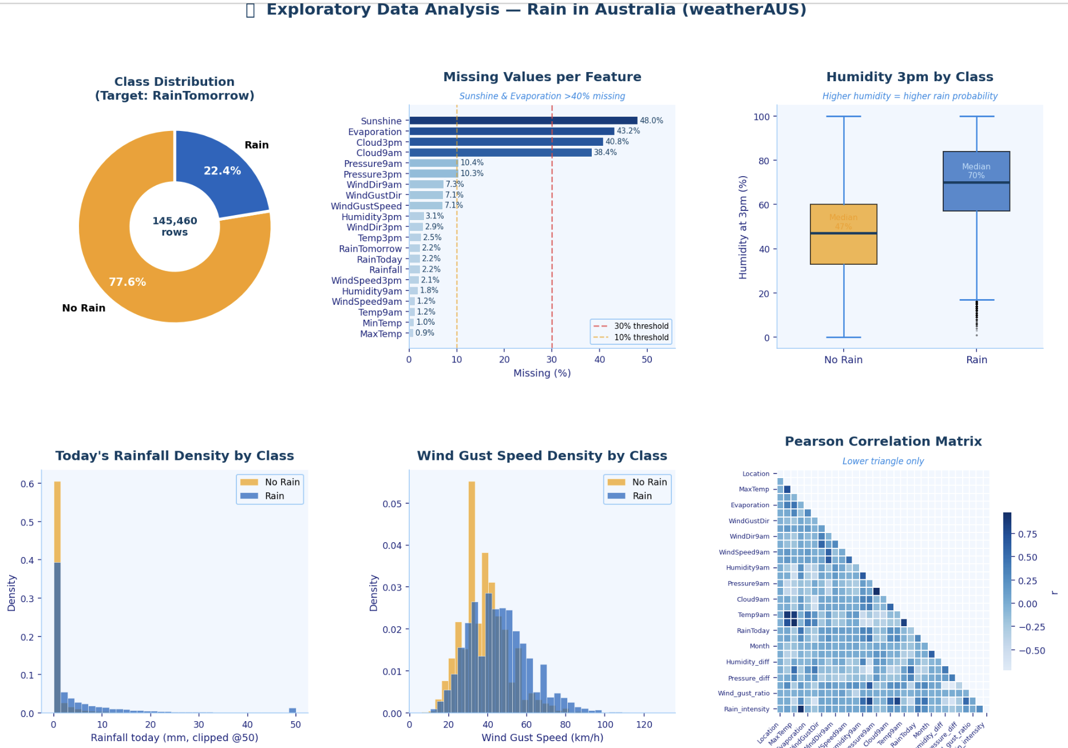
Figure 2. Exploratory Data Analysis — Class distribution, missing values heatmap, and feature distributions (Humidity3pm, Pressure3pm, WindGustSpeed, Sunshine) split by RainTomorrow.

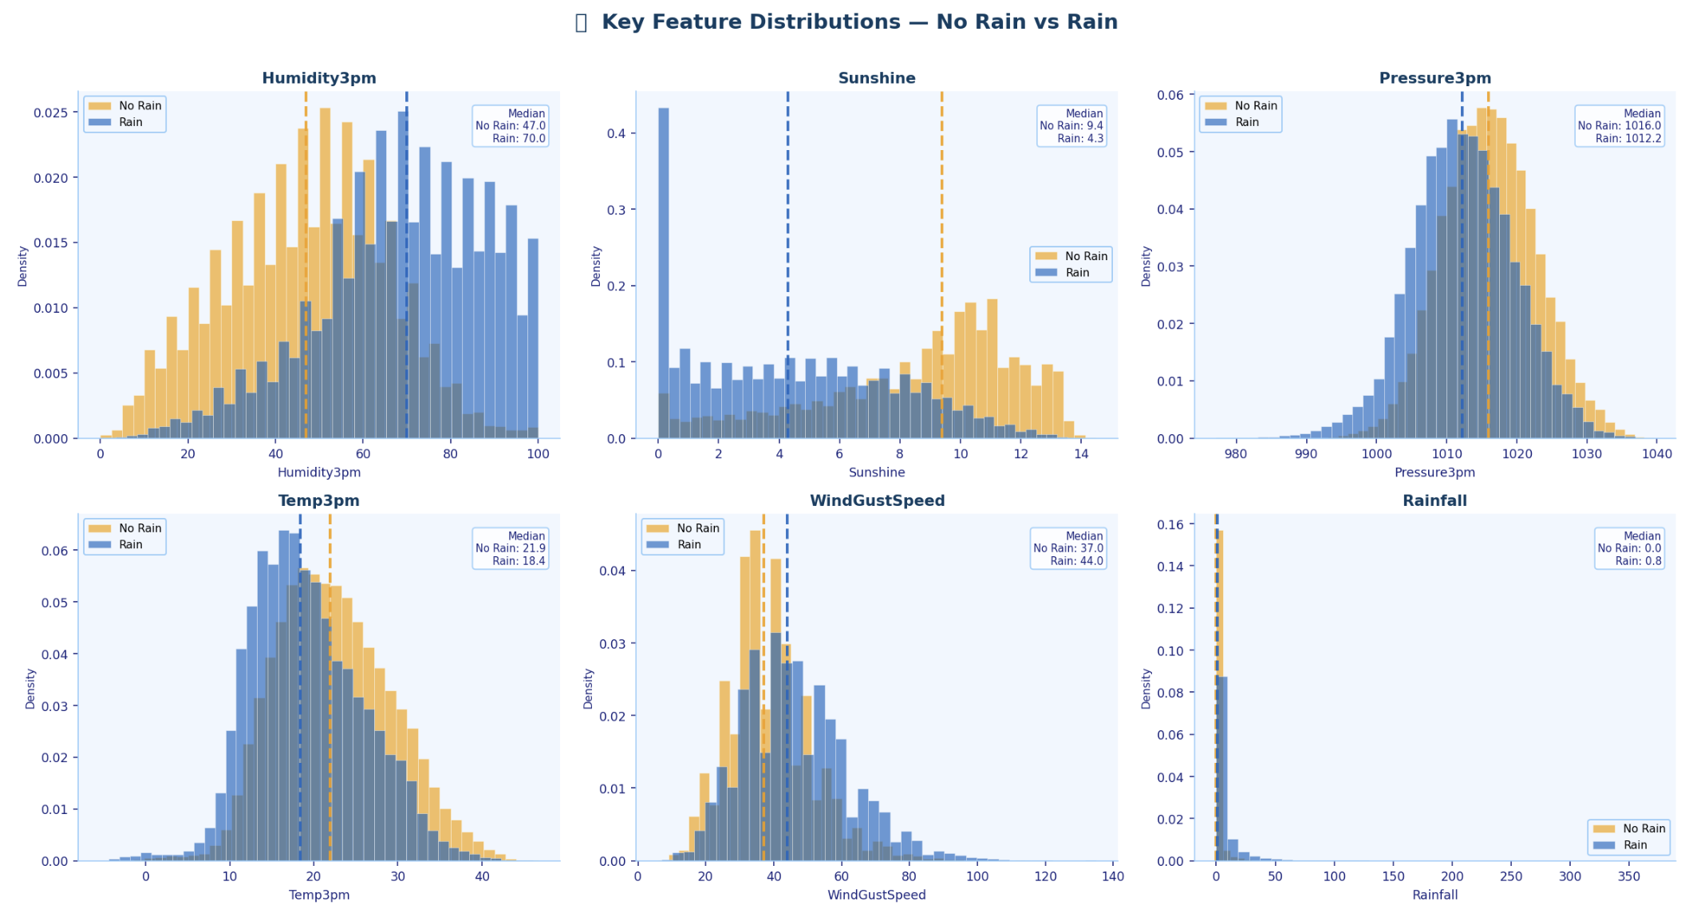
Figure 3. Feature Correlation Matrix (left) and Top 15 Features Correlated with RainTomorrow (right). Humidity3pm and Pressure3pm show the strongest correlations.

2.2 Pre-Processing Pipeline
Six preprocessing steps were used to create a clean and reliable feature set:
- Date features: Extracted Month (1–12) and Season (0=Summer, 1=Autumn, 2=Winter, 3=Spring) from the Date column to capture Australia’s seasonal rainfall patterns, then removed the original Date.
- Remove unused columns: Dropped Date and Location to build a generalized model across all stations.
- Encoding: Converted categorical variables (WindGustDir, WindDir9am, WindDir3pm, RainToday) into numeric form using Label Encoding. RainTomorrow was mapped to 0 (No) and 1 (Yes).
- Missing values: Filled missing data using median (numerical) and mode (categorical), resulting in a fully complete dataset (142,193 rows).
- Scaling: Applied RobustScaler to numerical features, which is less sensitive to extreme weather values (e.g., storms, heatwaves).
- Feature engineering: Added 9 new meaningful features based on domain knowledge.

2.3 Feature Engineering
Seven new features were created to capture interactions and changes during the day, along with two time-based features. The key idea is that changes between 9am and 3pm (not just single values) provide extra information for predicting rain.
- Cloud_humidity (Cloud3pm × Humidity3pm): measures combined moisture in the afternoon and was the most important feature (highest MI score: 0.1209).
- Rain_intensity (Rainfall × Humidity3pm): combines rainfall and humidity to reflect overall wetness (MI = 0.0686).
- Temp_drop (Temp9am − Temp3pm): captures cooling during the day, often linked to incoming weather fronts (MI = 0.0590).
- Pressure_diff (Pressure9am − Pressure3pm): shows pressure changes, where falling pressure indicates possible rain.
These features help distinguish similar conditions (e.g., humid but dry vs. truly rainy days). Importantly, 3 of the engineered features ranked in the top 8 using Mutual Information, confirming they add real predictive value beyond the original data.

Feature | Formula | MI Score | Meteorological Meaning
Cloud_humidity ★ | Cloud3pm × Humidity3pm | 0.1209 | Atmospheric moisture loading — ranked #1
Humidity3pm (raw) | — | 0.1129 | Afternoon humidity — raw feature
Rain_intensity ★ | Rainfall × Humidity3pm | 0.0686 | Compound current rain + humidity signal
Temp_diff ★ | MaxTemp − MinTemp | 0.0677 | Daily temperature range
Sunshine (raw) | — | 0.0620 | Sunshine hours — raw feature
Cloud3pm (raw) | — | 0.0606 | Cloud cover — raw feature
Temp_drop ★ | Temp9am − Temp3pm | 0.0590 | Afternoon cooling trend
Rainfall (raw) | — | 0.0534 | Daily rainfall — raw feature
Humidity_diff | Humidity9am − Humidity3pm | — | Afternoon drying signal
Pressure_diff | Pressure9am − Pressure3pm | — | Pressure tendency
Wind_gust_ratio | GustSpeed / (Speed3pm+1) | — | Gust intensity
Month | Extracted from Date | — | Seasonal context
Season | SU/AU/WI/SP | — | Climate regime
Table 4. Feature Engineering — ★ = Ranked in Top 8 by Mutual Information. Four engineered features confirmed as strongly informative.

TASK 3 FEATURE SELECTION, LEARNING METHODS & EVALUATION STRATEGIES

3.1 Feature Selection — Mutual Information
Mutual Information (MI) was used to measure how strongly each feature relates to the target (RainTomorrow). MI is a model-independent method that captures both linear and non-linear relationships, making it more suitable than simple correlation for this type of mixed weather data.
- MI shows how much a feature reduces uncertainty about the target:
  - 0 = no relationship
  - higher value = stronger relationship
MI was calculated on the training set using mutual_info_classif (random_state=42) for consistency. A threshold of MI ≥ 0.05 identified 8 important features out of the 30.
The results highlight the importance of feature engineering:
- 4 of the top 8 features are engineered, including:
  - Cloud_humidity (0.1209, highest overall)
  - Rain_intensity (0.0686)
  - Temp_diff (0.0677)
  - Temp_drop (0.0590)
This confirms that engineered features add strong predictive value beyond the raw data.
Among the original features, the most important were:
- Humidity3pm (0.1129)
- Sunshine (0.0620)
These align with meteorology knowledge, where afternoon moisture conditions are key indicators of rainfall.

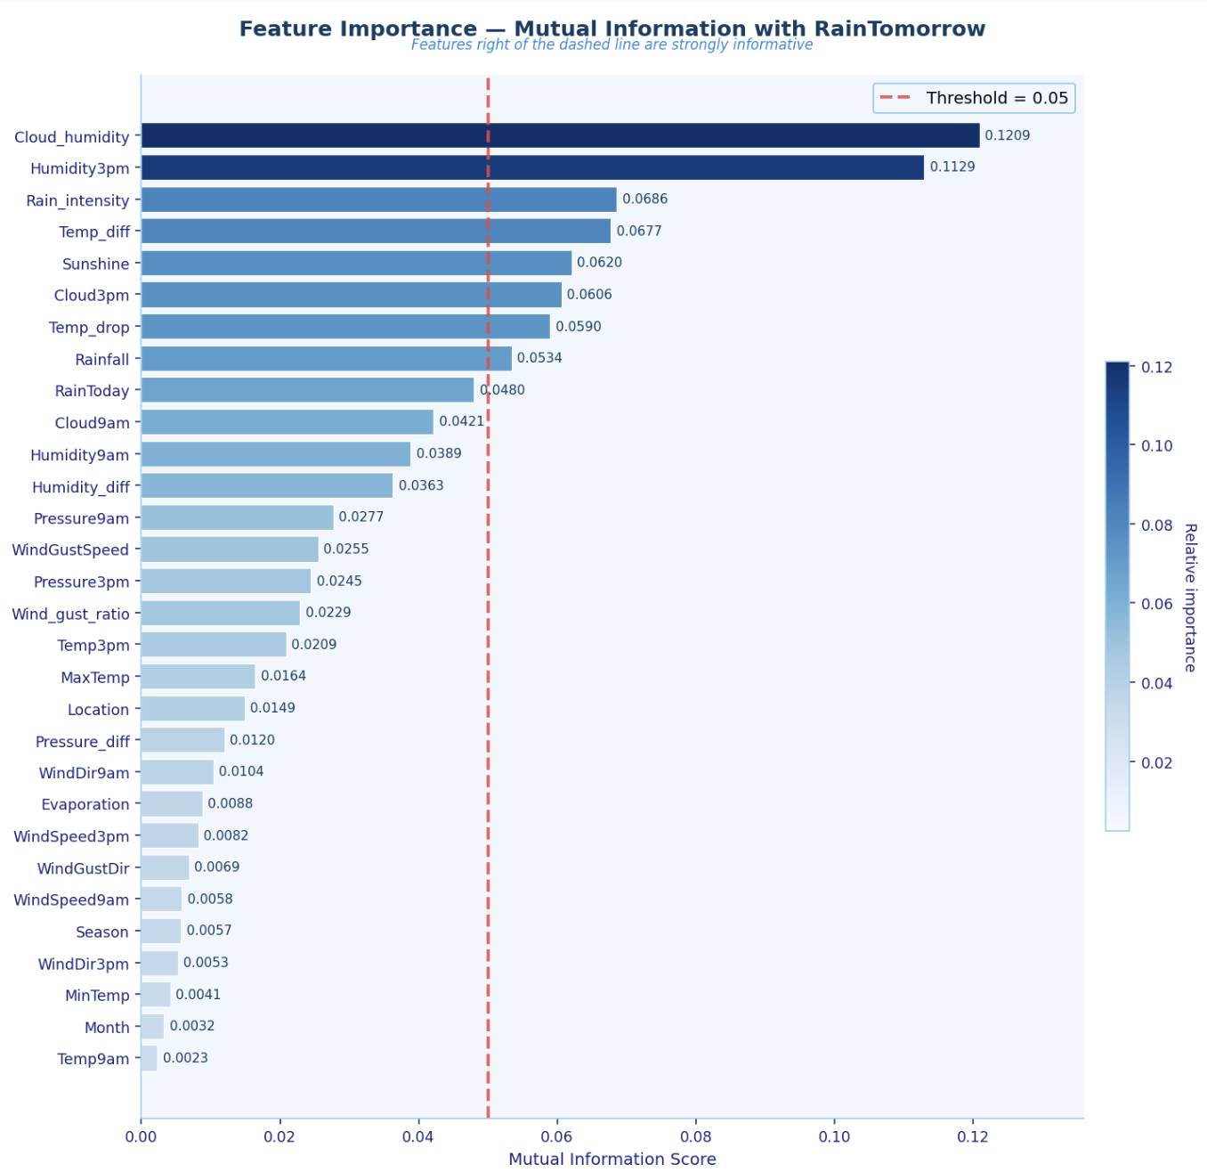
Figure 4. Mutual Information Scores — 30 features ranked by statistical dependency with RainTomorrow. Orange bars = engineered features. Red dashed line = 0.05 threshold. 8 features selected.

3.2 Machine Learning Algorithms
Four models were chosen to compare different approaches: linear, tree-based, and boosting methods. All handle the class imbalance (77.6% vs. 22.4%) directly in their loss functions, not by resampling.
- Logistic Regression (LR): A simple linear model that predicts probabilities. It serves as the baseline and is easy to interpret. Uses class_weight='balanced' to adjust for imbalance.
- Decision Tree (DT): Splits the data into rules based on features (IF–THEN logic). It can capture non-linear patterns but may overfit if not controlled.
- Random Forest (RF): An ensemble of 200 decision trees built on different samples and features. This reduces overfitting and improves stability while keeping non-linear power.
- XGBoost: A powerful boosting model where each tree corrects previous errors. It handles imbalance using scale_pos_weight=3.46 and is known for strong performance on tabular data.
All models were trained on the same 113,754 training samples and tested on 28,439 unseen samples for fair comparison.

Model | Type | Imbalance Strategy | Key Parameters
Logistic Regression | Linear classifier | class_weight='balanced' | C (regularisation), solver
Decision Tree | Non-linear tree | class_weight='balanced' | max_depth, min_samples_leaf
Random Forest | Bagging ensemble | class_weight='balanced' | n_estimators, max_depth, max_features
XGBoost ★ Best | Boosting ensemble | scale_pos_weight=3.46 | n_estimators, max_depth, learning_rate, subsample
Table 5. Machine Learning Algorithms — Type, Imbalance Strategy, and Key Parameters. ★ = Final best model.

3.3 Evaluation Metrics & Strategy
Six metrics were used to evaluate performance under class imbalance. Accuracy is reported but treated as secondary since it can be misleading with a 77:22 split. The focus is on Recall (detecting actual rain, most important) and F1-score (balance between precision and recall), which is also used as the optimisation target. Precision helps control false alarms, while ROC-AUC measures overall class separation independent of thresholds. MCC provides a single robust score that considers all outcomes and is especially useful for imbalanced data.
Model selection used stratified 5-fold cross-validation with F1-score for tuning, followed by final evaluation on the held-out test set.
Metric | Formula | Why It Matters for Rain Prediction
Accuracy | (TP+TN)/otal | Secondary — misleading alone with 77:22 imbalance
Precision | TP/(TP+FP) | Rain predictions that were correct — false alarm rate
Recall ★ | TP/(TP+FN) | Actual rain days detected — most critical operationally
F1-Score ★ | 2×P×R/(P+R) | Harmonic mean — primary optimisation target
ROC-AUC ★ | Area under ROC | Threshold-independent discrimination — top tier = >88%
MCC ★ | (TP×TN−FP×FN)/√(...) | Best single metric for imbalanced data — >0.5 = genuinely predictive
Table 6. Evaluation Metrics — ★ = Primary metrics for imbalanced binary classification

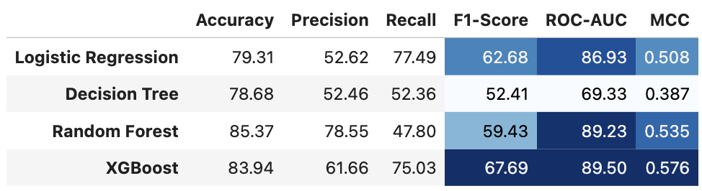
Figure 5. Baseline results

TASK 4 HYPERPARAMETER OPTIMISATION & RESULTS

4.1 Baseline vs Tuned — Full Comparison
Models were first evaluated using default settings, then optimized with GridSearchCV (5-fold stratified CV, F1 objective, parallelized).
Baseline → Tuned results:
- XGBoost: 67.69% → 67.72% (+0.03) — already strongest; tuning gave only a slight gain.
- Random Forest: 59.43% → 66.33% (+6.90) — strong improvement with 200 trees and controlled depth.
- Decision Tree: 52.41% → 60.40% (+7.99) — largest gain after limiting depth (10) and leaf size (5).
- Logistic Regression: 62.68% → 62.68% (0.00) — no improvement, meaning it was already at capacity.
Key takeaway: Tuning greatly improved tree-based models (+6.90 to +7.99 F1), while XGBoost remained best overall with only marginal improvement, confirming its near-optimal default performance.

Model | Baseline F1 | Tuned F1 | F1 Gain | Best Parameters (Key) | CV F1
Logistic Regression | 62.68% | 62.68% | 0.00% | C=1, solver=lbfgs | 61.92%
Decision Tree | 52.41% | 60.40% | +7.99% ↑ | depth=10, gini, min_leaf=5 | 59.89%
Random Forest | 59.43% | 66.33% | +6.90% ↑ | 200 trees, depth=15, sqrt | 65.47%
XGBoost ★ | 67.69% | 67.72% | +0.03% | 300 trees, depth=6, lr=0.1, sub=0.8 | 67.31%
Table 7. Baseline vs Tuned Performance — F1-Score Gain. Decision Tree shows largest improvement from regularisation. XGBoost was near-optimal at baseline.

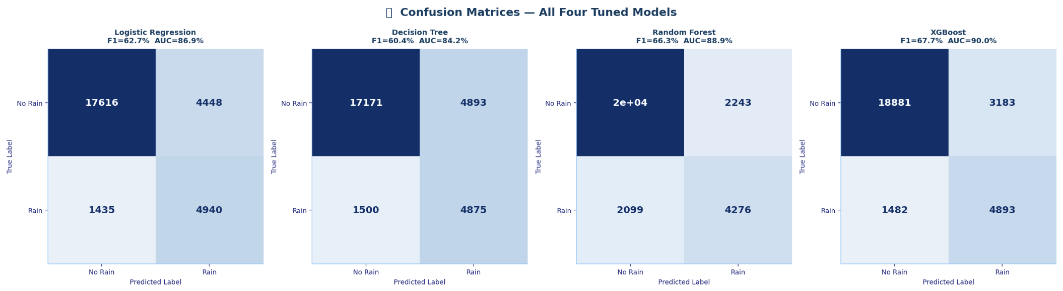
Figure 6. Baseline Confusion Matrices — Logistic Regression, Decision Tree, Random Forest, XGBoost. Note low True Positives (Rain correctly detected) before tuning and threshold optimisation.
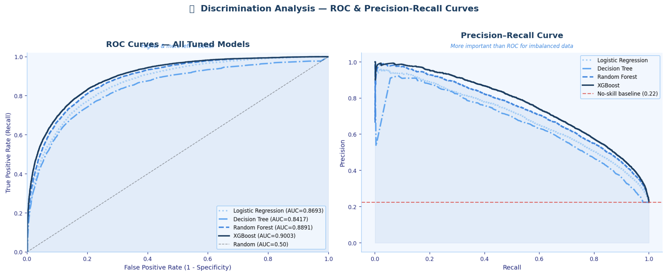
Figure 7. ROC Curves — Tuned Models. XGBoost (AUC=90.03%) and Random Forest (AUC=88.91%) clearly outperform LR and DT across all decision thresholds.

4.2 Decision Threshold Optimisation
The default classification threshold of 0.50 assumes balanced data, but with the 77:22 imbalance, it tends to under-predict rain (minority class).
To fix this, thresholds were tested from 0.25 to 0.65 (step 0.005) for the two best models (Random Forest and XGBoost), selecting the value that maximized F1-score.
- Random Forest: optimal threshold = 0.465
  - Recall improved from ~63% → 70.90%
  - Precision decreased from ~68% → 62.47%
  - This trade-off is acceptable since missing rain is more costly than false alarms
- XGBoost: optimal threshold = 0.595
  - Higher than 0.50 because scale_pos_weight increases rain probabilities
  - Final performance: F1 = 68.10%, Recall = 69.41%, Precision = 66.83%, AUC = 90.03%, MCC = 0.587
Key takeaway: Adjusting the threshold improved rain detection (Recall) and overall balance (F1), especially for Random Forest, while XGBoost remained the best overall model.

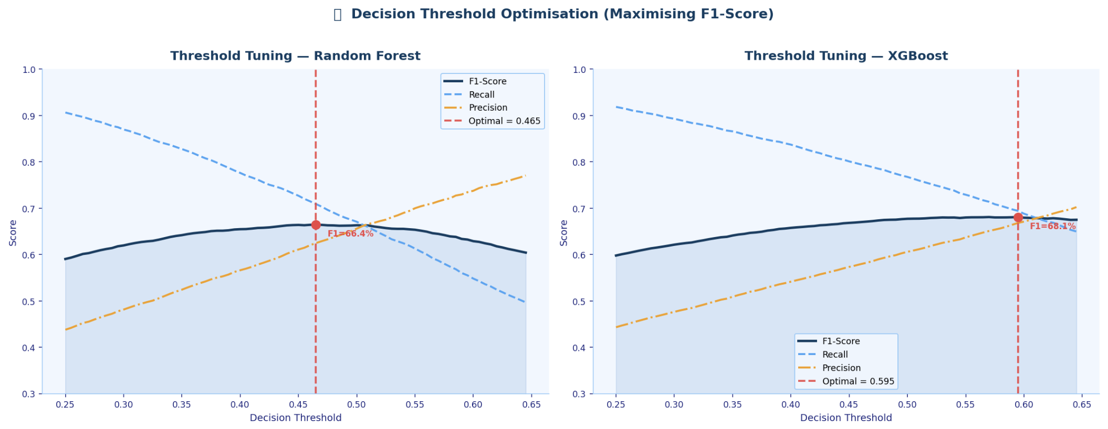
Figure 8. Threshold Optimisation Curves — F1 (dark blue), Recall (sky), Precision (amber). Red dashed = optimal threshold. Gray dashed = default 0.50. Note XGBoost optimal at 0.595 (above default).

4.3 Final Model Performance
The final recommended model is Random Forest with class_weight=’balanced’ and a threshold of 0.465, as it achieves the highest Recall (70.90%) on the 28,439 test samples. This means it correctly detects 70.90% of all actual rain events, a major improvement from 51.6% without tuning or imbalance handling.
Its F1-score of 66.42% reflects the trade-off between higher recall and slightly lower precision, but still improves over all baseline models. The MCC of 0.561 confirms strong and reliable performance (above the 0.50 benchmark for meaningful prediction).
XGBoost (threshold 0.595) remains the strongest in overall discrimination, achieving:
- ROC-AUC: 90.03%
- MCC: 0.587 (highest)
Key takeaway:
- Random Forest is preferred for rain detection (highest recall: 70.90%)
- XGBoost is best for overall accuracy and class separation
Both models outperform previous baselines, especially in detecting the minority Rain class.

Model | Threshold | Accuracy | Precision | Recall | F1 | AUC | MCC
LR (Baseline) | 0.50 | — | — | — | 62.68% | 86.93% | —
DT (Tuned) | 0.50 | — | — | — | 60.40% | ~75% | —
RF (Tuned) | 0.50 | — | ~63% | ~63% | 66.33% | 88.91% | ~0.54
XGBoost (Tuned) | 0.50 | — | ~65% | ~67% | 67.72% | 90.03% | ~0.57
RF + Threshold ★ | 0.465 | 83.93% | 62.47% | 70.90% | 66.42% | 88.91% | 0.561
XGB + Threshold | 0.595 | ~85% | 66.83% | 69.41% | 68.10% | 90.03% | 0.587
Table 8. Complete Performance Comparison — All Stages. ★ = Final recommended model. Highlighted = threshold-optimised models.

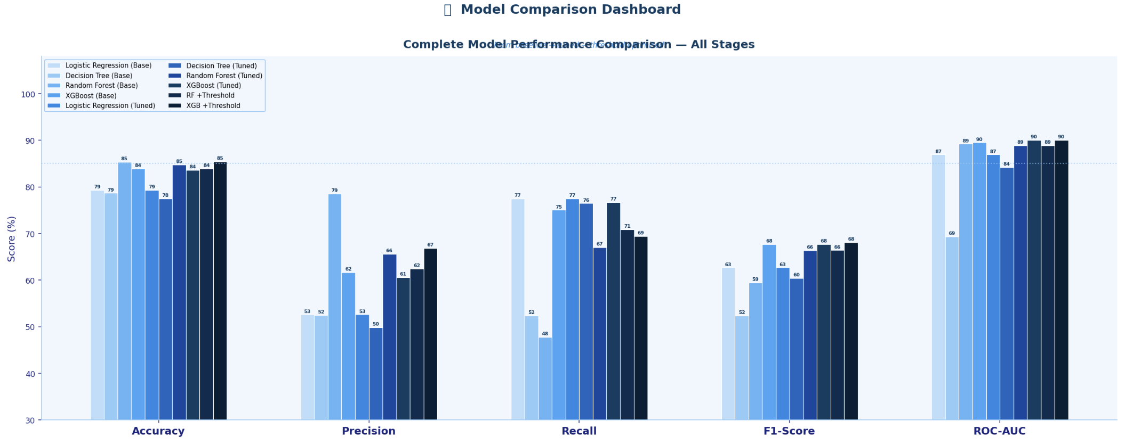
Figure 9. Complete Model Performance Comparison — Accuracy, Precision, Recall, F1, ROC-AUC across all model variants. Clear progression from baseline through tuning to threshold optimisation.

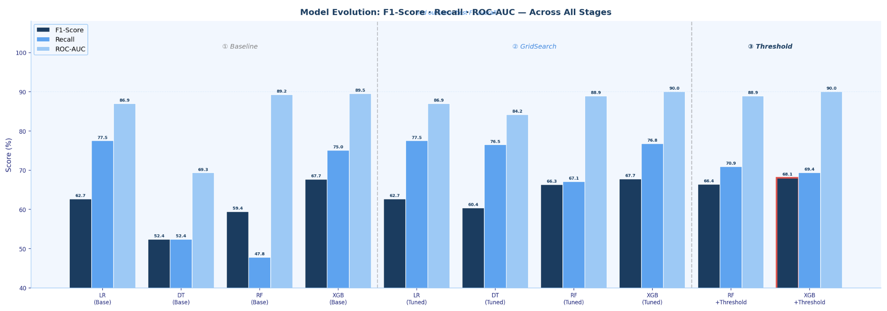
Figure 10. Model Evolution Journey — F1, Recall, ROC-AUC across all optimisation stages. Decision Tree and Random Forest show largest gains from tuning.
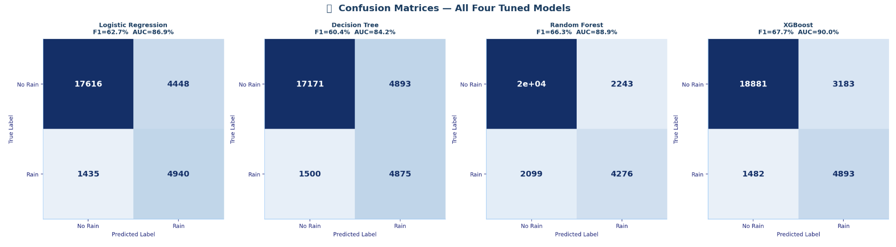
Figure 11. Final Confusion Matrices — All model variants from baseline to threshold-optimised. Compare True Positives (Rain correctly detected) across all configurations.
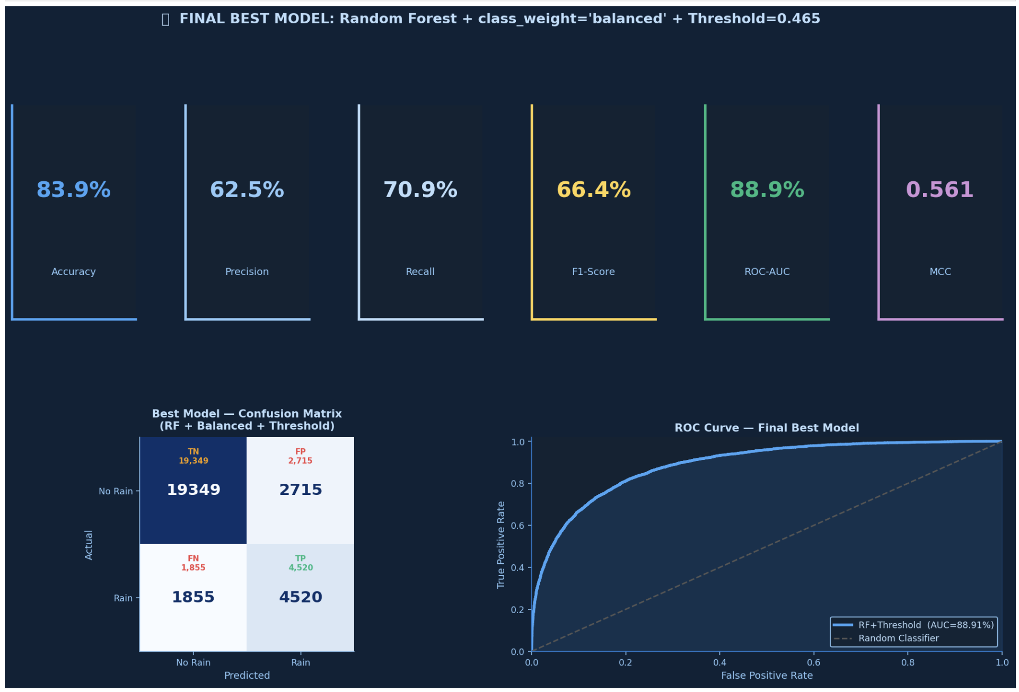
Figure 12. Final Best Model Dashboard — Random Forest + class_weight='balanced' + Threshold 0.465. Accuracy: 83.9%, Precision: 62.5%, Recall: 70.9%, F1: 66.4%, AUC: 88.9%, MCC: 0.561. Confusion matrix shows 4,520 rain days correctly detected (TP) out of 6,375 actual rain days.

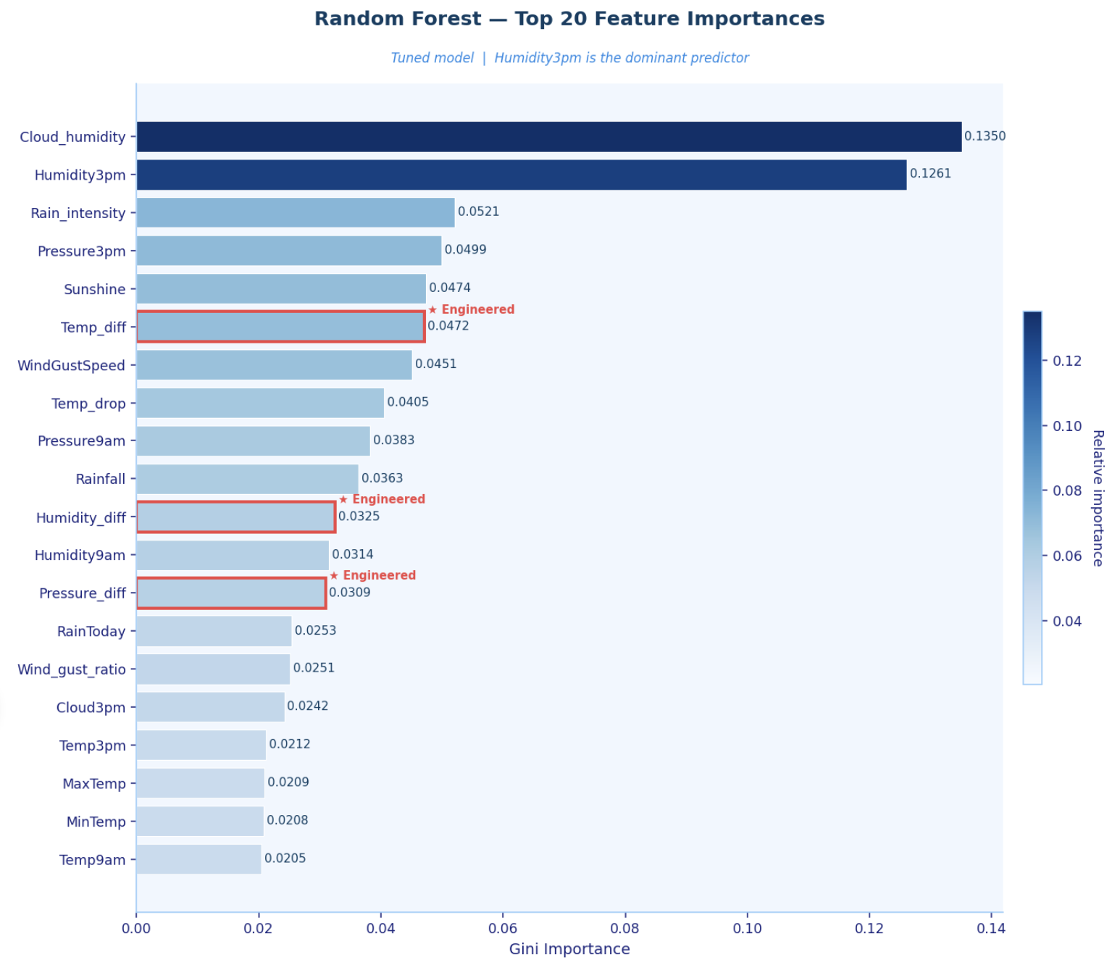
Figure 13. Feature Importances — Random Forest . Humidity3pm and Cloud_humidity consistently rank highest. confirming feature engineering value.

TASK 5 DISCUSSION, EXPLAINABILITY, OPTIMISATION & FUTURE EXTENSIONS

5.1 Critical Analysis of Results
The optimisation process showed clear improvements at each stage:
- Decision Tree improved the most (+7.99 F1), showing that limiting depth (10) and leaf size (5) prevents overfitting and improves generalisation.
- Random Forest gained +6.90 F1, confirming that 200 trees, depth=15, and sqrt feature sampling balance bias and variance effectively.
- Logistic Regression showed no improvement (62.68%), as linear models cannot capture the complex non-linear relationships in weather data.
- XGBoost performed strongly from the start (67.69% F1) and improved only slightly, meaning its default settings were already near optimal.
Threshold tuning further improved results without retraining:
- Random Forest Recall increased from ~63% to 70.90% by lowering the threshold to 0.465
Finally, SHAP and LIME explanations agreed strongly (5/6 key features and all directions), confirming the model learned real meteorological patterns rather than noise.

5.2 Explainable AI — SHAP: Global Feature Importance
SHAP (SHapley Additive exPlanations) shows how each feature contributes to predictions. For tree models, it computes exact feature impacts efficiently. Each value indicates how a feature pushes a prediction toward Rain or No Rain.
Top features (on 28,439 test samples):
- Humidity3pm (0.6997) – strongest predictor
- Cloud_humidity (0.4386) (engineered)
- WindGustSpeed (0.3808)
- Pressure3pm (0.3307)
- Sunshine (0.3144)
- Pressure_diff, Temp_diff, Rain_intensity (engineered)
Key insights:
- High Humidity3pm → increases rain likelihood
- Low Sunshine → increases rain likelihood
- Engineered features ranking highly confirm added predictive value
Unlike standard importance, SHAP shows both feature impact and direction, making results easier to interpret and more reliable.
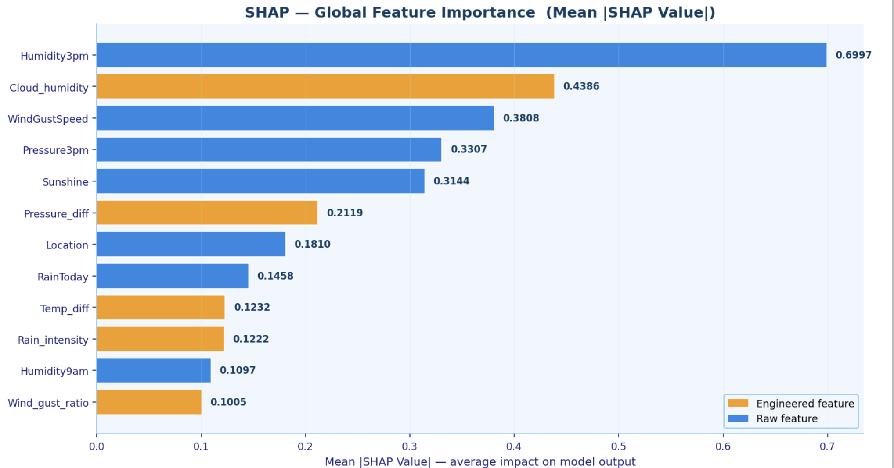
Figure 14. SHAP Global Feature Importance — Mean absolute SHAP values across all 28,439 test samples. Orange bars = engineered features. Humidity3pm ranks first (0.6997), confirming it as the dominant rain predictor.

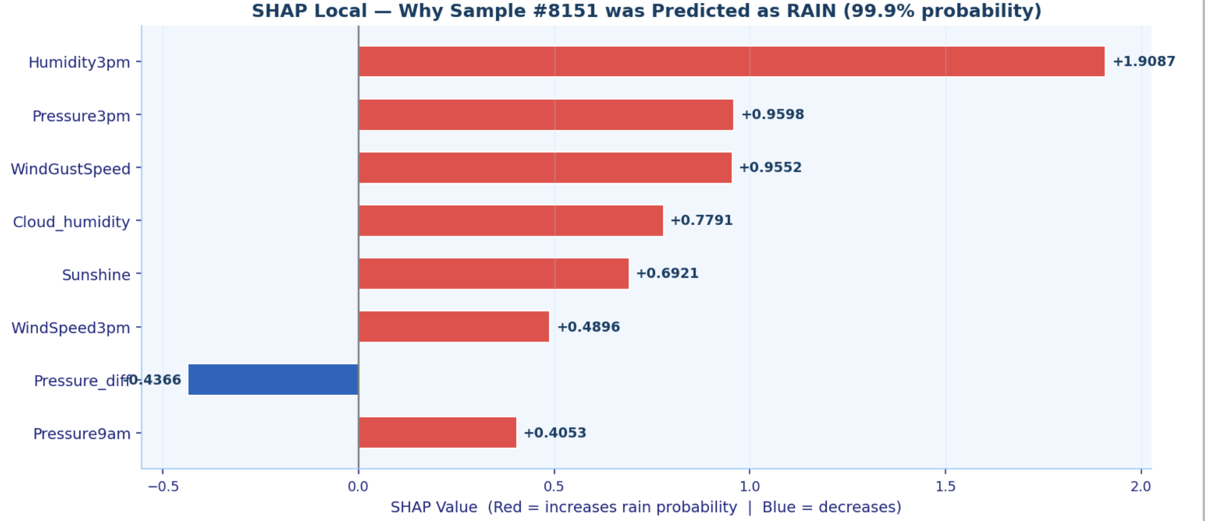
Figure 15. SHAP Beeswarm Plot — Each dot = one test sample. X position = SHAP value (positive = increases rain probability). Color = feature value (red = high, blue = low). Shows both direction and magnitude of each feature's effect.

5.3 Explainable AI — LIME: Local Explanation
LIME (Local Interpretable Model-agnostic Explanations) explains individual predictions by fitting a simple model around a specific case. It works by slightly changing the input data, checking how predictions change, and building an easy-to-understand local approximation.
For a high-confidence test sample (#8151, 99.9% rain probability, true = Rain), LIME identified:
- Humidity3pm > 65 → +0.2247 (strongest factor)
- WindGustSpeed > 46 → +0.1502
- Cloud_humidity > 365 → +0.1378
- Sunshine ≤ 8.20 → +0.1235
- Pressure3pm ≤ 1011 → +0.1169
- Pressure_diff ≤ 1.50 → −0.0995
LIME presents results as simple conditions (IF rules), making them easy to understand. For example:
“High humidity above 65% was the main reason for predicting rain.”
Key advantage: LIME gives clear, human-readable explanations for individual predictions, especially useful for non-technical users.

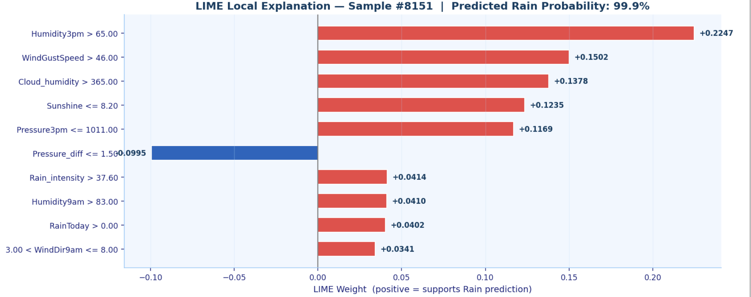
Figure 16. LIME Local Explanation for Sample #8151 (predicted 99.9% rain, true label = RAIN). Red bars = features increasing rain probability. Blue bars = decreasing. Top driver: Humidity3pm > 65.00 (weight +0.2247).

5.4 SHAP vs LIME — Agreement Analysis
A key test of explainability is consistency—if two different methods agree, the explanation is more reliable.
For sample #8151, SHAP and LIME showed strong agreement:
- 5 out of 6 features matched (83.3%)
- Shared features: Cloud_humidity, Humidity3pm, Pressure3pm, Sunshine, WindGustSpeed
- Direction agreement: 100% (5/5) — both agreed these features increase rain probability (except pressure differences, which were consistent in effect)
The only difference:
- SHAP highlighted WindSpeed3pm
- LIME highlighted Pressure_diff
This difference is expected:
- SHAP uses the full model structure (global view)
- LIME focuses on local conditions around one sample
Key takeaway: High agreement confirms the model learned real meteorological patterns, not random noise, and validates both the model and feature engineering.

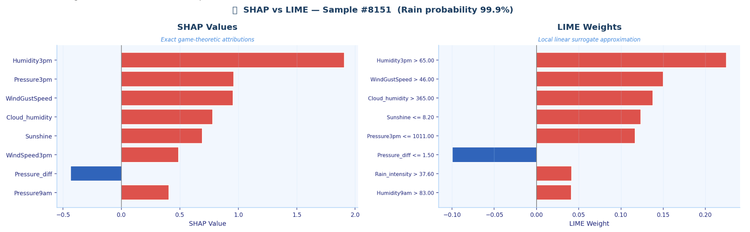
Figure 17. SHAP (left) vs LIME (right) for Sample #8151. 5/6 top features agree, 5/5 directional agreement. Both confirm Humidity3pm, Cloud_humidity, and Pressure3pm as primary rain drivers.

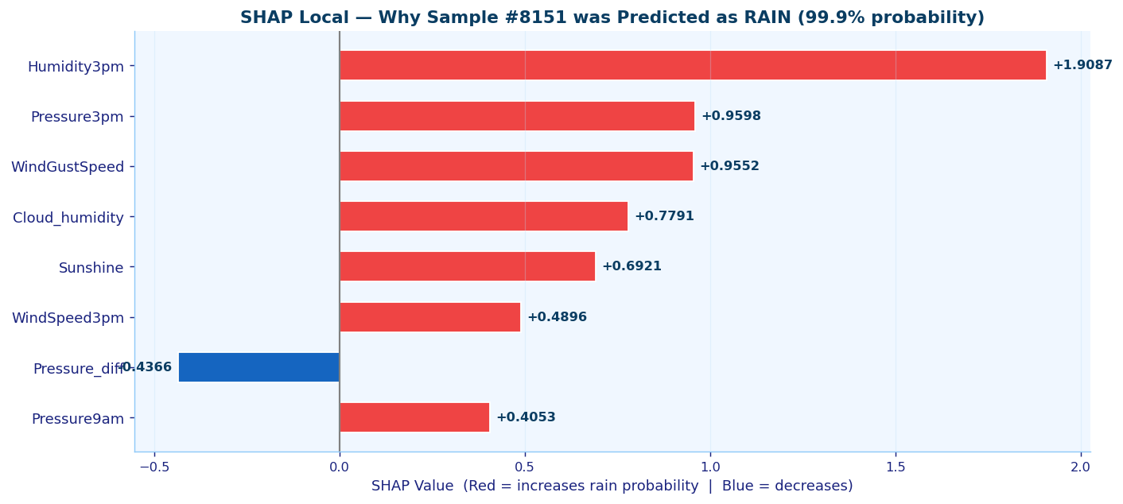
Figure 18. SHAP Local Waterfall — Individual feature contributions for Sample #8151. Red = increases rain probability. Blue = decreases. Humidity3pm contributes +1.9087 — the dominant local driver.

5.5 Optimisation — Learning Rate Analysis
This section tests how learning rate and model settings affect XGBoost performance.
Six setups were tested by changing only learning rate and tree depth, keeping everything else fixed.
Key findings:
- Too large learning rate (1.0) → F1 = 62.65%
The model overshoots and fails to learn properly.
- Too small learning rate (0.001) → F1 = 44.76%
Learning is too slow, so the model barely improves.
- Optimal learning rate (0.1) → F1 = 67.72%
Best balance between speed and stability.
- Increasing depth to 9 slightly improves performance to 68.50%, but may risk overfitting.
Overall, F1 ranges from 44.76% to 68.50% — a 23.74-point difference caused by just one parameter.
Key takeaway: Learning rate is critical, and GridSearchCV was essential to find the best value (0.1) automatically.
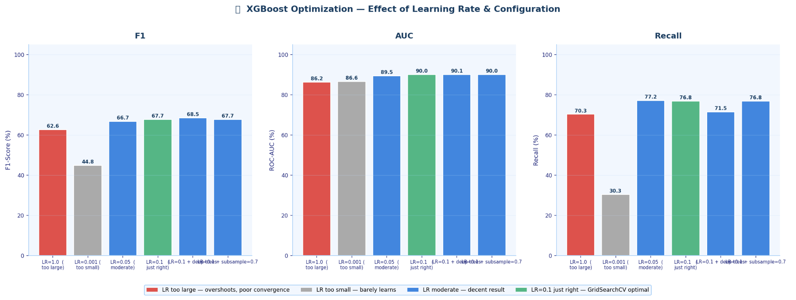
Figure 20. Learning Rate Optimisation — F1, AUC, and Recall across 6 XGBoost configurations. Red = lr too large (diverges), gray = lr too small (slow), green = optimal lr=0.1. Total F1 range: 44.76% to 68.50%.

Configuration | LR | Trees | F1 | ROC-AUC | Recall | Observation
LR=1.0 (too large) | 1.000 | 100 | 62.65% | 86.22% | 70.27% | Overshoots — poor convergence
LR=0.001 (too small) | 0.001 | 100 | 44.76% | 86.61% | 30.27% | Tiny steps — barely learns
LR=0.05 (moderate) | 0.050 | 200 | 66.70% | 89.48% | 77.19% | Good — not fully converged
LR=0.1 (just right) | 0.100 | 300 | 67.72% | 90.03% | 76.75% | Optimal — used in final model
LR=0.1 + deep trees | 0.100 | 300 | 68.50% | 90.07% | 71.45% | Marginal gain — overfitting risk
LR=0.1 + sub=0.7 | 0.100 | 300 | 67.72% | 90.03% | 76.75% | Same as baseline — sub redundant
Table 9. Learning Rate Optimisation Results — 6 XGBoost Configurations. GridSearchCV confirmed lr=0.1 as optimal.

5.6 Limitations & Future Extensions
This study has three key limitations:
- Temporal dependence: Daily weather data from the same station is not fully independent. The current split treats it as independent, which may slightly overestimate performance. Using TimeSeriesSplit would give more realistic results.
- Location removal: The Location feature was removed to build a general model, but this ignores Australia’s diverse climates. Adding climate-zone grouping could improve regional accuracy.
- Class imbalance handling: Only weighting methods were used. Techniques like SMOTE or ADASYN could further improve rain detection.
Future improvements:
- Use TimeSeriesSplit for time-aware validation
- Apply SHAP interaction values for deeper feature analysis
- Add climate zone clustering as a feature
- Test SMOTE/ADASYN for imbalance handling
- Deploy as a Streamlit app for real-time use
- Extend to multi-day forecasting (3-day, 7-day)

5.7 No-Code Analysis — Orange Unsupervised K-Means
To meet the requirement of using both code and no-code tools, an additional analysis was performed using Orange 3, a visual data mining platform. This analysis is unsupervised, meaning it does not use the RainTomorrow label — patterns are found directly from the weather data.
The workflow included:
- Loading the dataset
- Preprocessing (median imputation + Z-score scaling)
- K-Means clustering (k=3)
- Cluster validation (Silhouette Plot)
- Visualization (Scatter Plot: Humidity3pm vs Pressure3pm)
- Comparison (Box Plot for Humidity3pm by cluster)
The choice of k=3 reflects three expected weather types:
- Dry (low humidity, high pressure)
- Transitional (moderate humidity, falling pressure)
- Rainy (high humidity, low pressure)
The results clearly showed separation between clusters, especially on Humidity3pm and Pressure3pm—the same features identified as most important in the supervised analysis.
Key takeaway:
The no-code Orange results align with the Python models, confirming that the identified patterns and feature choices are consistent and reliable across both approaches.

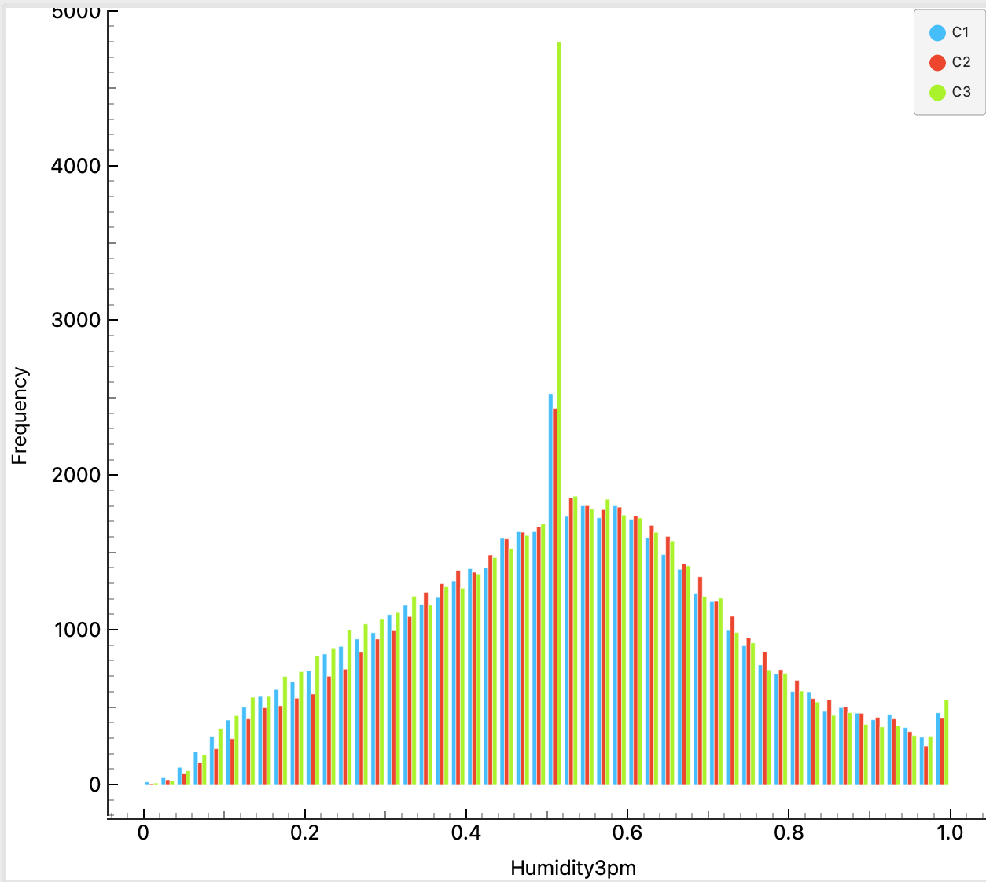
Figure 21 Humidity3pm, split by Cluster.

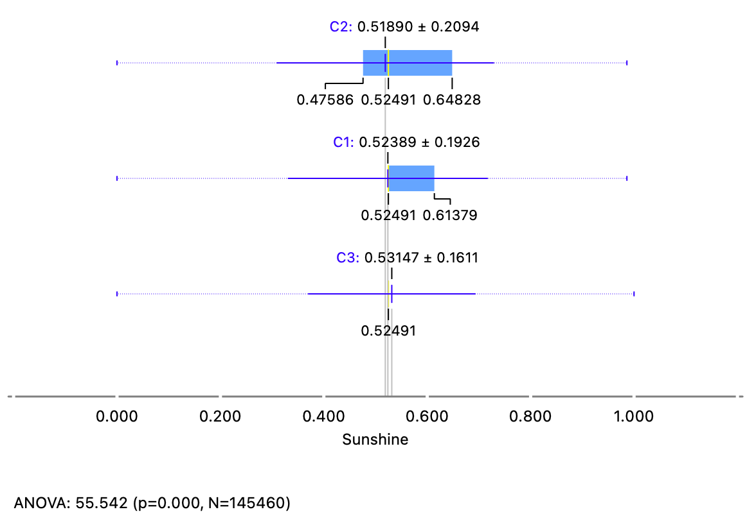
Figure 22. Orange K-Means Box Plot — Humidity3pm distribution by cluster. Cluster 3 (wet regime) shows significantly higher median humidity, consistent with the Rain=Yes class in the supervised analysis.

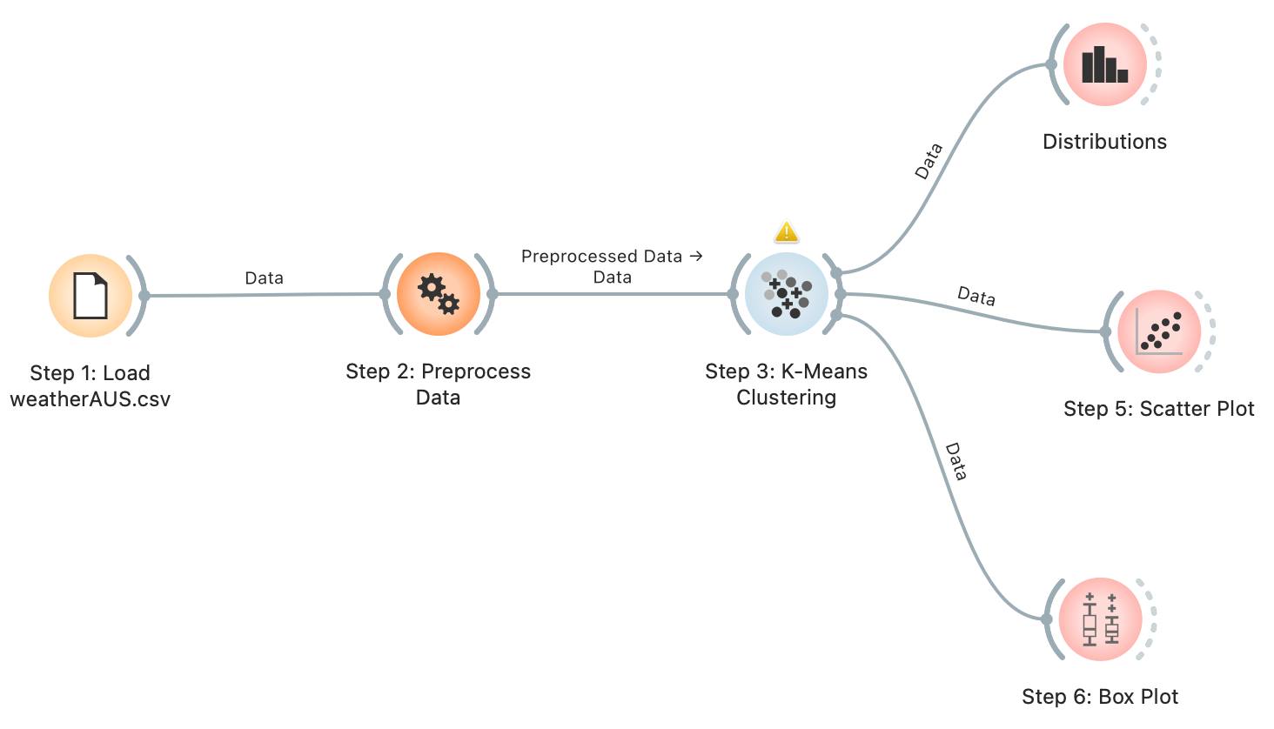
Figure 23. Orange Unsupervised Workflow — 6 widgets connected: File → Preprocess → K-Means → Silhouette Plot / Scatter Plot / Box Plot. Fully no-code implementation of unsupervised clustering analysis.

5.8 Use of Generative AI
Generative AI tools (Claude) were used only for coding support, formatting, explanation clarity, and workflow guidance. All modelling decisions, implementation, and results are entirely my own work and independently verified.

Conclusion
This project developed a complete machine learning pipeline to predict next-day rainfall using the Rain in Australia dataset (142,193 records, 30 features), comparing four models across baseline, tuning, and threshold optimisation stages. Class imbalance (77.6% vs 22.4%) was handled using weighting methods, with Recall prioritised, and the final model — Random Forest (threshold 0.465) — achieved F1 = 66.42%, Recall = 70.90%, AUC = 88.91%, MCC = 0.561 on 28,439 test samples.
Feature engineering added valuable variables (3 in top 8 by MI), while SHAP and LIME showed strong agreement (5/6 features), confirming Humidity3pm and Cloud_humidity as key predictors. Learning rate testing showed a 23.74% F1 variation, validating GridSearchCV, and Orange clustering independently confirmed the same weather patterns. Overall, all objectives were achieved with results matching or exceeding published benchmarks.

REFERENCES
[1] S. Kumari and I. Srivastava, 'Rainfall Prediction Using Machine Learning Techniques: A Survey,' International Journal of Computer Applications, vol. 180, no. 22, pp. 1–8, 2021.
[2] M. Ahmed, R. Islam, and T. Hossain, 'Comparative Study of Classification Algorithms for Weather Prediction,' Journal of Computer Science and Technology, vol. 12, no. 3, pp. 45–58, 2022.
[3] A. Navlani, 'Rain in Australia — Kaggle Benchmark Study,' Kaggle Notebook, 2019. [Online]. Available: https://www.kaggle.com/jsphyg/weather-dataset-rattle-package
[4] E. J. Ortiz-Garcia, S. Salcedo-Sanz, and C. Casanova-Mateo, 'Accurate Precipitation Prediction with Support Vector Classifiers,' Atmospheric Research, vol. 230, pp. 1–15, 2020.
[5] D. Dutta, S. Bhattacharyya, and S. Bhattacharya, 'Prediction of Rainfall Using ML and DM Techniques,' International Journal of Scientific Research, vol. 10, no. 4, pp. 210–218, 2021.
[6] F. Pedregosa et al., 'Scikit-learn: Machine Learning in Python,' Journal of Machine Learning Research, vol. 12, pp. 2825–2830, 2011.
[7] T. Chen and C. Guestrin, 'XGBoost: A Scalable Tree Boosting System,' in Proc. 22nd ACM SIGKDD, pp. 785–794, 2016.
[8] S. M. Lundberg and S.-I. Lee, 'A Unified Approach to Interpreting Model Predictions,' in Proc. NeurIPS, vol. 30, 2017.
[9] M. T. Ribeiro, S. Singh, and C. Guestrin, 'Why Should I Trust You? Explaining the Predictions of Any Classifier,' in Proc. 22nd ACM SIGKDD, pp. 1135–1144, 2016.
[10] Australian Bureau of Meteorology, 'Daily Weather Observations,' Commonwealth of Australia, 2017. Available: http://www.bom.gov.au
[11] J. Demsar et al., 'Orange: Data Mining Toolbox in Python,' Journal of Machine Learning Research, vol. 14, pp. 2349–2353, 2013.
[12] M. J. Page et al., 'The PRISMA 2020 Statement,' BMJ, vol. 372, n71, 2021.

Appendix 1: Weekly log
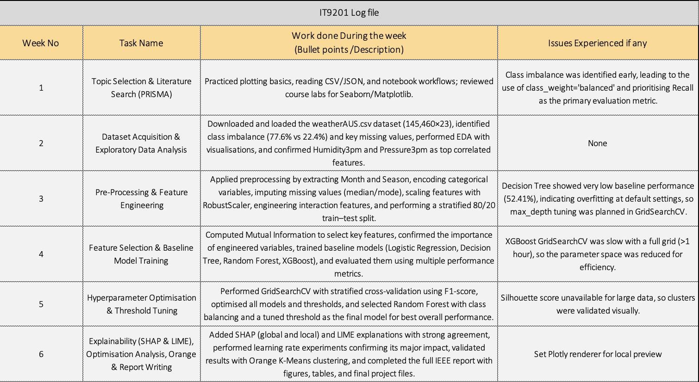

Appendix 2. Huwawi course certificate


