***Rufo, Mary Ann E.***

***Ortega, Joemarie Kim S.***

***BSCoE 5-1***

**ATTENDANCE WITH FACEBOOK**

**DESCRIPTION:**

“Attendance with Facebook” application captures photos, detects faces and uploads the captured photo in the user’s Facebook wall.

**SCOPE:**

1. It has “Login with Facebook” function which allows user to login his account which will be used in photo uploading.
2. It has “Capture Photo” function which calls the CAMERA intent.
3. It has “Detect Faces” function which identifies the faces in the captured photo.
4. It has “Upload Photo” function which uploads the captured photo in the user’s Facebook wall.

**LIMITATION:**

1. The “Face Detection” function can only detect up to maximum of five faces only.
2. The captured photo will be uploaded on user’s Facebook wall only, not in Facebook groups.
3. It doesn’t have “Logout with Facebook” function.

**SAMPLE UPLOAD ON FACEBOOK:**

**URL:** <http://www.facebook.com/photo.php?fbid=10200718560917616&set=a.10200718560837614.1073741829.1569504436&type=1&theater>

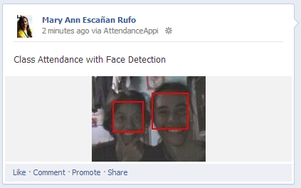

**SCREENSHOTS:**

|  |  |
| --- | --- |
| 1. When you start the application, “Login with Facebook” button will appear. Click the button. | **(1)login.JPG** |
| 1. Facebook login will appear. Here you will enter your username and password. | **(2)fb login.JPG** |
| 1. The “Take Picture” activity will appear. Click on the “Take Picture” button to start the Camera Intent. | **(3)take picture.JPG** |
| 1. The camera application will start. Here you will take your picture and capture it. | **startcam.JPG** |
| 1. Once you’re done, the “Detect Face” activity will start. Here it will display you’re captured photo and a button for detecting the face. Click on the “Detect Face” button. | **(3)new.JPG** |
| 1. The application will now detect the face in the photo. An “Upload to Facebook” button will appear. | **upload.JPG** |
| 1. Once you click the upload button, the picture will be posted on your Facebook wall. |  |