Retail Inventory Performance & Stock Optimization Analysis
- Project Overview
This project analyzes retail inventory data to understand product sales performance, potential revenue and profitability, and inventory levels. The analysis was designed from the perspective of a junior data analyst supporting retail inventory and business decision-making.
The dataset contains 1,000 retail products across multiple categories and suppliers, with information on product costs, retail prices, opening stock, units sold, closing stock, reorder points, and stock status.
The objective of the analysis was to identify high-performing products and categories, evaluate potential profitability, and highlight low-stock products that may require closer inventory monitoring.

Tools Used
- Microsoft Excel
- PivotTables
- PivotCharts
- Excel formulas
- Data validation and quality checks
- Dashboard development

Key Metrics
The analysis identified:
- 1,000 products
- 137,040 units sold
- 3.83M in potential revenue
- 1.63M in potential profit
- 420.7K in potential profit associated with products classified as LOWSTOCK
Note: Potential revenue and potential profit are analytical estimates calculated from the available dataset. They are not actual accounting revenue or reported financial profit.

2. Business Questions
The analysis was designed to answer the following business questions:
- Which products have the highest number of units sold?
- Which product categories generate the highest potential revenue?
- Which products generate the highest potential profit?
- Which product categories are the most profitable?
- Which products have the lowest closing stock?
- Which low-stock products have the highest potential profit?
- Which categories have the greatest number of products?
- Which suppliers contribute the most products and potential profit?
These questions were selected to evaluate three key areas of retail performance:
- Sales performance - identifying products and categories with high sales volume.
- Financial performance - comparing potential revenue and potential profit.
- Inventory management - identifying products with low stock levels that may require closer monitoring.

3. Data Preparation & Quality Checks
The dataset was reviewed for completeness, duplicate Product IDs, and consistency between opening stock, units sold, and closing stock. All Product IDs were unique, and the stock calculation check passed across the dataset. Three calculated fields were created in Excel: Profit per Unit, Potential Revenue, and Potential Profit. Blank category entries identified during analysis were removed before finalizing the dashboard.

4. Analysis & Findings
The cleaned dataset was analyzed using Excel PivotTables and PivotCharts. The analysis focused on product sales volume, potential revenue, potential profit, inventory levels, and supplier performance.

4. Analysis & Findings
The analysis was conducted using Excel PivotTables and PivotCharts. The key findings are summarized below.
Business Question | Key Finding
Which products have the highest number of units sold? | Power Bank recorded the highest sales volume at 3,162 units, followed by Eye Mask at 3,111 units.
Which categories generate the highest potential revenue? | Electronics generated the highest potential revenue at 1.24M.
Which products generate the highest potential profit? | Power Bank generated the highest potential profit at 96.6K.
Which categories are the most profitable? | Electronics generated the highest potential profit at 522.1K.
Which products have the lowest closing stock? | Card Deck had the lowest closing stock at 684 units, followed by Puzzle 500pc at 704 units.
Which low-stock products have the highest potential profit? | LED Desk Lamp had the highest potential profit among LOWSTOCK products at 36.8K, followed by Power Bank at 35.5K.
Which categories have the greatest number of products? | Beauty had the largest product count with 134 products.
Which suppliers contribute the most products and potential profit? | Premier Merchandise supplied the most products at 119, while Heritage Brands recorded the highest potential profit at 194.4K.

Key Interpretation
The results show that Electronics is the strongest financial category, leading both potential revenue and potential profit. Power Bank was also a notable performer, ranking highest in both units sold and potential profit.
The analysis also identified a potential inventory-management concern: several products classified as LOWSTOCK contribute meaningful potential profit. These products may therefore warrant closer inventory monitoring.
The supplier analysis shows that supplying the largest number of products does not necessarily correspond to the highest potential profit. Heritage Brands generated the highest potential profit despite supplying fewer products than Premier Merchandise.

5. Dashboard
An interactive Excel dashboard was developed to present the key findings in a concise and visual format.
The dashboard includes:
- Total products
- Total units sold
- Potential revenue
- Potential profit
- Low-stock potential profit
- Top 5 products by units sold
- Potential revenue by category
- Potential profit by category
- Top 5 LOWSTOCK products by potential profit
- Key findings and business recommendations
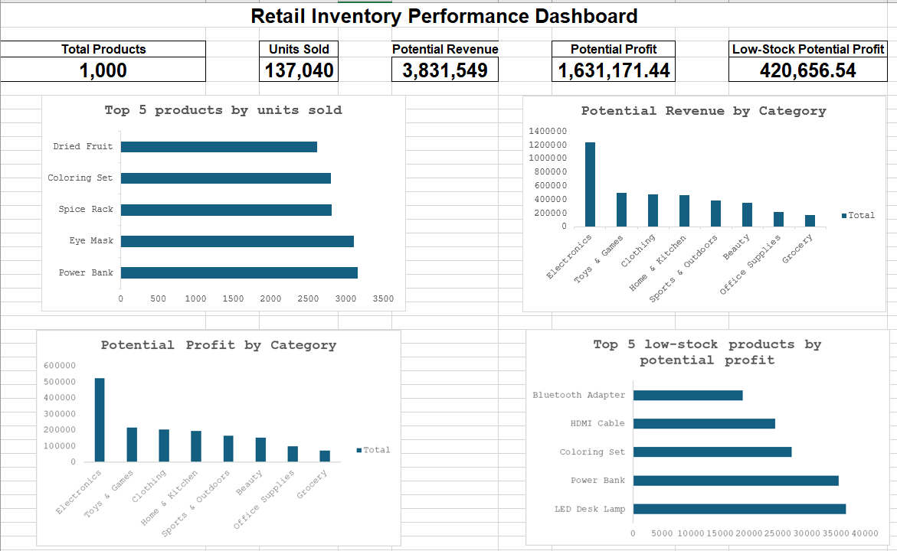
Figure 1: Figure 1: Retail Inventory Performance Dashboard — KPIs and Category/Product Analysis
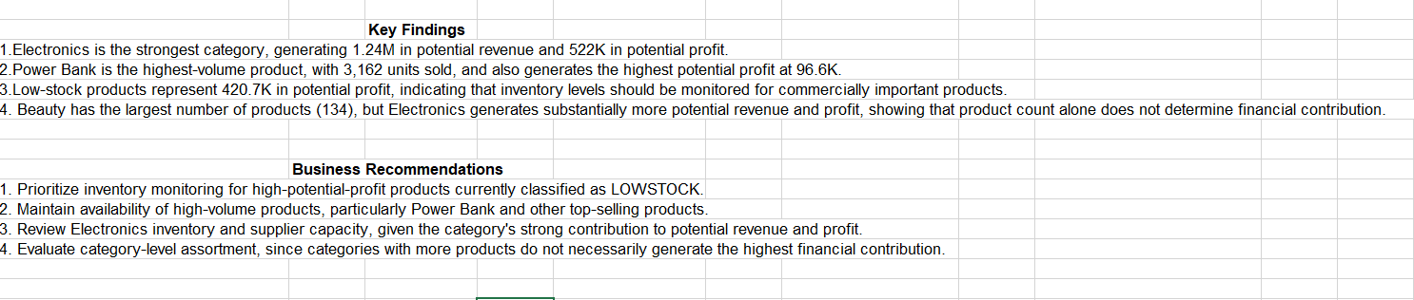
Figure 2: Retail Inventory Dashboard — Inventory Risk, Key Findings and Recommendations

The dashboard is designed to allow a decision-maker to quickly identify sales performance, financial contribution, and potential inventory risks.

6. Key Insights
The analysis produced several important business insights:
- Electronics is the strongest financial category, contributing approximately 1.24M in potential revenue and 522.1K in potential profit.
- Power Bank is a particularly strong product, ranking first in units sold and potential profit.
- High product count does not necessarily translate into higher financial contribution. Beauty had the largest number of products, while Electronics generated the highest potential revenue and profit.
- Some LOWSTOCK products contribute substantial potential profit, creating an inventory-monitoring priority.
- Supplier volume and profitability are not directly aligned. Premier Merchandise supplied the largest number of products, while Heritage Brands generated the highest potential profit.

7. Recommendations
Based on the analysis, the following actions could be considered:
- Monitor high-profit LOWSTOCK products to reduce the risk of inventory constraints affecting potential sales and profit.
- Maintain adequate stock levels for high-volume products, particularly Power Bank and other leading products.
- Review Electronics inventory and supplier capacity because of the category's strong potential revenue and profit contribution.
- Evaluate product assortment by financial contribution, rather than relying only on the number of products within a category.
- Monitor supplier performance using both product volume and profitability, since the supplier with the most products was not the supplier with the highest potential profit.

8. Limitations
The analysis has several limitations:
- Potential revenue and potential profit are calculated estimates based on units sold, retail price, and unit cost; they do not represent actual reported financial results.
- The dataset does not provide information on operating expenses, discounts, returns, taxes, or other costs that could affect actual profitability.
- Supplier lead times, minimum order quantities, and historical replenishment information were not available, so specific reorder decisions could not be determined.
- The analysis is based on the information contained in the provided dataset and may not represent the complete operational performance of a real retail business.

9. Conclusion
The analysis demonstrates how Excel can be used to transform raw retail inventory data into actionable business insights.
The results highlight strong sales and potential profitability in the Electronics category, identify high-performing products such as Power Bank, and draw attention to LOWSTOCK products with meaningful potential profit.
The combination of data validation, calculated metrics, PivotTable analysis, and dashboard visualization provides a structured approach to evaluating retail sales and inventory performance.

