Interstate Quantum Hackathon Project Report.

Title: AmineVQE: Quantum First Steps Toward Antidepressant Chemistry. Electronic and vibrational VQE for ammonia (NH₃) on two qubits.

Team name: QuantumHeal
Team members:
Mohamad Kassaee, PhD
Maryia Bairachnaya, PhD, The Douglas Research Centre (Canada, Montreal, QC), Research Associate

Submission Category: Rising Star

Summary:
• Built a real molecular model of NH₃ from 3D atomic coordinates and computed its electronic integrals with PySCF in the minimal STO-3G basis (10 electrons, 8 spatial orbitals).
• Reduced it to a small active space of 2 electrons in 2 orbitals (largely the nitrogen lone-pair region) and treated the other 8 electrons classically as a constant energy offset.
• Mapped the electronic problem onto 2 qubits using Qiskit Nature's parity mapping with known particle counts, giving a Hamiltonian of 9 Pauli terms.
• Designed a 3-parameter circuit (two RY rotations and one controlled-RY) that can represent any real two-qubit state, and optimized it with COBYLA from 3 random starting points.
• Recovered the exact ground-state energy of the reduced electronic model to within 0.008 mHa, far below our 1 mHa target.
• Extended the project to molecular vibrations: optimized the NH₃ geometry, computed its 6 vibrational modes, and scanned the energy along the N–H symmetric stretch.
• Built a 4-level anharmonic vibrational Hamiltonian, mapped it onto 2 qubits, and used the same circuit to find the vibrational ground state (zero-point energy) to within 0.01 cm⁻¹ of the exact answer.
• Showed that the starting point matters for VQE: warm starts near the harmonic ground state always converged, while some fully random starts stalled.
• Validated every step: Hermitian Hamiltonians, circuit-versus-matrix agreement, the variational bound, and agreement between the energy scan and the Hessian frequency.
• Visualized the results with convergence plots, an error chart, the vibrational potential with its energy levels, and an animation of the vibrating molecule.
• Set out next steps toward drug-relevant chemistry: methylamine, protonation, nitrogen inversion, and antidepressant fragments.

Motivation:
Many antidepressants contain amine groups, and the electronic structure of their nitrogen atom shapes how these molecules become protonated and interact with their targets in the brain. Our interests lie at the intersection of chemical engineering and the neurobiology of psychiatric disorders, so we wanted to explore how VQE and quantum computers could help describe this chemistry.
Ammonia (NH₃) is the simplest nitrogen compound and the parent structure of all amines. It is not itself an organic amine or a drug, but its small size lets us learn the full molecular VQE workflow on just two qubits before attempting methylamine or real drug fragments. We study two aspects of the molecule: its electrons, focusing on the nitrogen lone-pair region that makes amines basic, and its vibrations, focusing on the N--H symmetric stretch, a characteristic infrared signature of primary and secondary amines.
Project questions: (1) Can a simple two-qubit variational quantum eigensolver (VQE) recover the ground-state energy of a reduced NH₃ electronic Hamiltonian? (2) Can the same circuit find the vibrational ground state of the N–H symmetric stretch?
Approach and scope: We chose a problem small enough to finish and verify within the hackathon time frame, yet built from real molecular data. Every result is benchmarked against an exact classical answer, so we can state precisely how well the algorithm worked. We do not predict drug efficacy, transporter binding, amine pKa, or the energy of a real chemical bond, this project builds and validates the computational foundation for such questions.

Workflow and code:
The notebook has two parts that share one core idea: turn a piece of NH₃ physics into a 2-qubit Hamiltonian, solve it with the same circuit and optimizer, and check the result against an exact answer.

Electronic VQE (notebook Sections 1–8)
Step | Code / tool | What it does
Molecular model | PySCFDriver (PySCF) | Builds NH₃ from fixed coordinates and computes one- and two-electron integrals in the STO-3G basis with restricted Hartree–Fock orbitals.
Active space | ActiveSpaceTransformer | Keeps 2 electrons in the 2 frontier orbitals; folds the other 8 electrons and the nuclear repulsion into a constant energy offset.
Qubit mapping | ParityMapper | Maps 4 spin orbitals to qubits and removes 2 redundant qubits using the known particle counts (1 spin-up, 1 spin-down), leaving 2 qubits and 9 Pauli terms.
Exact reference | numpy.linalg.eigh | Diagonalizes the 4 × 4 Hamiltonian matrix to get the exact ground-state energy of the same reduced model.
Ansatz | make_ansatz (Qiskit) | RY on each qubit followed by a controlled-RY: 3 parameters, enough to represent any real two-qubit state.
VQE | Statevector + COBYLA | Computes the energy expectation value and lets COBYLA tune the 3 angles, from 3 reproducible random starts (seeds 7, 21, 42).
Validation and plots | assert checks, matplotlib | Checks Hermiticity, circuit–matrix agreement and the variational bound; plots convergence and per-seed errors.

The same circuit is used in both parts:
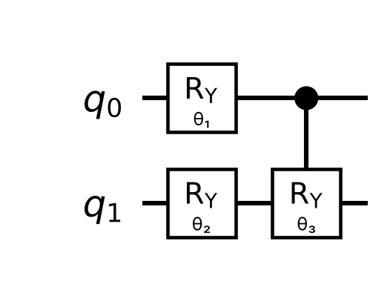
Circuit. The 3-parameter ansatz drawn by Qiskit: an RY rotation on each qubit, then an RY on qubit 1 controlled by qubit 0. The angles θ₁, θ₂, θ₃ are tuned by COBYLA.
Vibrational VQE (notebook Section 9)
Step | Code / tool | What it does
Geometry optimization | pyscf.geomopt (PyBerny) | Finds the RHF/STO-3G energy minimum, since vibrations are defined around a minimum.
Normal modes | Hessian + thermo.harmonic_analysis | Computes the 6 vibrational modes and their harmonic frequencies; the symmetric N–H stretch is selected automatically.
Energy scan | RHF single points | Computes the energy at 15 geometries displaced along the stretch (dimensionless coordinate ξ from −3.5 to +3.5).
Potential fit | numpy.polyfit (6th order) | Fits an anharmonic potential V(ξ); its curvature is checked against the Hessian frequency.
Vibrational Hamiltonian | Ladder operators | Writes kinetic plus potential energy in the harmonic-oscillator basis and keeps the 4 lowest levels (n = 0–3).
Qubit mapping | SparsePauliOp.from_operator | Binary encoding of 4 levels on 2 qubits (|n=0⟩ → |00⟩ … |n=3⟩ → |11⟩), giving 10 Pauli terms.
VQE | Same make_ansatz + COBYLA | Warm starts near |00⟩ (the harmonic ground state) and, for comparison, cold starts from fully random angles.
Validation and plots | assert checks, matplotlib | Same checks as Part A plus scan-versus-Hessian and truncation checks; plots the potential, levels, convergence, and an animation.

Results:

Electronic VQE
The reduced electronic Hamiltonian has 9 Pauli terms on 2 qubits. The best VQE run reproduced the exact ground-state energy of this model to within 0.008 mHa, and all three random starts finished below the 1 mHa target.
Quantity | Value
Hartree–Fock reference energy (full NH₃, STO-3G) | -55.45258128 Ha
Exact total energy of the reduced model | -55.45364331 Ha
Best VQE total energy (seed 7) | -55.4536353383 Ha
Best VQE error | 0.008 mHa
Errors by seed (7 / 21 / 42) | 0.008/ 0.8534 / 0.5957 mHa
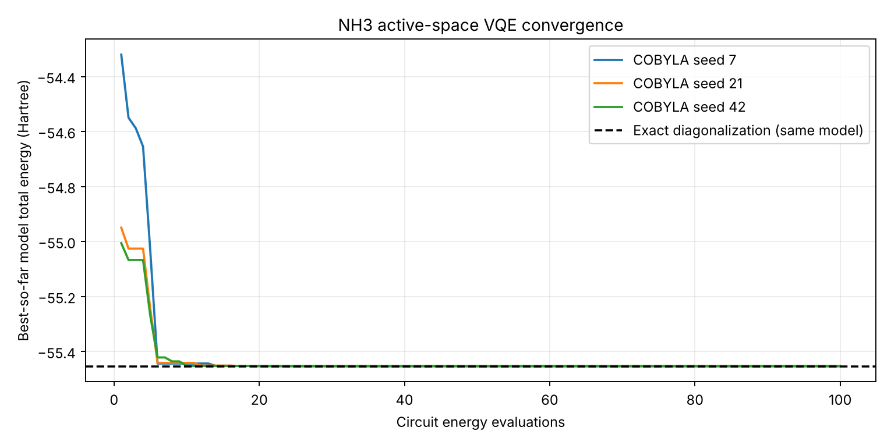
Figure 1. Electronic VQE convergence. Best-so-far total energy for each random start against the number of circuit evaluations. All runs reach the exact result of the same reduced model (dashed line) within about 15 evaluations.
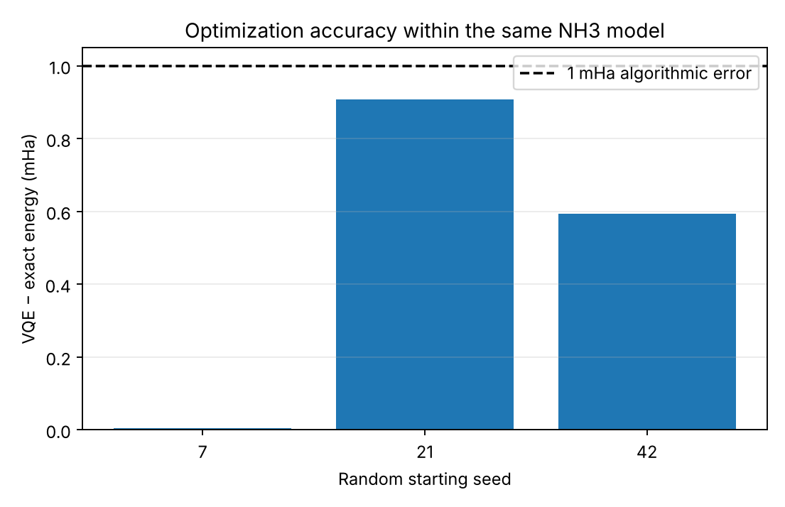
Figure 2. Electronic VQE error by starting seed, in milli-Hartree. All three runs are below the 1 mHa target; seed 7 (0.008 mHa) is too small to see on this scale.
Vibrational VQE
Geometry optimization lowered the energy by 2.84 mHa relative to our starting coordinates and gave an N–H bond length of 1.033 A. All 6 frequencies are real, confirming a true minimum. As expected for RHF with a minimal basis, the computed frequencies are higher than the measured ones.
Vibrational mode | Computed harmonic (cm⁻¹) | Experimental (cm⁻¹, approx.)
Umbrella (symmetric bend) | 1411 | 950
Asymmetric bend (×2) | 2076 | 1627
Symmetric N–H stretch (selected) | 3832 | 3337
Asymmetric N–H stretch (×2) | 4107 | 3444

The energy scan along the symmetric stretch is clearly anharmonic: compressing the bonds costs more energy than stretching them. The 6th-order fit matches the scan points to within 0.42 cm⁻¹, and its curvature gives 3831.9 cm⁻¹, in agreement with the Hessian (3831.8 cm⁻¹). Anharmonicity lowers the fundamental transition (n = 0 → 1) from 3832 to 3804 cm⁻¹.
Level n | Harmonic (cm⁻¹) | Exact, 4-level model (cm⁻¹) | Converged, 60 levels (cm⁻¹)
0 | 1915.9 | 1913.9 | 1913.9
1 | 5747.7 | 5727.8 | 5718.1
2 | 9579.5 | 9525.6 | 9493.3
3 | 13411.3 | 13949.9 | 13239.5

Keeping only 4 levels changes the ground-state energy by just 0.04 cm⁻¹, so the 2-qubit model describes the zero-point energy well; the higher levels, especially n = 3, would need more basis states. On this Hamiltonian, the same 3-parameter circuit found the vibrational ground state with an error of 0.0027 cm⁻¹. The optimized state is 99.7% |n = 0⟩, with small admixtures of higher levels caused by anharmonicity.
Starting strategy and seed | VQE energy (cm⁻¹)
Warm start, seed 7 | 1913.952
Warm start, seed 21 | 1913.956
Warm start, seed 42 (best) | 1913.962
Cold start, seed 7 | 1925.159
Cold start, seed 21 | 1913.998
Cold start, seed 42 | 1913.949
All warm starts were within 0.02 cm⁻¹ of the exact answer, while one of the three cold starts stopped above the 1 cm⁻¹ target. When the first rotation angle is close to zero, the controlled-RY angle barely changes the energy, so the landscape is flat in that direction and COBYLA can stall. Starting near the harmonic ground state avoids this, in the same way that electronic VQE usually starts from the Hartree–Fock state.
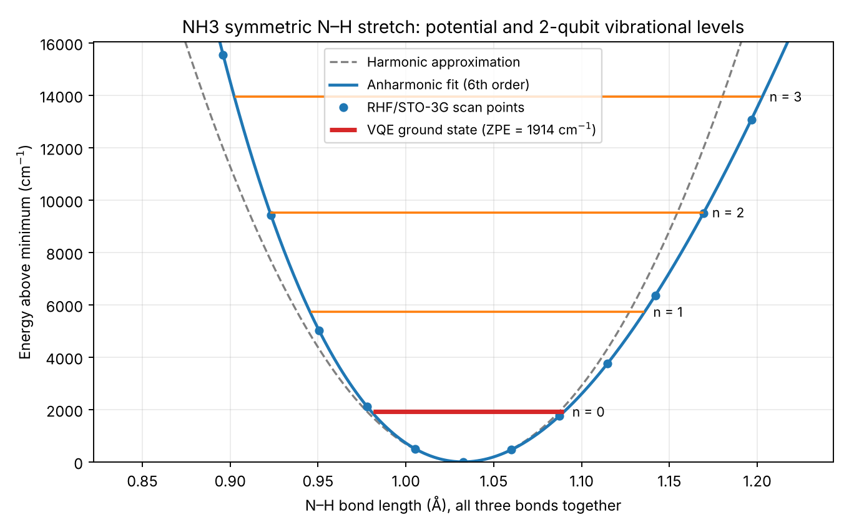
Figure 3. Potential energy along the N–H symmetric stretch, plotted against the N–H bond length. Points are RHF/STO-3G energies, the solid line is the anharmonic fit, and the dashed line is the harmonic approximation. Orange lines are the 4 levels of the 2-qubit model; the red line is the VQE ground state (zero-point energy, 1914 cm⁻¹).
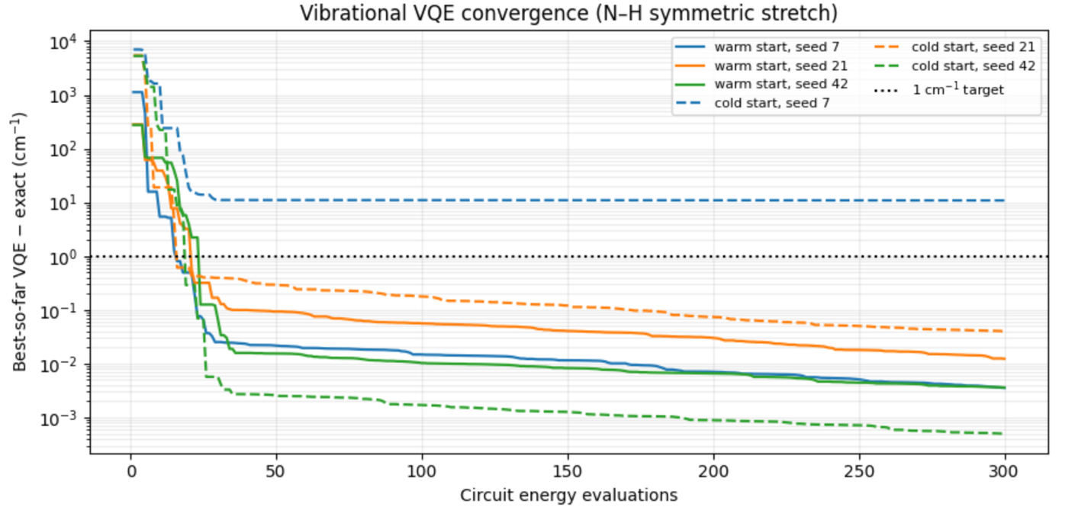
Figure 4. Vibrational VQE convergence (log scale). Solid lines: warm starts near |00⟩; dashed lines: cold starts from fully random angles. The dotted line marks the 1 cm⁻¹ target.
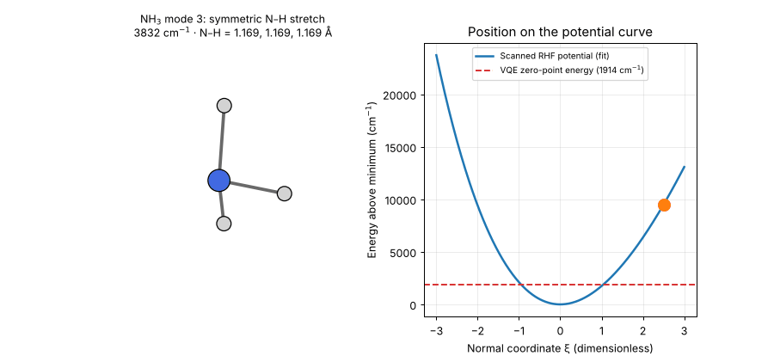
Figure 5. One frame of the notebook animation: NH₃ vibrating along its computed symmetric-stretch mode (left), with the matching position on the potential curve (right). Any of the 6 modes can be animated.

Conclusion:
We built and validated a complete VQE workflow for ammonia on two qubits. The same 3-parameter circuit recovered the exact electronic ground-state energy of our reduced model to within 0.008 mHa and the vibrational zero-point energy of the N–H symmetric stretch to within 0.0027 cm⁻¹. This gives us a tested foundation for moving toward the amine chemistry of antidepressant molecules.

Future directions toward drug discovery:
Our NH₃ pipeline is just the first step on a longer path. Each step below builds on the one before it.
Step 1. Methylamine, a real organic amine (feasible next). The natural next molecule is methylamine (CH₃NH₂), the simplest organic amine, with a real C–N bond like those in antidepressants. We would repeat the same pipeline: Hamiltonian → VQE → exact reference. The main challenges are choosing an active space that captures the chemically important orbitals, and handling a likely need for more qubits and a more specialized ansatz.
Step 2. Protonation, connecting energies to chemistry. Many antidepressants and other drugs that act on the central nervous system are protonated amines at physiological pH, which affects how they dissolve, cross membranes, and bind to their targets. Once we can model methylamine, we could compare its neutral and protonated forms. A meaningful comparison needs more than electronic energies alone: it requires a proper thermodynamic cycle that accounts for geometry changes, a reference for the proton, and the effects of solvent. Only then could the results relate to physiological pKa.
Step 3. Antidepressant fragments and drug-discovery workflows (longer term). Building on these steps, we could study representative amine-containing fragments of antidepressant molecules. Quantum chemistry calculations would then become one part of a broader workflow that includes conformer searches, solvation models, classical docking, and eventually realistic interactions with receptors and transporters.
Step 4. Nitrogen inversion (the umbrella mode). NH₃ can turn inside out like an umbrella in the wind. Along this mode the potential is a double well, which a single harmonic parabola cannot describe. The same inversion happens at the nitrogen of many amines, including drug molecules. Scanning this mode and solving the double-well problem on qubits would be a natural next vibrational study and a harder VQE test, because its ground state is no longer close to a single basis state.

Sources and acknowledgement:
- Provided lecture: vqe_lecture.ipynb, especially Part 4 — The variational principle and VQE for H₂ (workflow, optimization, and interpretation).
- Qiskit Nature: Getting started — molecular VQE workflow and parity mapping.
- Qiskit Nature: ActiveSpaceTransformer — active-space reduction.
- Qiskit Nature: ParityMapper — particle-sector-specific two-qubit tapering.
- Qiskit Nature: ElectronicEnergy — constants omitted from the qubit operator.
- IBM Quantum: Statevector — circuit expectation values.
- PySCF documentation: geometry optimization, analytic Hessian, and harmonic analysis (pyscf.hessian.thermo.harmonic_analysis).
- PyBerny: geometry optimizer called by PySCF.
- AI tools (ChatGPT (OpenAI) and Claude (Anthropic)) assisted with code and editing. All content was reviewed, tested, and validated by the team.

