**Duran, Aroma Joy B.**  BSIT 4-1

**Rabang, Mary Camille D**. ITELEC 4100 LEC

**Roca, Mario II**

**OUTPUT:**

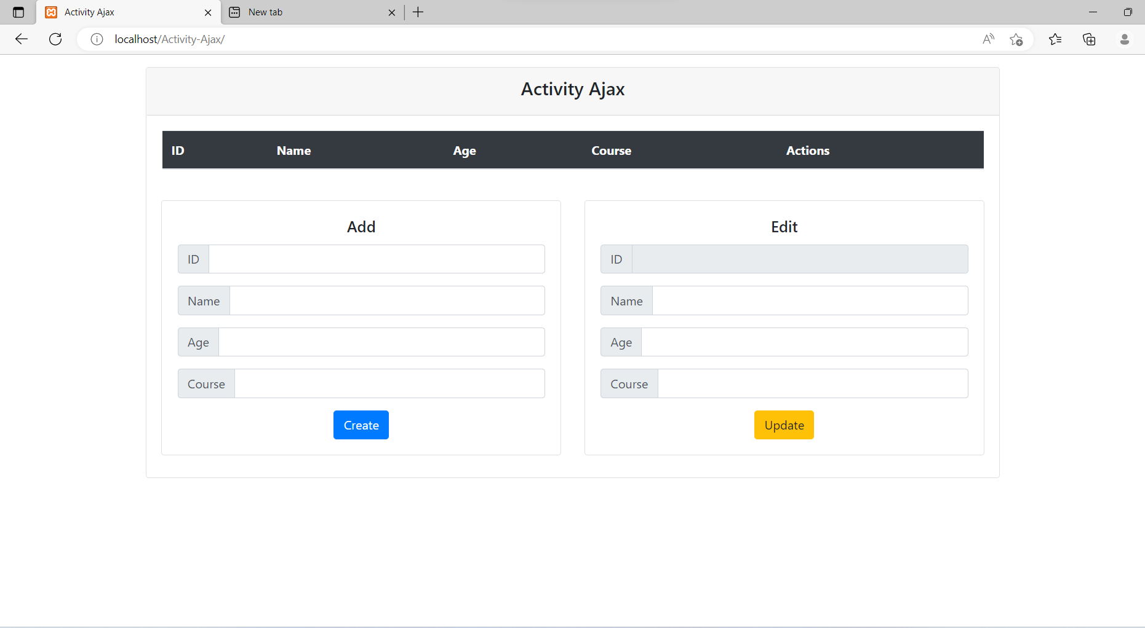

* **CREATE**

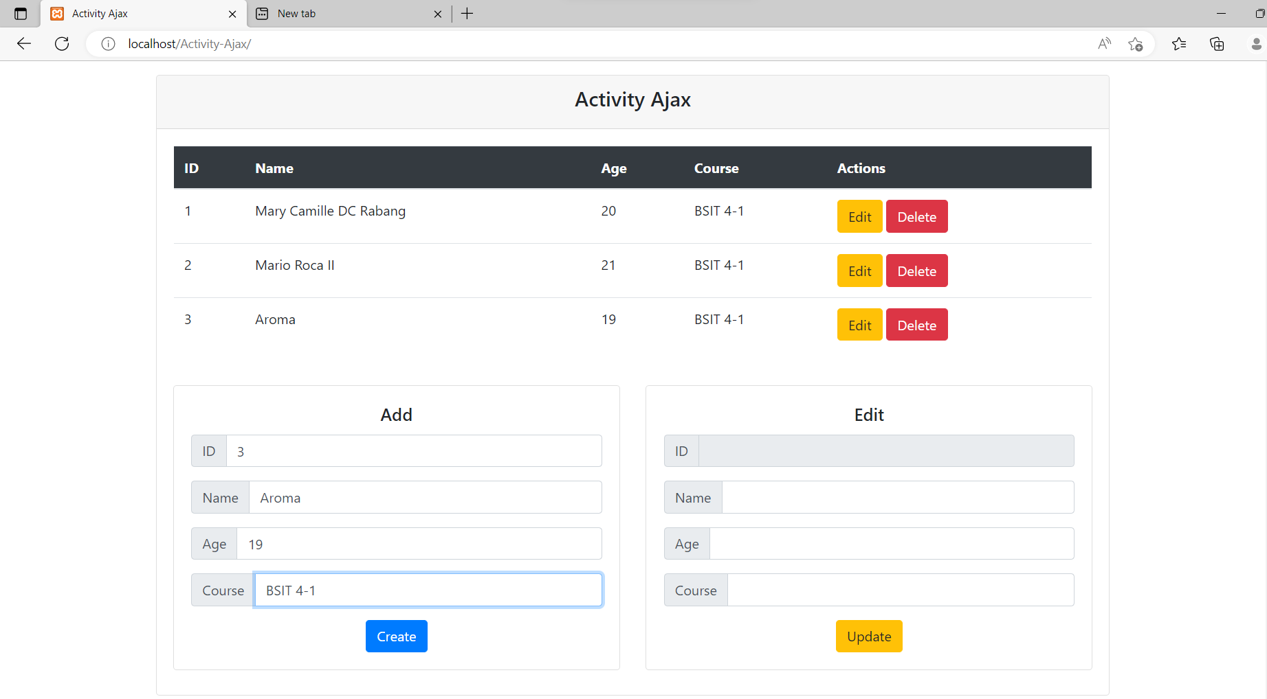

* **EDIT**

Before:

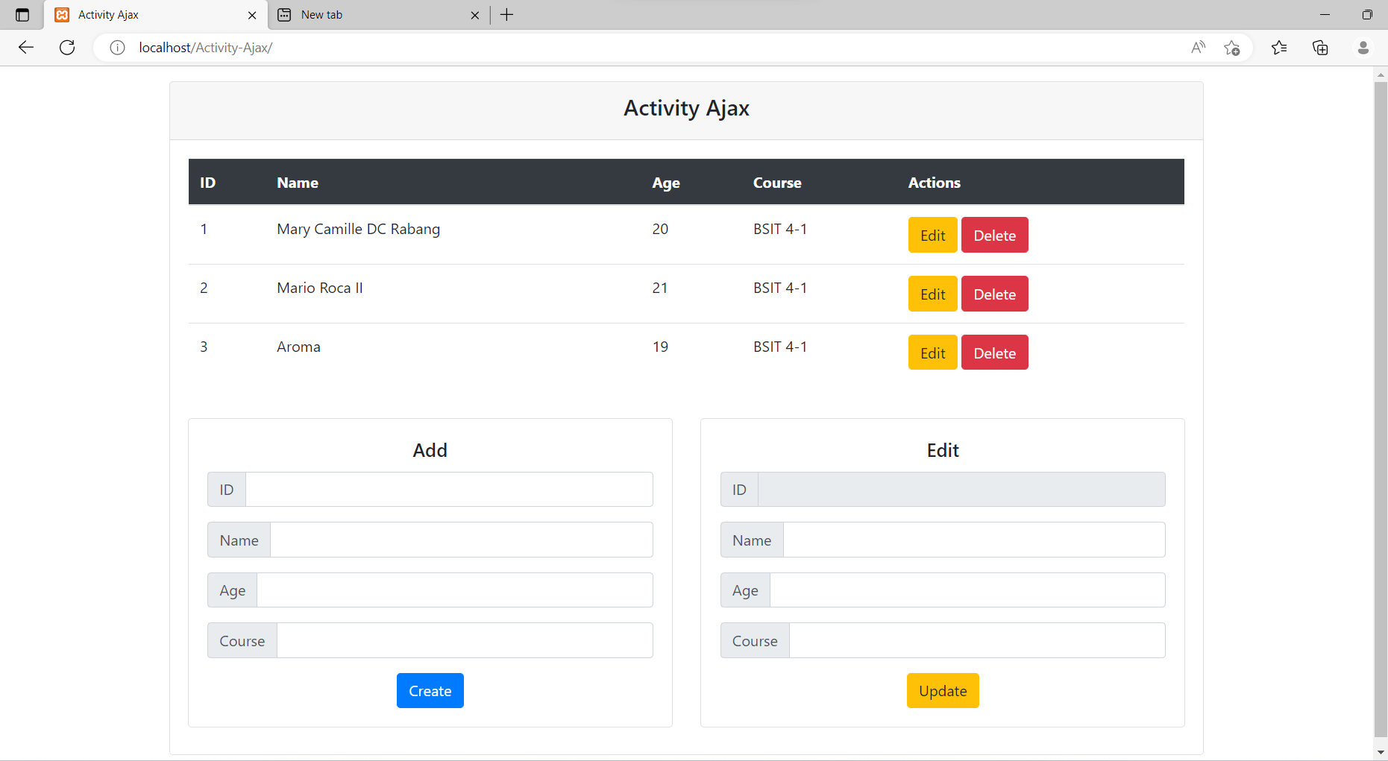

After **Update**:

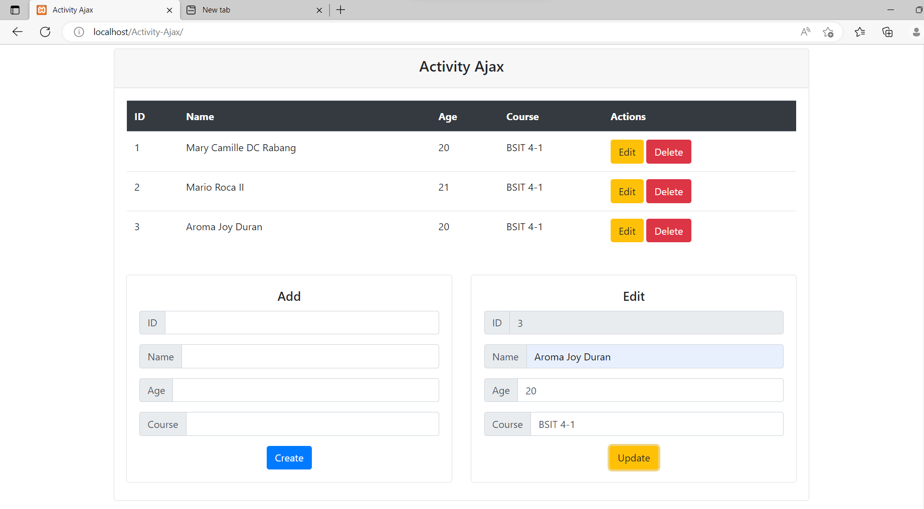

**III. DELETE**

