A Resume Generator with Augmented Reality Features

Mary Chew Jia Yi  
 Faculty of Computing  
 University Malaysia of Computer Science & Engineering  
 Cyberjaya Selangor Malaysia  
 jiayi1172@gmail.com

Ong Huey Fang  
 School of Information Technology  
 Monash University Malaysia  
 Bandar Sunway Selangor Malaysia  
ong.hueyfang@monash.edu

ABSTRACT

A resume is an essential tool for job seekers when it comes to job hunting. This paper is intended to develop a web-based resume generator alongside with augmented reality features, known as AResume. The web-based application is built for job applicants who have difficulty in creating a professional resume from scratch, as well as trying to attempt the ‘one-size-fits-all’ approach. AR.js and A-Frame are the main libraries or web AR frameworks employed in the development of AResume to enrich the experience of augmented reality. A web-based AR is developed over mobile AR because of its lightweight, cross-platform support and no installation required. A generated resume is embedded with a QR code and AR markers. The QR code could be scanned using a smartphone to direct users to the AR scanner website. Users are able to move the scanner from marker to marker to view different contents such as videos, photos, and documents. AResume not only enables job applicants to create a resume with augmented features but also provides a better user experience for hiring managers when reviewing resumes.

CCS CONCEPTS

• Human computer interaction • Interaction paradigms • Web-based interaction • Augmented reality

KEYWORDS

Augmented reality, resume, web development, marker-based, job application

ACM Reference format:

Permission to make digital or hard copies of all or part of this work for personal or classroom use is granted without fee provided that copies are not made or distributed for profit or commercial advantage and that copies bear this notice and the full citation on the first page. Copyrights for components of this work owned by others than ACM must be honored. Abstracting with credit is permitted. To copy otherwise, or republish, to post on servers or to redistribute to lists, requires prior specific permission and/or a fee. Request permissions from [Permissions@acm.org](mailto:Permissions@acm.org).

*iiWAS '20,* November 30-December 2, 2020, Chiang Mai, Thailand

© 2020 Association for Computing Machinery.

ACM ISBN 978-1-4503-8922-8/20/11$15.00  
<https://doi.org/10.1145/3428757.3429094>

Chew, M.J.I. and Ong H.F. 2020. A Resume Generator with Augmented Reality Features. In *The 22nd International Conference on Information Integration and Web-based Applications & Services (iiWAS '20), November 30-December 2, 2020, Chiang Mai, Thailand. ACM, New York, NY, USA, 5 pages. https://doi.org/10.1145/3428757.3429094*

1 Introduction

A resume or résumé is an essential tool to present one's background, skill sets and accomplishments for job applications. However, when it comes to resume screening, an employer or a recruiter typically takes about 8 to 10 seconds to screen through resumes before shortlisting candidates for interviews. Hence, an impressive and well-written professional resume is essential to make a good first impression on potential employers [1]. Nevertheless, resume writing is a challenging task, particularly for fresh graduates and most of them tend to make mistakes [2], ending up with a poorly-formatted and unprofessional resume. Moreover, some job seekers who have broad portfolios with numerous achievements, certifications, and projects would want to attempt the ‘one-size-fits-all’ approach but resulted in a lengthy resume.

The advent of the Web has made it easier for creating resumes by using an online resume generator such as NovoResume [3] and Rezumizer [4]. This study explored ways to enhance the existing systems and user experience by proposing a web-based resume generator with augmented reality (AR) features, known as AResume. It is an application for job seekers who have difficulties in creating a professional and informative resume from scratch. The main advantage of AResume compared with others is the capability to upload digital media as AR features for highlighting their achievements, certifications, projects and other information. AR is a technology that provides interactive experiences and displays 2D or 3D computer-generated perceptual information that overlays in the real-world environment.

A web AR is implemented in this project instead of mobile AR as it is lightweight, supports cross-platform and does not require installation. Besides, the performance of rendering AR features can be leveraged by offloading the application's computational tasks into the cloud. In the development, PHP, JavaScript and CSS are the main languages. In addition to that, AR.js and A-Frame are chosen as the web AR framework employed, and 000webhost is a free cloud service platform used for offloading the application into the cloud. AResume is expected to provide better user experience not only for job applicants but also for hiring managers when screening resumes.

The rest of the paper is organised as follows. First, Section 2 gives an overview and discusses some of the related works. Section 3 presents the findings from the survey analysis and user requirements. Then, the proposed AResume’s design is presented in Section 4. Subsequently, Section 5 concludes this paper.

2 Related Works

AR provides users with a sensory experience beyond reality by seamlessly integrating virtual contents with the real world. AR evolves historically from the year of 1996 till today that emerges the dedicated AR devices and powerful development kits as well as improves the performance of mobile devices and sensor integration and advances in computer vision technologies. AR has brought benefits to fields like entertainment, advertisement, education, navigation and maintenance. Pokemon Go, a location-based AR game has been prevalent till now since its public release in 2016. Along with that, Web AR is the latest technology nowadays and is gradually emerging as a promising direction for mobile AR [5].

There are two dominant platforms for mobile AR applications, which are hardware-based and app-based. The current mobile AR hardware and operating systems that comprise of Embedded Linux, Android and iOS present a complex diversity. Mobile AR has different implementation mechanisms such as the sensor-based, vision-based and hybrid tracking methods. A sensor-based method is a lightweight approach where mobile devices support sensors like accelerometers, gyroscopes, compasses, magnetometers and GPS. The vision-based mechanism is where the camera provides the basis for vision-based object recognition, detection and tracking, which supports both marker-based and markerless methods. The marker-based method uses a predefined marker to meet the tracking requirement, whereas markerless method detects and understands an unknown or outdoor real-world environment. It is currently using SLAM and collaborates it with other sensors to face the obstacle of computational inefficiency and limitations of the resources of mobile devices. Hybrid tracking mechanism combines different methods that increase the complexities of networking, storage and computational compared to the other mentioned mechanisms.

However, there are some downsides of mobile AR. The hardware-based implementation is costly, and lack of flexibility, whereas the app-based requires additional downloading and installation. Most of these applications or solutions are designed based on a specific platform that causes the inconvenience for cross-platform deployment. An AR application needs to go through repeated development cycles to accommodate different platforms and undoubtedly increases the cost of development and deployment [5].

The birth of web AR is known to be a promising future direction for mobile AR. It is because of its lightweight, native cross-platform features and pervasive service provisioning of mobile AR. The invention of the World Wide Web (WWW) makes the web AR possible. The idea of using the web in the technology of AR is that the web simplifies the service access for users, for example, Facebook and Snapchat which they are designed in a hybrid way (native + web) way that provides a good interaction experience and cross-platform support.

However, there are some challenges when AR meets the web in real life. Compared to mobile AR, web AR has limited computing and rendering capability that causes the degradation of the performance of web AR. It also hinders the fiducial tracking method that provides an accurate and robust tracking approach for web AR applications. Markerless mobile AR implementation is to be ported to the web. Another challenge of web AR is network delay. When web AR application is deployed into the cloud server, there are substantial communication delays, due to the limited data rate and unacceptable network delay which causes the difficulty for current mobile networks to support real-time operations like tracking and interaction.

Besides, web AR is a power-hungry application due to limited battery capacity. The need for the sensors to cooperate over a long period, the analysis of the information, computing, communication and display put tremendous pressure on the battery of the mobile device. Hence, the extreme energy consumption hinders the deployment of web AR. Also, diverse enabling infrastructures cause a compatibility challenge in terms of display platforms, operating systems and data formats. Besides, it is also challenging for the development of web AR when it comes to supporting different sensors, display platforms and OS. The virtual contents created by different tools also cause compatibility issues.

Regardless of the issues mentioned, two approached solutions can solve the issues. Both limited computing capability and limited battery capability can be resolved by offloading computation-intensive tasks to the remote cloud. It will accelerate the performance of web AR applications. Since they are dependent on mobile networks, the ‘browser + cloud’ approach causes high latency and communication delays. It happens when getting data from the cloud server. However, it can be resolved by the 5G network, the upcoming advanced network technology in the future that provides higher bandwidth (0.1 – 1 GB/s) and lower network delay (1 – 10 ms), which improves data transmission on mobile networks [5]. With the 5G network, a new paradigm which is called mobile edge computing provides cloud computing capabilities at the edge of networks that is close to mobile users and greatly reduces network latency [6]. However, the deployment of web AR applications into the cloud server requires a high monetary cost.

**Table 2.1: A comparison between existing similar resume generators and AResume**

|  |  |  |  |
| --- | --- | --- | --- |
| **Features** | Image result for novoresume logo | Image result for resumizer logo |  |
| Cross-platform support | x | x | √ |
| Web AR support | x | x | √ |
| Digital media upload | √ | x | √ |
| Produce augmented contents | x | x | √ |
| Free hosting for AR apps | x | x | √ |
| Free publication for AR apps | x | x | √ |
| Marker-based support | x | x | √ |
| Generate sharable URL | √ | x | √ |
| Create augmented resume | x | x | √ |

Some existing software applications have been developed to create resumes, business cards and the like. Some of them have integrated with the AR technology. Each of them has their functionalities, advantages and disadvantages as well. Table 2.1 above shows a summary of the comparison among the applications. It shows the features covered by each application.

3 Requirement Analysis

3.1 Survey Analysis

A survey was conducted to acknowledge the opinions and needs of general users regarding AResume. The number of respondents was 50 in total. Figure 3.1 shows the importance of information that should be displayed as AR in a resume. Based on the figure, the ‘very important’ and ‘important’ responses outnumbered the ‘less important’ and ‘not at all important’ for all types of information. It explains the importance and interest of the respondents on having AR capability in a resume generator. In general, most respondents believe AR is more important for transcripts, certificates and photos than videos, social media, and websites.

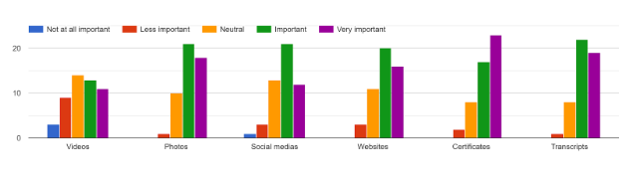

Figure 3.1: The importance of information displayed with AR

Similarly, Figure 3.2 below indicates the preference of features proposed in AResume. Such features are importing information from LinkedIn, generating sharable URL for a particular resume, creating an augmented resume, exporting resume into different file formats as well as scanning the resume to view the augmented contents. None of the respondents expressed dislike on any of the proposed features.

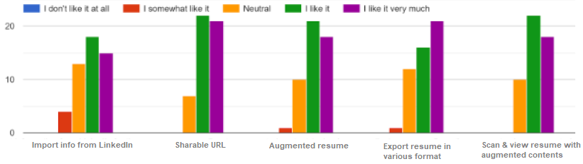

Figure 3.2: Preference of the proposed features in AResume

3.2 Functional Requirements

Figure 3.3 below shows the functional user requirements proposed for AResume using a use case diagram. A job applicant has access to functionalities: create a user account, choose a resume template, build a resume, upload digital media, view generated sharable link, scan markers on the generated resume, export resume into different file formats, download resume, edit and delete resume.

Apart from that, non-functional requirements were also taken into consideration when it comes to software development. AResume is a web AR application which is lightweight and has less computational tasks. When scanning the resume, the application should respond to any user interaction such as playing video, navigating to another URL, and displaying AR contents within 5 seconds or less.

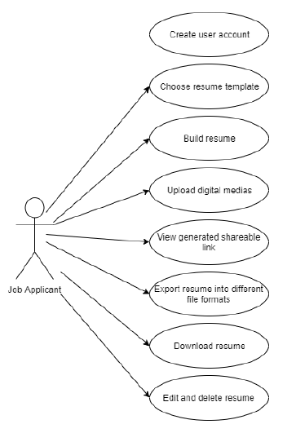

**Figure 3.3: The use case diagram for a job applicant**

4 The Proposed AResume

4.1 Architecture

Figure 4.1 below is the component diagram of AResume, which explains the overall system architecture. Users could input data in various format such as text, video, photos and documents for a particular resume through the web application in a browser. All the data are stored in the database hosted on the cloud. The web application and database is hosted with 000webhost that provides free web hosting. Through the web application, users could then be able to view information on the resume.

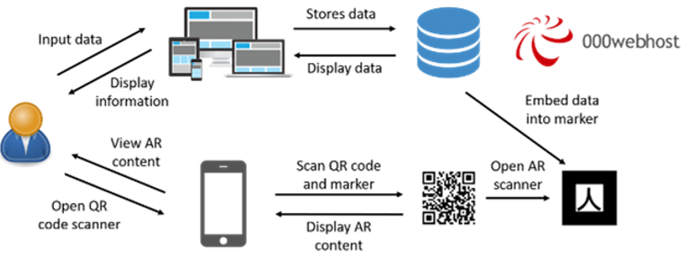

**Figure 4.1: AResume system architecture**

PHP, JavaScript and CSS are the main languages to develop this application together with AR.js and A-Frame libraries. The frontend design heavily relies on Bootstrap library and this application is hosted in 000webhost server integrated with MySQL database. All the information like personal information, education, work history, awards and activities (text, number, date, image, video) are stored in the database. Each generated resume is attached with a QR code (using a QR code generator API [11]) that embeds a URL for users to open AR scanner. Users are required to open a QR code scanner from a smartphone to scan the QR code on the resume and will be directed to the AR scanner. Based on the particular resume of a particular user, with the help of AR.js and A-Frame libraries, each digital media from the database can be seen as AR content that shows up in the smartphone when users move the phone around while scanning the AR markers. The web AR feature is supported across different mobile devices such as Android, iOS and Windows. This is a marker-based AR feature, hence it is lightweight and does not consume much CPU.

AR.js is an efficient AR solution on the web, which means it makes the web AR possible. It is efficient because it is faster than its predecessors. This framework has both WebGL and WebRTC that allow AR to be accessible in any mobile devices, even phones and laptops. It is an open-source tool, thus could still extend AR’s reach to all devices without demanding high system requirements [7]. AR.js only supports a marker-based application. Hence, developers are free to customize markers for development use. There is a marker generator called AR.js Marker Training [12] specifically for marker personalization. This marker generator only supports two types of markers which are pattern and barcode [8]. The marker generated is used in the resume and need a URL to it.

On the other hand, A-Frame is an open-source web framework to build virtual reality experiences. It is an entity-component built on top of Three.js as well as HTML, and it is pretty simple for developers to build web VR applications. The features of A-Frame are optimized performance, declarative HTML, entity-component architecture, as well as cross-platform support. It also has components available such as animations, lights, materials and geometries [9]. A-Frame is chosen to work with AR.js because it builds 3D scenes for the web [10]. It is useful to use this framework in AResume to load the components in the application.

There are a few custom markers on a resume after a resume is generated. Each marker is built using marker generator at [12]. To create a custom marker, upload an image and just download a generated pattern file (in .patt format) and a trained marker, followed by including the pattern filename and trained marker’s source location inside the code.

4.2 User Interfaces

Figure 4.2 and Figure 4.3 show the basic user interfaces for AResume. Users could start by signing up to an account, choosing a template, providing their personal information and choosing to edit or export their resume in the dashboard. They could also upload a video such as a self-introduction or other relatable information. Those who involve in creative arts, video is a great way to showcase their artworks. However, video is optional. Besides, there is a resume completion progress bar to show the completion progress.

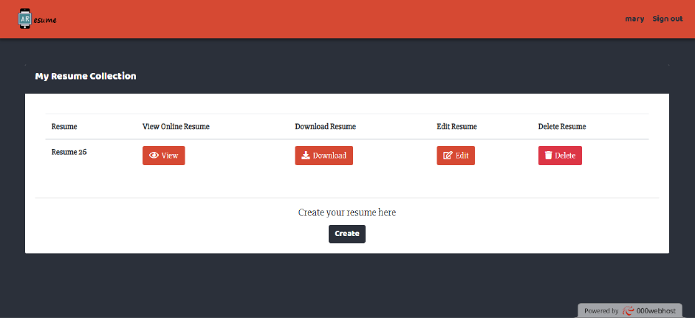

**Figure 4.2: User’s dashboard**

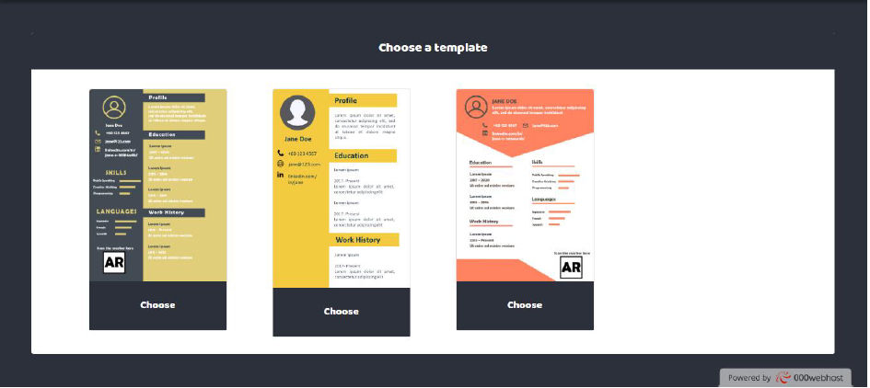

**Figure 4.3: Choose a template for a resume**

Figure 4.4 shows an online resume with a generated URL. When a resume is generated, a URL or link is generated for the particular resume. It is to allow users to share the URL of their resume and send it to the other people or hiring manager. In each resume, there is one QR code and a few AR markers. The QR code is embedded with AR scanner website URL, which requires users to open the QR code scanner using their smartphone. Each AR marker on the resume stores different contents of different sections.

Figure 4.5 illustrates the scanning process to open the AR scanner URL. First, open the QR code scanner of a smartphone to scan the QR code in the resume. It directed users to the AR scanner website and an instruction of how to scan the markers in the resume appeared in an alert box. Figure 4.6 shows an example of an AR display on the smartphone. When the AR scanner detects one of the markers, the AR content will appear. When a marker is not detected, the content will disappear.

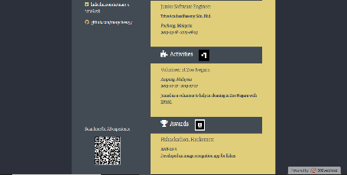

**Figure 4.4: Example of an online resume with generated URL**

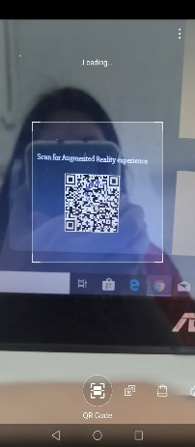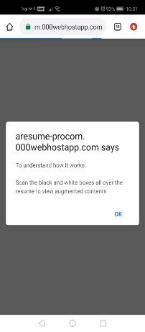

**Figure 4.5: The scanning process**

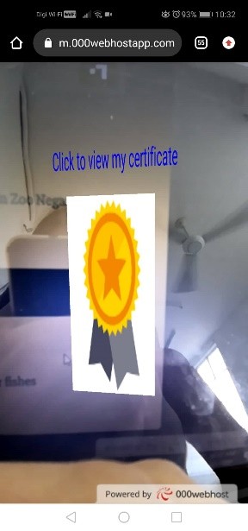

**Figure 4.6: A sample of AR display on a smartphone**

4.3 Evaluation

User acceptance testing was performed by the end-users to evaluate if the system can handle the tasks in real scenarios based on user requirements. The test results showed that the proposed application passed all the test cases. All the UAT testers were asked one question, which is the speed of loading the AR content. Majority of them scanned the markers, and the AR contents could show up within seconds. One of the testers, who is an iPhone user, mentioned that the speed of loading the AR content in his phone was quite fast, which was less than a second, despite using a 4G network.

Using AResume, a resume was successfully generated with AR markers attached to the resume. When scanning the resume, the QR code was successfully scanned and directed to the AR scanner website. There are several markers on the resume. Each marker contains different content. The AR scanner is able to scan each marker with different content appeared. Despite that, the size of the marker affects the AR output. The bigger the marker, the higher the possibility of the AR content to appear.

5 Conclusion

Building a resume is a tedious work as it includes the processes of drafting, formatting and writing. These processes may lengthen the time needed for creating a professional resume. Currently, there are some ways of building a resume, such as using an online resume generator or using Microsoft Word’s template. However, these kinds of tools could not help to encounter the problems of building a resume. This paper proposed a web-based resume generator with additional features of AR. Resume with AR feature enhances the attractiveness and interactivity of a resume and is more convenient for employers to view all the achievements and certifications of the applicants, without the necessity for job applicants to bring transcripts and certificates for the job interview. Job applicants could upload any digital medias such as videos, documents and pictures that act as augmented media when they scan the embedded markers on the resume, whether online or offline. The proposed architecture and technologies employed to develop AResume give an initial and better understanding of how AR could benefit in resume generation and future similar works.

REFERENCES

1. Roo, J. (2015). *The Importance of a Well Written Professional Resume | Roo Resumes*. Retrieved from https://www.linkedin.com/pulse/importance-well-written-professional-resume-roo-resumes-judi-roo/.
2. Mustafa, Z. (2018). *Writing a resume: Art of your ownself*. Retrieved from https://www.nst.com.my/education/2018/11/429011/writing-resume-art-your-ownself.
3. Resume Builder for 2020: Free Resume Builder. (n.d.). Retrieved from https://novoresume.com/
4. Free Resume Creator Online. (n.d.). Retrieved from https://resumizer.com/
5. Qiao, X., Ren, P., Dustdar, S., Liu, L., Ma, H., & Chen, J. (2019). Web AR: A Promising Future for Mobile Augmented Reality-State of the Art, Challenges, and Insights. *Proceedings of the IEEE*, *107*(4), 651–666.
6. Qiao, X., Ren, P., Dustdar, S., & Chen, J. (2018). A New Era for Web AR with Mobile Edge Computing. *IEEE Internet Computing*, *22*(4), 46–55.
7. Bhatt, T. (2018). *The Fundamentals of Developing Augmented Reality for Web With AR.js*. Retrieved from https://dzone.com/articles/the-fundamentals-of-developing-augmented-reality-f
8. Etienne, J. (2017*). Creating Augmented Reality with AR.js and A-Frame – A-Frame*. Retrieved from https://aframe.io/blog/arjs/
9. Introduction – A-Frame. (n.d.). Retrieved from https://aframe.io/docs/0.9.0/  
   introduction/
10. Huynh, C. (2019). *My first steps with the Web AR*. Retrieved from https://www.siclo-mobile.com/my-first-step-with-the-web-ar
11. Goqr.me. (2020). *QR Code API*. Retrieved from http://goqr.me/api/
12. Jeromeetienne.github.io. (2020). *AR.Js Marker Training*. Retrieved from https://jeromeetienne.github.io/AR.js/three.js/examples/marker-training/examples/generator.html

Conference Name:ACM Woodstock conference

Conference Short Name:WOODSTOCK’18

Conference Location:El Paso, Texas USA

ISBN:978-1-4503-0000-0/18/06

Year:2018

Date:June

Copyright Year:2018

Copyright Statement:rightsretained

DOI:10.1145/1234567890

RRH: F. Surname et al.