

**INDUSTRIAL TRAINING HANDBOOK**

*The guidelines in this Industrial Training Handbook are only applicable to* ***Bachelor of Computer Science (Hons)*** *and* ***Bachelor of Software Engineering (Hons)*** *at University Malaysia of Computer Science and Engineering.*

Version 1.0  
September 2019

1. **INTRODUCTION**

The Industrial Training is a compulsory course of degree programmes, which enables students to practice the subjects that have been studied in real working environment. University Malaysia of Computer Science & Engineering (UNIMY) aims to provide opportunities for students to gain industry experiences and to strengthen their skills and knowledge in their chosen field of study. Students are also encouraged to build soft skills and professionalism through interaction and communication with colleagues and people in the industry.

1. **LEARNING OUTCOMES**

At the end of the Industrial Training, students will be able to:

* carry out duties and responsibilities as a worker in the ICT sector;
* apply the skills and knowledge acquired during their studies;
* train self-discipline and ethical conduct in executing daily tasks.

1. **DEFINITIONS**

Term used in this handbook are explained in Table 1.

Table 1: Terms used in this handbook

|  |  |
| --- | --- |
| Industrial Training | A compulsory course in the degree curriculum at UNIMY, which includes the Bachelor of Computer Science (Hons) and the Bachelor of Software Engineering (Hons). Students shall be in the third year of study and completed their final year project to be eligible for industrial training. Students shall be placed at selected organisation for a period of 24 weeks. |
| Faculty Coordinator | The industrial training related activities are monitored and convened by the Faculty Coordinator(s), who is accountable to the Faculty Academic Committee. |
| Faculty Supervisor | Facilitate and guide the students during the industrial training and evaluate students’ performance and report. |
| Host organization | A specific company/organisation where placement(s) is provided to selected student(s) for doing his/her industrial training. |
| Organisation Supervisor | The direct supervisor of the student in the host organisation, where he/she undergo the industrial training. The Organisation Supervisor is responsible for facilitating and guiding the student throughout the training and will evaluate the student performance. |

1. **ASSESSMENT**

Students will be graded in their industrial training course based on the assessment components stated in Table 2.

Table 2: Assessment Components

|  |  |  |
| --- | --- | --- |
|  | **Component** | **Percentage** |
| 1. | Organisation Assessment | 40% |
| 2. | Industrial Training Report | 40% |
| 3. | Log Book | 20% |
| **TOTAL** | | **100%** |

* 1. **Organisation Assessment**

The Organisation Assessment Form will be provided by the Faculty to the host organisation. The Organisation Supervisor should fill in the report to assess or evaluate the performance of the student throughout the training. The report should be sealed and submit back to the Faculty Coordinator by hand or fax or email.

* 1. **Industrial Training Report**

The Industrial Training Report is part of the assessment component for the Industrial Training. Students are required to write a complete report and should submit it together with Logbook to the Faculty Coordinator not later than **two (2) weeks** before the training has been completed. The report must be in high-quality following the guidelines and formats set by the Faculty. It should explain the industry experiences, knowledge and skills gained throughout the industrial training. The guidelines for the Industrial Training Report can be found at **Appendix A**.

* 1. **Logbook**

The logbook is an important and meaningful collection of students’ work throughout their industrial training. A logbook can be used to record ideas, reflections, observations, contributions, skills acquired, tasks and duties performed, as well as the learning and problem-solving process. It is a good practice for students to update their logbook on a daily basis and to get their Organisation Supervisor verification on a weekly basis. It should be appended in the Industrial Training Report and submit to the Faculty Coordinator not later than **two (2) weeks** before the training has been completed. The weekly logbook form can be found in **Appendix B**.

1. **INDUSTRIAL TRAINING PROCEDURES**

There are three main phases of Industrial Training, and the process in each phase are described in the following sections. A summary of the Industrial Training Process Flow can be found at **Appendix C**.

* 1. **Before Industrial Training**

1. A briefing on Industrial Training will be conducted by the University, and it is compulsory for all eligible students to attend.
2. The students need to fill in the Industrial Training Registration Form (see **Appendix D**) and submit their cover letter and resume to the Faculty Coordinator. Students are responsible for producing a high-quality cover letter and resume to increase their chances of getting an industrial placement. Once approved, the University will issue official verification letter to the students for job application.
3. The students should identify prospective organisations for Industrial Training with full-time placement and relevant to their programme of study. A list of UNIMY’s industrial partners will be posted, and the University will assist every eligible student to arrange a placement with the partner. The organisation may interview, or just accept the student sent by the University. However, once the arrangement is done, the student must accept the offer unless he/she drops the course in the semester. If any students need the University assistance in arranging an industrial training placement, they must inform the Faculty Coordinator at least 3 months before the commencement of actual Industrial Training.
4. Alternatively, eligible students may approach the organisations they are keen to work with and apply for an industrial training placement on their own. If any students choose to do so, they must inform the Faculty Coordinator before applying to avoid any complications.
5. The students must inform the Faculty Coordinator their appointment with an organisation as soon as they receive it. Students are also required to fill in the Industrial Appointment Form (see **Appendix E**) and submit to the Faculty Coordinator.
6. If any students fail to secure an industrial training placement by the deadline stated by the University, they should inform the Faculty Coordinator at least 2 weeks before the commencement of actual Industrial Training, so that the University can try to help in any way possible.
   1. **During Industrial Training**
7. The Industrial Training period takes place for 24 weeks. During this period, the students are required to undergo training and performing all the duties and responsibilities assigned by their placement organisation.
8. Each student should be supervised by the host organisation designated supervisor. Besides, the progress of each student will be monitored and supervised by the faculty supervisor.
9. The students might be subjected to site visits by their Faculty Supervisor or the Faculty Coordinator with or without prior notice.
   1. **After Industrial Training**
10. Assessment will be done on the students’ Industrial Training based on the assessment schemes set by the Faculty. Every student and host organisation must submit all the required documents by the deadline stated by the University.
11. Each student should submit the Industrial Training Report and Log Book to the Faculty Coordinator.
12. Each host organisation should also fill in the Organisation Assessment Form and submit back to the Faculty.
13. **GENERAL RULES & REGULATIONS**
14. Only one industrial training placement for each student is allowed.
15. The students are **NOT ALLOWED** to change their industrial training placement once confirmation has been made with the University and after the submission of Industrial Training Appointment Form unless under exceptional cases with the approval of the University.
16. The students **MUST** abide by the code of conduct of UNIMY.
17. The students **MUST** abide by the rules and regulations of the organisation.
18. The students **MUST** behave properly and dress professionally.
19. The students **MUST** be punctual for work and adhere to the working hours as specified by the organisation
20. The students **MUST** obtain approval from the Organisation Supervisor before going on leave and **MUST** record it in the logbook with evidence (e.g. medical certificate).
21. The students are responsible for his/her own expenses, including the cost of accommodation and transportation during the industrial training.
22. Failure to submit all the required documents within the stipulated time and date by the Faculty will cause the student fail the course.
23. Inform the Organisation Supervisor and Faculty Coordinator for any problems that occurred during the training.
24. The students shall be liable for and will indemnify the company against any liability, loss, claim or proceeding in respect to personal injuries (whether fatal or otherwise) to the student or anyone or property damage arising caused by any negligent act or omission on the student part during the period of industrial training in the organisation.
25. The students are reminded to uphold the good name of the University and should promote a good relationship between UNIMY and the organisation.

**APPENDIX A**

**GUIDELINE FOR INDUSTRIAL TRANING REPORT**

The report must be word-processed, and produced to a professional standard, and it should contain the following:

* A cover page (see next page)
* Table of contents
* List of figures and tables (if applicable)
* Section A, B, C & D
* List of references (if applicable)

The report should encompasses the following FOUR sections:

**SECTION A: OVERVIEW OF THE HOST ORGANISATION (20 MARKS)**

* Explain about the host organisation’s background, core business, vision, mission, and organisation’s structure.
* Explain about the department/division/unit/team in which your industrial training takes place.
* Analyse the customers and product/services that are related to the department/division/unit/team you are in (whichever applicable).

**SECTION B: INVOLVEMENT DURING THE INDUSTRIAL TRAINING (35 MARKS)**

Explain the significance of the tasks that you perform in your host organization, covering the following points:

* Explain the projects/tasks that you are involved in, the role that you play and the tasks that you performed in your organization/department/team.
* Explain experiences, skills and knowledge gained throughout the period of industrial training.
* Explain the significance of your contributions to your host organization / department/team.
* Describe if you have been provided with training or were given adequate chances to learn.

**SECTION C: REFLECTION OF THE INDUSTRIAL TRAINING (25 MARKS)**

* Determine and explain which theories, techniques and knowledge that you have acquired in your studies has applicability in the task assigned.
* Explain the problems that you have encountered at the workplace. Explain how you have rectified these problems, or if they are to date still unresolved, recommend what can be done about them.
* Describe what are the new skills, technologies, or knowledge of the field you have learned from your supervisor, workers or reference in workplace.

**SECTION D: CONCLUSION (15 MARKS)**

* State overall achievement and overall task performance during the Industrial Training.
* Explain in your opinion, how this industrial training benefited you as a student.
* Provide opinion and suggestion on how to improve the industrial training in future.

|  |
| --- |
| The report format and presentation should follow UNIMY’s thesis writing guideline **(5 MARKS)** |



**FACULTY OF COMPUTING**

**INDUSTRIAL TRANING REPORT**

BY

STUDENT’S NAME

YEAR

PROGRAMME NAME

TRAINING PLACE :

TRAINING PERIOD :

ORGANISATION SUPERVISOR :

FACULTY SUPERVISOR :

**APPENDIX B**



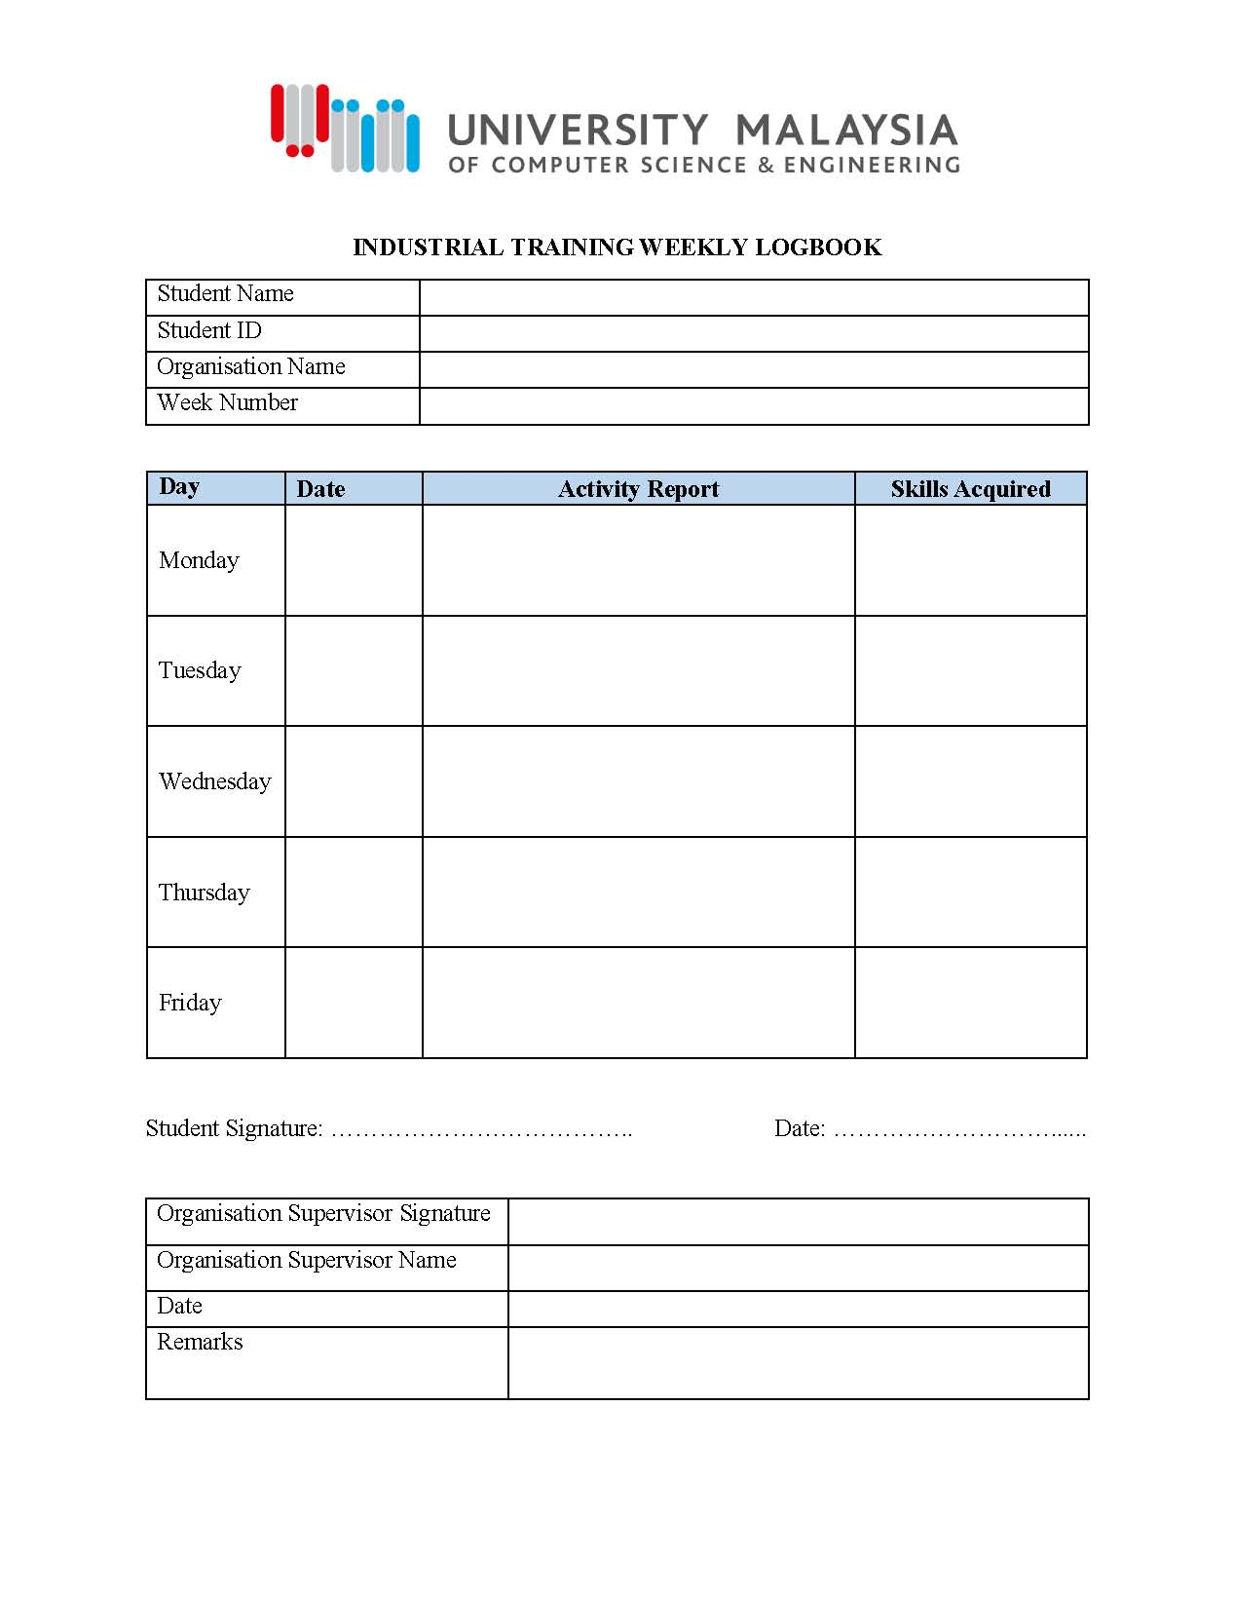

**APPENDIX C**

**INDUSTRIAL TRAINING PROCESS FLOW CHART**

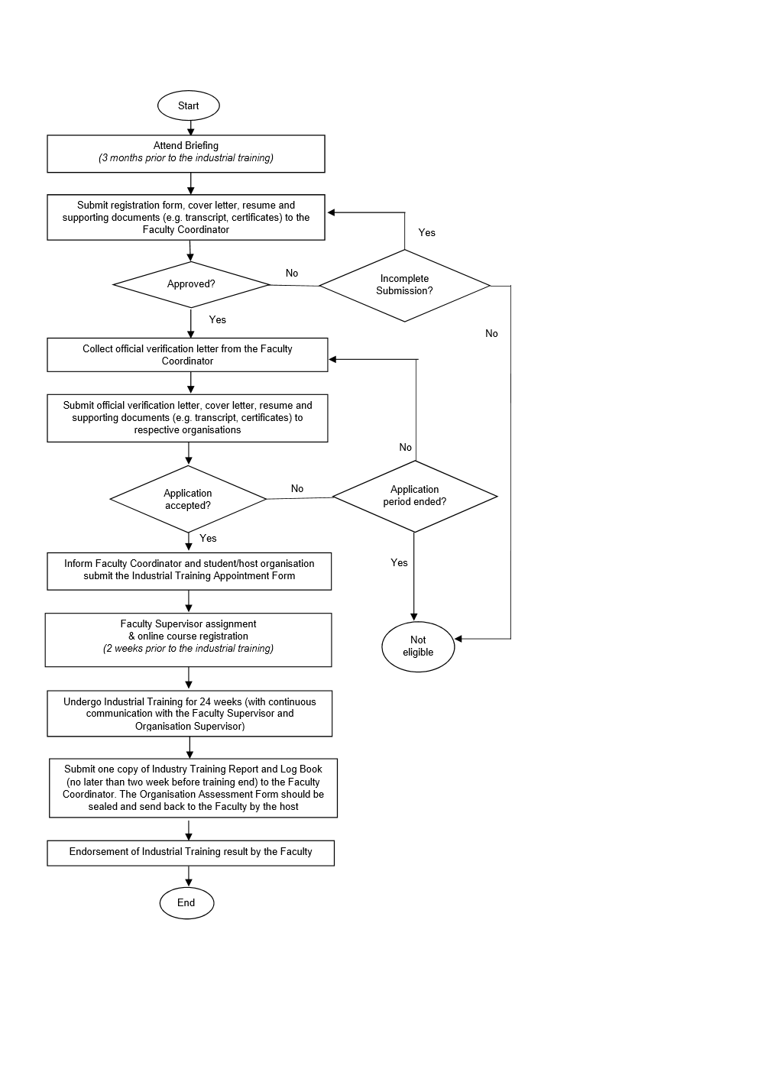

**APPENDIX D**



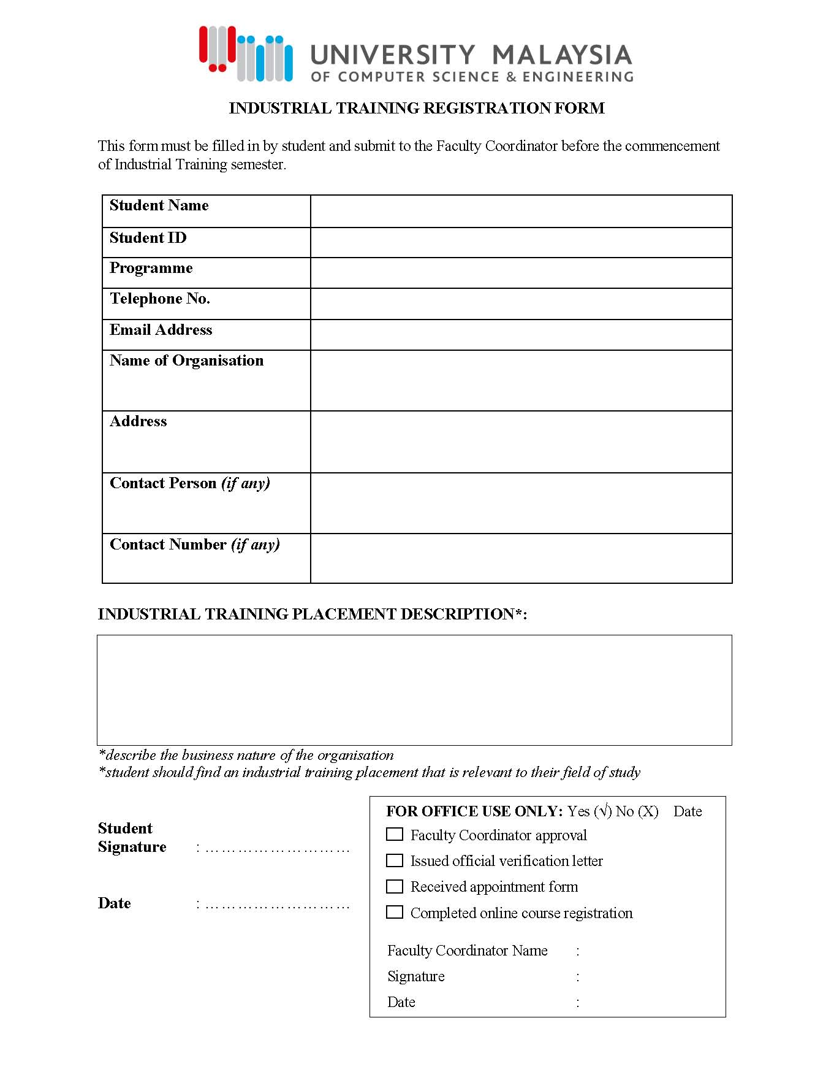

**APPENDIX E**



