**Effects of Online Learning Engagement Techniques for a College Stress Reduction Module**

MaryClare C. Colombo & Paige H. Fisher, Seton Hall University

**Abstract:** Engagement strategies such as retrieval practice, feedback and visual aids can enhance learning in traditional settings, but little is known about their impact on virtual learning. The current study assesses efficacy of engagement strategies integrated into a virtual stress management intervention. Preliminary analyses indicate that these engagement strategies facilitated participant comprehension. Effects were magnified in a subset of high-neuroticism participants. Findings suggest that engagement strategies warrant consideration for inclusion in online pedagogy.

**Background**

* Online learning on the rise, requiring study of engagement strategies

**Learning Engagement Strategies**

* Retrieval practice and feedback can enhance content-based learning (Putnam, Nestojko, & Roediger, 2017).
  + Retrieval practice (testing effect): repeated quizzing strengthens semantic network connections and enhances understanding of material → stronger long-term learning (Kornell, 2014; Roediger & Karpicke, 2006)
  + Feedback: explains why the answer is correct and magnifies the effects of retrieval practice (Butler, Godbole, & Marsh, 2013; Kornell, Klein, & Rawson, 2015)
* Visuals enhance understanding because they are processed very quickly, faster than text (Thorpe, Fize, & Marlot, 1996)
* Less is known about the combined effects of the different engagement strategies when used online and outside classroom settings

**Therapeutic Interventions**

* Online therapy is effective and can be more feasible and accessible
* Transition to college is stressful and stress management interventions can help, and these can be fully online (e.g., Titov et al., 2008)
* The current study fills a gap by examining the impact of common traditional learning strategies in an online program

**Hypotheses**

* Holistic effect of retrieval practice plus feedback and visuals will result in the greatest reduction in cognitive distortions, the greatest increase in perceived control over stressful events, and the highest scores on the final comprehension test
  + Exploratory analyses for effects of personality traits on intervention and cognitive distortions (particularly neuroticism)

**Method**

The present study examined whether engagement strategies enhanced learning of the material of a 1-session online stress intervention.

**Participants**

* 100 introductory-psychology student participants

|  |  |  |  |  |  |
| --- | --- | --- | --- | --- | --- |
| **Class Year & Age** | **First year** | **Sophomore** | **Junior** | **Senior** | **Age** |
| 27 | 54 | 14 | 5 | 19.05 (0.8) |
| **Race/Ethnicity** | **White** | **Black** | **Asian** | **Latinx** | **Middle Eastern** |
| 60 | 3 | 21 | 14 | 2 |
| **Gender & # of Participants** | **Man** | **Woman** | **Specified Gender** | **Total # of participants** | |
| 21 | 78 | 1 (nonbinary) | 100 + 26 for N = 60 subset | |

**Measures**

***Baseline only***

* Big Five Personality Inventory (a measure of five facets of personality)
  + *I am someone who… can be tense*
* Cognitive Flexibility Inventory (a measure of ability to produce alternate explanations)
  + *I consider multiple options before making a decision. (13 to 78, high scores mean more flexibility)*

***Post-intervention only***

* Final comprehension test (a measure of how well the material was learned and understood)
  + *Which of the following statements is the most accurate about stress’s role in people’s life? (Moderate stress can motivate you to complete tasks that need to get done.)*
* Demographics questionnaire (class year, age, race/ethnicity, gender)

***Baseline and post-intervention***

* Inventory of Cognitive Distortions (a measure of maladaptive thoughts)
  + *I attempt to achieve perfection in all areas of my life. (0-34, higher indicates more cognitive distortions*
* Perceived Control over Stressful Events scale (a measure of perceived control the fictional character has over an event) *(8-32, higher numbers mean more perceived control)*
  + *There isn’t much Alex can do to keep the event from affecting them.*

**Procedure & Study Design**

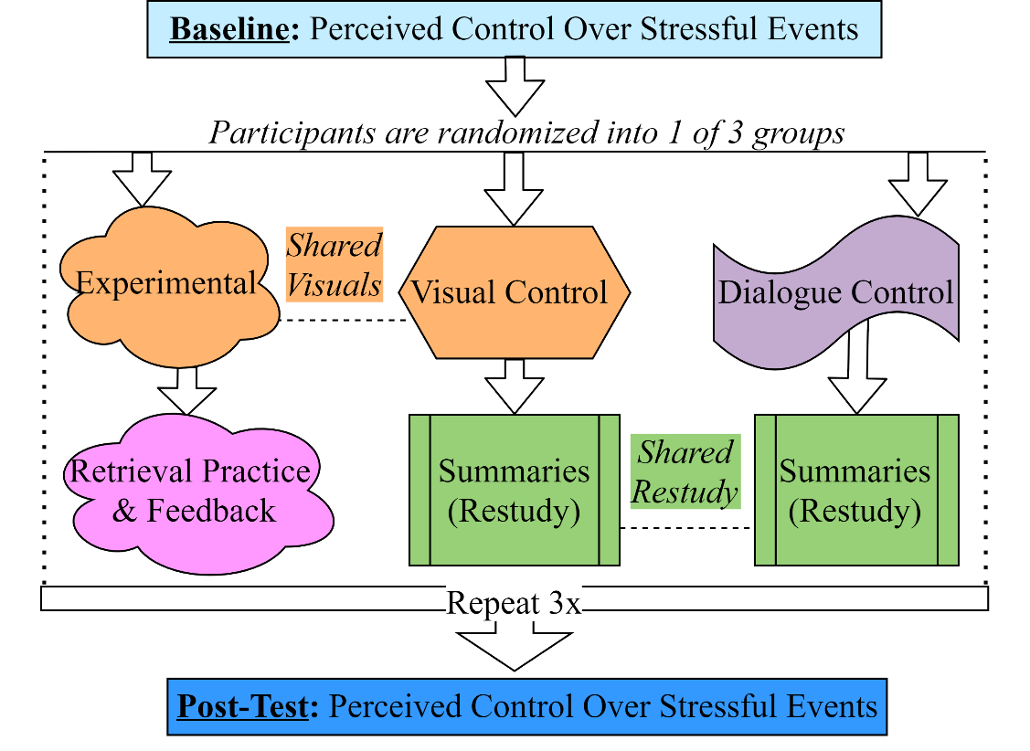100 participants completed the Baseline measures before being randomly assigned to one of three intervention conditions the experimental group (*N* = 34), the visual control group (*N* = 33), and the dialogue control group (*N* = 33).

**Intervention content (available upon request in OSF)**

The stress intervention described a counseling session for a fictional college student who experiences stress and goes to counseling. Participants read dialogue between the student and the counselor that emphasized fundamental aspects of cognitive-behavioral interventions for stress. The text describing the intervention was identical for all 3 conditions, but other features varied. The experimental group included visual aids to supplement key ideas in the text as well as several engagement strategies: quiz-style questions and feedback interspersed throughout the “session” that tested comprehension of prior therapy content. The visual control group also had visual aids but no engagement strategies. The dialogue control group had neither engagement strategies nor visual aids. Instead of engagement strategies, participants in both control groups (visual control and dialogue control) read content summaries (i.e., the restudy condition in traditional retrieval practice studies) interspersed throughout. After completing the intervention, all participants completed the post-test measures and were debriefed.

**Results**

The results of this pilot study indicate that the intervention impacted predictions of future stress. Those in the experimental group expected the fictional character to be more successful in controlling future stress than the dialogue control group, with the visual control group’s perceived control falling between.

**Perceived Control over Stressful Events (PCSE) Analyses for all participants**

* A 3(group: experimental, visual, dialogue) x 2(time: baseline & post-intervention) mixed factorial analysis of variance (ANOVA) on perceived control found main effects of group (*p* < .001, *η²p* = 0.16) and time (*p* < .001, *η²p* = 0.08).
* These results indicate that overall perceived control increased from baseline to post-intervention for all conditions as well as differentially across condition. The effect sizes were moderate for the main effect of time and large for the main effect of group.
* As predicted, the dialogue control group had the smallest changes in perceived control (non-significant contrasts) across the three conditions. In contrast to my prediction that the experimental group would experience larger increases than the visual control group, the biggest changes were in the visual control group.

**PCSE Analyses for Neuroticism Subsets**

* In a subset (*N* = 60 from additional targeted recruitment) of participants with higher neuroticism, I conducted an exploratory 3(group) x 2(time) mixed factorial ANOVA and compared it to an ANOVA on participants with low neuroticism (*N* = 54). In the high neuroticism subset, there was a main effect of time (*p* < .001, *η²p* = 0.12) and group (*p* = .025, *η²p* = 0.29), while there were no main effects or interactions in the low neuroticism subset (All *p*’s > .05).
* These results indicate that the intervention across conditions was more effective for participants with high neuroticism than participants with low neuroticism. Specifically, it seems as though the participants with high neuroticism drove the effects of group and time on all participants, as the high neuroticism subset had larger effect sizes.
* Experimental and visual control groups experienced significant increases in perceived control while the dialogue control group did not in high neuroticism subset post-hocs.

**Further analyses**

* I conducted a planned multiple linear regression examining the predictive abilities of the Big 5 personality facets on baseline cognitive distortions. Lower neuroticism (reverse scored: *β* = -0.38, *p* < .001), extroversion (*β* = -0.23, *p* = 0.02), low conscientiousness (reverse scored: *β* = -0.23, *p* = 0.012), and low openness (*β* = 0.25, *p* = 0.005) predicted lower cognitive distortions, model *R2adj* = .264). Agreeableness did not significantly predict baseline cognitive distortions. These results suggest that low neuroticism, high extroversion, low openness, and low conscientiousness may serve as “protection” against cognitive distortions.
* Other planned and exploratory analyses were conducted with the following dependent variables: Inventory of Cognitive Distortions, a final comprehension test, and the Cognitive Flexibility Inventory. These analyses are available upon request.

**Conclusion**

* Overall improvements in perceived control over stress for the fictional character, and the experimental group tended to predict higher perceived control than the dialogue control group. Contrary to predictions, the experimental group did not have larger changes in perceived control over the visual control group, though both did have larger improvements in perceived control than the dialogue group.
* Personality factors predicted cognitive distortions and specifically, in a high neuroticism subset, participants predicted a greater amount of perceived control.
* Results are promising for both the utility of engagement strategies in online treatment and of a brief, single session online stress management intervention.
* A follow up study in Feb. 2021 will examine a revised quizzing/comprehension test in a high neuroticism subset.

**References**

Butler, A. C., Godbole, N., & Marsh, E. J. (2013). Explanation feedback is better than correct answer feedback for promoting transfer of learning. *Journal of Educational Psychology, 105*(2), 290-298. https://doi.org/10.1037/a0031026

Kornell, N. (2014). Attempting to answer a meaningful question enhances subsequent learning even when feedback is delayed. *Journal of Experimental Psychology: Learning, Memory, and Cognition, 40*(1), 106-114. https://doi.org/10.1037/a0033699

Kornell, N., Klein, P. J., & Rawson, K. A. (2015). Retrieval attempts enhance learning, but retrieval success (versus failure) does not matter. *Journal of Experimental Psychology: Learning, Memory, and Cognition, 41*(1), 283-294. https://doi.org/10.1037/a0037850

Putnam, A. L., Nestojko, J. F., & Roediger, H. L. III. (2017). *Improving student learning: Two strategies to make it stick*. In J. C. Horvath, J. M. Lodge, & J. Hattie (Eds.), *From the laboratory to the classroom: Translating science of learning for teachers* (p. 94–121). Routledge/Taylor & Francis Group.

Roediger, H. L., & Karpicke, J. D. (2006). Test-enhanced learning. *Psychological Science, 17*(3), 249–255. https://doi.org/10.1111/j.1467-9280.2006.01693.x

Thorpe, S., Fize, D., & Marlot, C. (1996). Speed of processing in the human visual system. *Nature, 381*, 520-522.

Titov, N., Andrews, G., Choi, I., Schwencke, G., & Mahoney, A. (2008). Shyness 3: Randomized controlled trial of guided versus unguided Internet-based CBT for social phobia. *Australian and New Zealand Journal of Psychiatry, 42*, 1030-1040.