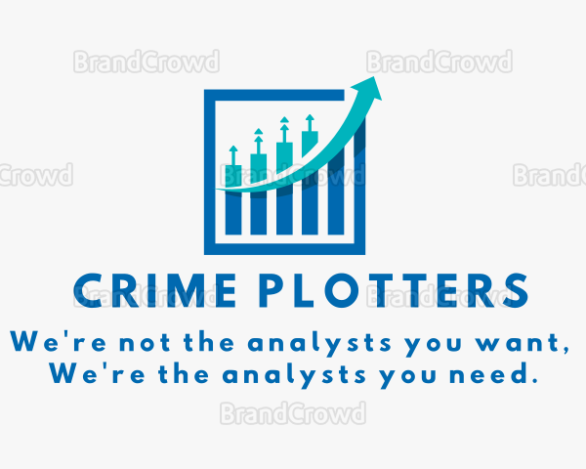

Crime_Plotters

### **Team Members**

|  |  |  |
| --- | --- | --- |
| **Name** | **Email** | **Phone Number** |
| Mary | mmackin899@gmail.com | 415-619-9093 |
| Abe | abes@supermicro.com | 650-465-3204 |
| Aye | ayenmon@gmail.com | 818-642-1890 |
| Marco | marcoamartnz@gmail.com | 714-882-9952 |
| Katrina | katwong@gmail.com | 310-592-8517 |

### **Background**

The impact of the COVID-19 pandemic on crime rates in major metropolitan areas. (As we saw yesterday, there's a lot of data for these cities—Chicago, New York, LA.) The scope of our work could be March 2017 - March 2020 and then March 2020 - March 2023.

### **Hypothesis/Null Hypothesis**

* Larger cities have more crime
  + 2017 - 2022
  + Analyzed by types of crimes
    - person
    - property
    - society
  + Analyzed by rich vs poor populations
    - US Census CA poverty levels
    - group cities by size, eliminate the very small

### 

### **Motivation**

Analysis of the impacts to society having gone through a global pandemic

### **Questions to answer**

Possible questions we can investigate from there (building off what we discussed yesterday):

Is there a change in the types of crime?

Is there a change in the policing of crime?

Is there an increase in crime in all neighborhoods or only certain zip codes?

Does an increase in population density correlate to an increase in the crime rate?

Does the poverty level of an area correlate in any way with the crime rate?

### **Tools/Modules to use**

* Python
* Pandas
* Matplotlib
* NumPy
* SciPy
* etc.

### **Data sets to use**

List all possible databases you’ll use

* US Census
* Crime Data
* data.gov

### **Tasks Breakdown**

Analysis wizard: Primary -Abe, Contributor -

§ responsible for written analysis including: § discussion of the results (positive/negative/no correlation, etc) and theories as to why § summary of major findings § discussion of limitations in the data and its impact on the result

Query commander: Primary - Katrina, Contributor -

§ responsible for finding answers to interesting questions posed by the group via data analysis techniques learned in class § analysis code and jupyter notebook used to answer questions

Data whisperer: Primary: Mary, Contributor - Abe

§ responsible for API data request(s) and downloading results to json format file § code and description of process used in jupyter notebooks

Cleanup master: Primary: Marco, Contributor -

§ responsible for taking the json file and, using pandas, clean data set(s) for analysis § cleanup process, code in jupyter notebooks

Graphics guru: Primary - Aye, Contributor -

§ responsible for creating 6-8 visualizations of the data (2 per question asked of the data (charts, maps, graphs, etc) using matplotlib, etc. § discussion of why certain types of visualization chosen § code in jupyter notebooks

### **Tasks and timeline**

|  |  |  |  |
| --- | --- | --- | --- |
|  | **Date** | **Task** | **Notes** |
| **Seg-1.1** | **2/28/23** | (I assume you’ve started ..) |  |
| **Seg-1.2** | **3/1/23** | (Still a good time to start ..) |  |
| **Seg-1.3** | **3/2/23** | Neural Networks Day-2 | Normal Class |
| **Seg-1.4** | **3/3/23** | (Start now ..) |  |
| **Seg-1.5** | **3/4/23** | (Go Back 3 Spaces ..) |  |
| **Seg-1.6** | **3/5/23** |  |  |
| **Seg-2.1** | **3/6/23** |  | Group Roster and Project Idea Proposal Due |
| **Seg-2.2** | **3/7/23** |  |  |
| **Seg-2.3** | **3/8/23** |  |  |
| **Seg-2.4** | **3/9/23** |  |  |
| **Seg-2.5** | **3/10/23** |  |  |
| **Seg-2.6** | **3/11/23** |  |  |
| **Seg-3.1** | **3/12/23** |  |  |
| **Seg-3.2** | **3/13/23** |  |  |
| **Seg-3.3** | **3/14/23** |  |  |
| **Seg-3.4** | **3/15/23** |  |  |
| **Seg-3.5** | **3/16/23** |  |  |
| **Seg-3.6** | **3/17/23** |  |  |
| **Seg-4.1** | **3/18/23** |  |  |
| **Seg-4.2** | **3/19/23** |  |  |
| **Seg-4.3** | **3/20/23** |  |  |
| **Seg-4.4** | **3/21/23** | Mock Presentation |  |
| **Seg-4.5** | **3/22/23** |  |  |
| **Seg-4.6** | **3/23/23** | PROJECT PRESENTATION | 4th Segment and  Self Assessment Due |
| **Seg-5.1** |  |  | All submissions Due |

### **Presentation**

Divide your presentation steps to tasks and assign it to members.

Suggested by:  
Khaled Karman