General Introduction
When every second matters
In emergency medicine, clinical decisions are made in an environment where time is limited, information is incomplete, and uncertainty is unavoidable. A patient arrives with a few symptoms and abnormal vital signs, and the physician must rapidly determine whether the situation is benign, potentially dangerous, or immediately life-threatening. In such circumstances, every additional source of reliable information can influence both the quality and the speed of the decision.
Among the tools available at the bedside, point-of-care ultrasound (POCUS) has become an increasingly central component of emergency assessment. Unlike conventional imaging workflows, which may require transporting the patient, scheduling specialised equipment, and waiting for a formal interpretation, POCUS allows the clinician to acquire images directly at the bedside and use them within the same examination. It is portable, involves no ionising radiation, costs comparatively little, and can provide information about the lungs, the heart and the abdomen within minutes. For the presentations that dominate emergency practice — acute dyspnoea, chest pain, abdominal pain, undifferentiated shock — it frequently answers the decisive question faster than any other available investigation.
The availability of an image, however, does not by itself guarantee an accurate diagnosis.
POCUS remains strongly dependent on the operator. Acquisition varies with probe position, anatomical orientation, patient habitus, machine settings and technique. Interpretation requires clinical expertise acquired over years of supervised practice, and it is hardest precisely where it matters most: in emergency situations, where several distinct conditions produce similar appearances, where the examination is performed under time pressure, often at night, and often by a clinician whose primary specialty is not radiology. The same clip that yields a confident diagnosis in experienced hands may yield nothing in less experienced ones. The challenge is therefore not to acquire more medical images, but to transform heterogeneous observations into reliable and actionable clinical information.
This challenge grows when the rest of the clinical picture is considered. An ultrasound examination is only one part of the evidence available during an emergency evaluation. Vital signs, symptoms, age, medical history and laboratory measurements provide additional evidence that may either support or contradict what is seen on the screen. A patient may appear relatively stable by their vital signs while the ultrasound reveals a potentially severe abnormality; conversely, an isolated imaging finding may carry limited significance once the patient’s symptoms and physiological state are taken into account. The real difficulty lies not in interpreting each source independently, but in understanding how the sources interact.
From isolated models to clinical intelligence
Recent advances in artificial intelligence, computer vision and large language models offer a way to approach this problem from a multimodal perspective. Convolutional networks can learn to recognise patterns in ultrasound images and now match specialist performance on several well-defined imaging tasks. Machine-learning models can analyse structured clinical information such as vital signs and patient characteristics. More recently, large language models have demonstrated the ability to integrate heterogeneous information and produce structured reasoning over complex textual and numerical inputs.
Yet most published work stops at a single organ and a single question — a model that detects B-lines, or one that segments the left ventricle — evaluated in isolation. A clinician facing an undifferentiated patient does not have a single question. They have a patient, with vital signs, a history, laboratory results and an ultrasound probe, and they must integrate all of it. Placing an AI model in front of a physician does not, in itself, constitute a clinical decision-support system.
A useful emergency AI system must understand what it is looking at, what it does not know, how reliable its information is, and when it should admit uncertainty. A model that produces a confident answer from incomplete or contradictory evidence is more dangerous than one that explicitly asks for additional information, because it introduces error while appearing to remove it. This observation motivates the central idea of the project:
Artificial intelligence should not replace the emergency clinician’s reasoning. It should act as a clinical co-pilot that organises evidence, highlights important findings, identifies uncertainty, and supports safer decision-making.

POCUS-Emergency: an intelligent multimodal co-pilot
The project POCUS-Emergency: Intelligent Multimodal Assistant for Clinical Ultrasound and Decision Support in Emergencies explores this concept through a modular multi-agent architecture. Rather than developing a single model responsible for the entire diagnostic process, the system separates the problem into specialised components, each answering a question it has the information to answer.
The Triage Agent focuses on the patient rather than the image. It analyses the chief complaint, vital signs, age and available red-flag indicators to estimate an urgency level.
The Ultrasound Agent focuses exclusively on POCUS data. Depending on the organ examined, it routes the input to the appropriate computer-vision model and produces structured findings together with confidence information and Grad-CAM explainability. Its objective is not to decide whether a patient is urgent, but to answer a more fundamental question: what does the ultrasound show?
The Clinical Reasoning Agent brings these outputs together. It combines triage information, imaging findings, clinical history, physiological measurements and biological data, while accounting for missing information, model limitations, confidence and contradictions between sources. A retrieval-augmented generation (RAG) mechanism grounds the reasoning in a curated medical knowledge base, and a locally deployed medical language model transforms the structured evidence into a ranked differential diagnosis with supporting arguments, explicit uncertainty, and an escalation decision.
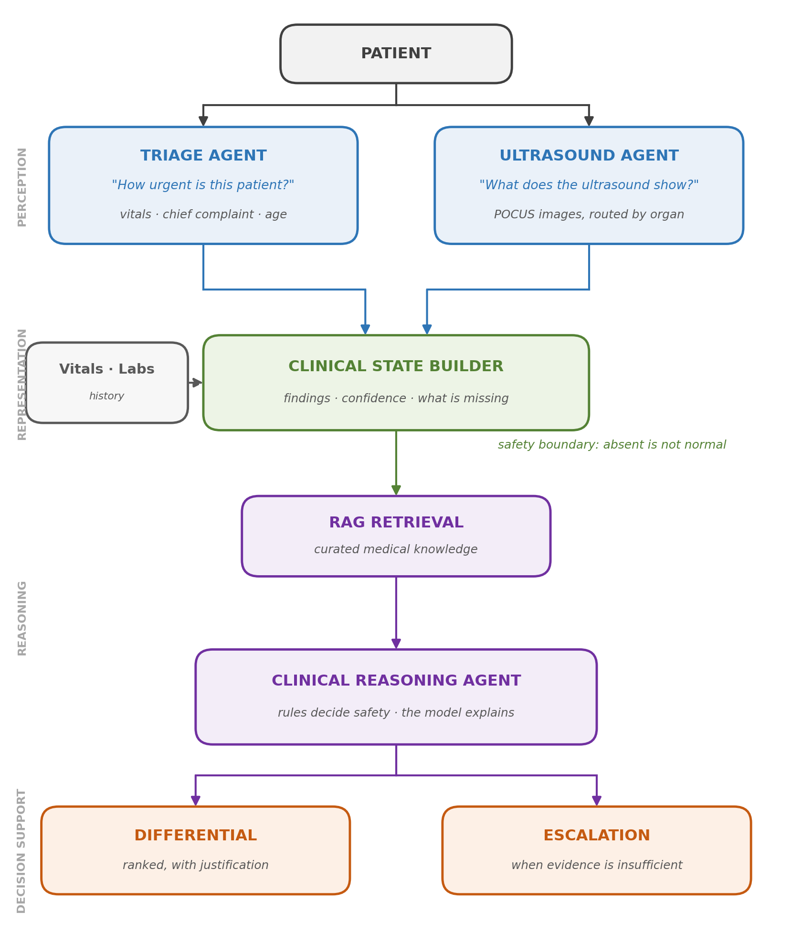
Figure 1: Overall architecture of POCUS-Emergency. Perception, representation, reasoning and decision support are separated into distinct layers.
The architecture reflects a fundamental design principle: perception and reasoning must not be confused. The Triage and Ultrasound Agents are responsible for extracting information; the Clinical Reasoning Agent is responsible for integrating that information into a broader clinical context. No perception model is permitted to declare a patient urgent, because no perception model sees enough of the patient to make that judgement.
Beyond diagnosis: reasoning under uncertainty
A further objective of POCUS-Emergency is to address uncertainty explicitly rather than implicitly. In real emergency medicine, the absence of information is not equivalent to a normal result. A laboratory test that was never performed cannot be interpreted as negative, and a model that was never trained to detect a particular pathology cannot be used to exclude it.
The system therefore incorporates an intermediate Clinical State Builder that standardises the outputs of the different agents and represents explicitly:
- available and missing clinical information;
- abnormal versus normal measurements;
- model confidence and whether that confidence is calibrated;
- the stated limitations of each perception model;
- conflicts between clinical and imaging evidence.
This structured representation acts as a safety boundary between the perception models and the language model. It prevents the reasoning layer from silently treating missing evidence as negative evidence, or from interpreting a model outside the scope it was trained for. When evidence is insufficient, confidence is low, or clinically important findings disagree, the system escalates the case instead of forcing a definitive conclusion. That mechanism also provides the foundation for a future simulation component, in which uncertain situations could be explored in a controlled environment before a real decision is committed to.
Project objectives
The ambition of this work is therefore not to build another isolated ultrasound classifier, but to examine how specialised AI models can cooperate as a clinical co-pilot, transforming heterogeneous emergency data into structured, explainable and uncertainty-aware decision support. Three complementary objectives follow:
- Perceive — extract meaningful information from patient data and from POCUS images.
- Reason — combine these observations with clinical knowledge and contextual information.
- Escalate when necessary — recognise when the available evidence is insufficient or contradictory, rather than generating an unjustified conclusion.
The objective is not to make artificial intelligence decide instead of the clinician, but to make the available clinical evidence easier to understand, cross-check and act upon.
This perspective guides the remainder of the report, from dataset preparation and case-level validation, through the development of the specialised perception agents, to the multimodal clinical reasoning layer.
Organisation of this report
The report follows the order in which the system was built, so that each chapter depends only on what precedes it.
- Chapter 1 — Project Presentation. The problem addressed, the business and data science objectives, and the multi-agent architecture chosen to meet them.
- Chapter 2 — Preliminary Study. Existing work in automated ultrasound interpretation, its strengths and its limits, and the gap this project addresses.
- Chapter 3 — Data and Preparation. The datasets used, their annotation, and the case-level partitioning that governs every result reported afterwards.
- Chapter 4 — Perception Agents. Development of the triage, lung, cardiac and gallbladder modules, including the experiments that failed and the corrections they prompted.
- Chapter 5 — Clinical Reasoning Agent. The Clinical State Builder, retrieval, the medical language model, output validation and the escalation policy.
- Chapter 6 — Integration and Prototype. The complete pipeline and the contract through which the agents communicate.
- Chapter 7 — Evaluation and Discussion. What the measured results mean clinically, what did not work, and the limitations that remain.
A conclusion summarising the contributions and outlining perspectives closes the report, followed by the difficulties encountered during the internship, the bibliography and the annexes.

Chapter 1: Project Presentation

1.1 Introduction
This chapter defines the problem the project addresses, the solution proposed, and the organisational framework within which the work was carried out. It establishes the business and data science objectives against which the subsequent technical chapters should be read, and details the three-agent architecture introduced in the general introduction.

1.2 Problematic
The central question this project addresses can be stated directly:
How can multimodal artificial intelligence be integrated into point-of-care ultrasound to improve diagnostic accuracy, assist clinicians at the bedside, and strengthen the quality of emergency care?
This question decomposes into four concrete difficulties, each of which shapes a design decision later in the report.
Operator dependence. Image acquisition and interpretation both vary with the skill of the individual clinician. A system that assists interpretation must therefore be robust to variation in acquisition, not merely accurate on well-acquired images.
Interpretation under time pressure. Emergency decisions are made in minutes. An assistant whose output requires careful reading provides no benefit; its findings must be immediately legible and must carry an explicit indication of how far they can be trusted.
Fragmented information. Vital signs, imaging, laboratory results and history arrive separately and at different times. The clinical decision depends on their combination, but each source is typically presented in isolation.
The cost of unwarranted confidence. A decision-support system that presents an uncertain finding with the same authority as a certain one is worse than no system at all, because it introduces error while appearing to reduce it. This constraint proved to be the single strongest influence on the architecture described below, and is the reason calibration, evidence grading and the escalation policy are treated as core components rather than refinements.

1.3 Proposed solution
The proposed solution is an assistant that interprets point-of-care ultrasound, cross-checks the result against the patient’s clinical data, and presents a reasoned differential diagnosis together with an explicit statement of what remains uncertain. Two objectives were defined at the outset.
Business Objective. Reduce time-to-diagnosis and diagnostic error for critically ill emergency patients by providing the operator with an assistant that interprets images, cross-checks clinical data, and — for ambiguous or high-stakes cases — allows the physician to examine the reasoning before committing to a decision.
Data Science Objective. Deliver the components that make this possible:
- Computer vision models that detect defined pathologies from point-of-care ultrasound, each returning a calibrated confidence rather than a bare score.
- An explainability layer relating model attention to anatomical regions a clinician can verify.
- A structured clinical state that records not only what was found, but what was not measured and what the models cannot exclude.
- A reasoning layer that converts imaging findings and clinical data into a ranked differential diagnosis with grounded justification.
- An escalation policy determining, from confidence, severity and data completeness, whether a case can be answered directly or requires further examination.

1.4 Overall approach
The system is organised as three agents with strictly separated responsibilities. The separation is not incidental; it is the mechanism by which the fourth difficulty above — unwarranted confidence — is controlled.
Agent | Input | Output
Triage Agent | Chief complaint, vital signs, age, red-flag symptoms | Urgency level with calibrated confidence
Ultrasound Agent | Ultrasound image or clip, routed by organ | Findings with calibrated confidence and attention maps
Clinical Reasoning Agent | Both of the above, plus laboratory results and history | Ranked differential diagnosis and escalation decision
Table 1.1: Responsibilities of the three agents
The Triage Agent and the Ultrasound Agent operate in parallel. They take different inputs and neither depends on the other’s output, which reflects clinical reality: vital signs are recorded while imaging is performed, not afterwards.
The Ultrasound Agent reports findings and does not assign urgency. This distinction is deliberate and is enforced throughout the implementation. A radiologist records "multiple B-lines, small consolidation, no pleural effusion"; the inference to pulmonary oedema, and the decision about how urgently to act, require vital signs, laboratory results and history that the imaging model never sees. Allowing an imaging model to emit an urgency verdict would place a clinical decision inside a component that lacks the information to make it, and would duplicate that logic in two places within the system.
The Clinical Reasoning Agent occupies the position of the senior physician who receives the nurse’s rapid assessment and the imaging report, weighs both against the laboratory results and the patient’s history, and reaches a conclusion. It is the only component permitted to decide urgency or recommend action.
A second separation applies within the reasoning agent itself. The safety-critical determinations — which tests are absent, which model limitations apply, whether the agents disagree, whether escalation is warranted — are computed by deterministic rules before the language model is consulted, and the model’s output is checked against the structured state afterwards. The language model reasons over evidence that has already been constrained; it does not decide whether the case is safe. Asking a language model directly what should be done would place the least predictable component in charge of the most consequential decision. This design is described in Chapter 5.

1.5 Project management framework
The work was organised into sequential phases, each concluding with a working, evaluated component. The ordering was chosen so that every phase produced something the next phase depended on, rather than developing components in parallel and integrating them at the end.
Phase | Objective | Outcome | Status
1 | Triage Agent on structured emergency data | Three-tier urgency classifier (low / medium / high), calibrated | Complete
2 | Perception modules: lung, cardiac, gallbladder | Three evaluated organ models with calibrated confidence | Complete
3 | Unified Ultrasound Agent | Organ routing, shared output contract, encounter storage | Complete
4 | Clinical State Builder | Standardised representation of all agent outputs | Complete
5 | Clinical Reasoning Agent | Safety layer, escalation policy, retrieval and reasoning | In progress
Table 1.2: Development phases
A vascular / deep-vein-thrombosis module was considered during planning and deliberately excluded from the scope of the internship, in order to complete the four modules above to a defensible standard rather than five to a partial one.
One methodological rule governed all phases: no design decision was adopted on the basis of expectation alone. Where a change was proposed — a different architecture, an augmentation strategy, an additional dataset — it was implemented, measured against the existing baseline, and retained only if the measurement supported it. Several proposals that appeared well motivated were rejected on this basis, and those rejections are reported in the chapters that follow rather than omitted. In a clinical context, a result that cannot be defended is of no use regardless of how favourable it appears.
Development was carried out primarily in Python using PyTorch, with training performed on Google Colab GPU instances. The limited and intermittent availability of that hardware was itself a constraint on the experimental programme, and is discussed in the chapter on difficulties encountered.

1.6 Conclusion
This chapter has established the problem, the objectives, and the architecture that addresses them. Two separations organise the entire system: perception is separated from reasoning, and within the reasoning agent, deterministic safety rules are separated from language-model inference. Both recur throughout the remainder of this report.
The following chapter examines existing work in automated ultrasound interpretation, identifying both the published results against which this project is measured and the gap it addresses.

