# OData plugin for SugarCRM

* Installation

1. Login with administrator account and go to ‘Admin’ section.

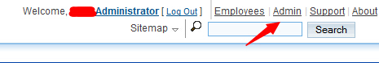

1. Go to developer section and select ‘Module Loader’

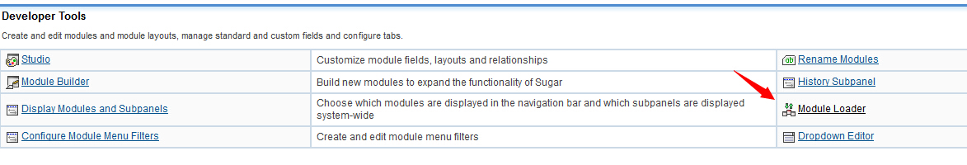

1. Select SugarOdata.zip in Module file selector and click ‘Upload’

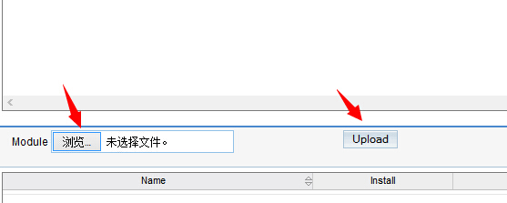

1. After upload succeed, then install that package.

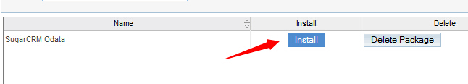

1. Accept License and commit.

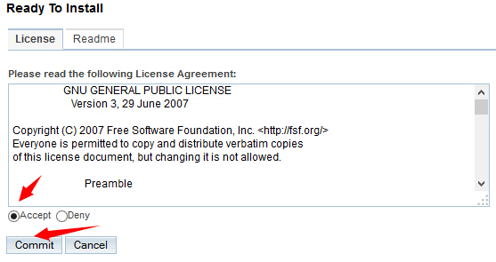

1. After install succeed then click ‘Back to Module Loader’.

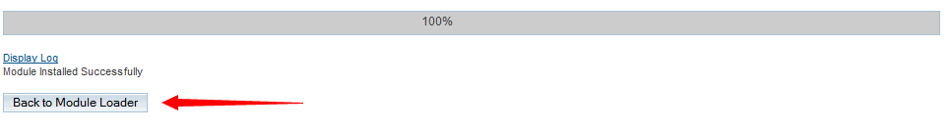

1. You can see ‘SugarCRM Odata’ module is already there.

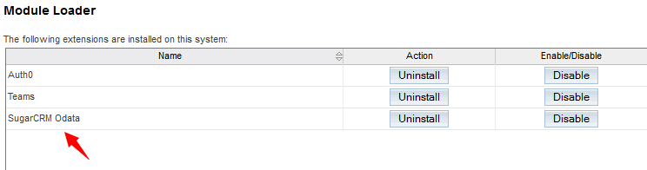

* Usage guide

1. Go to admin ‘Users’ section and Click ‘SugarOdata’.



1. Go to ‘Create Sugarodata’ and input table name and save

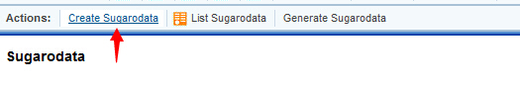

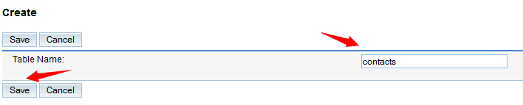

1. Go to ‘List Sugarodata’ to see your database table data you want to share.

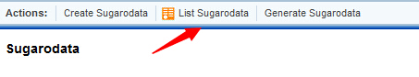

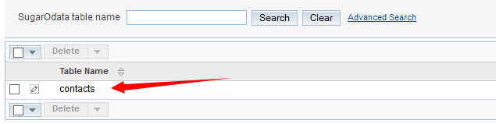

1. If you want to more table data to share, you could go to create another table in ‘Create Sugarodata’ section and you can delete table name in ‘List Sugarodata’ section by check the box and click delete button.
2. Go to ‘Generate Sugarodata’ section to generate odata.

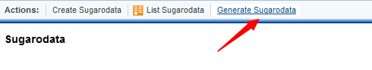

1. After generation you will find odata links, click those links to see your odata.

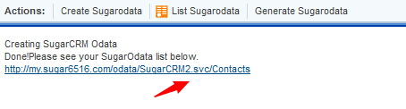

* Notice

1. This module only support Apache web server.
2. If your server is Linux, after installation, you have to add /yourpathtosugarcrm/odata/library this path to your php.ini include_path, in order to add this library code through PHP ‘Include_path’

.