# Steel City Meals

This project is to provide you a view of all food pantries and food services provided in the Pittsburgh region. Community organizers serving residents who have difficulties accessing food and local residents are able to use this program to find out detailed information including name, address, phone, and rating about food pantries/services.

## Team Members

Mary Fleck [mfleck@andrew.cmu.edu](mailto:mfleck@andrew.cmu.edu)

Matthew Liu [mcliu@andrew.cmu.edu](mailto:mcliu@andrew.cmu.edu)

Jiaying Shi [jiaying2@andrew.cmu.edu](mailto:jiaying2@andrew.cmu.edu)

Raghav Sood [rsood2@andrew.cmu.edu](mailto:rsood2@andrew.cmu.edu)

## Prerequisites

The below packages/modules are needed to install before running the project.

* requests
* beautifulsoup
* json
* fuzzywuzzy
* pandas
* re
* numpy
* matplotlib.pyplot
* collections

## Running the project

1. Download the source code
2. Download the map file in the same directory
3. Open the code on idle
4. Run the code

## Screenshots

The following is the output that the user should see once the program runs. The user would then type the option they desire (1, 2, 3, 4, 5, A, B, or Q). Note that options 4 and 5 generate as separate windows that may appear behind the user’s current window. Option B simply creates a csv file in the directory where the program is stored.

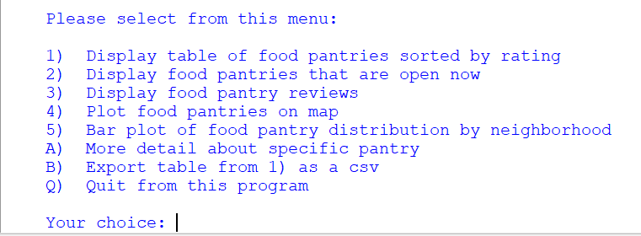

## API Reference

One of the data sources is scraped from google reviews with an API key. For your convenience, a group member has provided an API key to be used until March 6th. However, if the user wishes, they should generate their own.

1. Create a google account with payment enabled and follow the link below to find out how to create a project and generate an api key. The api key could be generated at no cost, and 300 usd free credit is provided to all accounts for future usage.

<https://developers.google.com/places/web-service/get-api-key>

1. Enable the google places api to the project on google console, and linked the billing account to the project.
2. Enter your api key in the code area where shows “api_key = ”, and then everything is all set.

## Video Link

Data Focussed Python C3 Group 2 on YouTube:

<https://www.youtube.com/watch?v=6V_LqL6Iarw>