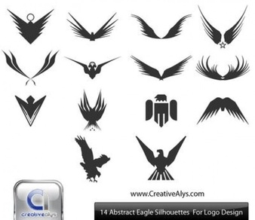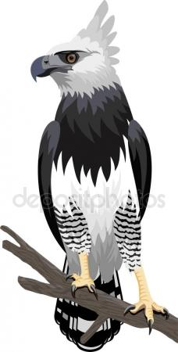

ONE CLICK

ONE BUSINESS



ONE BUSINESS

ONE CLICK

ONE BUSINESS

ONE CLICK

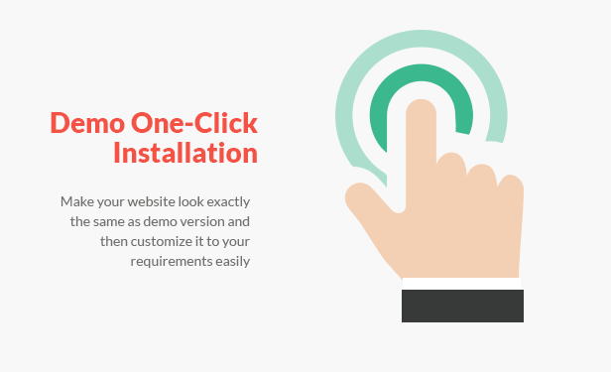



NE CLICK

ONE

BUSINESS

**ONE CLICK**

**ONE BUSINESS**

**ONE CLICK**

**ONE BUSINESS**