Ansible playbook

vi tasks.yml

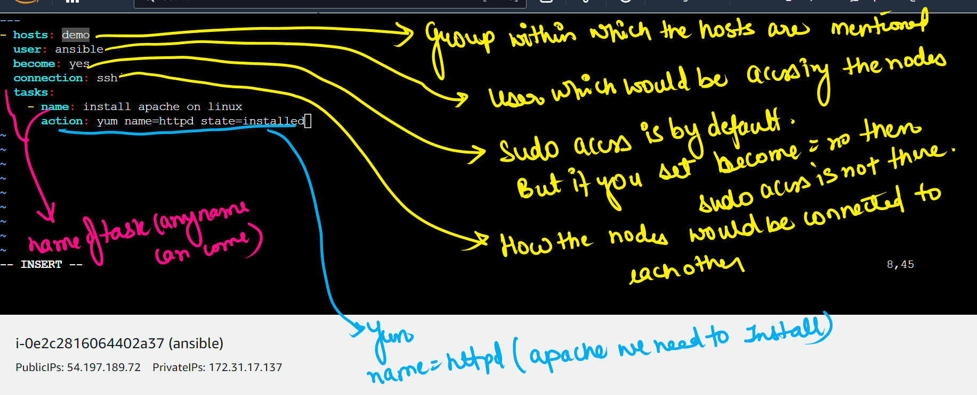

--- #Target yaml file which will download the httpd

- hosts: demo

user: ansible

become: yes

connection: ssh

tasks:

- name: install apache on linux

action: yum name=httpd state=installed

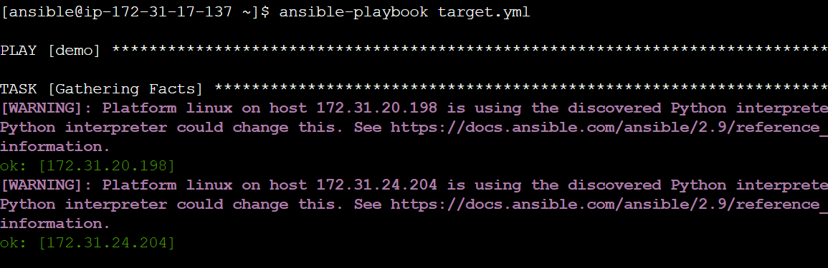

## deleting the apache installed in node 1 and node2

vi target.yml

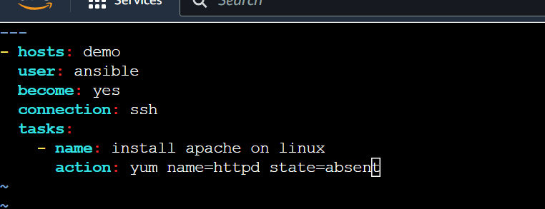





This will delete the apache in nodes

Variables

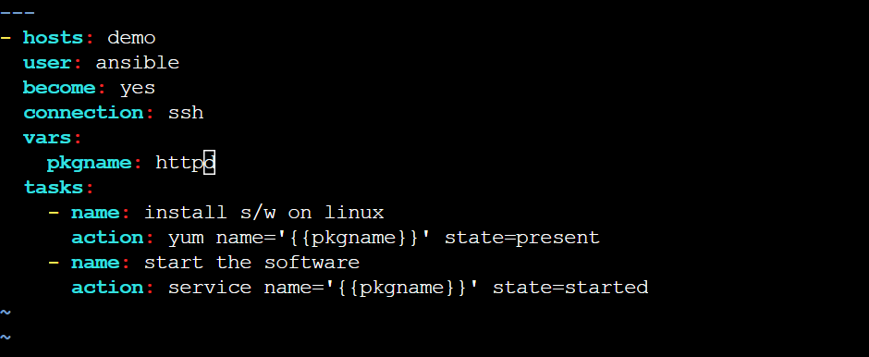

---

- hosts: demo

user: ansible

become: yes

connection: ssh

vars:

pkgname: httpd

tasks:

- name: install s/w on linux

action: yum name='{{pkgname}}' state=present

- name: start the software

action: service name='{{pkgname}}' state=started

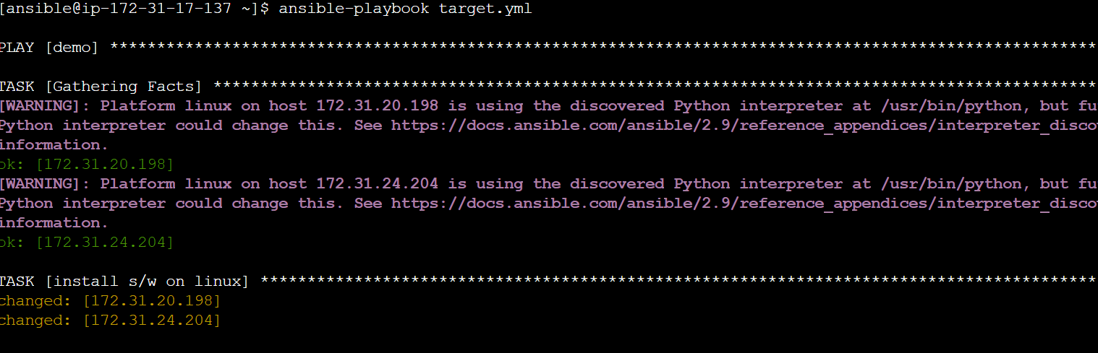

###We can also launch a website via playbook

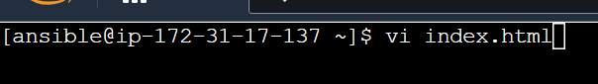

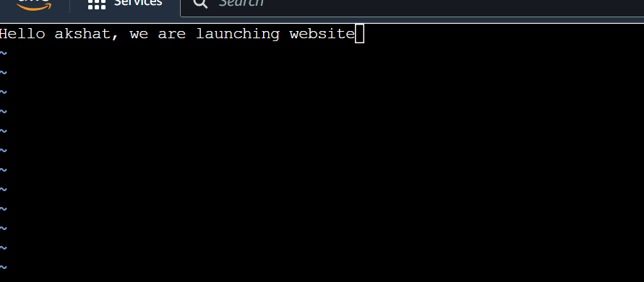



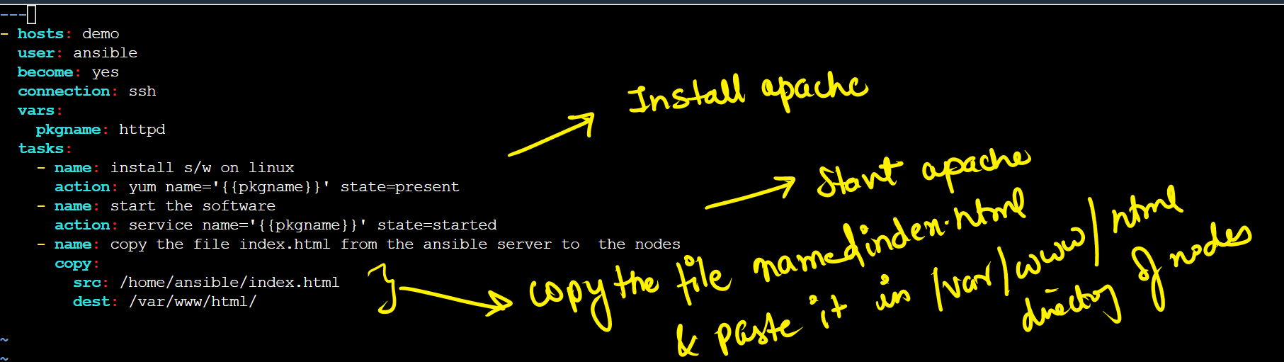

---

- hosts: demo

user: ansible

become: yes

connection: ssh

vars:

pkgname: httpd

tasks:

- name: install s/w on linux

action: yum name='{{pkgname}}' state=present

- name: start the software

action: service name='{{pkgname}}' state=started

- name: copy the file index.html from the ansible server to the nodes

copy:

src: /home/ansible/index.html

dest: /var/www/html/

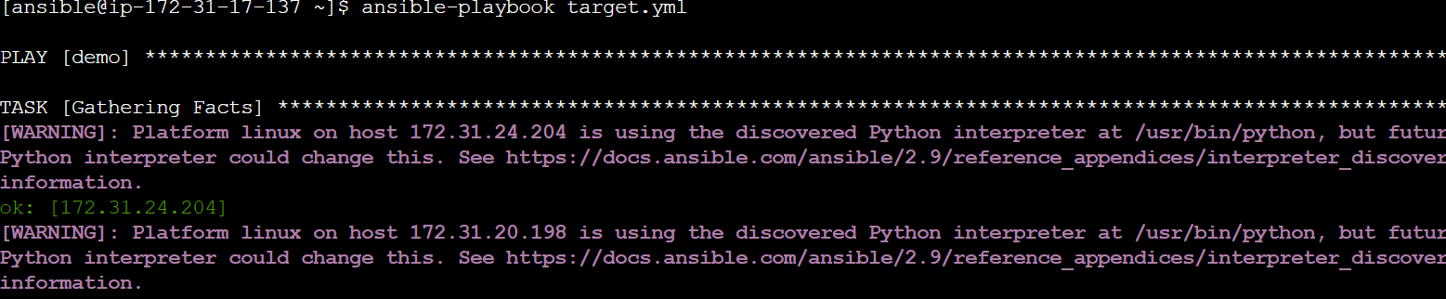

ansible-playbook target.yml