Terraform : Infrastructure as a code service

Launch aws and Devops in aws v2 machine

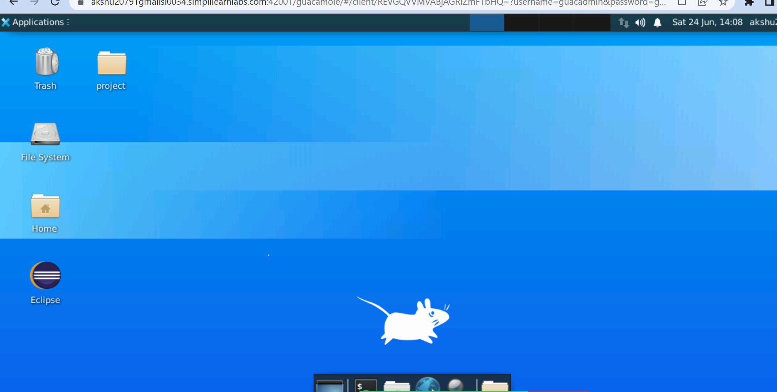

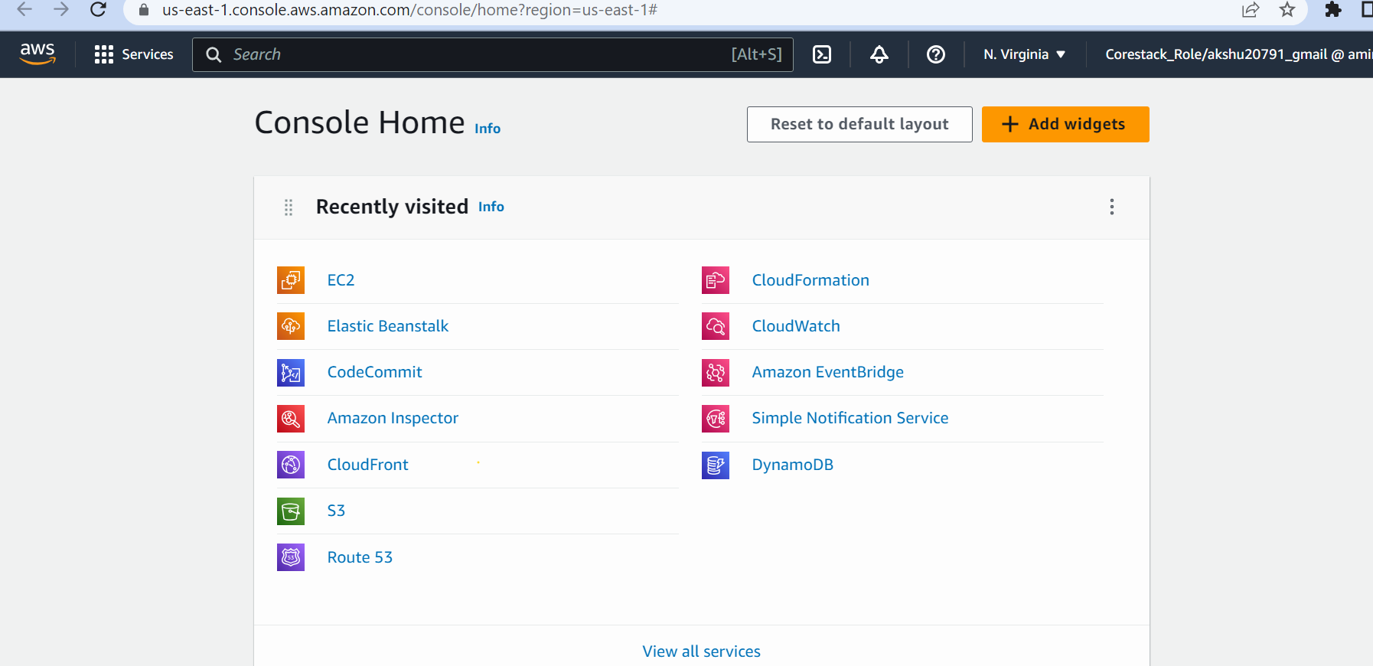

https://developer.hashicorp.com/terraform/downloads

Go to ubuntu machine:

wget -O- https://apt.releases.hashicorp.com/gpg | sudo gpg --dearmor -o /usr/share/keyrings/hashicorp-archive-keyring.gpg

echo "deb [signed-by=/usr/share/keyrings/hashicorp-archive-keyring.gpg] https://apt.releases.hashicorp.com $(lsb_release -cs) main" | sudo tee /etc/apt/sources.list.d/hashicorp.list

sudo apt update && sudo apt install terraform

terraform –version



Lets create a directory where we will work





Open : <https://registry.terraform.io/providers/hashicorp/aws/latest/docs> these are complete documentation of any resource u want to create in terraform

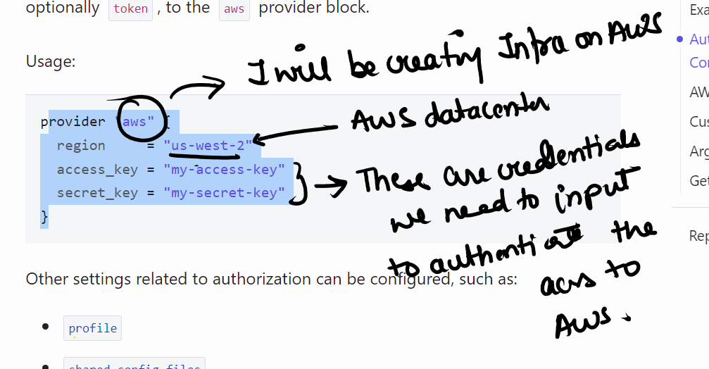

In the terminal of your ubuntu machine:

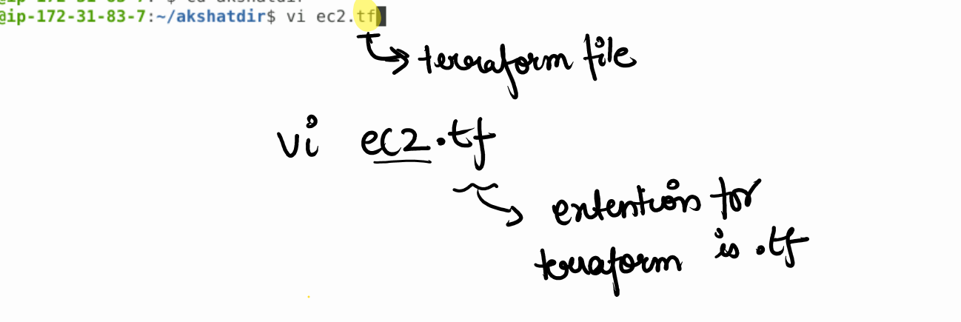

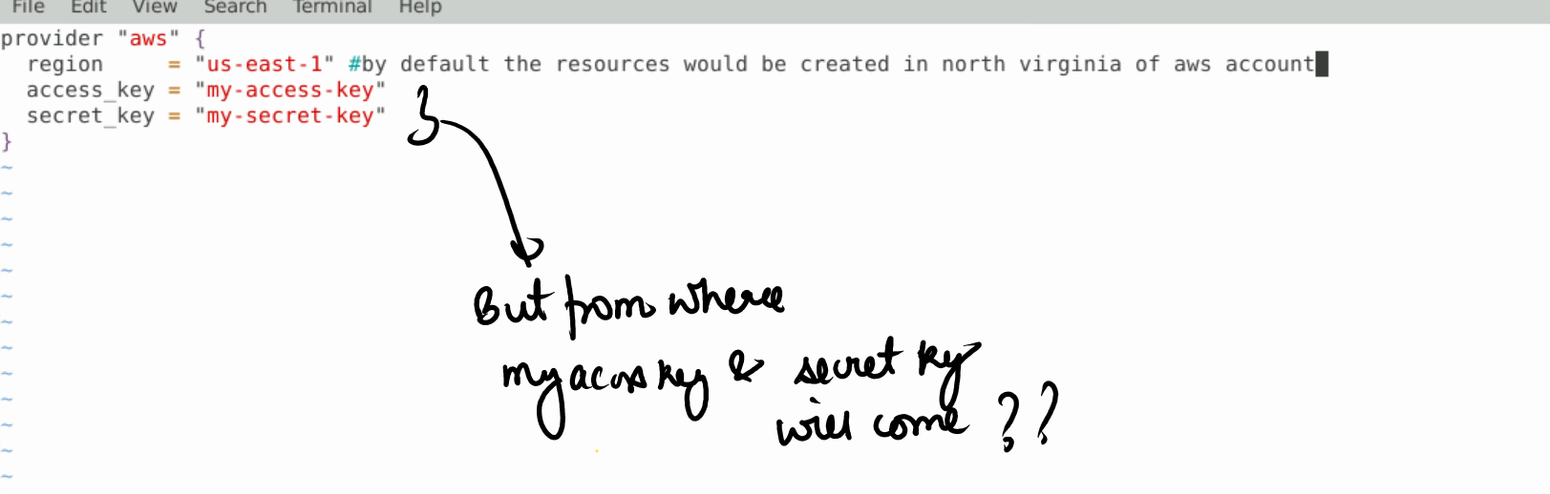

To get access key and secret access key …go to your aws account

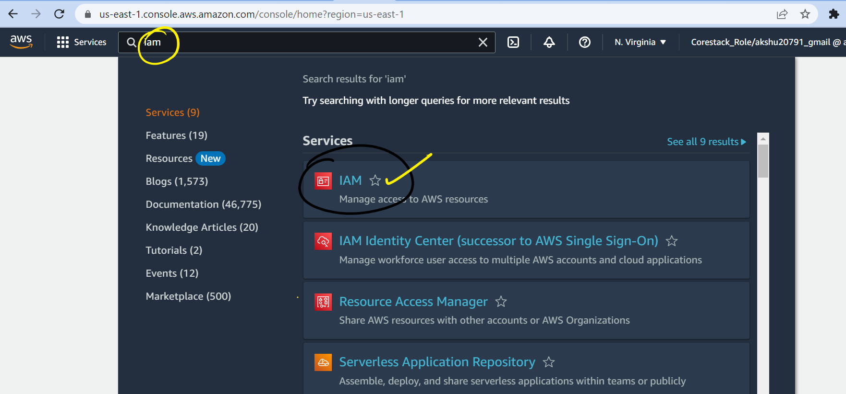

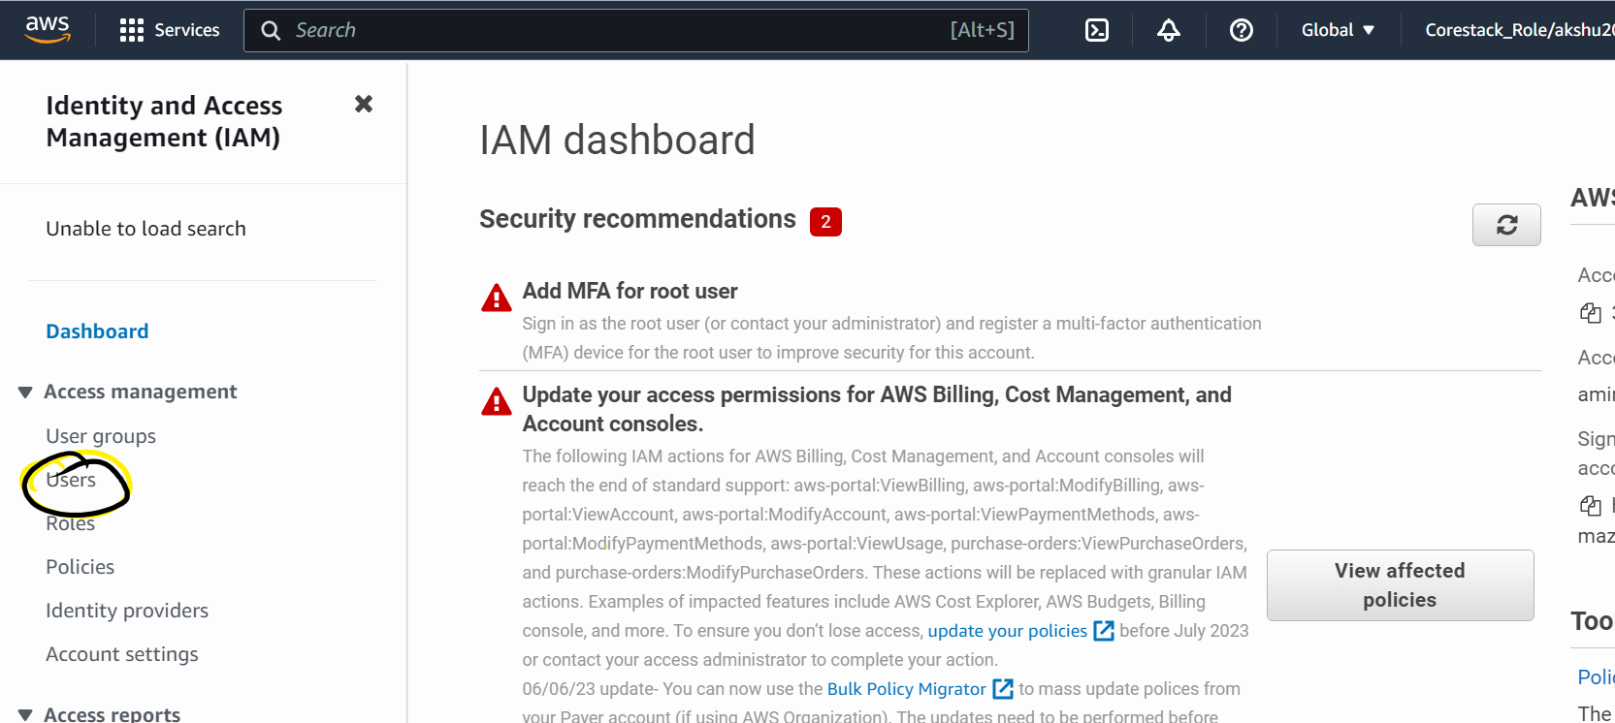

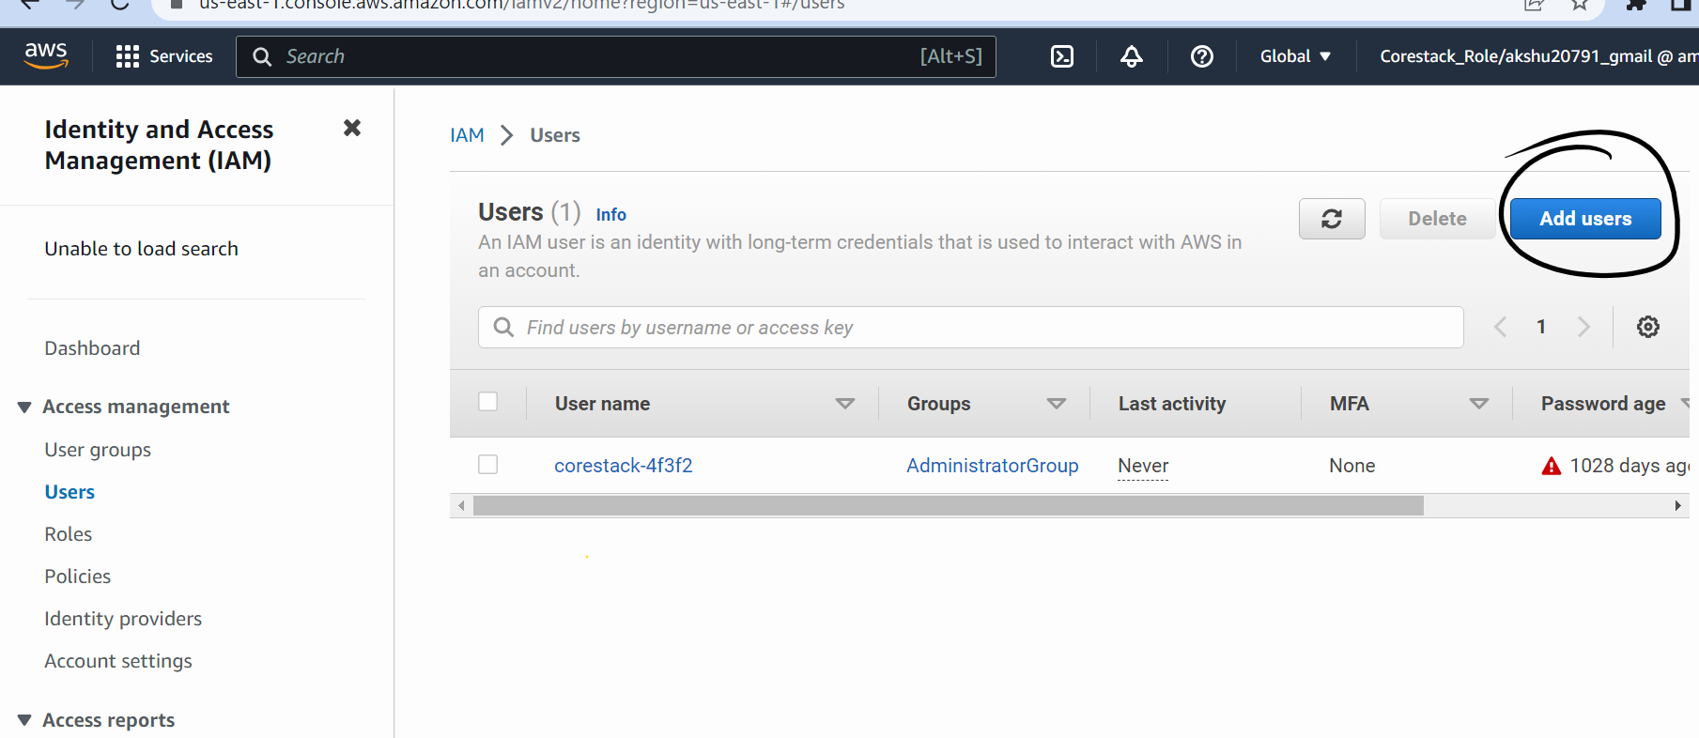

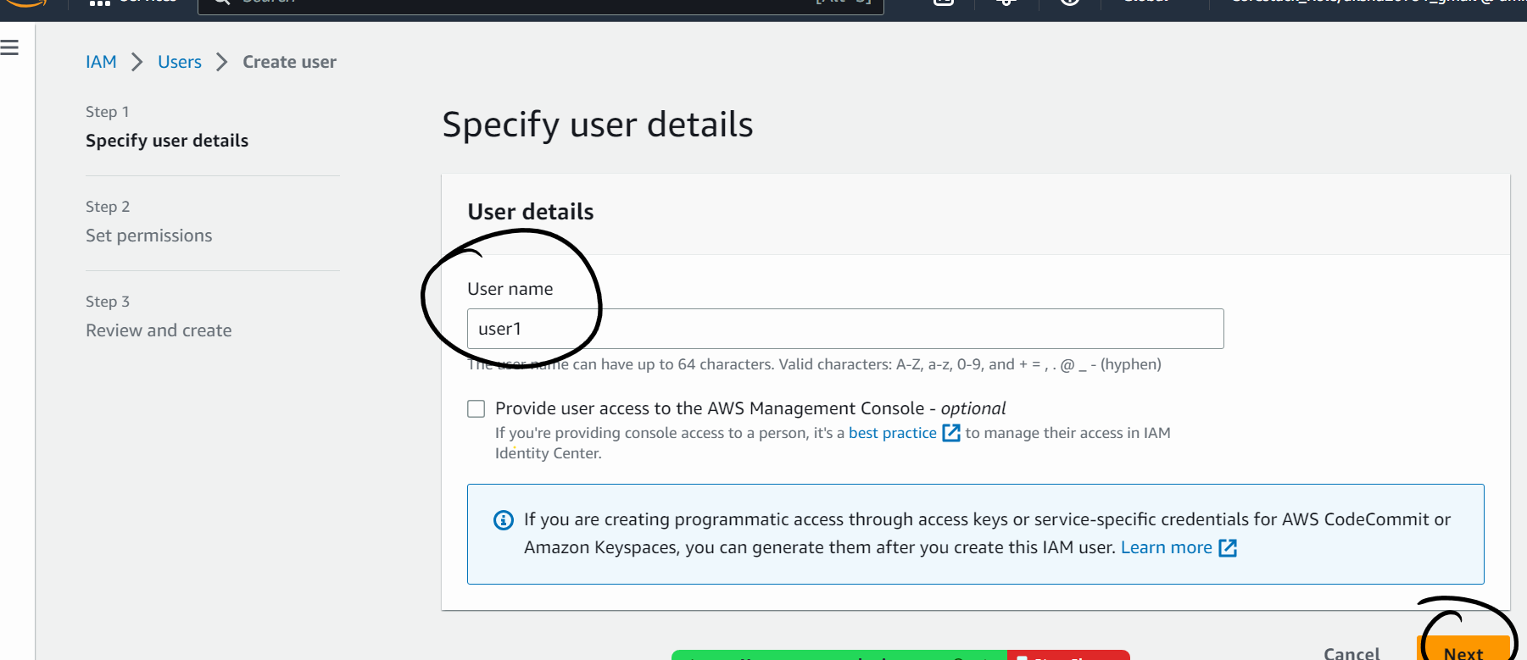

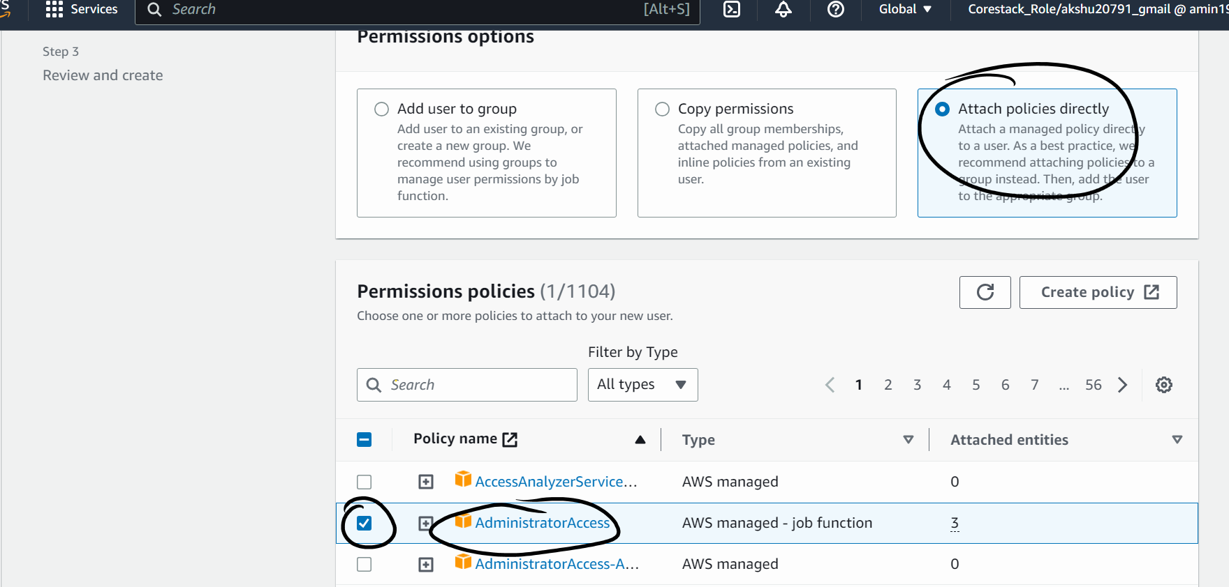

Next

Create the user

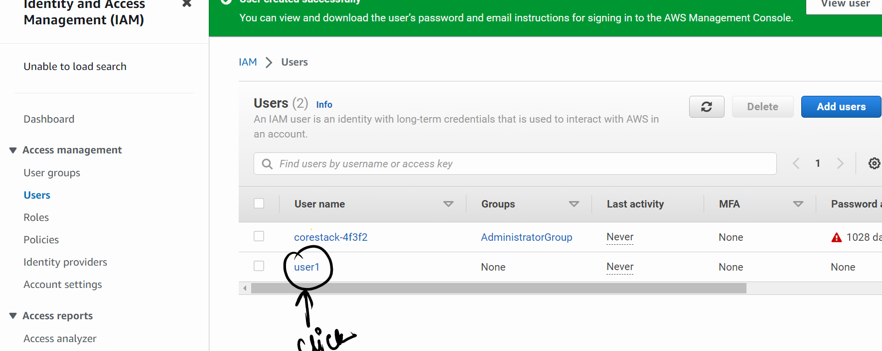

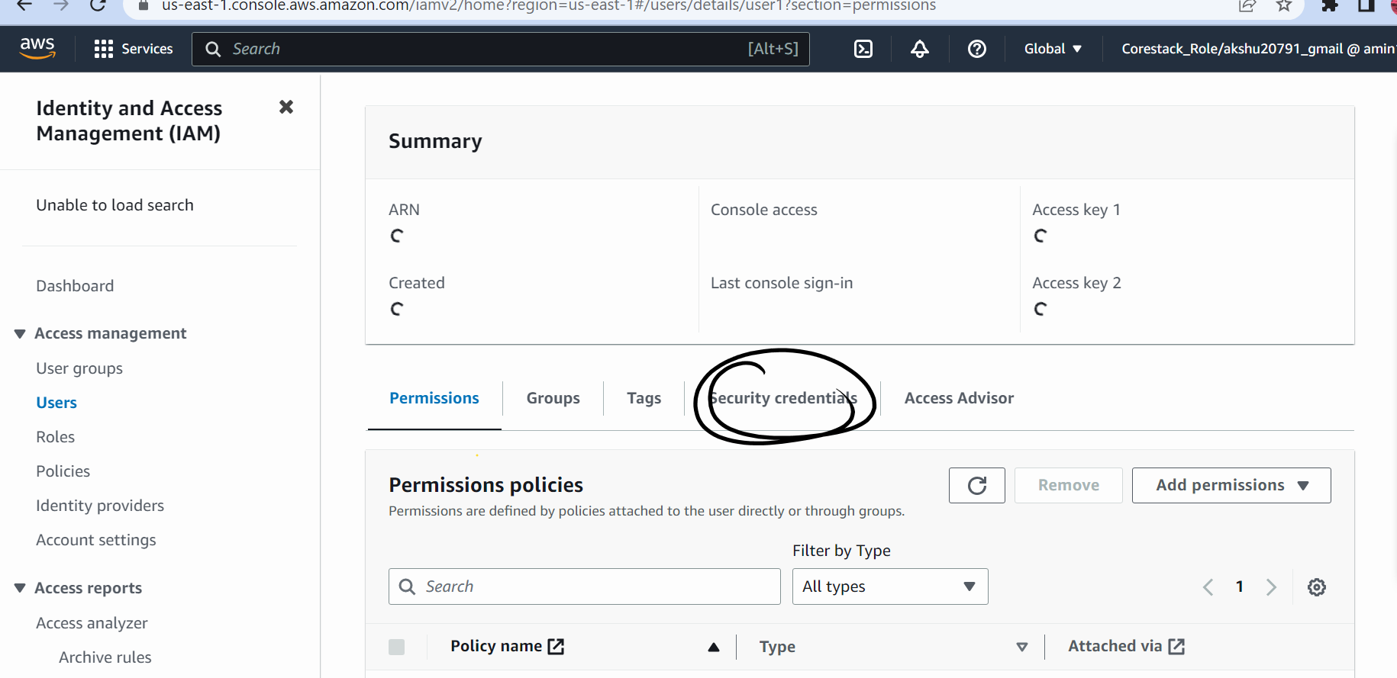

Scroll down

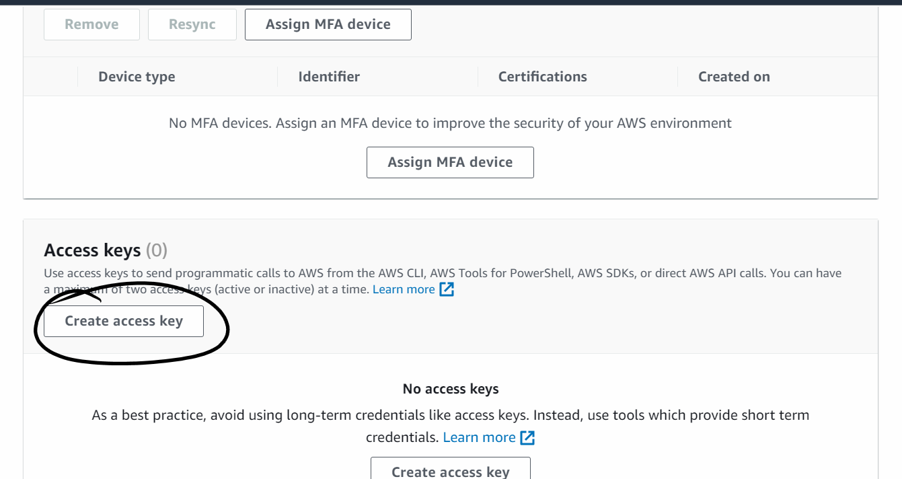

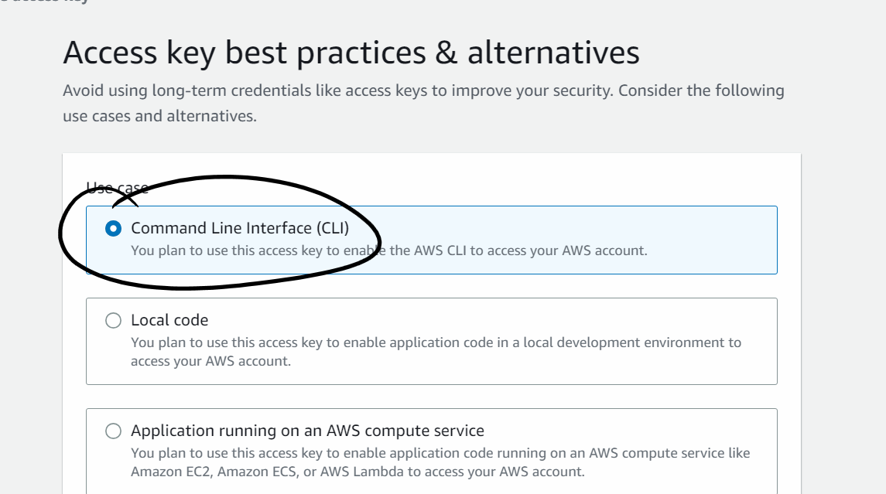

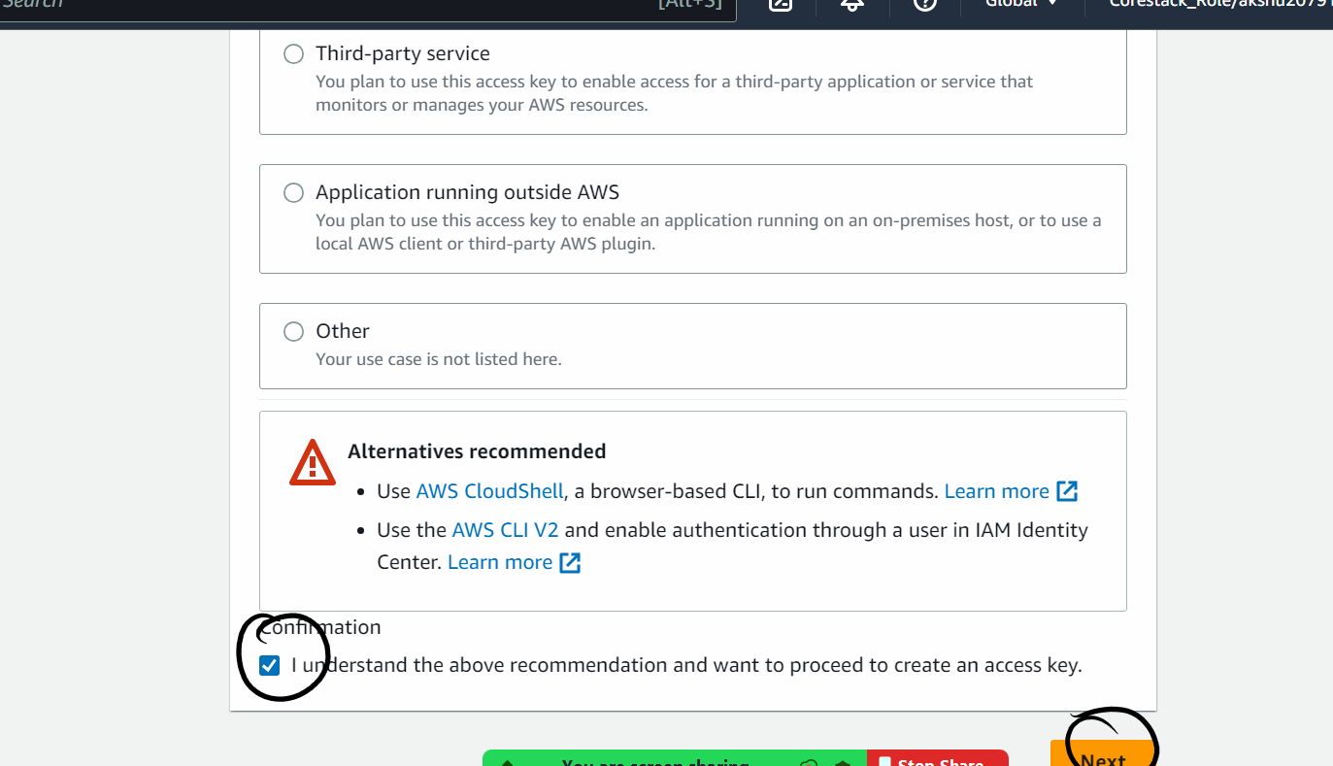

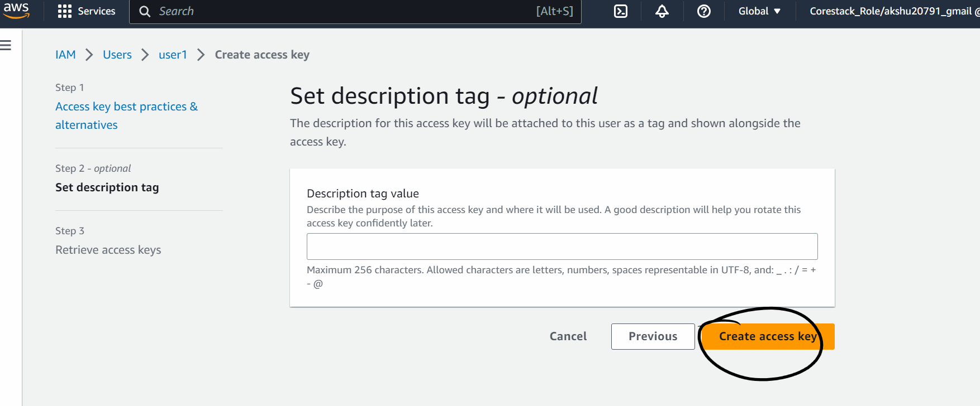

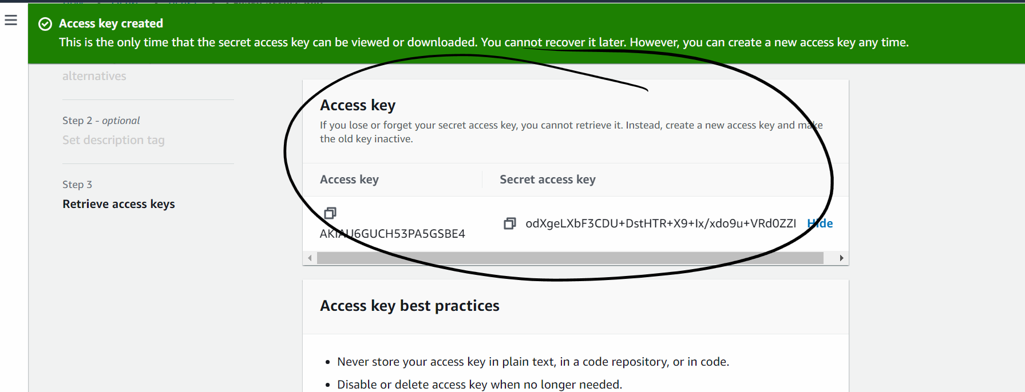

Now copy them one by one and paste it in your code

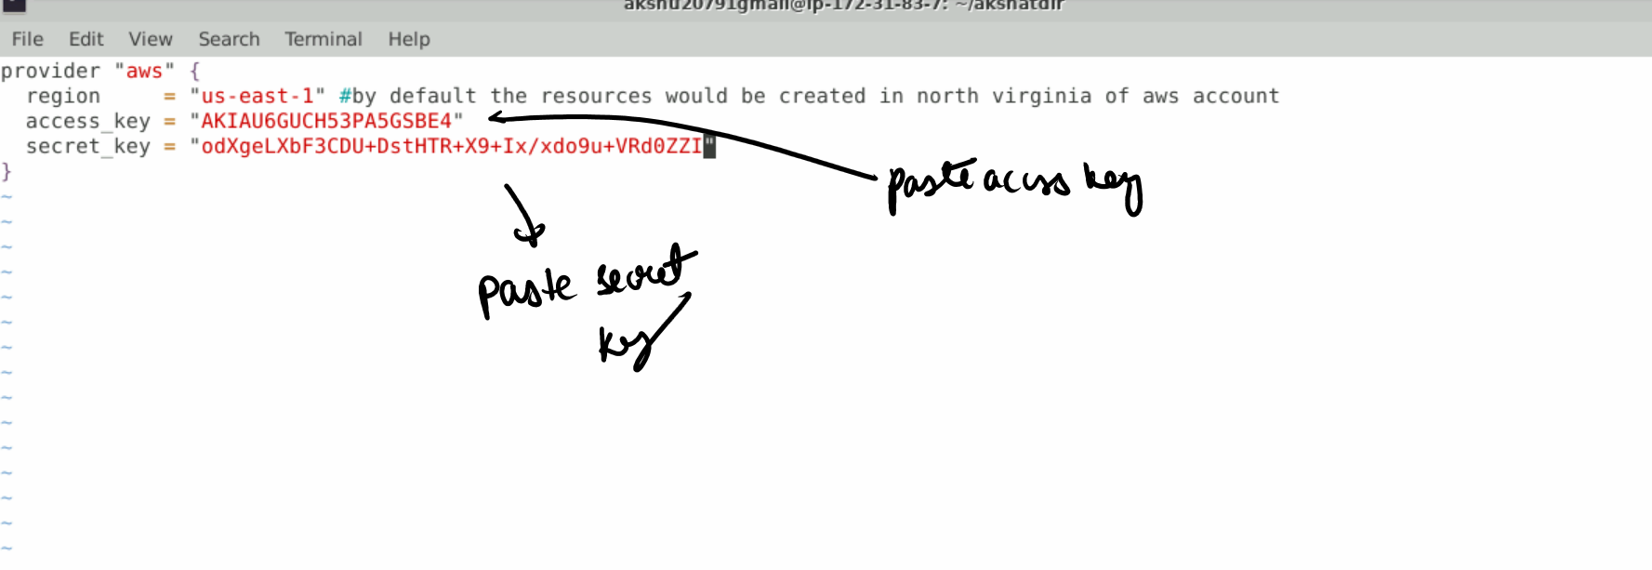

Save and quit   
press esc :wq