THIS IS FOR ONLY LEARNING PUPROSE ..THIS IS CLASS PROJECT NOT THE COURSE END PROJECT

COURSE END PROJECT LINK: https://docs.google.com/document/d/1TtmCjEwip_TLdobrLROB17ToCQkewdqd/edit?usp=drive_link&ouid=103157204066713600014&rtpof=true&sd=true

Lets suppose you are working for Company A and you have a server created in that company. You have deployed the app and put it in the container and app is working fine…  
Now you want to deploy the app in the client server as well…which is company B production server

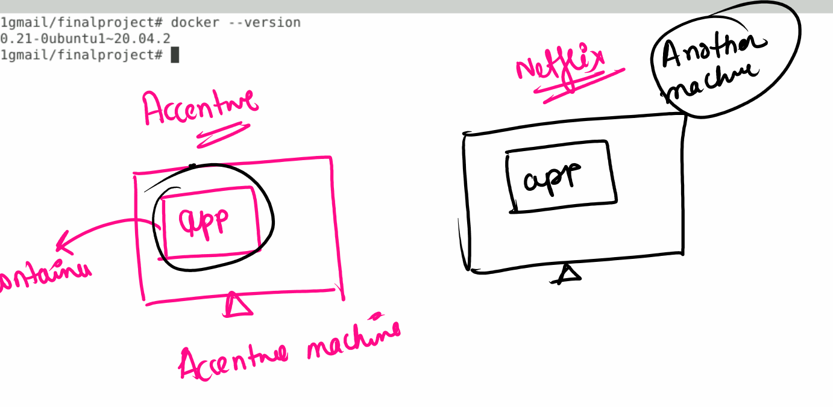

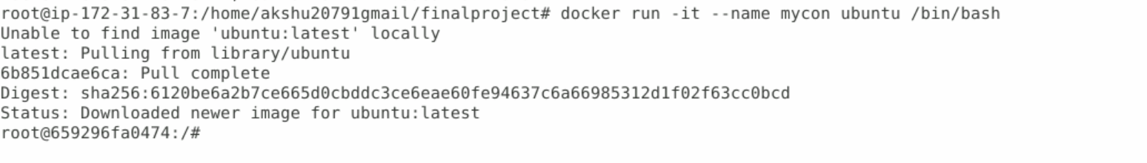

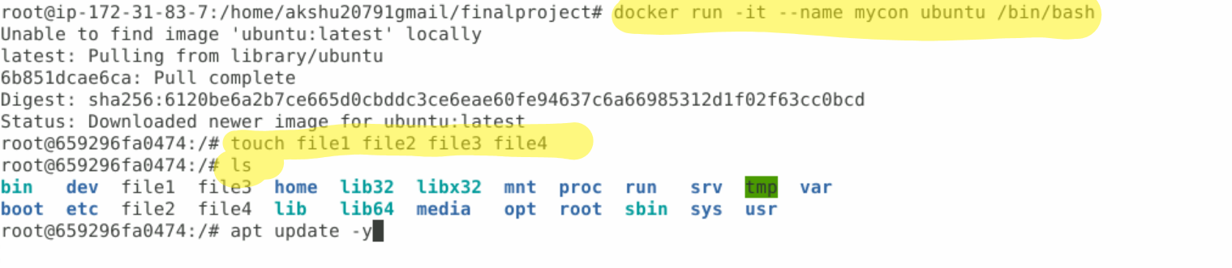

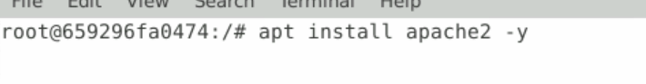

exit

docker ps -a



### Create a custom image of the container ….  
  
  
  


docker images

##

Go to dockerhub.com

And login …if you don’t have an account…signup

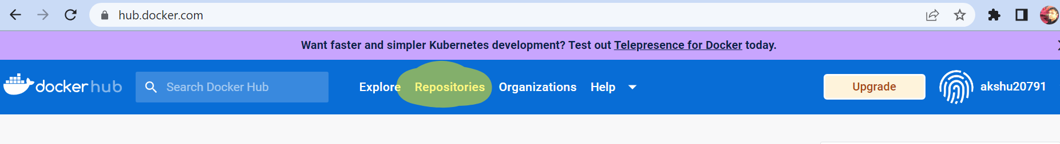

Lets login to the dockerhub.com



In password use your dockerhub.com password

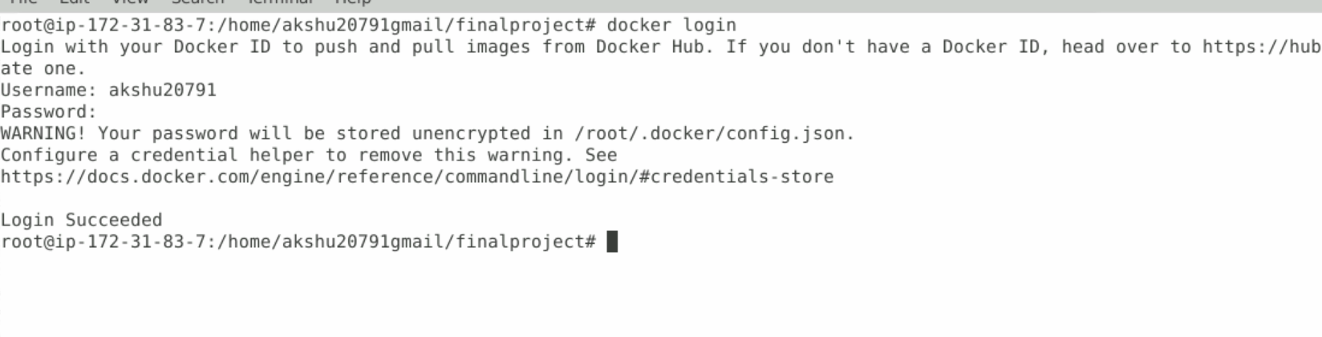

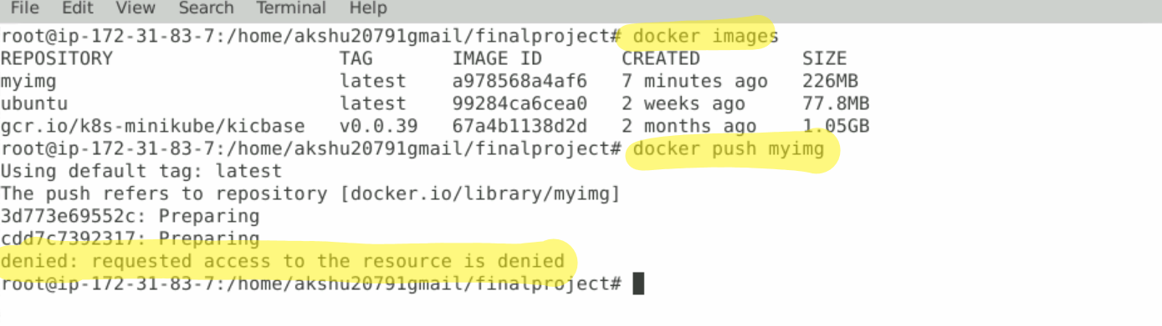

**ERROR WILL COME UP**

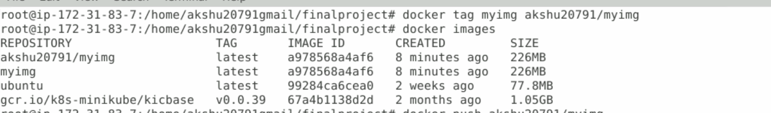



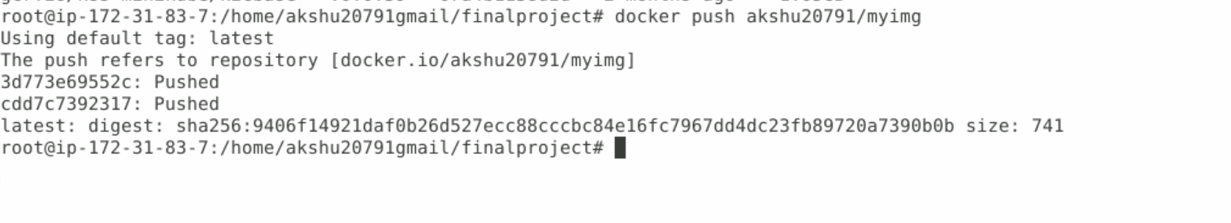



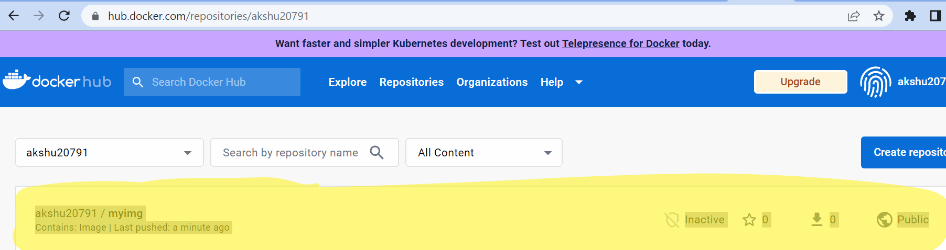

## NOW CLIENT WILL PULL THIS IMAGE

Lets suppose this the client machine

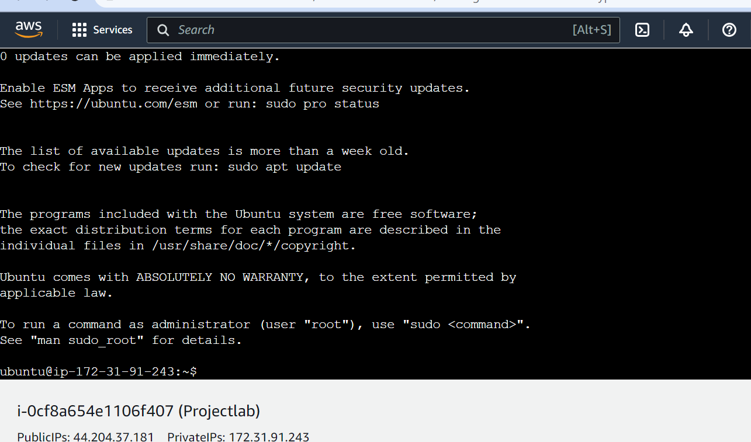

sudo su

apt update -y

apt install docker.io -y

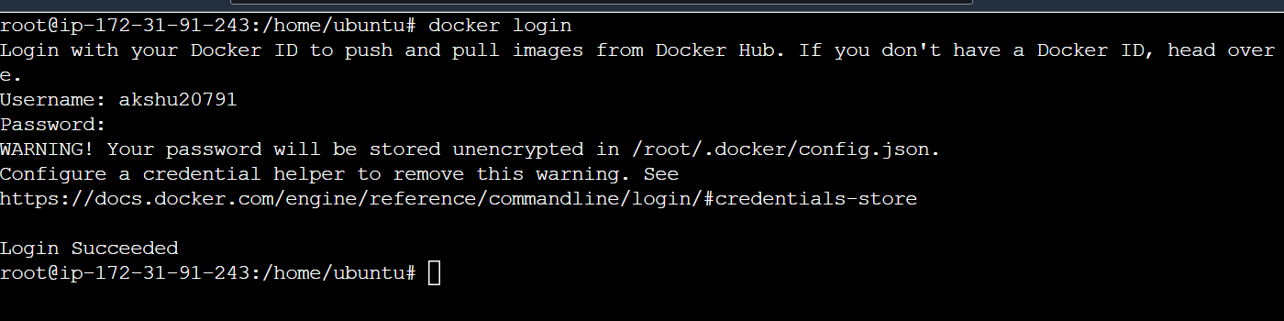

docker login

(use your dockerhub credentials to login)

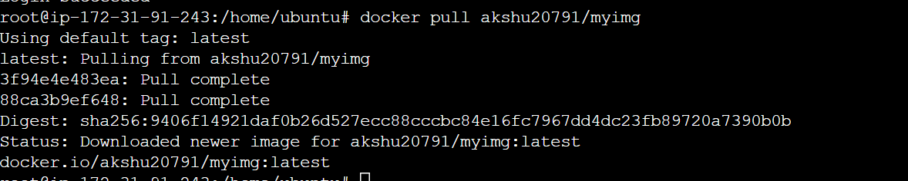



docker pull <<<<your dockerhub id will come>>>/myimg  
  
