**Homework 1 Problem 6**

The problem in this SolidWorks simulation step-by-step is from the homework 1 problems as below:

**Problem 6:**

Determine the force F3 necessary to produce a clockwise moment of 11 x 103 lb.ft moment about point *A*.



**Solution:**



Compared to this problem, students should confirm the 11 x 103 lb.ft moment at point A using the force calculated here.

To answer this question, we have created a SolidWorks model with dimensions exacting that of the above problem with a few assumptions such that the model is a 3D rather than a 2D problem as in here. Using SolidWorks statics simulations, we can determine the moment.

1. Download the HW1P6 folder and unzip the contents (Or open the file using Citrix).
2. Make sure that the Simulations tab is visible in your SolidWorks window. Right click the tool bar at the top of your SolidWorks, go to the Tabs option, and ensure that SOLIDWORKS Add-Ins is checked.
3. Open a new simulation study and select the static option with default settings.
4. Fix the geometry on one side of the I-beam that is affixed to a wall in the figure.

1. Add the F3 tension force of the rope pulling the beam of 148 lbf.

1. Use the annotation function to create a coordinate system at the corner of the beam add each x and y-component of the F2 force.

1. Add the second force F1 solely in the y-direction using the same coordinate system

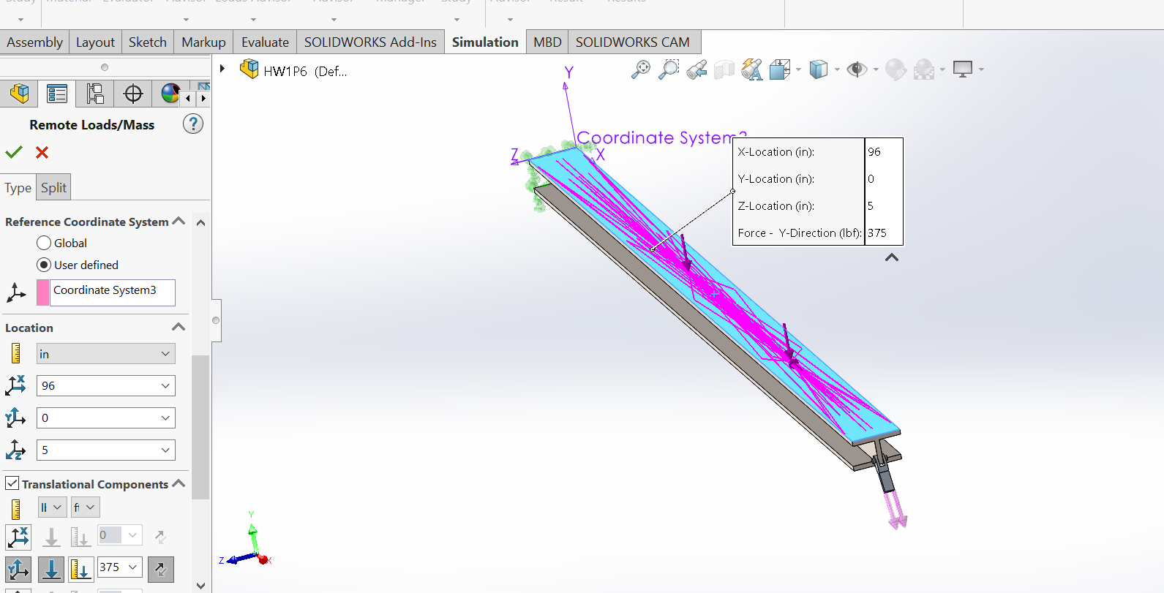

1. Add the materials as below:

1. Apply a mesh to the model with the default settings, ensure that all components have a check mark next to them.
2. Run the simulation.
3. Find the moment using find result force body force function with the point annotation function as your point to evaluate moment and the surface of the top of the beam being the length with which we are evaluating. **Compare the resulting moment to 11 x 103 lb.ft.**

