**Homework 4 Problem 4**

The problem in this SolidWorks simulation step-by-step is from the homework 4 problems as below:

**Problem 4:**

Determine the required diameters of the pins at *A* and *B*. The allowable shear stress is τallow = 6 ksi. Pin *A* is subjected to double shear, whereas pin *B* is subjected to single shear.

**Solution:**

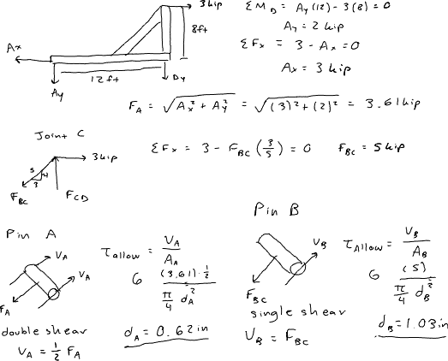

Compared to this problem, students should confirm that the calculated diameter does remain within the allowable shear stress of 6 ksi.

To answer this question, we have created a SolidWorks model with dimensions exacting that of the above problem with a few assumptions such that the model is a 3D rather than a 2D problem as in here. Using SolidWorks statics simulations, we can determine the shear force.

1. Download the HW4P4 folder and unzip the contents (Or open the file using Citrix).
2. Make sure that the Simulations tab is visible in your SolidWorks window. Right click the tool bar at the top of your SolidWorks, go to the Tabs option, and ensure that SOLIDWORKS Add-Ins is checked.
3. Open a new simulation study and select the static option with default settings.
4. Fix the geometry of the bottom of the system of beams

1. Apply a force to the surface of the pin at the top of the system of 3kip.

1. Apply the required material to each component as below:

1. Apply a mesh to the model with the default settings, ensure that all components have a check mark next to them.
2. Determine the shear stress against each pin by probing for the resulting stress along each pin. (**Hint: the max stress is, indeed, exceeded**) What does this tell you about the assumptions we made to solve this problem?