**Homework 6 Problem 3**

The problem in this SolidWorks simulation step-by-step is from the homework 6 problems as below:

**Problem 3:**

The beam is made from three boards nailed together as shown. If the moment acting on the cross section is M = 1 kip . ft, determine the maximum bending stress in the beam.

With the following solution:

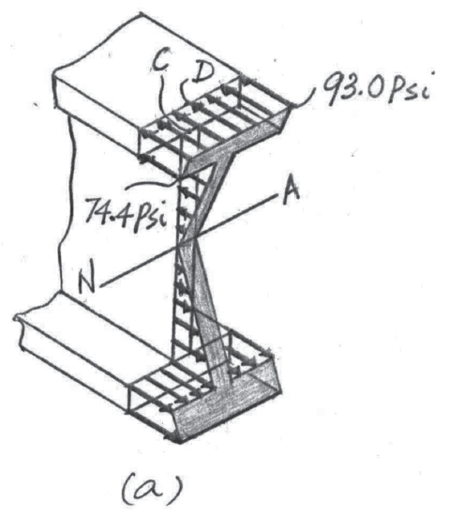

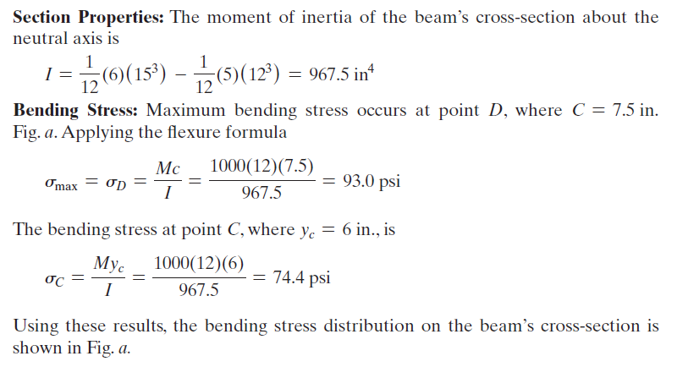

Compared to this problem, students should calculate the stress at the same locations after applying the same moment to an I-beam.

To answer this question, we have created a SolidWorks model with dimensions exacting that of the above problem with a few assumptions such that the model is a 3D rather than a 2D problem as in here. Using SolidWorks statics simulations, we can determine the maximum stress in the beam’s cross-section

.

1. Download the HW6P3 folder and unzip the contents (Or open the file using Citrix).
2. Make sure that the Simulations tab is visible in your SolidWorks window. Right click the tool bar at the top of your SolidWorks, go to the Tabs option, and ensure that SOLIDWORKS Add-Ins is checked.
3. Open a new simulation study and select the static option with default settings.
4. Fix the geometry of one side of the I-beam.

1. Create a coordinate system at the bottom left corner of the second I-beam surface and add a remote load of -120 lb rad in the clockwise direction of the x-axis with 1000lb rad in the y-axis as a distributed load.

1. Apply the Balsa material to the part.

1. Create a default mesh, ensuring that the part has a check mark next to it.
2. Run the simulation.
3. Probe for the stress at the top edge of the I-beam, determine it’s maximum and compare to your analytical results.

Compare the maximum stress to your analytical solution. What does this result tell you about the accuracy of the assumptions made in calculating the bending stress analytically vs. as a simulation?