**Homework 7 Problem 5**

The problem in this SolidWorks simulation step-by-step is from the homework 7 problems as below:

Determine the equation of the elastic curve for the beam using the x coordinate that is valid for 0 ≤ x < L/2. Specify the slope at A and the beam’s maximum deflection. EI is constant.

With the following solution:

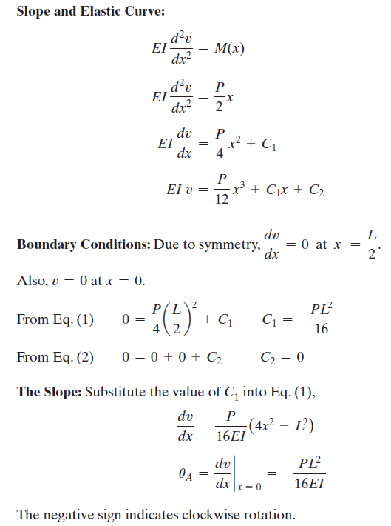

Compared to this problem, students should determine the deflection given that the force P is equal to 1000 lbf, L is equal to 48in, an I that you can calculate from the model, and an E consistent with ASTM A36 Steel and validate the resulting deflection against the calculated equation.

To answer this question, we have created a SolidWorks model with dimensions exacting that of the above problem with a few assumptions such that the model is a 3D rather than a 2D problem as in here. Using SolidWorks statics simulations, we can determine the maximum deflection.

1. Download the HW7P5 folder and unzip the contents (Or open the file using Citrix).
2. Make sure that the Simulations tab is visible in your SolidWorks window. Right click the tool bar at the top of your SolidWorks, go to the Tabs option, and ensure that SOLIDWORKS Add-Ins is checked.
3. Open a new simulation study and select the static option with default settings.
4. Fix the geometry of the supports on both sides of this simply supported I-beam

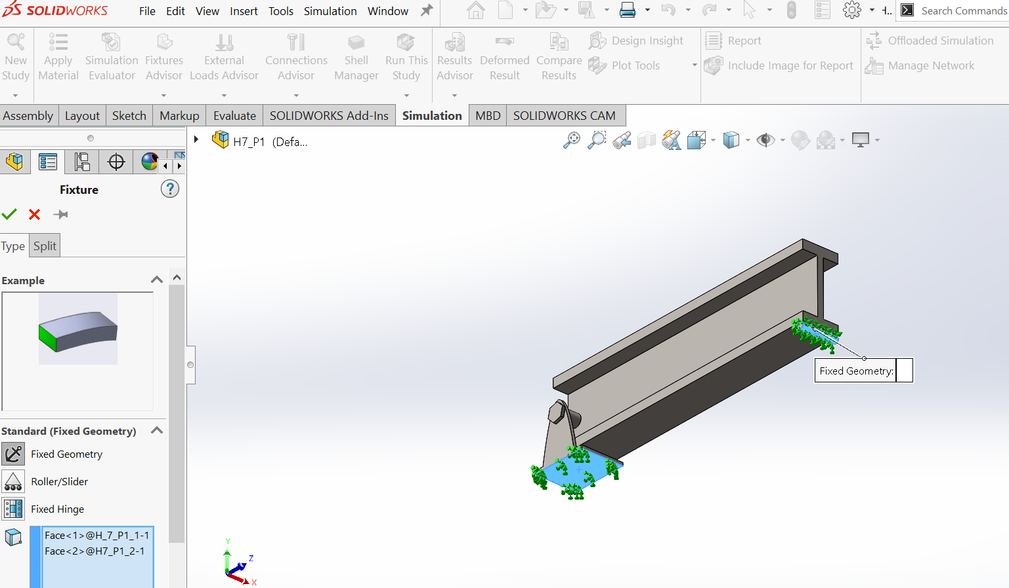

1. Add a remote load of 1000 lbf in the y-direction to the center of the top of this assembly using a coordinate system added as an annotation at the corner of the top surface of the I-beam

1. Add the materials as follows:

1. Probe along the corner edge of the beam to get the maximum deflection at the center

To compare the results, some measurements need to be taken.

L = 3.75-3.8 ft (distance between supports)

I = moment of inertia of principle axis (in this case, Iy = 558.5 in^4)

E = 29007547.53 psi (elastic modulus or youngs modulus)

P = 1000 lbf

Using the equation of the elastic curve as above, find the maximum deflection and compare to the simulation result. **What was the error percent? What does this tell you about our simulation or the superposition method?**