**Homework 7 Problem 8**

The problem in this SolidWorks simulation step-by-step is from the homework 7 problems as below:

**Problem 8:**

The W24 × 104 A-36 steel beam is used to support the uniform distributed load and a concentrated force which is applied at its end. If the force acts at an angle with the vertical as shown, determine the **horizontal** (x-direction) and **vertical** (y-direction) displacement at A.

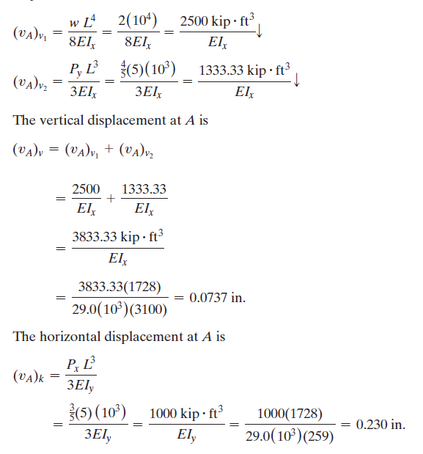

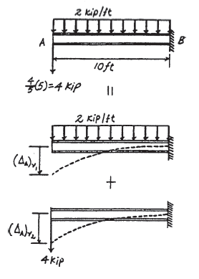

Compared to this problem, students should determine the displacement the by applying the forces above to a 3D model and evaluate the deflection.

To answer this question, we have created a SolidWorks model with dimensions exacting that of the above problem with a few assumptions such that the model is a 3D rather than a 2D problem as in here. Using SolidWorks statics simulations, we can determine the deflection.

1. Download the HW7P8 folder and unzip the contents (Or open the file using Citrix).
2. Make sure that the Simulations tab is visible in your SolidWorks window. Right click the tool bar at the top of your SolidWorks, go to the Tabs option, and ensure that SOLIDWORKS Add-Ins is checked.
3. Open a new simulation study and select the static option with default settings.
4. Fix the geometry of the supports on one side of the I beam.

1. Apply the x and y-components of the 5-kip force using the annotation function to create a point in the center of the beam’s cross-section

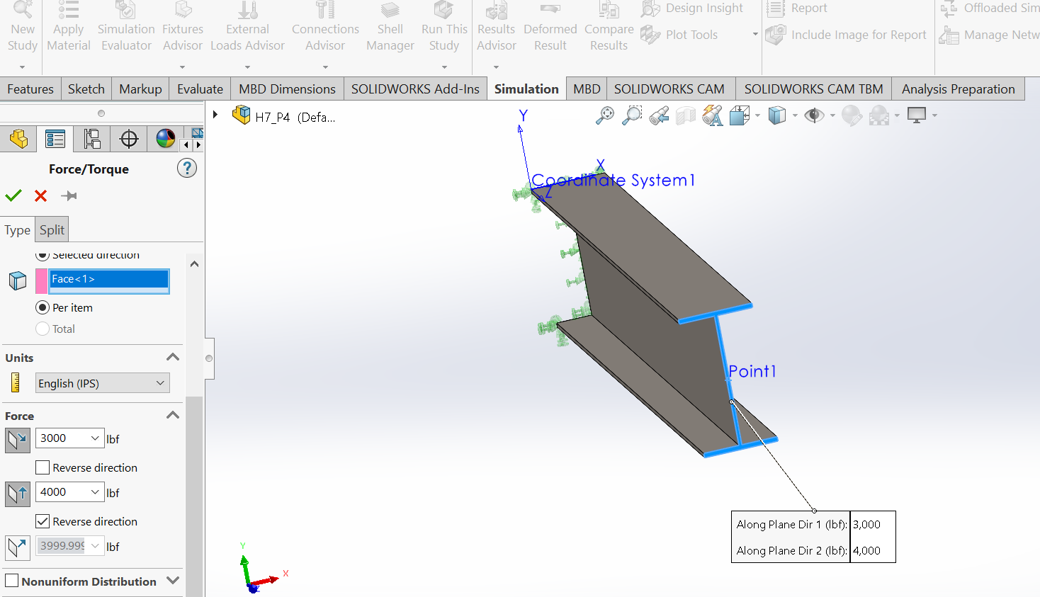

1. Apply a distributed load on the top surface of the beam of 2kip/ft

1. Add the required material as below

1. Apply a mesh to the model with the default settings, ensure that all components have a check mark next to them.
2. Determine the displacement in the x and y-direction and **compare to the analytical solution**

