**Lecture 3 Example 6**

The problem in this SolidWorks simulation step-by-step is from the lecture 3 problems as below:

**Example 6:**

**Given: The 4kN load at B of the beam is supported by pins at A and C.**

**Find: The support reactions at A and C.**

**Plan:**

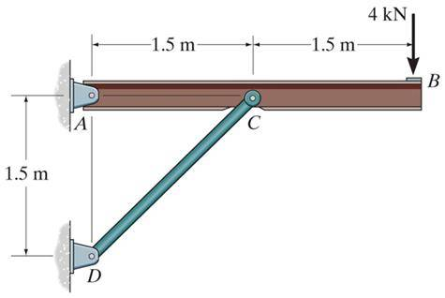

With the following solution:

FBD of the beam:

**AX**

**AY**

**A**

1.5 m

**C**

**B**

4 kN

**FCD**

45°

1.5 m

**Note:** Upon recognizing CD as a two-force member, the number of unknowns at C is reduced from two to one. Now, using E-o-f E, we get,

+ ∑MA = FCD sin 45° × 1.5 – 4 × 3 = 0

FCD = 11.31 kN or 11.3 kN

→ + ∑FX = AX + 11.31 cos 45° = 0; AX = – 8.00 kN

↑ + ∑FY = AY + 11.31 sin 45° – 4 = 0; AY = – 4.00 kN

Compared to this problem, students should confirm the support reactions determined here using the above forces.

To answer this question, we have created a SolidWorks model with dimensions exacting that of the above problem with a few assumptions such that the model is a 3D rather than a 2D problem as in here. Using SolidWorks statics simulations, we can determine the support reaction at A and C.

1. Download the L3E6 folder and unzip the contents (Or open the file using Citrix).
2. Make sure that the Simulations tab is visible in your SolidWorks window. Right click the tool bar at the top of your SolidWorks, go to the Tabs option, and ensure that SOLIDWORKS Add-Ins is checked.
3. Open a new simulation study and select the static option with default settings.
4. Fix the geometry of the brackets affixed to the wall at both locations.

1. Apply a force of a total of 4000N at the face of a small portion of the beam.

1. Apply the required material to each component as below:

1. Apply a mesh to the model with the default settings, ensure that all components have a check mark next to them.
2. Determine the reaction force at each bracket using the find result force body force function and **compare the results to the analytical solution**.