FEDERAL STATE AUTONOMOUS EDUCATIONAL INSTITUTION

OF HIGHER EDUCATION

ITMO UNIVERSITY

Report

on the practical task No. 3

“Algorithms for unconstrained nonlinear optimization. First- and second-order methods”

Performed by

*Mariia Koroleva*

*J42322c*

Accepted by

Dr Petr Chunaev

St. Petersburg

2021

**Goal**

*The use of first- and second-order methods (Gradient Descent, Conjugate Gradient Descent, Newton’s method and ﻿Levenberg-Marquardt algorithm) in the tasks of unconstrained nonlinear optimization*

**Formulation of the problem**

*Generate random numbers $α∈\left(0,1\right)$ and $β∈\left(0,1\right)$. Furthermore, generate the noisy data $\left\{x_{k},y_{k}\right\}$, where $k=0,…,100$, according to the following rule:*

$y_{k}=αx_{k}+β+δ_{k}, x_{k}=\frac{k}{100}$*,*

*where $δ_{k}\sim N\left(0,1\right)$ are values of a random variable with standard normal distribution. Approximate the data by the following linear and rational functions:*

1. $F\left(x,a,b\right)=ax+b$*(linear approximant),*
2. $F\left(x,a,b\right)=\frac{a}{1+bx}$*(rational approximant),*

*by means of least squares through the numerical minimization (with precision $ε=0.001$) of the following function:*

$$D\left(a,b\right)=\sum_{k=0}^{100}{({F\left(x_{k},a,b\right)-y_{k})}^{2}}.$$

*To solve the minimization problem, use the methods of Gradient Descent, Conjugate Gradient Descent, Newton’s method and ﻿Levenberg-Marquardt algorithm. If necessary, set the initial approximations and other parameters of the methods. Visualize the data and the approximants obtained* ***separately for each type of approximant****. Analyze the results obtained (in terms of number of iterations, precision, number of function evaluations, etc.) and compare them with those from Task 2 for the same dataset.*

**Brief theoretical part**

In this paper, we consider such minimization methods as Gradient Descent, Conjugate Gradient Descent, Newton’s method and ﻿Levenberg-Marquardt algorithm. Here is their description:

*Gradient descent* is based on the observation that if f(x) is defined and differentiable in a neighborhood of a point a, then f(x) decreases fastest in a neighborhood of a in the direction of −∇af. One obtains the following formula:

an+1 = an − γ∇an f

for γ ∈ R+ small enough, then f(an) ≥ f(an+1). With this observation in mind, one starts with a guess a0 for a local minimum of f and considers the sequence {an} such that an+1 = an − γn∇an f, n ≥ 0. Here the value of the step size γn may be non-fixed and changed at every iteration (many possible ways to choose).

*Conjugate Gradient Descent.*

Given a function f(x), x ∈ R n and an initial approximation a0, one starts in the steepest descent direction: ∆a0 = −∇a0 f.

Find the step length α0:= arg minα f (a0 + α∆a0) and the next point a1 = a0 + α0∆a0. After this iteration, the following steps constitute one iteration of moving along a subsequent conjugate direction sn, where s0 = ∆a0:

* Calculate the steepest direction ∆an = −∇an f.
* Compute βn according to certain formulas.
* Update the conjugate direction sn = ∆an + βnsn−1.
* Find αn = arg minα f(an + αsn).
* Update the position: an+1 = an + αnsn

The choice of βn due to Fletcher-Reeves:

The choice of βn due to Polak-Ribiere:

*Newton’s method.*

Let f : Rn → R be convex and Hxf is invertible for x ∈ Rn . The one-dimensional scheme can be generalized to several dimensions by replacing the derivative with the gradient, ∇f, and the reciprocal of the second derivative with the inverse of the Hessian matrix, Hf: an+1 = an − [Han f] −1∇an f, n ≥ 0.

﻿*Levenberg-Marquardt algorithm*

The application of LMA is the least-squares curve fitting problem: given a set (xi, yi) m i=1, find the parameters β (column vector) of the model curve f(x, β) so that the sum of the squares of the deviations S(β) is minimized: Xm i=1.

arg min β S(β) ≡ arg min β

**Results**

|  |  |  |  |
| --- | --- | --- | --- |
| **Results of Linear Approximation** | | | |
| **Algorithm name** | **Number of iterations** | **Function min** | **Number of function calculations** |
| **Gradient descent** | 8 | 101,405 | 6 |
| **Conjugate gradient descent** | 2 | 101,404 | 24 |
| **Newton's method** | 3 | 101,404 | 46 |
| **Levenberg-Marquardt algorithm** | - | 101,404 | 7 |
| **\*Exhaustive search** | 4004002 | 101,404 | 4004001 |
| **\*Gauss method** | 30 | 101,405 | 30 |
| **\*Nelder-Mead** | 24 | 101,404 | 47 |

|  |  |  |  |
| --- | --- | --- | --- |
| **Results of Rational Approximation** | | | |
| **Algorithm name** | **Number of iterations** | **Function min** | **Number of function calculations** |
| **Gradient descent** | 10 | 101,677 | 8 |
| **Conjugate gradient descent** | 8 | 101,404 | 72 |
| **Newton's method** | 8 | 101,404 | 13 |
| **Levenberg-Marquardt algorithm** | - | 118,747 | 20 |
| **\*Exhaustive search** | 4004002 | 101,404 | 4004001 |
| **\*Gauss method** | 253 | 115,752 | 253 |
| **\*Nelder-Mead** | 53 | 101,404 | 102 |

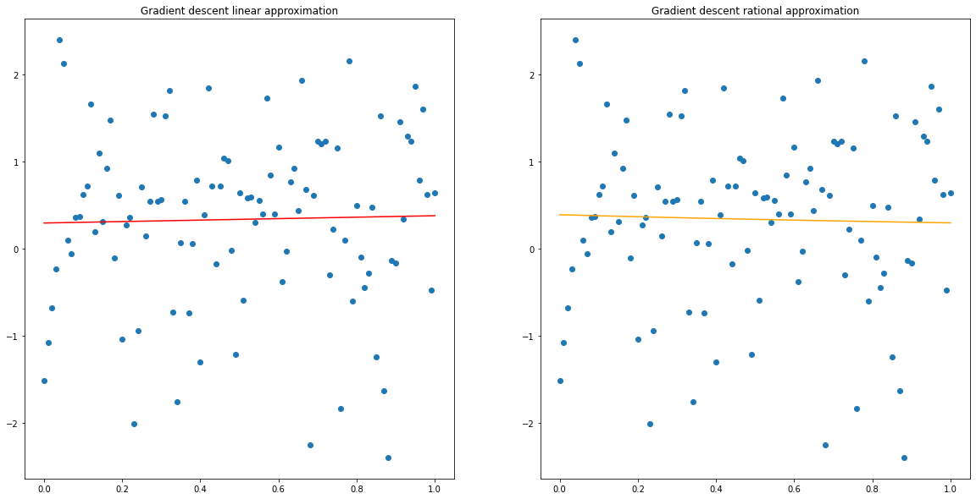

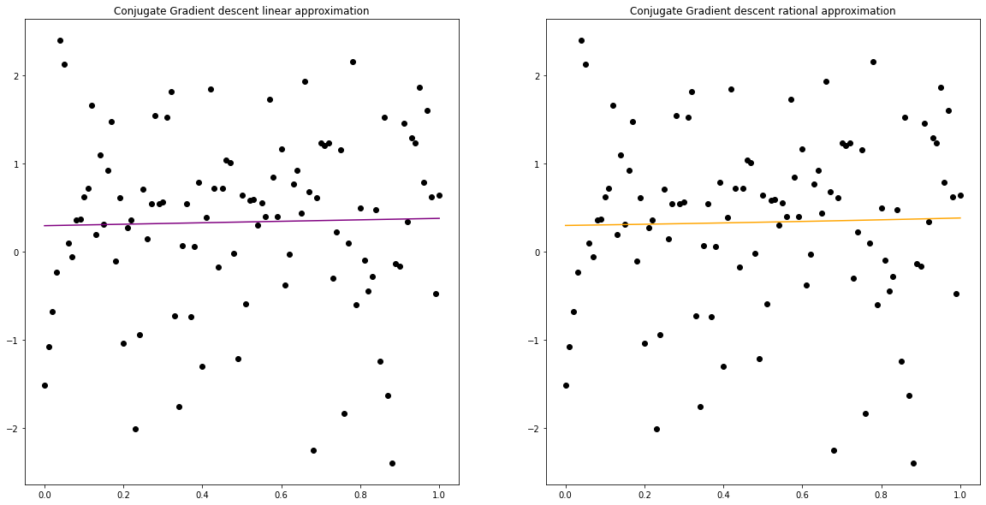

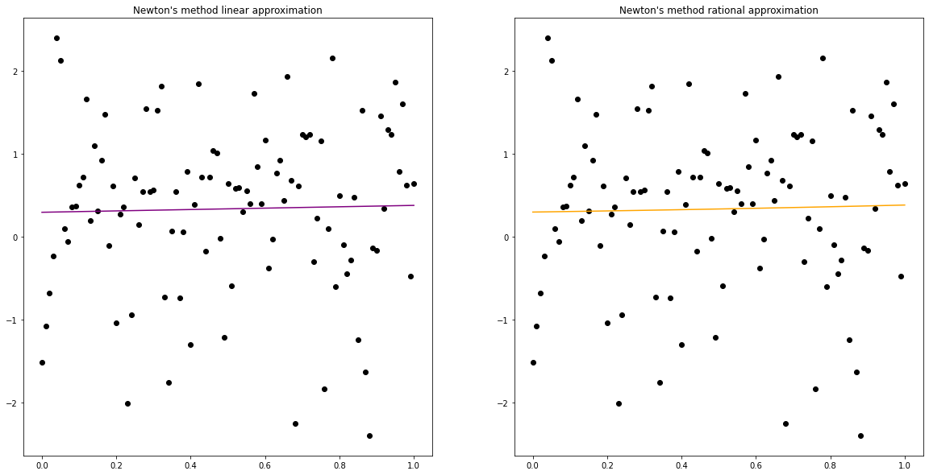

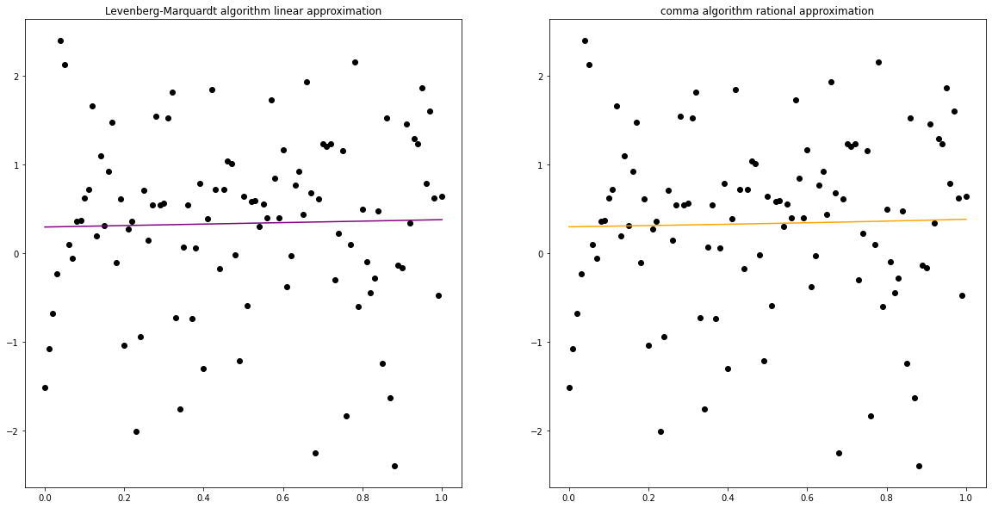

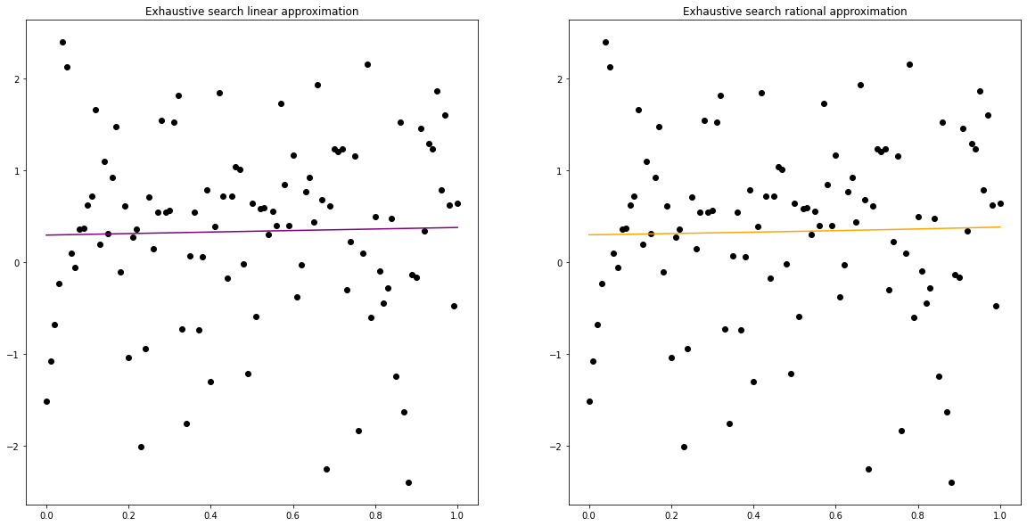

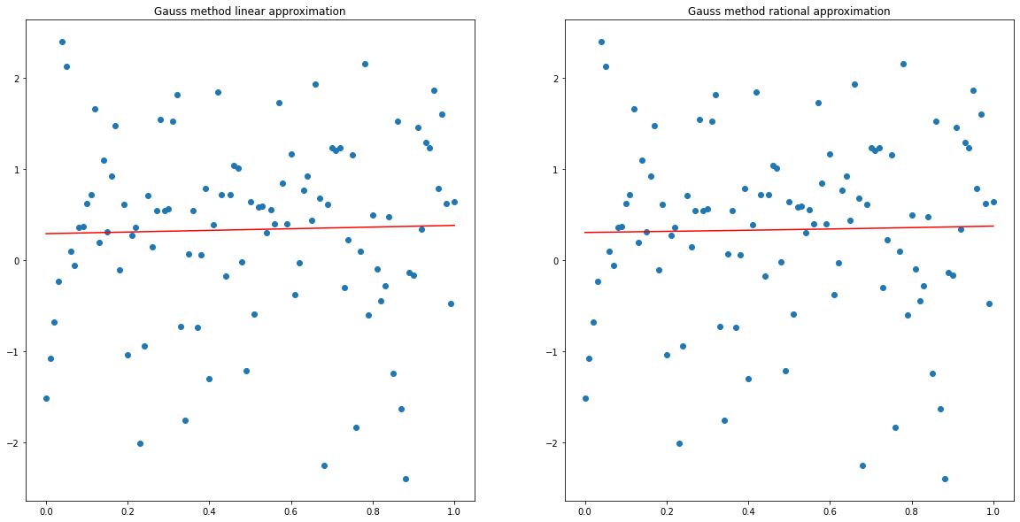

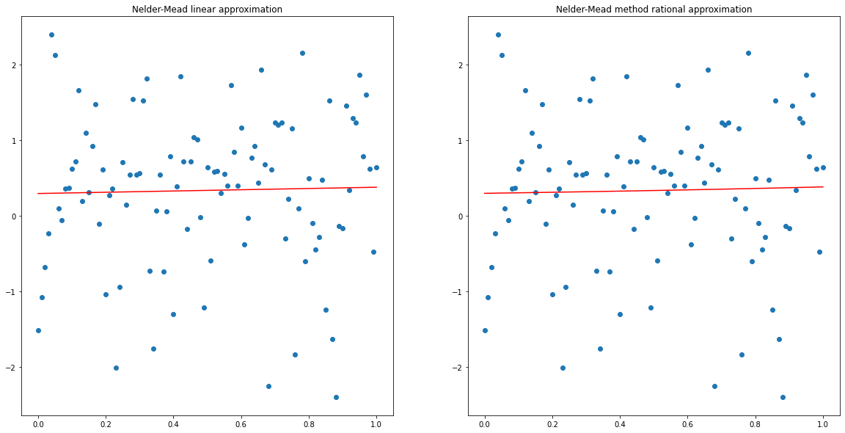

**Conclusions**

• Due to the significant disparity of the generated data, there are no significant graphical differences between the approximations.

• In linear approximation, the accuracy of all algorithms is almost the same.

• Exhaustive search turned out to be the most inefficient in terms of the number of iterations and time spent in both linear and non-linear approximations.

• Judging by such an indicator as the number of iterations, the most efficient algorithms are Conjugate gradient descent and Newton’s method

• Judging by such an indicator as the number of function evaluations, the most efficient algorithm is Gradient descent.

• In the non-linear approximation, the Levenberg-Marquardt algorithm showed the lowest accuracy.

**Appendix**

import numpy as np

import itertools

import matplotlib.pyplot as plt

import random

from scipy import optimize

from autograd import jacobian, grad

import pandas as pd

eps = 0.001

delta = np.random.randint(1, 100) / 100

alpha = np.random.randint(1, 100) / 100

betta = np.random.randint(1, 100) / 100

k = np.array(list(range(0, 101)))

X = np.array(list(map(lambda x: x/100, k)))

Y= np.array([alpha*x + betta + np.random.normal(0, 1)

               for i, x in enumerate(X)])

f_lin = lambda x, point: point[0] * x + point[1]

f_rat = lambda x, point: point[0] / (1 + point[1] * x)

D = lambda args: sum([(args[0](x, args[1]) - y) ** 2 for x, y in zip(X, Y)])

D_fun_linear   = lambda args: D((f_lin, args))

D_fun_rational = lambda args: D((f_rat, args))

results_lin = pd.DataFrame()

results_lin['Algorithm name'] = ['Gradient descent', 'Conjugate gradient descent', 'Newton\'s method', 'Levenberg-Marquardt algorithm', '*Exhaustive search', '*Gauss method', '*Nelder-Mead']

results_lin.set_index('Algorithm name', inplace=True)

results_lin.style.set_caption("Results of linear approximation")

header_list = ['Number of iters', 'Function min', 'Number of func calculations']

results_lin = results_lin.reindex(columns = header_list)

results_rat = pd.DataFrame()

algs = ['Gradient descent', 'Conjugate gradient descent', 'Newton\'s method', 'Levenberg-Marquardt algorithm', '*Exhaustive search', '*Gauss method', '*Nelder-Mead']

results_rat['Algorithm name'] = algs

results_rat.set_index('Algorithm name', inplace=True)

results_rat.style.set_caption("Results of rational approximation")

header_list = ['Number of iters', 'Function min', 'Number of func calculations']

results_rat = results_lin.reindex(columns = header_list)

Gradient descent

def golden_section(f, a, b, eps=eps):

    x1 = a + (3 - 5**0.5)*(b - a)/2

    x2 = b + (5**0.5 - 3)*(b - a)/2

    i = 0

    f1 = f(x1)

    f2 = f(x2)

    while np.abs(a - b) >= eps:

        if f(x1) <= f(x2):

            b = x2

            x2 = x1

            x1 = a + (3 - np.sqrt(5))/2*(b - a)

            f2 = f1

            f1 = f(x1)

        else:

            a = x1

            x1 = x2

            x2 = b + (np.sqrt(5) - 3)/2*(b - a)

            f1 = f2

            f2 = f(x2)

        i += 1

    return (a+b)/2, i + 2, i

def gradient_descent(f, args):

    f_min_previous = f(args)

    args = np.random.randint(1, 100) / 100, np.random.randint(1, 100) / 100

    f_min = f(args)

    i = 0

    while np.abs(f_min - f_min_previous) > eps:

        f_min_previous = f_min

        gradient = grad(f)

        def one_dim_step(h):

            return f(args - h * np.array(gradient(args)))

        h = golden_section(one_dim_step, 0, 1)[0]

        args = args - h * np.array(gradient(args))

        f_min = f(args - h * np.array(gradient(args)))

        i += 1

    return args[0], args[1], f_min, i+2, i

%%time

grad_lin_res = gradient_descent(D_fun_linear, [0, 0])

grad_lin_res

num_of_iterations, func_value, func_count = grad_lin_res[3], round(grad_lin_res[2], 3), grad_lin_res[4]

results_lin.loc[algs[0], :] = [num_of_iterations, func_value, func_count]

%%time

grad_rat_res = gradient_descent(D_fun_rational, [0, 0])

grad_rat_res

num_of_iterations, func_value, func_count = grad_rat_res[3], round(grad_rat_res[2], 3), grad_rat_res[4]

results_rat.loc[algs[0], :] = [num_of_iterations, func_value, func_count]

fig, axes = plt.subplots(1, 2, figsize=(20, 10))

axes.flat[0].plot(X, f_lin(X, (grad_lin_res[0], grad_lin_res[1])), color='red')

axes.flat[0].scatter(X, Y)

axes.flat[0].set_title('Gradient descent linear approximation')

axes.flat[1].plot(X, f_rat(X, (grad_rat_res[0], grad_rat_res[1])), color='orange')

axes.flat[1].scatter(X, Y)

axes.flat[1].set_title('Gradient descent rational approximation');

## Conjugate Gradient descent

cg_lin_res = optimize.minimize(D_fun_linear, np.random.rand(2), method='CG', tol=0.001)

cg_lin_res

num_of_iterations, func_value, func_count = cg_lin_res.nit, round(cg_lin_res.fun, 3), cg_lin_res.nfev

results_lin.loc[algs[1], :] = [num_of_iterations, func_value, func_count]

cg_rat_res = optimize.minimize(D_fun_rational, np.random.rand(2), method='CG', tol=0.001)

cg_rat_res

num_of_iterations, func_value, func_count = cg_rat_res.nit, round(cg_rat_res.fun, 3), cg_rat_res.nfev

results_rat.loc[algs[1], :] = [num_of_iterations, func_value, func_count]

fig, axes = plt.subplots(1, 2, figsize=(20, 10))

axes.flat[0].plot(X, f_lin(X, cg_lin_res.x), color='purple')

axes.flat[0].scatter(X, Y, color='k')

axes.flat[0].set_title('Conjugate Gradient descent linear approximation')

axes.flat[1].plot(X, f_rat(X, cg_rat_res.x), color='orange')

axes.flat[1].scatter(X, Y, color='k')

axes.flat[1].set_title('Conjugate Gradient descent rational approximation');

## Newton's method

ncg_lin_res = optimize.minimize(D_fun_linear, np.random.rand(2),jac=jacobian(D_fun_linear), method='Newton-CG', tol=0.001)

ncg_lin_res

num_of_iterations, func_value, func_count = ncg_lin_res.nit, round(ncg_lin_res.fun, 3), ncg_lin_res.nfev

results_lin.loc[algs[2], :] = [num_of_iterations, func_value, func_count]

ncg_rat_res = optimize.minimize(D_fun_rational, np.random.rand(2),jac=jacobian(D_fun_rational),

                       method='Newton-CG', tol=0.001)

ncg_rat_res

num_of_iterations, func_value, func_count = ncg_rat_res.nit, round(ncg_rat_res.fun, 3), ncg_rat_res.nfev

results_rat.loc[algs[2], :] = [num_of_iterations, func_value, func_count]

fig, axes = plt.subplots(1, 2, figsize=(20, 10))

axes.flat[0].plot(X, f_lin(X, ncg_lin_res.x), color='purple')

axes.flat[0].scatter(X, Y, color='k')

axes.flat[0].set_title('Newton\'s method linear approximation')

axes.flat[1].plot(X, f_rat(X, ncg_rat_res.x), color='orange')

axes.flat[1].scatter(X, Y, color='k')

axes.flat[1].set_title('Newton\'s method rational approximation');

## Levenberg-Marquardt algorithm

f_lin_ = lambda args, x, y: args[0] * x + args[1] - y

f_rat_ = lambda args, x, y: args[0] / (1 + args[1] * x) - y

lm_lin_res = optimize.least_squares(f_lin_, np.random.rand(2), args=(X, Y), method='lm')

num_of_iterations, func_value, func_count = '-', round(D_fun_linear(lm_lin_res.x), 3), lm_lin_res.nfev

results_lin.loc[algs[3], :] = [num_of_iterations, func_value, func_count]

fig, axes = plt.subplots(1, 2, figsize=(20, 10))

axes.flat[0].plot(X, f_lin(X, lm_lin_res.x), color='purple')

axes.flat[0].scatter(X, Y, color='k')

axes.flat[0].set_title('Levenberg-Marquardt algorithm linear approximation')

axes.flat[1].plot(X, f_rat(X, lm_rat_res.x), color='orange')

axes.flat[1].scatter(X, Y, color='k')

axes.flat[1].set_title('comma algorithm rational approximation');

# **Lab 2 algorithms**

from itertools import product

f_lin = lambda x, a, b: a * x + b

f_rat = lambda x, a, b: a / (1 + b * x)

D = lambda f, X, Y, a, b: sum([(f(x, a, b) - y) ** 2 for x, y in zip(X, Y)])

## Exhaustive search

steps = np.arange(-1, 1.001, 0.001)

def exhaustive_search_multi(f, X, Y, alpha, betta):

    f_min = D(f, X, Y, alpha, betta)

    alpha_res = 0

    betta_res = 0

    i = 0

    for alpha, betta in list(product(steps, steps)):

        curr_f = D(f, X, Y, alpha, betta)

        if curr_f < f_min:

            f_min = curr_f

            alpha_res = alpha

            betta_res = betta

        i += 1

    return [alpha_res, betta_res, f_min, i+1, i]

%%time

exh_lin_res = exhaustive_search_multi(f_lin, X, Y, 0, 0)

exh_lin_res

num_of_iterations, func_value, func_count = exh_lin_res[3], round(exh_lin_res[2], 3), exh_lin_res[-1]

results_lin.loc[algs[4], :] = [num_of_iterations, func_value, func_count]

%%time

exh_rat_res = exhaustive_search_multi(f_rat, X, Y, 0, 0)

exh_rat_res

num_of_iterations, func_value, func_count = exh_rat_res[3], round(exh_rat_res[2], 3), exh_rat_res[-1]

results_rat.loc[algs[4], :] = [num_of_iterations, func_value, func_count]

fig, axes = plt.subplots(1, 2, figsize=(20, 10))

axes.flat[0].plot(X, f_lin(X, exh_lin_res[0], exh_lin_res[1]), color='purple')

axes.flat[0].scatter(X, Y, color='k')

axes.flat[0].set_title('Exhaustive search linear approximation')

axes.flat[1].plot(X, f_rat(X, exh_rat_res[0], exh_rat_res[1]), color='orange')

axes.flat[1].scatter(X, Y, color='k')

axes.flat[1].set_title('Exhaustive search rational approximation');

## Gauss method

# Gauss

eps = 0.001

def dichotomy_for_D(f, X, Y, a, b, a_opt, b_opt, par = 'a'):

    i = 0

    delta = np.random.uniform(0, eps)

    while np.abs(a - b) > eps:

        x1 = (a + b - delta) / 2

        x2 = (a + b + delta) / 2

        f_1 = D(f, X, Y, x1, b_opt) if par == 'a' else D(f, X, Y, a_opt, x1)

        f_2 = D(f, X, Y, x2, b_opt) if par == 'a' else D(f, X, Y, a_opt, x2)

        if f_1 <= f_2:

            b = x2

            fmin = f_1

        else:

            a = x1

            fmin = f_2

        i += 1

    return x1, i*2, i

def gauss(f, X, Y, z1 = 0, z2 = 0):

    f_min_prev = D(f, X, Y, z1, z2)

    z1_prev = z1

    z1 =  dichotomy_for_D(f, X, Y, -1, 1 + eps, z1, z2)[0]

    f_min = D(f, X, Y, z1, z2)

    i = 1 + dichotomy_for_D(f, X, Y, -1, 1 + eps, z1, z2)[2]

    j = 2 + dichotomy_for_D(f, X, Y, -1, 1 + eps, z1, z2)[1]

    l = 1

    while (np.abs(f_min - f_min_prev) >= eps) and (np.abs(z1 - z1_prev) >= eps):

      if l % 2 == 0:

          z1_prev = z1

          z1 =  dichotomy_for_D(f, X, Y, -1, 1 + eps, z1, z2)[0]

          f_min_prev = f_min

          f_min = D(f, X, Y, z1, z2)

          i += 1 + dichotomy_for_D(f, X, Y, -1, 1 + eps, z1, z2)[2]

          j += 1 + dichotomy_for_D(f, X, Y, -1, 1 + eps, z1, z2)[1]

      else:

          z2_prev = z2

          z2 =  dichotomy_for_D(f, X, Y, -1, 1 + eps, z1, z2, par = 'b')[0]

          f_min_prev = f_min

          f_min = D(f, X, Y, z1, z2)

          i += 1 + dichotomy_for_D(f, X, Y, -1, 1 + eps, z1, z2, par = 'b')[2]

          j += 1 + dichotomy_for_D(f, X, Y, -1, 1 + eps, z1, z2, par = 'b')[1]

          if np.abs(z2 - z2_prev) < eps:

              break

      l += 1

    return z1, z2, j, i

%%time

F_linear_opt_2 = gauss(f_lin, X, Y, alpha, betta)

num_of_iterations, func_value, func_count = F_linear_opt_2[3], round(D(f_lin, X, Y, F_linear_opt_2[0], F_linear_opt_2[1]), 3), F_linear_opt_2[-1]

results_lin.loc[algs[5], :] = [num_of_iterations, func_value, func_count]

%%time

F_rational_opt_2 = gauss(f_rat, X, Y, alpha, betta)

num_of_iterations, func_value, func_count = F_rational_opt_2[3], round(D(f_lin, X, Y, F_rational_opt_2[0], F_rational_opt_2[1]), 3), F_rational_opt_2[-1]

results_rat.loc[algs[5], :] = [num_of_iterations, func_value, func_count]

# Gauss method

fig, axes = plt.subplots(1, 2, figsize=(20, 10))

axes.flat[0].plot(X, f_lin(X, F_linear_opt_2[0], F_linear_opt_2[1]), color = 'red')

axes.flat[0].scatter(X, Y)

axes.flat[0].set_title('Gauss method linear approximation')

axes.flat[1].plot(X, f_rat(X, F_rational_opt_2[0], F_rational_opt_2[1]), color = 'red')

axes.flat[1].scatter(X, Y)

axes.flat[1].set_title('Gauss method rational approximation')

## Nelder-Mead

def F_linear_point(x, point):

    return point[0]*x + point[1]

def F_rational_point(x, point):

    return point[0]/(1 + point[1]*x)

def D_point(point, f, X, Y):

    return sum([(f(x_i, point) - y_i)**2 for x_i, y_i in zip(X, Y)])

def nelder_mead(f, X, Y):

    result = optimize.minimize(D_point, np.random.rand(2), args=(f, X, Y), method ='nelder-mead')

    return result

%%time

F_linear_opt_3 = nelder_mead(F_linear_point, X, Y)

num_of_iterations, func_value, func_count = F_linear_opt_3.nit, round(F_linear_opt_3.fun, 3), F_linear_opt_3.nfev

results_lin.loc[algs[6], :] = [num_of_iterations, func_value, func_count]

%%time

F_rational_opt_3 = nelder_mead(F_rational_point, X, Y)

num_of_iterations, func_value, func_count = F_rational_opt_3.nit, round(F_rational_opt_3.fun, 3), F_rational_opt_3.nfev

results_rat.loc[algs[6], :] = [num_of_iterations, func_value, func_count]

# Nelder-Mead

fig, axes = plt.subplots(1, 2, figsize=(20, 10))

axes.flat[0].plot(X, f_lin(X, F_linear_opt_3.x[0], F_linear_opt_3.x[1]), color = 'red')

axes.flat[0].scatter(X, Y)

axes.flat[0].set_title('Nelder-Mead linear approximation')

axes.flat[1].plot(X, f_rat(X, F_rational_opt_3.x[0], F_rational_opt_3.x[1]), color = 'red')

axes.flat[1].scatter(X, Y)

axes.flat[1].set_title('Nelder-Mead method rational approximation')

!pip install openpyxl

writer = pd.ExcelWriter('results_lin.xlsx')

results_lin.to_excel(writer)

writer.save()

writer_ = pd.ExcelWriter('results_rat.xlsx')

results_rat.to_excel(writer_)

writer_.save()