

PROJECT REPORT (UI/UX DESIGN LAB)
ON
MUSIC STREAMING WEBSITE UI

By

MARYLIN NITHIKA

1NZ24CS107 - G

Department of Computer Science and Engineering - 3

AY: 2025-2026

Department of Computer Science and Engineering - 3
CERTIFICATE
Certified that the project work entitled “Music Streaming Website UI” was carried out by Ms. Student name (1NZ24CS107), a Bonafide student of New Horizon College of Engineering in partial fulfilment for the award of Bachelor of Engineering in Computer Science and Engineering of the Visvesvaraya Technological University, Belagavi during the year 2025-26. It is certified that all corrections/suggestions indicated for Internal Assessment have been incorporated in the Report deposited in the Departmental library. The project report has been approved as it satisfies the academic requirements in respect of the project work prescribed for the Bachelor of Engineering Degree.

Signature of the Mentor
Name of the Mentor :
Designation
Dept. of XYZ
SEE Viva
Name of the examiners Signature with date
1……………………………………………………………………….………………….…………………
2………………………………………………………………………………………….………………….

ABSTRACT
The Vynyl Music Streaming Platform is a UI/UX based web application developed using HTML, CSS, and JavaScript to provide users with an interactive and visually appealing music streaming experience. The project focuses on designing a modern and user-friendly interface that simulates the core features of a real-world music streaming application.
The application consists of multiple pages including a welcome page, login page, signup page, and a music player interface. The interface includes features such as playlist management, music controls, progress tracking, search functionality, and responsive navigation components. The project emphasizes aesthetic design principles, smooth user interaction, and effective layout structuring.
The user interface was initially designed using Figma to create a consistent visual style and prototype workflow before implementation. CSS was used extensively for styling, animations, responsive layouts, and modern visual effects, while JavaScript was used to implement interactive functionalities such as play/pause controls, playlist selection, progress bar updates, and dynamic user interactions.
This project demonstrates the practical implementation of UI/UX design concepts along with frontend web development technologies. It highlights the importance of usability, accessibility, responsiveness, and user-centered design in creating engaging digital applications.

CONTENTS
CERTIFICATE | I
ABSTRACT | II
LIST OF FIGURES | III
LIST OF TABLES | IV
- INTRODUCTION ABOUT UI/UX DESIGN | 1
1.1 | 1
- HTML,CSS PROJECT | 9  9  10  15  19
22
22
25
- Figma project  3.1 | 27  27  27  27
- OUTCOME, APPLICATIONS & BENEFITS | 34
REFERENCES | 39
ANNEXURE (if required) | 40

- INTRODUCTION ABOUT UI/UX DESIGN

User Interface (UI) and User Experience (UX) design are important aspects of modern web and application development. UI design focuses on the visual appearance of an application, including layouts, typography, colors, buttons, icons, and interactive components. UX design focuses on improving user satisfaction by creating systems that are easy to use, efficient, accessible, and enjoyable.
In today’s digital world, users expect applications to be visually attractive, responsive, and intuitive. Music streaming platforms especially require smooth navigation and engaging interfaces because users interact continuously with playlists, albums, songs, and playback controls. Therefore, effective UI/UX design plays a major role in improving the overall user experience.

The Vynyl Music Streaming Platform was developed as a frontend UI/UX project to demonstrate the implementation of modern web design principles using HTML, CSS, and JavaScript. The project includes multiple webpages such as the landing page, login page, signup page, and a music player dashboard. Each page was designed with consistency in color palette, typography, spacing, and interactive elements to provide a seamless user experience.

The project workflow began with wireframing and interface prototyping using Figma. The designed layouts were then converted into functional webpages using HTML for structure, CSS for styling and animations, and JavaScript for implementing interactive features. The application includes functionalities such as playlist creation, music controls, search interaction, navigation elements, progress tracking, and dynamic UI updates.

The main objective of this project is to understand the principles of UI/UX design and apply frontend development technologies to create a visually appealing and interactive web application. The project also helps in improving practical skills in responsive design, interface consistency, animation handling, and event-driven programming.
The Vynyl platform demonstrates how thoughtful UI/UX design can improve usability and engagement while creating a professional and modern web application experience.

- HTML, CSS, JS PROJECT

  - HTML SECTION
index.html
<!DOCTYPE html>
<html lang="en">

<head>
<meta charset="UTF-8" />
<meta name="viewport" content="width=device-width, initial-scale=1.0"/>
<title>Vynyl – Welcome</title>

<link rel="preconnect" href="https://fonts.googleapis.com">

<link href="https://fonts.googleapis.com/css2?family=Bebas+Neue&family=DM+Sans:wght@300;400;500;600&display=swap" rel="stylesheet">

<link rel="stylesheet" href="index.css">
</head>

<body>

<div class="container">

<!-- Vinyl SVG logo -->
<div class="logo-wrap">
<svg viewBox="0 0 100 100" xmlns="http://www.w3.org/2000/svg">

<defs>
<radialGradient id="vg" cx="50%" cy="45%" r="50%">
<stop offset="0%" stop-color="#2a1a0e"/>
<stop offset="100%" stop-color="#0d0805"/>
</radialGradient>

<radialGradient id="shine" cx="35%" cy="30%" r="40%">
<stop offset="0%" stop-color="#ffffff" stop-opacity="0.18"/>
<stop offset="100%" stop-color="#ffffff" stop-opacity="0"/>
</radialGradient>
</defs>

<!-- Outer disc -->
<circle cx="50" cy="50" r="48" fill="url(#vg)"/>

<!-- Grooves -->
<circle cx="50" cy="50" r="44" fill="none" stroke="#1a0f08" stroke-width="0.5" opacity="0.6"/>
<circle cx="50" cy="50" r="40" fill="none" stroke="#1a0f08" stroke-width="0.5" opacity="0.6"/>
<circle cx="50" cy="50" r="36" fill="none" stroke="#1a0f08" stroke-width="0.5" opacity="0.6"/>
<circle cx="50" cy="50" r="32" fill="none" stroke="#1a0f08" stroke-width="0.5" opacity="0.5"/>
<circle cx="50" cy="50" r="28" fill="none" stroke="#1a0f08" stroke-width="0.5" opacity="0.4"/>

<!-- Shine blobs -->
<ellipse cx="35" cy="30" rx="10" ry="15"
fill="#ffffff"
opacity="0.13"
transform="rotate(-20 35 30)"/>

<ellipse cx="28" cy="50" rx="6" ry="10"
fill="#ffffff"
opacity="0.07"
transform="rotate(10 28 50)"/>

<!-- Label -->
<circle cx="50" cy="50" r="18" fill="#d4b97a"/>
<circle cx="50" cy="50" r="12" fill="#e8d5a3"/>

<!-- Center hole -->
<circle cx="50" cy="50" r="4" fill="#fff"/>

<!-- Shine overlay -->
<circle cx="50" cy="50" r="48" fill="url(#shine)"/>

</svg>
</div>

<h1>WELCOME TO VYNYL!</h1>

<p class="subtitle">
The fastest growing music streaming platform
</p>

<div class="divider"></div>

<a href="login.html" class="btn-login">
Log in
</a>

<p class="signup-text">
Dont have an account?
click here to
<a href="signup.html">Sign Up</a>
</p>

</div>

<script src="index.js"></script>

</body>
</html>

signup.html
<!DOCTYPE html>
<html lang="en">

<head>
<meta charset="UTF-8"/>
<meta name="viewport" content="width=device-width, initial-scale=1.0"/>

<title>Vynyl – Sign Up</title>

<link rel="preconnect" href="https://fonts.googleapis.com">

<link href="https://fonts.googleapis.com/css2?family=Bebas+Neue&family=DM+Sans:wght@300;400;500;600&display=swap" rel="stylesheet">

<link rel="stylesheet" href="signup.css">
</head>

<body>

<div class="container">

<div class="logo-wrap">

<svg viewBox="0 0 100 100" xmlns="http://www.w3.org/2000/svg">

<defs>

<radialGradient id="vg" cx="50%" cy="45%" r="50%">
<stop offset="0%" stop-color="#2a1a0e"/>
<stop offset="100%" stop-color="#0d0805"/>
</radialGradient>

<radialGradient id="shine" cx="35%" cy="30%" r="40%">
<stop offset="0%" stop-color="#ffffff" stop-opacity="0.18"/>
<stop offset="100%" stop-color="#ffffff" stop-opacity="0"/>
</radialGradient>

</defs>

<circle cx="50" cy="50" r="48" fill="url(#vg)"/>

<circle cx="50" cy="50" r="44"
fill="none"
stroke="#1a0f08"
stroke-width="0.5"
opacity="0.6"/>

<circle cx="50" cy="50" r="40"
fill="none"
stroke="#1a0f08"
stroke-width="0.5"
opacity="0.6"/>

<circle cx="50" cy="50" r="36"
fill="none"
stroke="#1a0f08"
stroke-width="0.5"
opacity="0.6"/>

<circle cx="50" cy="50" r="32"
fill="none"
stroke="#1a0f08"
stroke-width="0.5"
opacity="0.5"/>

<ellipse cx="35" cy="30"
rx="10"
ry="15"
fill="#ffffff"
opacity="0.13"
transform="rotate(-20 35 30)"/>

<ellipse cx="28" cy="50"
rx="6"
ry="10"
fill="#ffffff"
opacity="0.07"
transform="rotate(10 28 50)"/>

<circle cx="50" cy="50" r="18" fill="#d4b97a"/>
<circle cx="50" cy="50" r="12" fill="#e8d5a3"/>
<circle cx="50" cy="50" r="4" fill="#fff"/>

<circle cx="50" cy="50" r="48" fill="url(#shine)"/>

</svg>

</div>

<h1>
Sign up to<br>
start listening
</h1>

<div class="form-group">

<label>Email address</label>

<input
type="email"
placeholder="name@gmail.com"
id="email"
/>

</div>

<button class="btn-next" onclick="handleNext()">
Next
</button>

<div class="divider-row">
<span>or</span>
</div>

<button class="btn-phone">
Sign up with phone number
</button>

<p class="login-text">
Already have an account?<br>

<a href="login.html">
Log in
</a>
</p>

</div>

<script src="signup.js"></script>

</body>
</html>

login.html

<!DOCTYPE html>
<html lang="en">

<head>
<meta charset="UTF-8"/>
<meta name="viewport" content="width=device-width, initial-scale=1.0"/>

<title>Vynyl – Log in</title>

<link rel="preconnect" href="https://fonts.googleapis.com">

<link href="https://fonts.googleapis.com/css2?family=Bebas+Neue&family=DM+Sans:wght@300;400;500;600&display=swap" rel="stylesheet">

<link rel="stylesheet" href="login.css">
</head>

<body>

<div class="container">

<div class="logo-wrap">

<svg viewBox="0 0 100 100" xmlns="http://www.w3.org/2000/svg">

<defs>

<radialGradient id="vg" cx="50%" cy="45%" r="50%">
<stop offset="0%" stop-color="#2a1a0e"/>
<stop offset="100%" stop-color="#0d0805"/>
</radialGradient>

<radialGradient id="shine" cx="35%" cy="30%" r="40%">
<stop offset="0%" stop-color="#ffffff" stop-opacity="0.18"/>
<stop offset="100%" stop-color="#ffffff" stop-opacity="0"/>
</radialGradient>

</defs>

<circle cx="50" cy="50" r="48" fill="url(#vg)"/>

<circle cx="50" cy="50" r="44"
fill="none"
stroke="#1a0f08"
stroke-width="0.5"
opacity="0.6"/>

<circle cx="50" cy="50" r="40"
fill="none"
stroke="#1a0f08"
stroke-width="0.5"
opacity="0.6"/>

<circle cx="50" cy="50" r="36"
fill="none"
stroke="#1a0f08"
stroke-width="0.5"
opacity="0.6"/>

<circle cx="50" cy="50" r="32"
fill="none"
stroke="#1a0f08"
stroke-width="0.5"
opacity="0.5"/>

<ellipse cx="35" cy="30"
rx="10"
ry="15"
fill="#ffffff"
opacity="0.13"
transform="rotate(-20 35 30)"/>

<ellipse cx="28" cy="50"
rx="6"
ry="10"
fill="#ffffff"
opacity="0.07"
transform="rotate(10 28 50)"/>

<circle cx="50" cy="50" r="18" fill="#d4b97a"/>
<circle cx="50" cy="50" r="12" fill="#e8d5a3"/>
<circle cx="50" cy="50" r="4" fill="#fff"/>

<circle cx="50" cy="50" r="48" fill="url(#shine)"/>

</svg>

</div>

<h1>Log in</h1>

<div class="form-group">
<label>Email address</label>

<input
type="email"
placeholder="name@gmail.com"
id="email"
/>
</div>

<div class="form-group">

<label>Password</label>

<input
type="password"
placeholder="••••••••"
id="password"
/>

</div>

<button class="btn-login" onclick="handleLogin()">
Log in
</button>

<p class="forgot">
<a href="#">Forgot your password?</a>
</p>

<p class="back">
Don't have an account?
<a href="signup.html">Sign Up</a>
</p>

<p class="back">
<a href="index.html">← Back to home</a>
</p>

</div>

<script src="login.js"></script>

</body>
</html>

player.html

<!DOCTYPE html>
<html lang="en">
<head>
<meta charset="UTF-8"/>
<meta name="viewport" content="width=device-width, initial-scale=1.0"/>
<title>Vynyl – Player</title>

<link rel="preconnect" href="https://fonts.googleapis.com">
<link href="https://fonts.googleapis.com/css2?family=Bebas+Neue&family=DM+Sans:wght@300;400;500;600;700&display=swap" rel="stylesheet">

<link rel="stylesheet" href="player.css">
</head>

<body>

<aside class="sidebar">
<div class="sidebar-logo">
<!-- SVG LOGO HERE -->
</div>

<div>
<div class="playlists-header">
Your playlists
<button class="add-btn" onclick="addPlaylist()">+</button>
</div>
</div>

<div id="playlists-list">
<div class="playlist-item active" onclick="selectPlaylist(this)">
My Desi Dream
</div>
</div>
</aside>

<main class="main">

<div class="topbar">

<div class="home-icon" onclick="goHome()">
🏠
</div>

<input
class="search-bar"
type="text"
placeholder="search for tracks, artists, albums"
id="searchInput"
oninput="onSearch()"
/>

</div>

<div class="content">

<div class="filters">
<button class="pill active" onclick="filterPill(this,'all')">ALL</button>
<button class="pill" onclick="filterPill(this,'music')">MUSIC</button>
<button class="pill" onclick="filterPill(this,'podcasts')">PODCASTS</button>
</div>

<section>
<div class="section-title">Recently Played</div>

<div class="recently-played">

<div class="recent-card" onclick="playTrack('Blue Night 1999','Various Artists','🎵')">
<div class="recent-thumb">🎵</div>
<span class="recent-name">Blue Night 1999</span>
</div>

<div class="recent-card" onclick="playTrack('My Desi Dream','Various Artists','🎶')">
<div class="recent-thumb">🎶</div>
<span class="recent-name">My Desi Dream</span>
</div>

</div>
</section>

<section>
<div class="section-title">Recommended for you</div>

<div class="rec-grid">

<div class="rec-card" onclick="playTrack('Top 20 Hits','Various','🔥')">
<div class="rec-art purple">TOP 20</div>
<div class="play-dot"></div>
<div class="rec-label">Top 20 hits of the month</div>
</div>

<div class="rec-card" onclick="playTrack('Thriller','Michael Jackson','🎤')">
<div class="rec-art">🎤</div>
<div class="play-dot"></div>
<div class="rec-label">Album : Thriller</div>
</div>

</div>
</section>

</div>
</main>

<div class="player-bar">

<div class="now-playing">

<div class="now-thumb">🎧</div>

<div class="now-info">
<div class="track-label">Now playing</div>
<div class="track-name" id="trackName">Heat Waves</div>
<div class="track-artist" id="trackArtist">Glass Animals</div>
</div>

</div>

<div class="controls">

<div class="ctrl-buttons">

<button class="ctrl-btn" onclick="prevTrack()">⏮</button>

<button class="ctrl-btn play" id="playBtn" onclick="togglePlay()">
▶
</button>

<button class="ctrl-btn" onclick="nextTrack()">⏭</button>

</div>

<div class="progress-row">

<span class="time">2:04</span>

<div class="progress-track" onclick="seekTrack(event)">
<div class="progress-fill" id="progressFill">
<div class="progress-thumb"></div>
</div>
</div>

<span class="time">3:19</span>

</div>

</div>

</div>

<script src="player.js"></script>
</body>
</html>

2.2 CSS SECTION
index.css
*, *::before, *::after {
box-sizing: border-box;
margin: 0;
padding: 0;
}

:root {
--bg: #1e1e1e;
--bg2: #252525;
--teal: #2a7f7f;
--teal-light: #34a0a0;
--cream: #e8d5a3;
--white: #f0f0f0;
--muted: #888;
--radius: 12px;
}

body {
background: var(--bg);
font-family: 'DM Sans', sans-serif;
color: var(--white);
min-height: 100vh;

display: flex;
flex-direction: column;
align-items: center;
justify-content: center;

gap: 0;
overflow: hidden;
}

/* Background grain */
body::before {
content: '';

position: fixed;
inset: 0;

background-image: url("data:image/svg+xml,%3Csvg viewBox='0 0 200 200' xmlns='http://www.w3.org/2000/svg'%3E%3Cfilter id='n'%3E%3CfeTurbulence type='fractalNoise' baseFrequency='0.85' numOctaves='4' stitchTiles='stitch'/%3E%3C/filter%3E%3Crect width='100%25' height='100%25' filter='url(%23n)' opacity='0.04'/%3E%3C/svg%3E");

pointer-events: none;
z-index: 0;
}

.container {
position: relative;
z-index: 1;

text-align: center;

display: flex;
flex-direction: column;
align-items: center;

gap: 18px;
padding: 40px 24px;

animation: fadeUp 0.8s ease both;
}

@keyframes fadeUp {
from {
opacity: 0;
transform: translateY(28px);
}

to {
opacity: 1;
transform: translateY(0);
}
}

/* Vinyl logo */
.logo-wrap {
width: 90px;
height: 90px;

animation: spin 12s linear infinite;
cursor: default;
}

.logo-wrap:hover {
animation-play-state: paused;
}

@keyframes spin {
from {
transform: rotate(0deg);
}

to {
transform: rotate(360deg);
}
}

.logo-wrap svg {
width: 100%;
height: 100%;
}

h1 {
font-family: 'Bebas Neue', sans-serif;

font-size: clamp(2rem, 6vw, 3rem);

letter-spacing: 0.08em;
color: var(--white);

line-height: 1;
}

.subtitle {
font-size: 0.95rem;
color: var(--muted);

font-weight: 300;
letter-spacing: 0.02em;
}

.divider {
width: 320px;
max-width: 90vw;
height: 1px;

background: linear-gradient(
90deg,
transparent,
#444,
transparent
);
}

.btn-login {
display: inline-block;

background: var(--teal);
color: #fff;

font-family: 'DM Sans', sans-serif;
font-weight: 600;
font-size: 1rem;

padding: 14px 64px;

border-radius: 50px;
text-decoration: none;
border: none;

cursor: pointer;

transition:
background 0.2s,
transform 0.15s;

letter-spacing: 0.03em;
}

.btn-login:hover {
background: var(--teal-light);
transform: translateY(-2px);
}

.signup-text {
font-size: 0.88rem;
color: var(--muted);
}

.signup-text a {
color: var(--teal-light);

font-weight: 600;
text-decoration: none;

transition: color 0.2s;
}

.signup-text a:hover {
color: var(--cream);
}

login.css
*, *::before, *::after {
box-sizing: border-box;
margin: 0;
padding: 0;
}

:root {
--bg: #1e1e1e;
--teal: #2a7f7f;
--teal-light: #34a0a0;
--cream: #e8d5a3;
--white: #f0f0f0;
--muted: #888;
--input-bg: #2d2d2d;
--input-border: #3a3a3a;
}

body {
background: var(--bg);

font-family: 'DM Sans', sans-serif;
color: var(--white);

min-height: 100vh;

display: flex;
flex-direction: column;
align-items: center;
justify-content: center;

padding: 24px;
}

/* Background texture */
body::before {
content: '';

position: fixed;
inset: 0;

background-image: url("data:image/svg+xml,%3Csvg viewBox='0 0 200 200' xmlns='http://www.w3.org/2000/svg'%3E%3Cfilter id='n'%3E%3CfeTurbulence type='fractalNoise' baseFrequency='0.85' numOctaves='4' stitchTiles='stitch'/%3E%3C/filter%3E%3Crect width='100%25' height='100%25' filter='url(%23n)' opacity='0.04'/%3E%3C/svg%3E");

pointer-events: none;
z-index: 0;
}

.container {
position: relative;
z-index: 1;

display: flex;
flex-direction: column;
align-items: center;

gap: 20px;

width: 100%;
max-width: 400px;

animation: fadeUp 0.7s ease both;
}

@keyframes fadeUp {

from {
opacity: 0;
transform: translateY(24px);
}

to {
opacity: 1;
transform: translateY(0);
}
}

/* Logo */
.logo-wrap {
width: 72px;
height: 72px;

animation: spin 12s linear infinite;
}

@keyframes spin {

from {
transform: rotate(0deg);
}

to {
transform: rotate(360deg);
}
}

.logo-wrap svg {
width: 100%;
height: 100%;
}

h1 {
font-family: 'Bebas Neue', sans-serif;

font-size: 2.4rem;
letter-spacing: 0.06em;
}

/* Form */
.form-group {
width: 100%;

display: flex;
flex-direction: column;

gap: 6px;
}

label {
font-size: 0.9rem;
color: var(--white);

font-weight: 500;
}

input {
width: 100%;

background: var(--input-bg);

border: 1.5px solid var(--input-border);
border-radius: 8px;

padding: 12px 16px;

color: var(--white);

font-family: 'DM Sans', sans-serif;
font-size: 0.95rem;

outline: none;

transition: border-color 0.2s;
}

input::placeholder {
color: #555;
}

input:focus {
border-color: var(--teal);
}

/* Login button */
.btn-login {
width: 100%;

background: var(--teal);
color: #fff;

font-family: 'DM Sans', sans-serif;
font-weight: 600;
font-size: 1rem;

padding: 14px;

border-radius: 50px;
border: none;

cursor: pointer;

transition:
background 0.2s,
transform 0.15s;

letter-spacing: 0.02em;

margin-top: 6px;
}

.btn-login:hover {
background: var(--teal-light);
transform: translateY(-1px);
}

/* Links */
.forgot {
font-size: 0.85rem;
color: var(--muted);

text-align: center;
}

.forgot a {
color: var(--teal-light);
text-decoration: none;
}

.forgot a:hover {
text-decoration: underline;
}

.back {
margin-top: 8px;

font-size: 0.85rem;
color: var(--muted);
}

.back a {
color: var(--teal-light);

font-weight: 600;
text-decoration: none;
}

.back a:hover {
color: var(--cream);
}

signup.css
*, *::before, *::after {
box-sizing: border-box;
margin: 0;
padding: 0;
}

:root {
--bg: #1e1e1e;
--teal: #2a7f7f;
--teal-light: #34a0a0;
--cream: #e8d5a3;
--white: #f0f0f0;
--muted: #888;
--input-bg: #2d2d2d;
--input-border: #3a3a3a;
}

body {
background: var(--bg);

font-family: 'DM Sans', sans-serif;
color: var(--white);

min-height: 100vh;

display: flex;
flex-direction: column;
align-items: center;
justify-content: center;

padding: 24px;
}

/* Background texture */
body::before {
content: '';

position: fixed;
inset: 0;

background-image: url("data:image/svg+xml,%3Csvg viewBox='0 0 200 200' xmlns='http://www.w3.org/2000/svg'%3E%3Cfilter id='n'%3E%3CfeTurbulence type='fractalNoise' baseFrequency='0.85' numOctaves='4' stitchTiles='stitch'/%3E%3C/filter%3E%3Crect width='100%25' height='100%25' filter='url(%23n)' opacity='0.04'/%3E%3C/svg%3E");

pointer-events: none;
z-index: 0;
}

.container {
position: relative;
z-index: 1;

display: flex;
flex-direction: column;
align-items: center;

gap: 18px;

width: 100%;
max-width: 400px;

animation: fadeUp 0.7s ease both;
}

@keyframes fadeUp {

from {
opacity: 0;
transform: translateY(24px);
}

to {
opacity: 1;
transform: translateY(0);
}
}

/* Logo */
.logo-wrap {
width: 72px;
height: 72px;

animation: spin 12s linear infinite;
}

@keyframes spin {

from {
transform: rotate(0deg);
}

to {
transform: rotate(360deg);
}
}

.logo-wrap svg {
width: 100%;
height: 100%;
}

/* Heading */
h1 {
font-family: 'Bebas Neue', sans-serif;

font-size: 2.4rem;
letter-spacing: 0.06em;

text-align: center;
line-height: 1.1;
}

/* Form */
.form-group {
width: 100%;

display: flex;
flex-direction: column;

gap: 6px;
}

label {
font-size: 0.9rem;
color: var(--white);

font-weight: 500;
}

input {
width: 100%;

background: var(--input-bg);

border: 1.5px solid var(--input-border);
border-radius: 8px;

padding: 12px 16px;

color: var(--white);

font-family: 'DM Sans', sans-serif;
font-size: 0.95rem;

outline: none;

transition: border-color 0.2s;
}

input::placeholder {
color: #555;
}

input:focus {
border-color: var(--teal);
}

/* Button */
.btn-next {
width: 100%;

background: var(--teal);
color: #fff;

font-family: 'DM Sans', sans-serif;
font-weight: 600;
font-size: 1rem;

padding: 14px;

border-radius: 50px;
border: none;

cursor: pointer;

transition:
background 0.2s,
transform 0.15s;
}

.btn-next:hover {
background: var(--teal-light);
transform: translateY(-1px);
}

/* Divider */
.divider-row {
display: flex;
align-items: center;

gap: 12px;
width: 100%;
}

.divider-row span {
color: var(--muted);
font-size: 0.85rem;
}

.divider-row::before,
.divider-row::after {
content: '';

flex: 1;
height: 1px;

background: #3a3a3a;
}

/* Phone Button */
.btn-phone {
width: 100%;

background: transparent;
color: var(--white);

font-family: 'DM Sans', sans-serif;
font-weight: 500;
font-size: 0.95rem;

padding: 13px;

border-radius: 50px;
border: 1.5px solid #444;

cursor: pointer;

transition:
border-color 0.2s,
color 0.2s;
}

.btn-phone:hover {
border-color: var(--teal-light);
color: var(--teal-light);
}

/* Login text */
.login-text {
font-size: 0.88rem;
color: var(--muted);

text-align: center;
}

.login-text a {
color: var(--white);

font-weight: 700;
text-decoration: none;
}

.login-text a:hover {
color: var(--teal-light);
}

player.css
* {
margin: 0;
padding: 0;
box-sizing: border-box;
}

:root {
--bg: #1a1a1a;
--sidebar-bg: #141414;
--card-bg: #242424;
--header-bg: #1e1e1e;
--teal: #2a7f7f;
--teal-light: #34a0a0;
--cream: #e8d5a3;
--white: #f0f0f0;
--muted: #888;
}

body {
background: var(--bg);
color: var(--white);
font-family: 'DM Sans', sans-serif;

display: grid;
grid-template-columns: 200px 1fr;
grid-template-rows: 1fr 80px;

height: 100vh;
}

.sidebar {
background: var(--sidebar-bg);
padding: 16px;

display: flex;
flex-direction: column;
gap: 16px;
}

.playlists-header {
display: flex;
justify-content: space-between;
align-items: center;

color: var(--muted);
}

.add-btn {
background: none;
border: none;
color: var(--muted);
cursor: pointer;
}

.playlist-item {
background: var(--card-bg);
padding: 10px;
border-radius: 8px;
cursor: pointer;
}

.playlist-item.active {
background: #333;
}

.main {
display: flex;
flex-direction: column;
}

.topbar {
background: var(--header-bg);
padding: 16px 24px;

display: flex;
align-items: center;
gap: 16px;
}

.search-bar {
flex: 1;

background: var(--card-bg);
border: none;
border-radius: 20px;

padding: 10px 16px;

color: white;
}

.content {
padding: 24px;

display: flex;
flex-direction: column;
gap: 24px;
}

.filters {
display: flex;
gap: 8px;
}

.pill {
border: none;
border-radius: 50px;
padding: 8px 18px;
cursor: pointer;

background: #333;
color: white;
}

.pill.active {
background: white;
color: black;
}

.section-title {
font-size: 1.1rem;
margin-bottom: 12px;
}

.recently-played,
.rec-grid {
display: flex;
gap: 12px;
flex-wrap: wrap;
}

.recent-card,
.rec-card {
background: var(--card-bg);
border-radius: 10px;
padding: 12px;
cursor: pointer;
}

.recent-thumb,
.rec-art,
.now-thumb {
display: flex;
align-items: center;
justify-content: center;
}

.player-bar {
grid-column: 1 / -1;

background: #111;

display: flex;
align-items: center;
justify-content: space-between;

padding: 0 20px;
}

.controls {
flex: 1;

display: flex;
flex-direction: column;
align-items: center;
}

.ctrl-buttons {
display: flex;
gap: 16px;
}

.ctrl-btn {
background: none;
border: none;
color: white;
cursor: pointer;
}

.ctrl-btn.play {
width: 40px;
height: 40px;

border-radius: 50%;

background: white;
color: black;
}

.progress-row {
display: flex;
align-items: center;
gap: 10px;
width: 100%;
}

.progress-track {
flex: 1;
height: 4px;

background: #333;
border-radius: 4px;
}

.progress-fill {
width: 54%;
height: 100%;

background: white;
}

  - JAVASCRIPT SECTION
index.js
console.log("Welcome to Vynyl");

login.js
function handleLogin() {

const email =
document.getElementById('email').value;

const password =
document.getElementById('password').value;

// Validation
if (!email || !password) {

alert('Please fill in all fields.');

return;
}

// Redirect to player page
window.location.href = 'player.html';
}
signup.js
function handleNext() {

const email =
document.getElementById('email').value;

// Validation
if (!email || !email.includes('@')) {

alert('Please enter a valid email address.');

return;
}

// Redirect to player page
window.location.href = 'player.html';
}

player.js
let isPlaying = false;
let progressPct = 54;
let progressTimer = null;

const tracks = [
{
name: 'Heat Waves',
artist: 'Glass Animals'
},
{
name: 'Blue Night 1999',
artist: 'Various Artists'
},
{
name: 'My Desi Dream',
artist: 'Various Artists'
}
];

let currentTrackIdx = 0;

function togglePlay() {

isPlaying = !isPlaying;

const btn = document.getElementById('playBtn');

if (isPlaying) {
btn.innerHTML = '⏸';
startProgress();
}

else {
btn.innerHTML = '▶';
clearInterval(progressTimer);
}
}

function startProgress() {

clearInterval(progressTimer);

progressTimer = setInterval(() => {

progressPct += 0.2;

if (progressPct >= 100) {
progressPct = 0;
nextTrack();
}

document.getElementById('progressFill')
.style.width = progressPct + '%';

}, 100);
}

function loadTrack(idx) {

currentTrackIdx =
(idx + tracks.length) % tracks.length;

const track = tracks[currentTrackIdx];

document.getElementById('trackName')
.textContent = track.name;

document.getElementById('trackArtist')
.textContent = track.artist;
}

function nextTrack() {
loadTrack(currentTrackIdx + 1);
}

function prevTrack() {
loadTrack(currentTrackIdx - 1);
}

function playTrack(name, artist) {

document.getElementById('trackName')
.textContent = name;

document.getElementById('trackArtist')
.textContent = artist;

if (!isPlaying) {
togglePlay();
}
}

function seekTrack(e) {

const rect =
e.currentTarget.getBoundingClientRect();

progressPct =
((e.clientX - rect.left) / rect.width) * 100;

document.getElementById('progressFill')
.style.width = progressPct + '%';
}

function filterPill(el) {

document.querySelectorAll('.pill')
.forEach(p => p.classList.remove('active'));

el.classList.add('active');
}

function onSearch() {

const q =
document.getElementById('searchInput')
.value;

console.log(q);
}

function addPlaylist() {

const name = prompt('Playlist name:');

if (!name) return;

const div = document.createElement('div');

div.className = 'playlist-item';
div.textContent = name;

div.onclick = () => selectPlaylist(div);

document.getElementById('playlists-list')
.appendChild(div);
}

function selectPlaylist(el) {

document.querySelectorAll('.playlist-item')
.forEach(p => p.classList.remove('active'));

el.classList.add('active');
}

function goHome() {
document.getElementById('searchInput').value = '';
}

2.4 OUTPUT

index.html

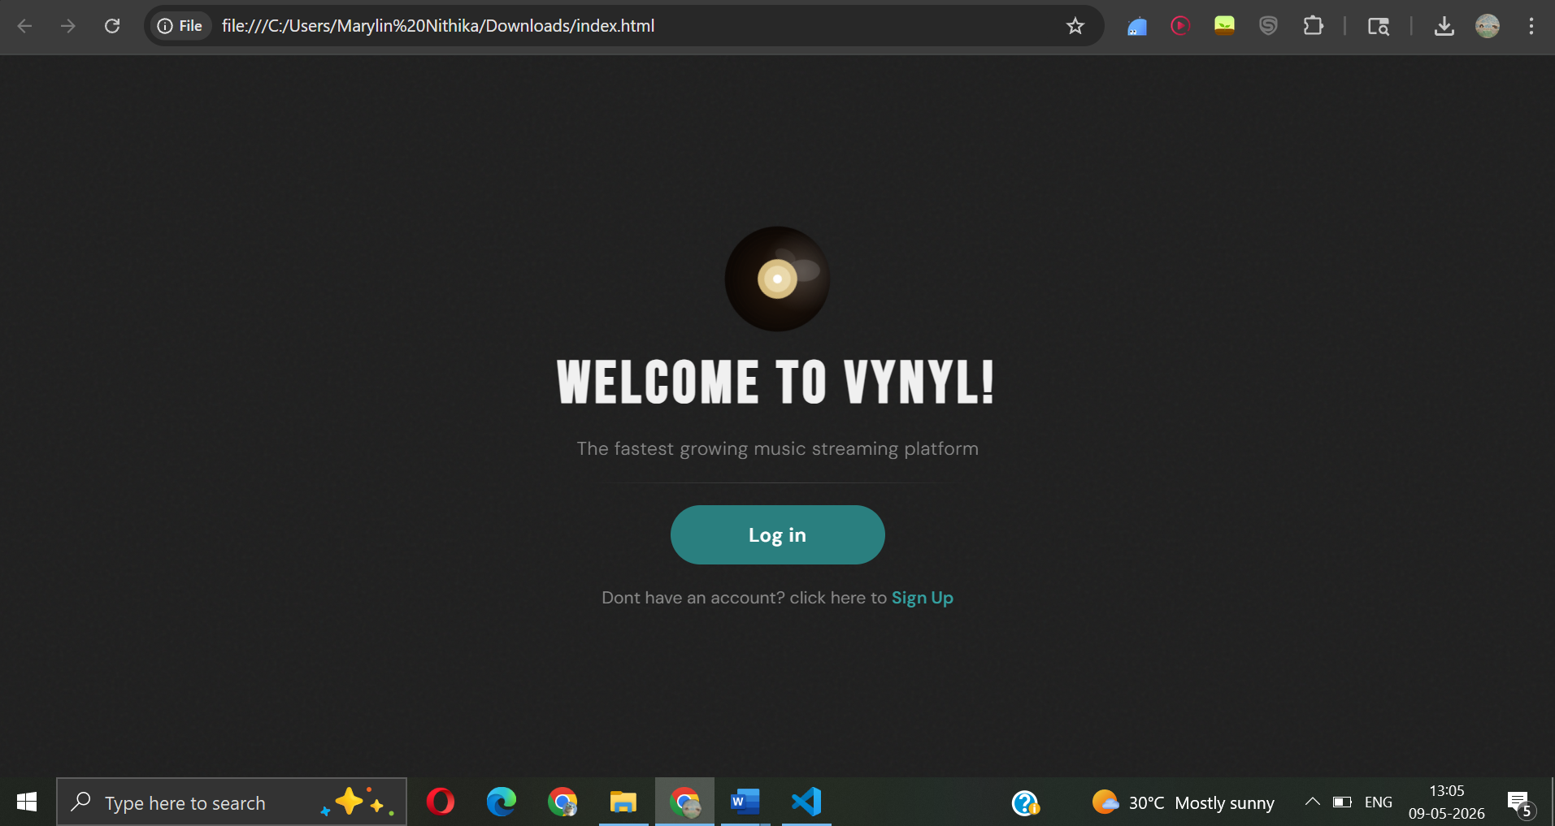

signup.html

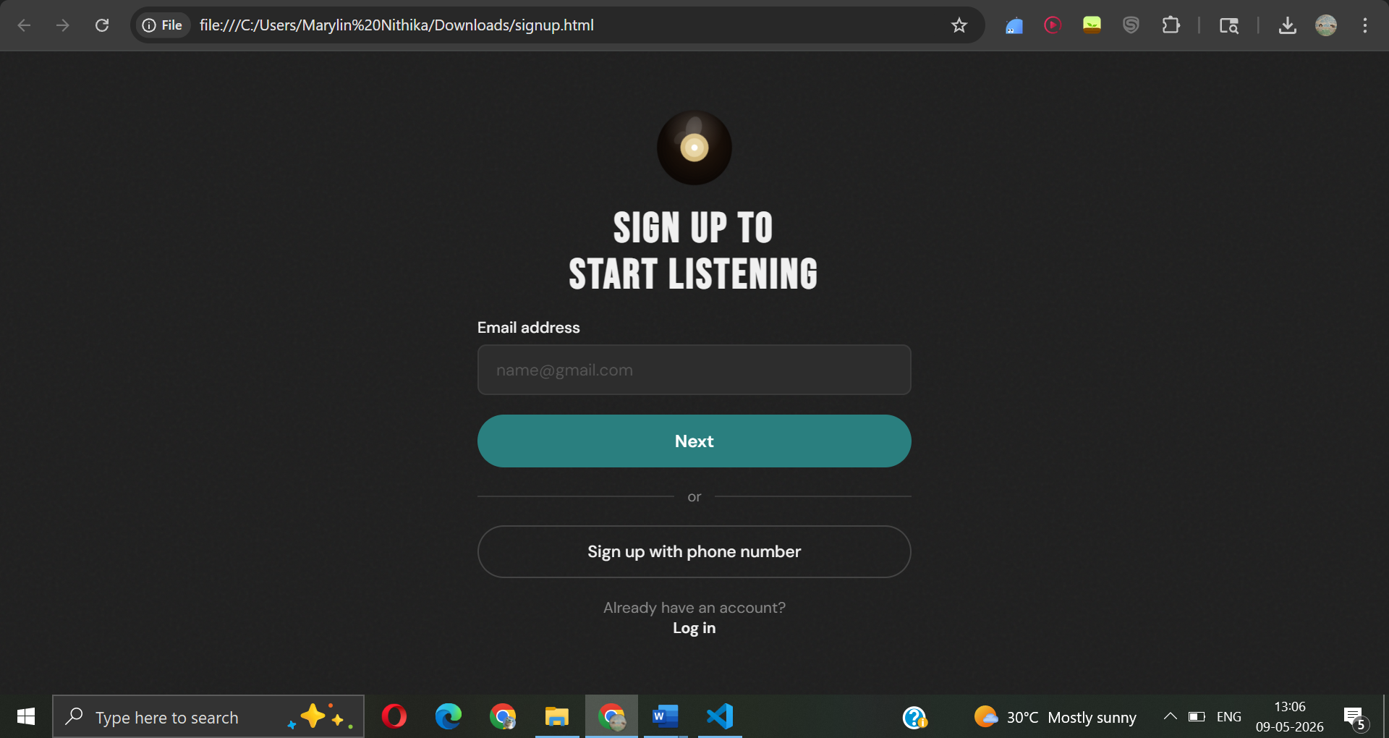

login.html

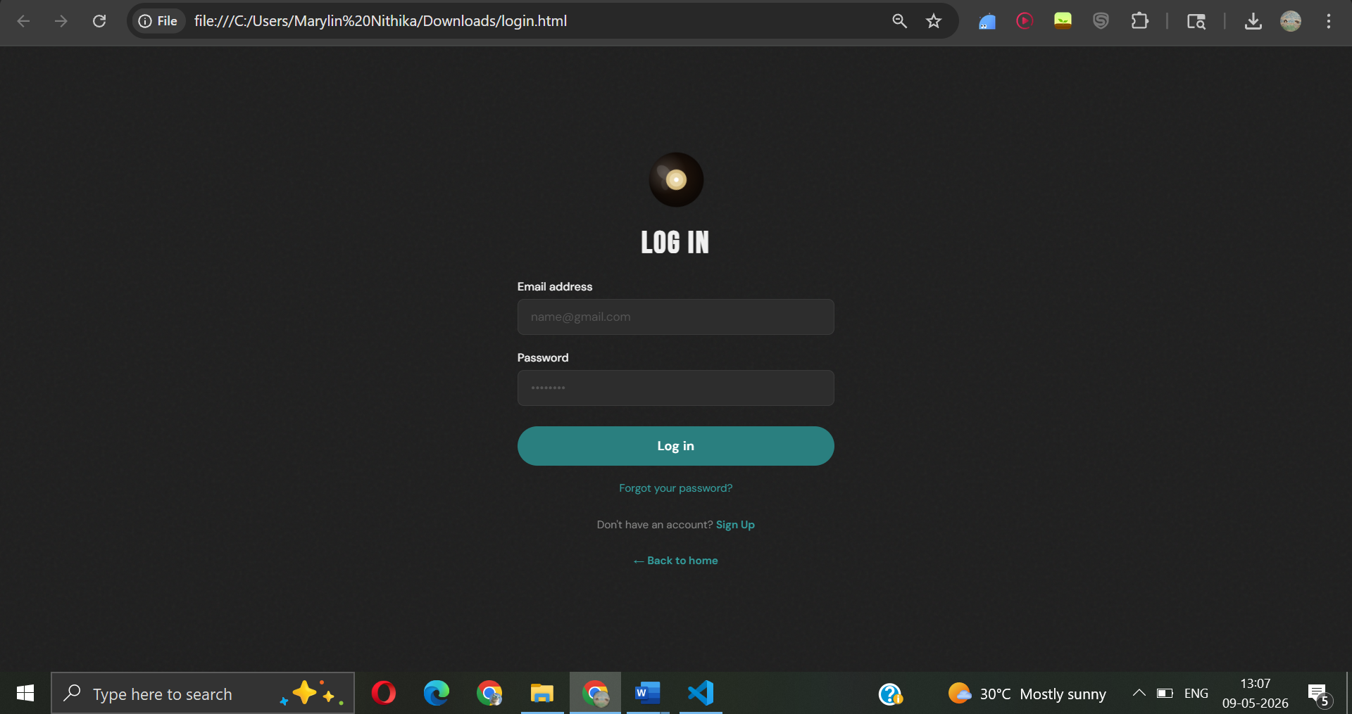

player.html

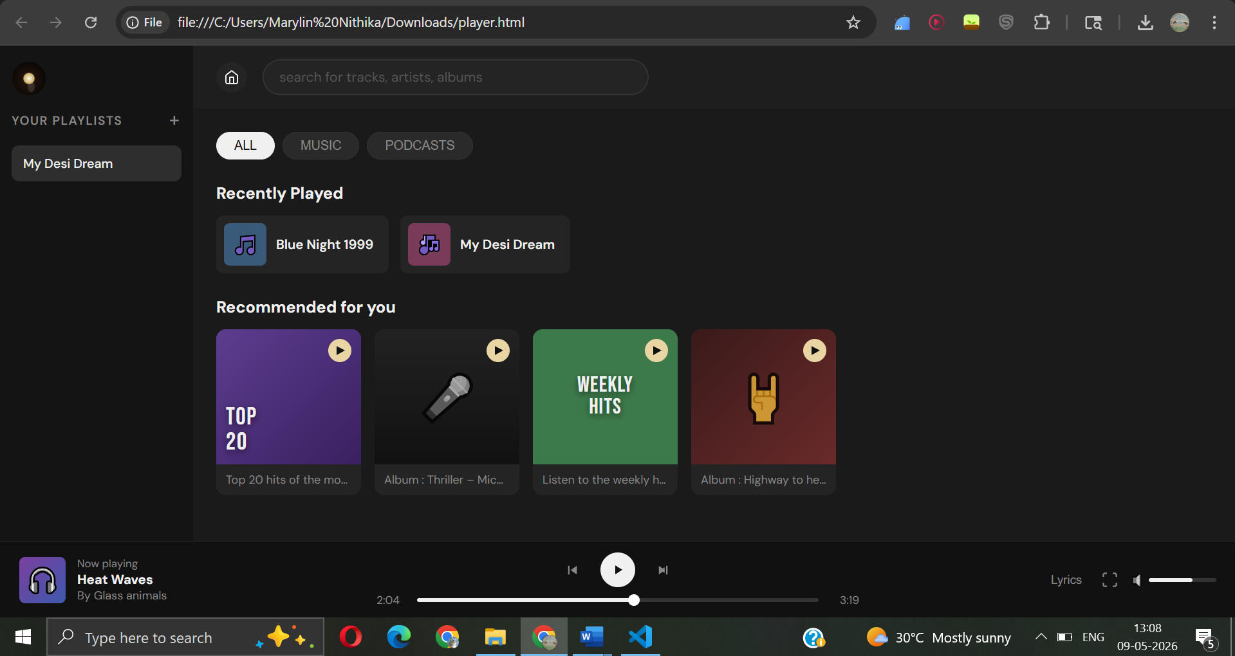

- FIGMA PROJECT
3.1 Figma steps

- Open Figma and create a new design file for the Vynyl Music Streaming Platform.
- Create desktop frames using the Frame Tool (F) with suitable dimensions for all application pages.
- Design the Welcome Page containing:
o Vinyl-style animated logo
o Welcome heading: “WELCOME TO VYNYL!”
o Subtitle text
o Login button
o Signup navigation link
- Apply a dark-themed background using shades of black and gray for a modern music streaming appearance.
- Add typography using Google Fonts such as:
o Bebas Neue for headings
o DM Sans for body text and buttons
- Design the Login Page using:
o Email input field
o Password input field
o Login button
o Forgot password link
o Navigation links to signup and home page
- Design the Signup Page containing:
o Email address input field
o Next button
o Phone number signup button
o Login navigation link
- Create the Music Player Dashboard frame with:
o Sidebar navigation
o Playlist section
o Search bar
o Recently played section
o Recommended music section
o Playback controls
- Design playlist cards using:
o Rounded rectangles
o Music thumbnails/emojis
o Playlist titles
o Hover effect styling
- Add playback control components including:
o Play/Pause button
o Next/Previous buttons
o Progress bar
o Volume control slider
- Create a Lyrics Panel section with:
o Album artwork placeholder
o Track title and artist name
o Lyrics display container
- Use Auto Layout to maintain consistent spacing, alignment, and responsiveness between UI components.
- Add modern UI styling such as:
o Rounded corners
o Shadows and hover effects
o Smooth transitions and animations
- Create interactive prototype links between:
o Welcome page
o Login page
o Signup page
o Music player dashboard
- Apply a consistent color palette throughout the design using:
o Dark gray and black backgrounds
o Teal accent colors
o White and muted gray text colors
- Use constraints and responsive alignment techniques to ensure proper layout adaptation across screen sizes.
- Preview the prototype using the Present option in Figma to test navigation flow and UI interactions.
- Export the final frames and screenshots as PNG/JPG files for project documentation and frontend implementation.
These steps were implemented for the Vynyl Music Streaming Platform UI/UX project.

3.2 FIGMA OUTPUT

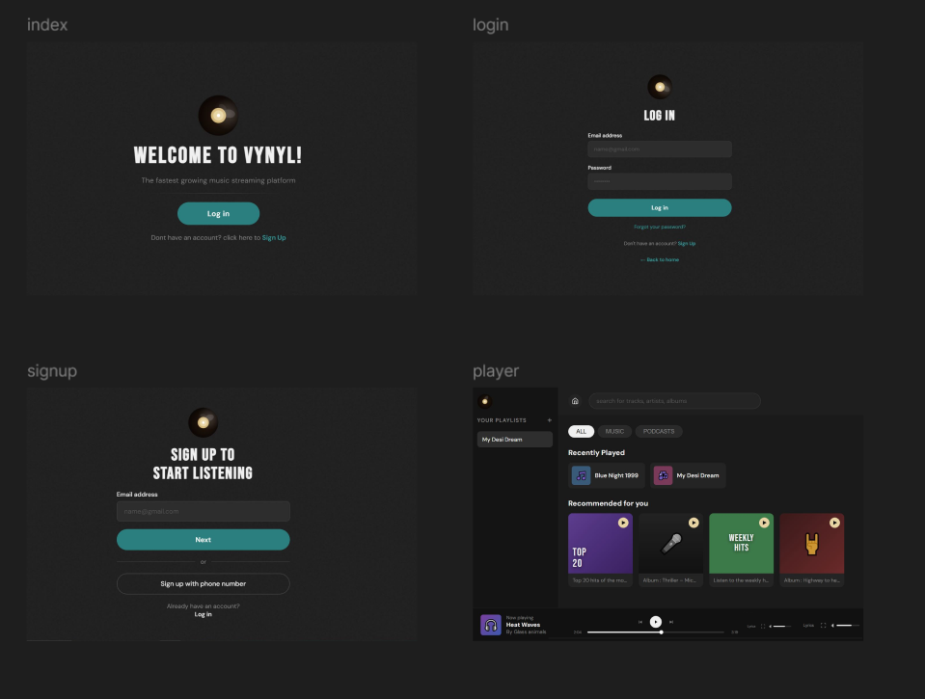

- OUTCOME, APPLICATIONS & BENEFITS

4.1 Outcome of the Project

The Vynyl Music Streaming Platform was successfully designed and developed as a frontend UI/UX web application using HTML, CSS, JavaScript, and Figma. The project achieved the objective of creating a modern, visually appealing, and interactive music streaming interface that simulates the functionality of a real-world streaming platform.
The final application includes multiple webpages such as:
- Welcome page
- Login page
- Signup page
- Music player dashboard
The project successfully demonstrates various frontend development concepts including:
- Responsive web design
- UI component structuring
- Interactive user interfaces
- Navigation handling
- Dynamic playlist management
- Progress bar functionality
- Music playback simulation
- Search interaction
The use of Figma during the design phase helped in creating a consistent and professional UI before implementation. The completed project improved understanding of UI/UX principles, frontend technologies, layout management, and event-driven programming.

4.2 Applications of the Project

The Vynyl Music Streaming Platform can be applied in various real-world scenarios related to music streaming and entertainment applications.
Applications include:
- Online music streaming platforms
- Podcast and audio streaming services
- Media player interfaces
- Entertainment dashboard applications
- UI/UX prototyping projects
- Frontend web development learning projects
- Digital media management systems
- Responsive web application design practice
The project can also serve as a foundation for advanced applications by integrating:
- Backend databases
- User authentication systems
- Real-time audio streaming
- Recommendation systems
- AI-based music suggestions
- Cloud storage and playlist synchronization

4.3 Benefits of the Project

The Vynyl Music Streaming Platform provides several technical and practical benefits.
Technical Benefits
- Improves understanding of HTML, CSS, and JavaScript
- Demonstrates implementation of responsive UI design
- Enhances knowledge of frontend development concepts
- Provides experience in event handling and DOM manipulation
- Develops skills in layout structuring and component organization
UI/UX Benefits
- Improves user interaction and navigation experience
- Demonstrates modern dark-theme interface design
- Maintains visual consistency across webpages
- Uses animations and transitions for better engagement
- Creates an intuitive and user-friendly interface
Educational Benefits
- Helps students understand the complete UI/UX workflow
- Provides practical exposure to Figma prototyping
- Bridges the gap between design and implementation
- Encourages creativity in interface development
- Improves problem-solving and frontend development skills
Future Scope
The project can be further enhanced by adding:
- Real audio streaming support
- Backend integration
- Database connectivity
- User profile management
- Music recommendation algorithms
- Mobile responsive optimization
- API integration for songs and lyrics
- Advanced playlist customization
The project demonstrates how effective UI/UX design combined with frontend technologies can create engaging and professional web applications for modern digital platforms.

- REFERENCES

https://www.figma.com
https://developer.mozilla.org/en-US/docs/Web/HTML
https://developer.mozilla.org/en-US/docs/Web/CSS
https://developer.mozilla.org/en-US/docs/Web/JavaScript
https://unsplash.com
https://fonts.google.com
https://www.w3schools.com

