Auditor, Maricar

Serino, Mary Mae

Machine Problem (Matlab): Problem 2

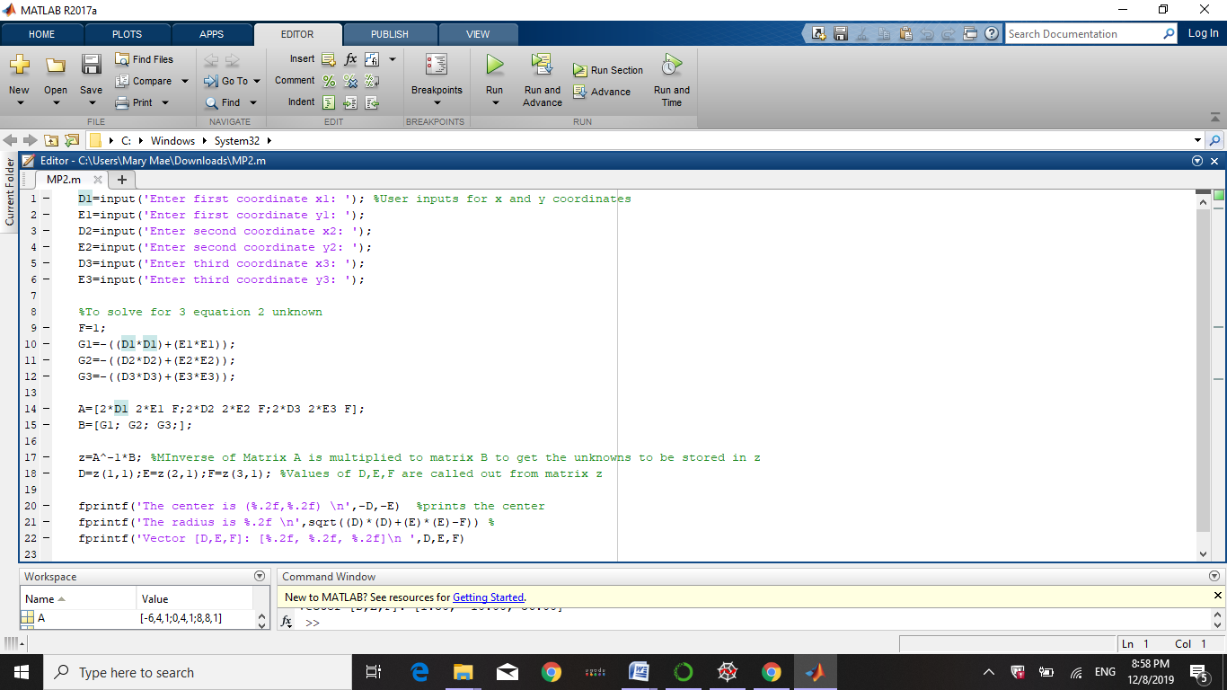Editor Window

The output of the center, radius and vector in the Command Window

