Auditor, Maricar

Serino, Mary Mae

Machine Problem (Python): Problem 1

Python Script file

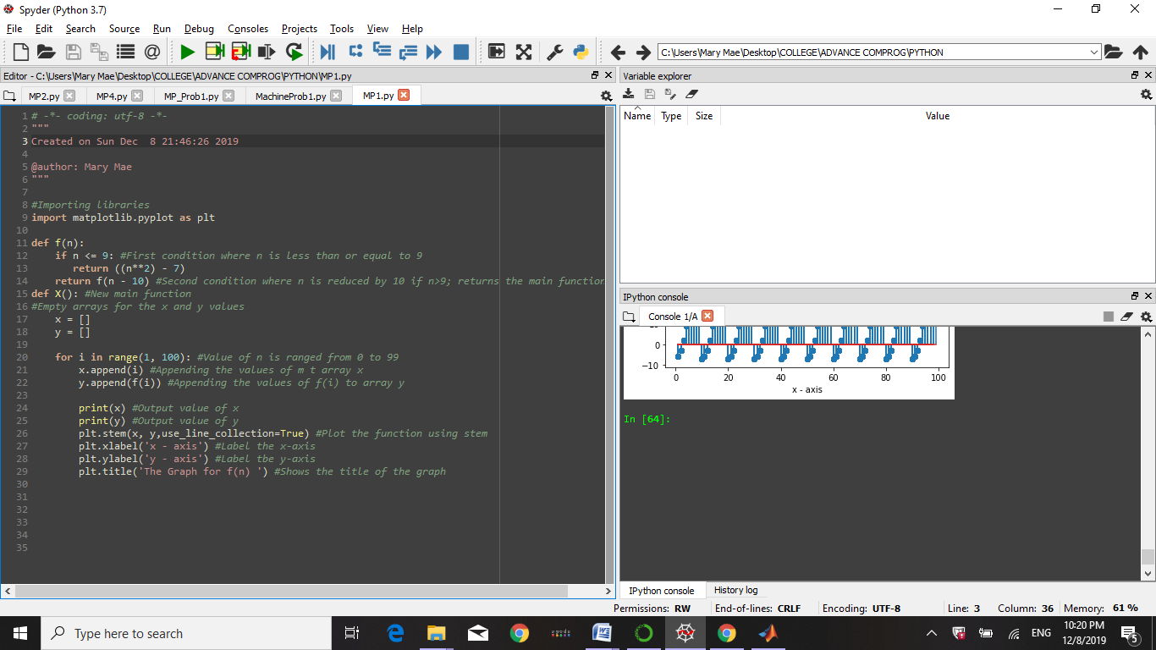

Python Console

Typing the main function ‘X()’, it will result to this graph:

