Auditor, Maricar

Serino, Mary Mae

Machine Problem (Python): Problem 4

Python Script file

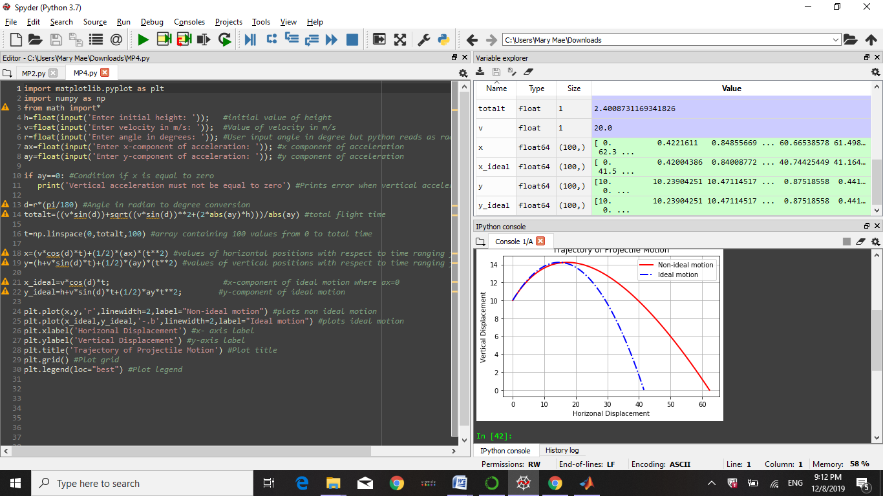

Python Console

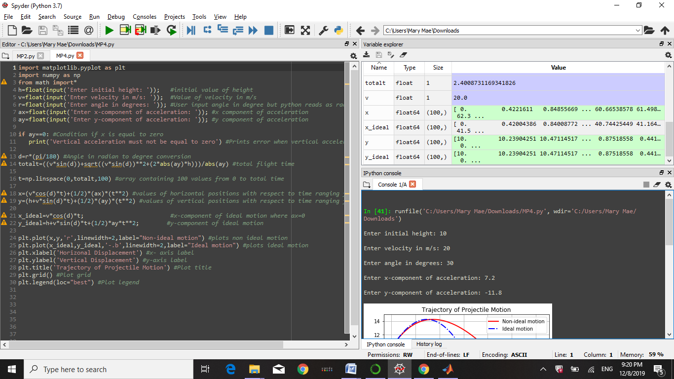

Given the following inputs, it resulted in this graph:

