Auditor, Maricar

Serino, Mary Mae

Machine Problem (Python): Problem 5

Python Script file

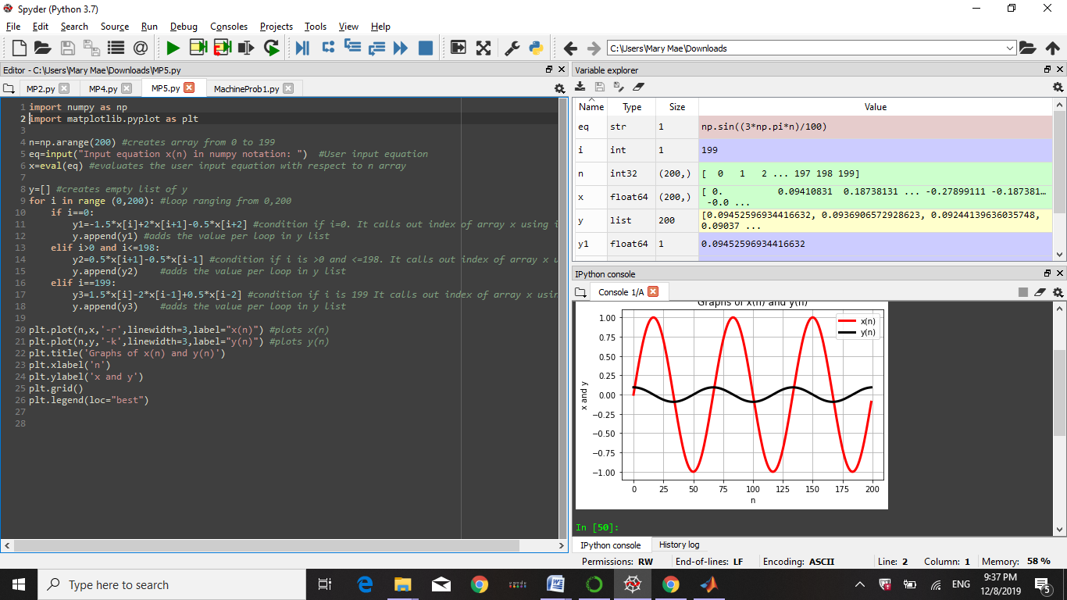

Python console

When the function np.sin((3\*np.pi\*n)/100) is inputted in the console, it results to this plot:

