**Flowchart** is a diagram with an algorithm of functions or process of a project. Flowchart use shapes that has a corresponding function. In flowchart you can easily identify the steps and will help to improve the process of a project. Flowchart will give a visual flow of an activity (input, process and output). In programming, flowchart is being used before the actual coding, it guides the programmers for the steps they have to make.

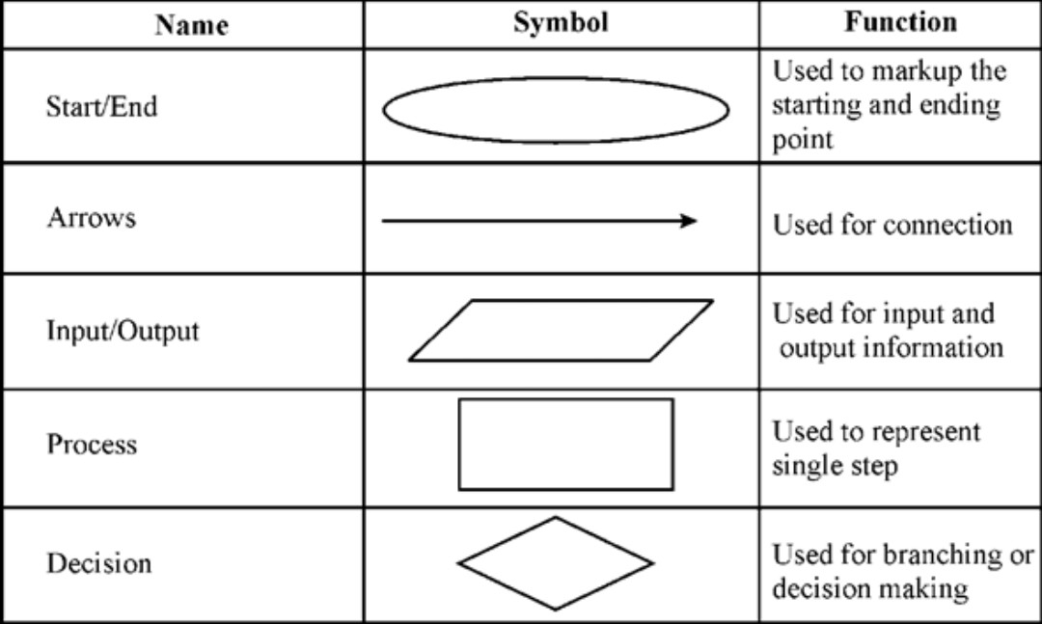

<https://www.chegg.com/homework-help/flowchart-symbols-represent-aspect-system-chapter-2-problem-3rq-solution-9780133055863-exc>

**Pseudocode** detailed algorithmic design tool for programming but not readable by the computer program. It is used for the planning of the algorithm of the program but use more natural language. It guides the programmers to develop a program in detailed and descriptive manner.

**Own Example**:

IF (you’re happy);

THEN, smile;

ELSE, don’t smile;

END IF;