*PROPERTIES MANAGER* USER'S MANUAL

INTRODUCTION

Properties Manager is an application designed for Microsoft Windows OS. It could help landlords with organizing their belongings through personalized list of real estates, which are being set by themselves, and updated online. It provides communication between owners, and administrators of the properties, as well as monitoring incomes and outcomes.

This users manual is dedicated to both owners, and administrators.

System minimal requirements

1 GB of RAM memory

Operating System: Windows 7 or newer.

Minimum 300 MB of free disk space

Processor : 1,6 Ghz or more.

Installation

Download instalation file, and click at the icon. Installation manager will guide you through the installation process.

LOGIN

At first login with your User ID type it in, and click ***Accept.***

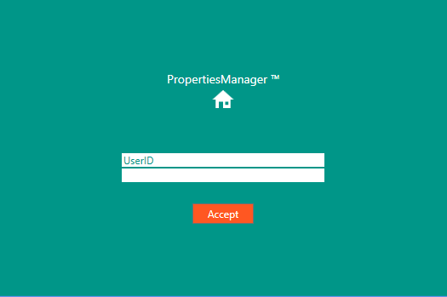

MAIN MENU

Select option, which you would like to run. At first you would like to add properties, since you haven't got any.

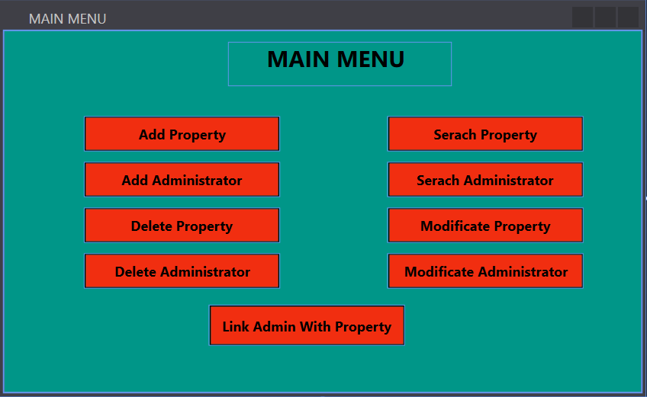

Adding Property

Enter NAME, LOCATION, AND AREA in which peoperty is located. Choose one type by clicking in the combobox and then clicking in the TYPE, which you would like to choose. Than click ***Add***, which will add a property to the list.

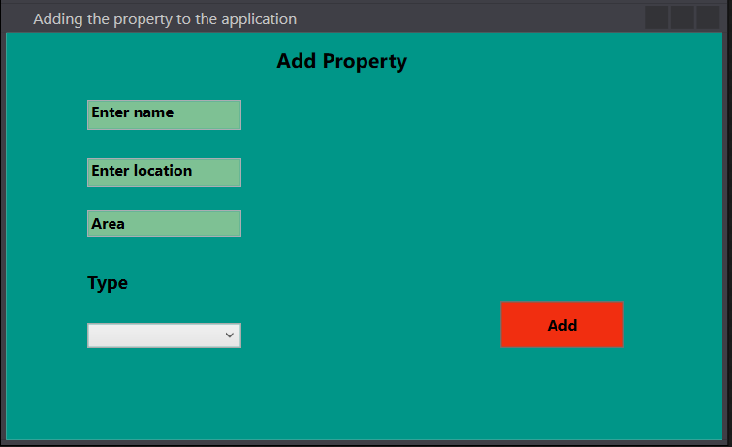

Adding Admins

Click on the particular rectangle. Then type in data. Then click ***Modify***.

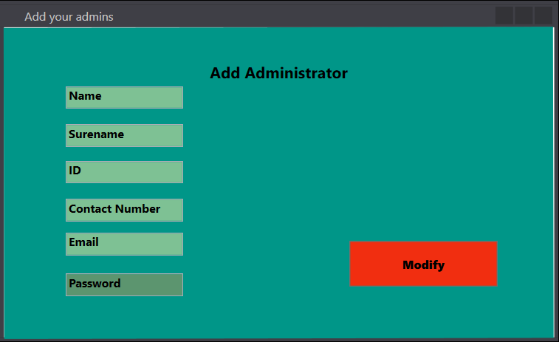

Linking Admin with Property

Particular admins could administrate properties. Manage it by clicking in the combobox. There will be shown list of properties, or administrators, which you've allready added. Choose the right ones, than click ***LINK***. Every time you would like to link administrator with property you should repeat the activity.

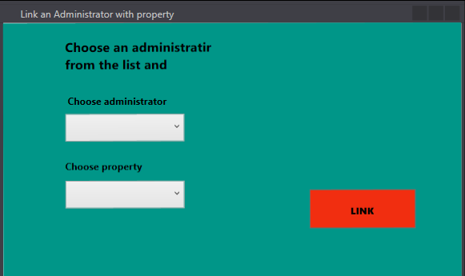

Seraching Admin

Type in Id of the admin or/and administrator's name. Click ***SERACH.*** Results will be shown on the list at the right.

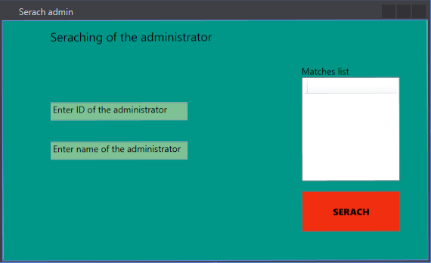

Seraching Property

Type in Id of the ***ID*** of the property, ***location, value***, and choose the ***type*** from combobox. Not all of the data must be typed in. Click ***SERACH.*** Results will be shown on the list at the right.

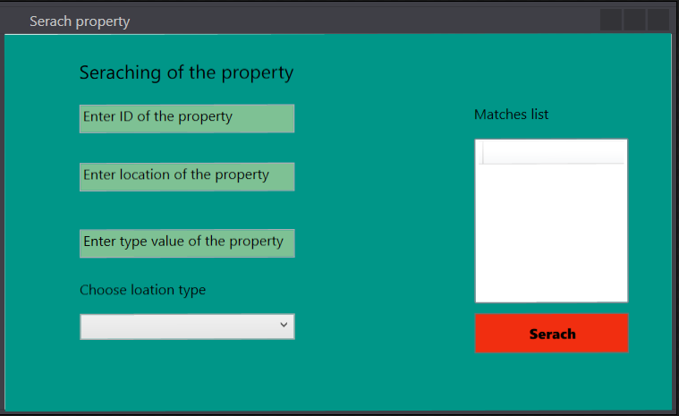

Delete Aminnistrator

Click at the combobx. The list of admins, who you have added will be shown. Just click at theese of you would like to delete, then click at ***Delete Administrator*** button. If you would like delete more than one admin just repeat the activity.

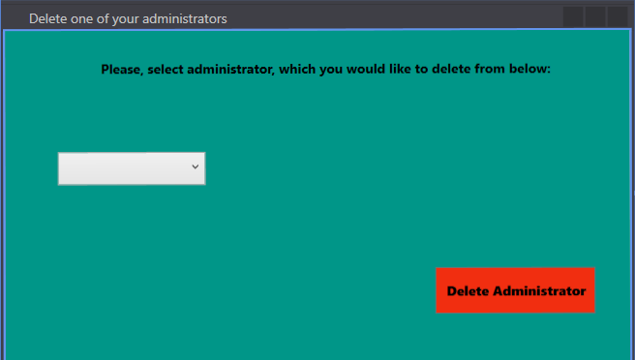

Delete Property

Click at the combobx. The list of properties, which you have added will be shown. Just click at theese of you would like to delete, then click at ***Delete Property*** button. If you would like delete more than one property just repeat the activity.

