**Party Bot Project Proposal**

Zach Munich 100897929

Preeti Nigam 100217175

Kevin Miller 100864348

Maryn Marsland 100854916

Professor: Cheryl Schramm

Department of Systems and Computer Engineering

Faculty of Engineering

Carleton University

October 6, 2015

**1.0 User Introduction to Party Bot System**

When at a party, or just hanging out at home, it is often necessary to have to walk over to fill up snacks, change the tunes, or snap a picture of the moment. Using technology, all of these unfortunate tasks could be taken care of at the press of a button. This project aims to develop a Party Bot system. The Party Bot will be able to move around a room while playing music, take pictures both when prompted and automatically at regular intervals, and bring food upon request. The user will be able to use a controller to call the bot to them or other locations, cause it to take a picture, prompt it to bring food and refill the food at a dispenser if needed, and change the music that the bot is playing. When not responding to a command, the bot will autonomously move about the party space, allowing guests to take food, pose for pictures, and enjoy the music as the bot passes.

**2.0 Proposed System Design**

The system will consist of three Raspberry Pi computers, one as a controller and two to connect with and control the hardware components. The controller of the system, shown on the left of Figure 1, will be connected to a PiFace - to provide buttons and lights - and to a battery pack to allow it to be portable. Once it is turned on and the program run, the controller Pi can be disconnected from the other hardware so it can be used as a portable remote. The lower left side of Figure 1, Pi2, shows the second Raspberry Pi, which is connected to the dispenser components of the system. There will be a sensor to tell when the bot is in place, which the Pi will monitor and when the bot is detected the Pi will cause the dispenser to release the snacks into the bowl fixed on to the bot. The third Pi, represented as Pi1 on the right of Figure 1, will be connected to the bot itself. This Pi will control the camera, music, and bot activity. The bot will consist of a Roomba, with a bowl attached to the top surface for holding snacks, speakers, and a small web cam for taking photos. It will be able to initially map out the room so that the user can specify the locations of the dispenser and select other destinations as desired. Then the bot will move autonomously around the room, playing music and allowing users to take food as it passes, until it receives a command from the controller. The possible commands include changing the song, calling the bot to a specific location, taking a picture, and refilling or bringing food. The controller will send these commands through a wireless connection to Pi3, on the bot, which will cause the hardware to perform the correct action.

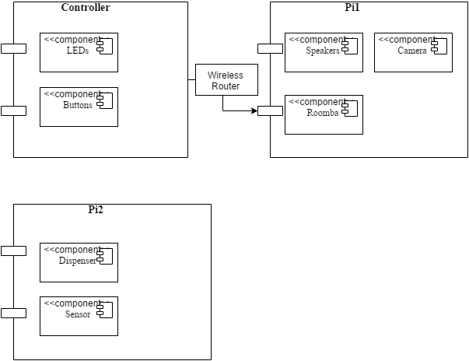

**Figure 1:** Deployment diagram showing three Raspberry Pis of the system and their related components

**3.0 Testing Plan**

To test the system a number of software and hardware tests will be performed, following the general plan developed.

1. Hardware Testing

i. Testing wireless network connections

ii. Testing camera feature using camera attached to Raspberry Pi

iii. Testing music feature by using speakers attached to Raspberry Pi

iv. Testing the Dispenser

v. Testing the LEDs

vi. Testing the Buttons

vii. Testing Roomba control, motion, and mapping

viii. Testing sensors etc.

2. Software Testing

i. Unit Testing

Testing would start at the most elemental level. Each component of the code will be tested independently to make sure the system works at the lowest level. The code in the controller will be tested first to make sure each of the commands can be entered and transmitted. The code on the Pi connected to the bot will be tested to make sure it can correctly receive commands, process every possible command, and cause the Roomba, speakers, and camera to operate as intended. The consistency of the reception of the messages will be monitored, to establish a level of expected effectiveness of the system. Finally, the Pi that controls the dispenser will be tested, to make sure the sensor properly causes the dispenser to operate, making sure the opening only occurs when the bot is in place and stays open for the correct amount of time.

ii. Testing for Boundary Cases

If applicable, all cases lying on the boundary would be tested to see the results. This includes making sure the Roomba can operate effectively at the edges of its mapped area,

iii. Integration Testing

All the individual components would be integrated and run together to ensure the system as a whole operates correctly. The entire system will be run and tested to check for robustness. The key features of this will be making sure that the bot can trigger the dispenser and fill properly, that the connection between the controller Pi and bot Pi is maintained effectively, and that all the mapped destinations are set correctly with the controller.

v. Functional Testing

As per the objectives of the project, functionality of each component would be tested under a variety of conditions.

vi. Acceptance Testing

Keeping in mind an imaginary guest in the party, the features valuable to a user will be considered to make sure they are all included as proposed. The requirements of the assignment will also be considered, to ensure that all of the elements of the grading scheme are satisfied.

**4.0 Project Milestones**

The proposed timeline for the development of this project is shown in Table 1. A number of proposed expected milestones are presented with approximate time frames, along with the definite deadlines for the project. Additionally, the team members tentatively set to lead each aspect of the development are indicated, although all members plan to contribute to some extent on most aspects.

**Table 1: Project Milestone Timeline**

|  |  |  |  |
| --- | --- | --- | --- |
| Project Milestone | Completion Date | Expected Days to Complete | Leading team member(s) |
| Collect hardware | Oct. 16, 2015 | 10 | All |
| Pi-Bot Connected | Oct. 16, 2015 | 1 | Preeti & Maryn |
| Get Bot moving | Oct. 16, 2015 | 1 | Kevin & Zack |
| Generate movement maps | Oct. 23, 2015 | 14 | Zack |
| Allow selection of destinations | Oct. 23, 2015 | 7 | Kevin |
| Code for controller, button processing and LEDs | Oct. 23, 2015 | 14 | Maryn |
| Deadline: Check-in | October 23, 2015 | - | - |
| Deadline: Design Review Presentation | November 3, 2015 | - | - |
| Code for dispenser, reading sensor and controlling dispenser door | Nov. 13, 2015 | 7 | Kevin |
| Code for bot, handling controller prompts, controlling music output, moving bot, taking pictures | Nov. 13, 2015 | 30 | Zack & Preeti |
| Testing system components | Nov. 20, 2015 | 30 | Preeti  (with whole team contributing extensively) |
| Deadline: Check-in | November 20, 2015 | - | - |
| Deadline: Code Review Presentation | November 24, 2015 | - | - |
| Testing system cases altogether | Nov. 27, 2015 | 14 | All |
| Deadline: Final Demonstration | December 4, 2015 | - | - |

**5.0 Conclusion:**

The proposed Party Bot project will involve the development of a system of Raspberry Pis and other hardware. The Party Bot will allow users to remotely change music, refill snacks, take pictures, and call the bot to locations in a room. The components of the system will operate together to allow for a system that allows the bot to move freely about a space, interact with a food dispenser, and respond to user commands.