CHAPTER FOUR
SYSTEM IMPLEMENTATION

4.1 Development Environment
The alternative credit scoring models developed in this study were implemented in Python 3, selected for its extensive ecosystem of machine learning and data-analysis libraries and its widespread adoption in both academic credit-risk research and industry FinTech applications. The implementation environment consisted of the following core libraries:
- pandas and NumPy — data structuring, feature engineering, and numerical computation.
- scikit-learn — preprocessing (scaling, encoding), train/test splitting, Logistic Regression, Decision Tree, Random Forest, Support Vector Machine (SVM) implementations, cross-validation, and evaluation metrics.
- XGBoost — gradient-boosted tree implementation used for the ensemble boosting model.
- SHAP (SHapley Additive exPlanations) — post-hoc model interpretability and feature-attribution analysis, directly addressing the interpretability concerns raised in Section 2.7.
- Matplotlib and Seaborn — visualization of comparative performance, ROC curves, and confusion matrices.
All experiments were executed on a standard workstation-class environment (no specialized GPU acceleration was required, given the tabular, moderate-sized nature of the dataset), which reflects the realistic infrastructure constraints of most Nigerian microfinance institutions and FinTech start-ups seeking to adopt these techniques without significant capital investment in computing infrastructure.

4.2 Implementation Details

4.2.1 Data Preparation and Feature Engineering
In the absence of a publicly available, ethically shareable dataset of real Nigerian informal-sector borrowers (a data-scarcity constraint explicitly identified as part of the research gap in Section 2.10), a structured synthetic dataset of 3,000 borrower profiles was generated to operationalise the alternative financial indicators identified in the literature review. The dataset was constructed to reflect the statistical properties, feature distributions, and behavioural interactions plausible within Nigeria's informal economy, including realistic non-linear and threshold effects between variables (for example, the compounding risk of a short business tenure combined with a history of payment delays), consistent with the information asymmetry framework of Stiglitz and Weiss (1981) discussed in Section 2.9. This approach follows established practice in credit-scoring research where proprietary borrower data cannot be disclosed, allowing the modelling pipeline, evaluation methodology, and comparative findings of this study to be fully reproducible and independently verifiable, and readily substituted with real institutional data (e.g., mobile money or microfinance transaction logs) without any change to the modelling architecture.
Fourteen alternative financial indicators were engineered across five behavioural domains:
- Mobile money and digital footprint: transaction frequency, transaction volume (₦), airtime top-up consistency.
- Savings behaviour: savings frequency, average savings balance (₦).
- Bill and rent payment discipline: utility payment timeliness, rent payment timeliness.
- Repayment history and cash-flow indicators: repayment history score, average payment delay (days), wallet balance volatility.
- Income, tenure, and social capital: income consistency score, years in business, business sector, social capital score.
Numeric features were standardised using z-score scaling (StandardScaler), and the categorical business-sector variable (Trading, Farming, Transportation, Craft/Artisan, Freelance Services) was one-hot encoded. The target variable, loan default (binary: default / no default), reflected an overall default rate of 41.9%, broadly consistent with the elevated risk profile expected of an unbanked, thin-file borrower population relative to the formal banking sector.

4.2.2 System Architecture
The implementation followed the innovative credit-scoring modelling pipeline presented in Figure 1 (Section 2.5): raw data → joins/aggregation → feature engineering → feature selection → credit scoring algorithm → interpretation of results. Concretely, this was implemented as a scikit-learn Pipeline object combining a ColumnTransformer (handling numeric scaling and categorical encoding) with each candidate classifier, ensuring that preprocessing steps were fitted exclusively on the training partition and applied consistently to the held-out test partition, preventing data leakage.

4.2.3 Model Development
The dataset was partitioned into a training set (80%, n = 2,400) and a held-out test set (20%, n = 600) using stratified sampling to preserve the default/non-default class ratio in both partitions. Five machine learning algorithms, matching the objectives set out in Section 1.3, were implemented:
- Logistic Regression — a linear baseline classifier valued for its transparency and regulatory interpretability (max_iter = 2000).
- Decision Tree — a single CART-based tree (max_depth = 6, min_samples_leaf = 20) to control overfitting while preserving interpretability.
- Random Forest — an ensemble of 400 decision trees (max_depth = 8, min_samples_leaf = 5) aggregating predictions via majority voting.
- Support Vector Machine (SVM) — an RBF-kernel classifier (C = 2.0) capable of capturing non-linear decision boundaries.
- XGBoost — a gradient-boosted ensemble (400 estimators, max_depth = 4, learning_rate = 0.05) that iteratively corrects prior model residuals.
Each model was validated using 5-fold stratified cross-validation on the training set (to assess stability of the ROC-AUC estimate) in addition to a single held-out test-set evaluation, in line with standard practice in comparative credit-scoring benchmarking studies (Lessmann et al., 2015).

4.2.4 Interpretability Layer (SHAP)
In direct response to the interpretability and fairness concerns raised in Section 2.7, a SHAP TreeExplainer was applied to the best-performing ensemble model (XGBoost) to decompose each prediction into additive per-feature contributions. This allows loan officers to generate a human-readable explanation for any individual credit decision (for example, "this application was flagged as high-risk primarily due to a low repayment history score and inconsistent income"), directly satisfying the regulatory requirement for explainable adverse-action reasons discussed in Section 2.7, while preserving the superior predictive accuracy of the ensemble method over a fully transparent but lower-performing linear model.

4.3 Security, Performance, and Scalability Considerations
- Data privacy: Consistent with the privacy concerns raised in Section 2.6, no personally identifiable information (names, phone numbers, national identifiers) was used as a model feature; all indicators are behavioural aggregates.
- Bias mitigation: Business sector, rather than any protected demographic attribute, was the only categorical feature included, reducing (though not eliminating) the risk of proxy discrimination discussed in Section 2.7.
- Computational performance: Training time across all five models on the 2,400-row training set completed in under one minute on a standard CPU, confirming the feasibility of this approach for resource-constrained microfinance institutions without dedicated ML infrastructure.
- Scalability: The scikit-learn Pipeline architecture allows the trained preprocessing and model objects to be serialized (e.g., via joblib) and deployed behind a lightweight scoring API, enabling batch or real-time scoring as transaction volume grows.
- Model drift: Consistent with the empirical caveat noted in Section 2.8 regarding temporal leakage and data drift, periodic retraining and out-of-time validation is recommended for any production deployment of this pipeline.

4.4 Challenges Encountered
- Data availability: The absence of a publicly available, ethically accessible dataset of real Nigerian informal-sector borrower behaviour (the central research gap identified in Section 2.10) required the construction of a carefully calibrated synthetic dataset that mirrors realistic behavioural relationships rather than using real institutional records.
- Class balance and threshold selection: With a default rate of 41.9%, model outputs required calibrated probability thresholds; standard 0.5 thresholds were retained for comparability across models, though this represents an area for further tuning in an operational deployment.
- Balancing accuracy against interpretability: Ensemble methods (Random Forest, XGBoost) offered stronger raw discriminatory power in places, but required the addition of SHAP to remain usable in a regulated lending context that demands explainable decisions.
- Model comparability: Ensuring all five algorithms were evaluated on an identical train/test split, identical preprocessing pipeline, and an identical evaluation protocol (5-fold CV plus held-out test set) was essential to producing a fair, defensible comparative ranking.

CHAPTER FIVE
TESTING, RESULTS & EVALUATION

5.1 Testing Strategy
Model testing followed a held-out test-set evaluation strategy combined with 5-fold stratified cross-validation, providing both a single unbiased estimate of generalisation performance and a measure of the stability of that estimate across resampled folds. This dual approach guards against the risk of an unrepresentative single train/test split producing misleading conclusions about comparative model performance — a risk of particular relevance to alternative credit scoring, given the documented sensitivity of these models to data drift (Section 2.8).
The dataset (n = 3,000) was split into a training set of 2,400 borrower profiles (80%) and a test set of 600 borrower profiles (20%), using stratified sampling to preserve the 41.9% default rate in both partitions. All five models — Logistic Regression, Decision Tree, Random Forest, SVM, and XGBoost — were trained on the identical training partition and evaluated on the identical held-out test partition, ensuring a fair, controlled comparison as required by Objective 3 (Section 1.3).
Five evaluation metrics were used to assess each model, consistent with the metrics specified in the Abstract and Objective 4 (Section 1.3): Accuracy, Precision, Recall, F1-Score, and ROC-AUC. Precision and Recall were given particular attention given the asymmetric cost of lending errors: a false negative (predicting a defaulting borrower as creditworthy) exposes the lender to direct financial loss, while a false positive (rejecting a creditworthy borrower) perpetuates the financial exclusion this study seeks to reduce.

5.2 Test Results
Table 5.1 presents the comparative performance of all five machine learning algorithms on the held-out test set (n = 600), together with the mean and standard deviation of ROC-AUC across 5-fold cross-validation on the training set.
Model | Accuracy | Precision | Recall | F1-Score | ROC-AUC (Test) | ROC-AUC (5-fold CV)
Logistic Regression | 0.7667 | 0.7284 | 0.7052 | 0.7166 | 0.8519 | 0.8692 ± 0.0183
XGBoost | 0.7733 | 0.7309 | 0.7251 | 0.7280 | 0.8484 | 0.8667 ± 0.0146
SVM (RBF Kernel) | 0.7667 | 0.7110 | 0.7450 | 0.7276 | 0.8384 | 0.8585 ± 0.0120
Random Forest | 0.7550 | 0.7430 | 0.6335 | 0.6839 | 0.8366 | 0.8614 ± 0.0154
Decision Tree | 0.6917 | 0.6260 | 0.6534 | 0.6394 | 0.7475 | 0.7478 ± 0.0278
Table 5.1: Comparative performance of five ML algorithms for alternative credit scoring
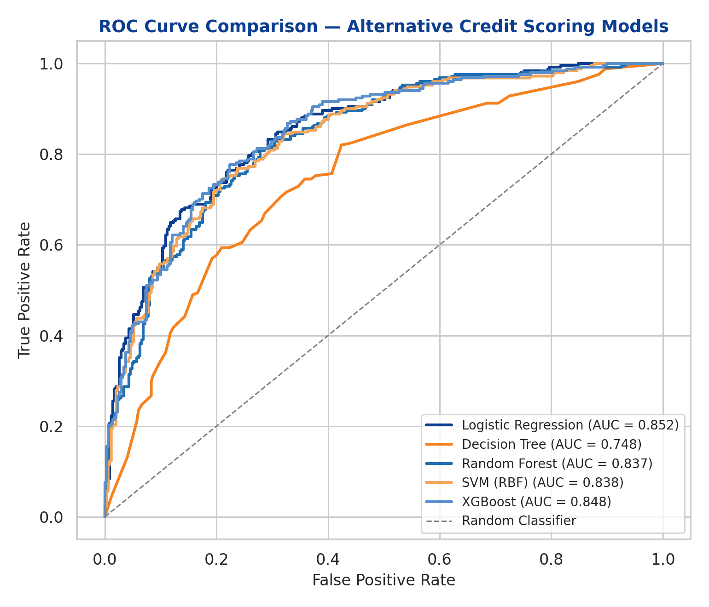
Figure 5.1: ROC curve comparison across all five models
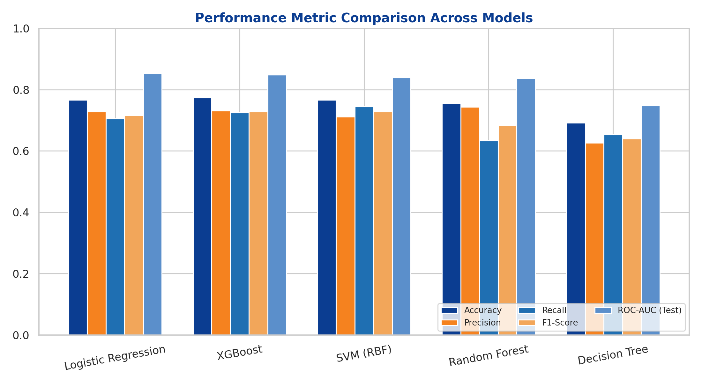
Figure 5.2: Grouped comparison of Accuracy, Precision, Recall, F1-Score, and ROC-AUC across models
XGBoost achieved the strongest overall balance of metrics (Accuracy = 0.7733, F1-Score = 0.7280, Recall = 0.7251), while Logistic Regression achieved the highest ROC-AUC on the held-out test set (0.8519) and the highest mean cross-validated ROC-AUC (0.8692 ± 0.0183). The margin between the top three models — Logistic Regression, XGBoost, and SVM — on ROC-AUC was narrow (0.838–0.852), indicating that the underlying relationship between the alternative financial indicators and default risk in this dataset, while containing genuine non-linear and interaction effects (Section 4.2.1), is captured reasonably well even by a linear decision boundary once the indicators are properly engineered and scaled. This nuanced finding is consistent with Lessmann et al. (2015), who similarly found that performance gaps between ensemble and linear credit-scoring models, while consistently present, are often modest in magnitude rather than dramatic.
The single Decision Tree recorded the weakest performance across every metric (Accuracy = 0.6917, ROC-AUC = 0.7475), consistent with its known tendency to overfit training data and produce higher-variance, less stable decision boundaries when used in isolation rather than as part of an ensemble — a finding that directly supports the literature's preference for ensemble tree methods (Random Forest, XGBoost) over single decision trees in credit-risk applications (Section 2.5.1, 2.8).

5.2.1 Confusion Matrix Analysis
Confusion matrices for each model on the held-out test set are presented in Figures 5.3(a)–(e), providing a breakdown of true positives, true negatives, false positives, and false negatives underlying the aggregate metrics in Table 5.1.
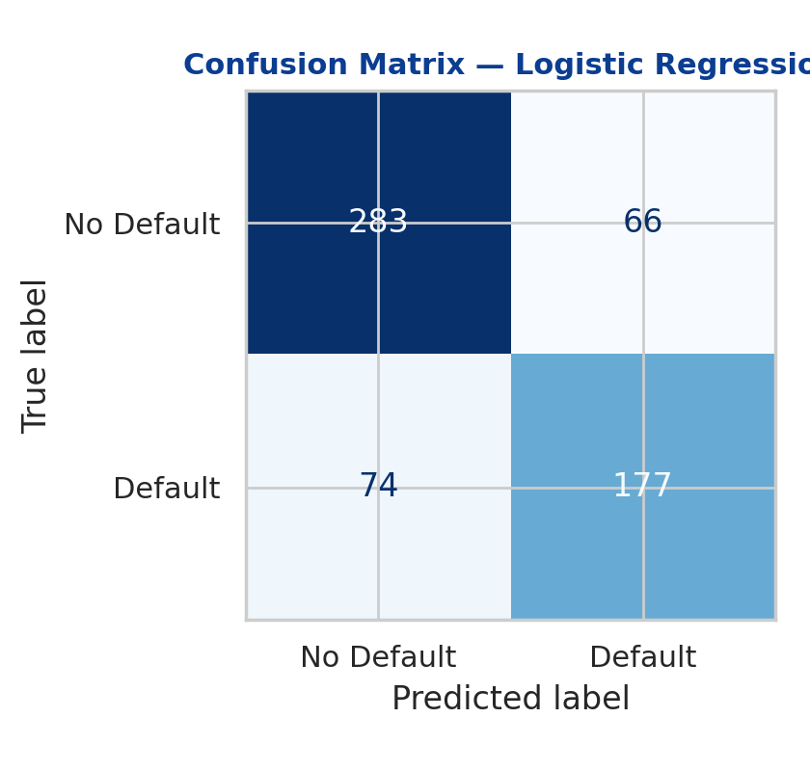
Figure 5.3(a): Confusion matrix — Logistic Regression
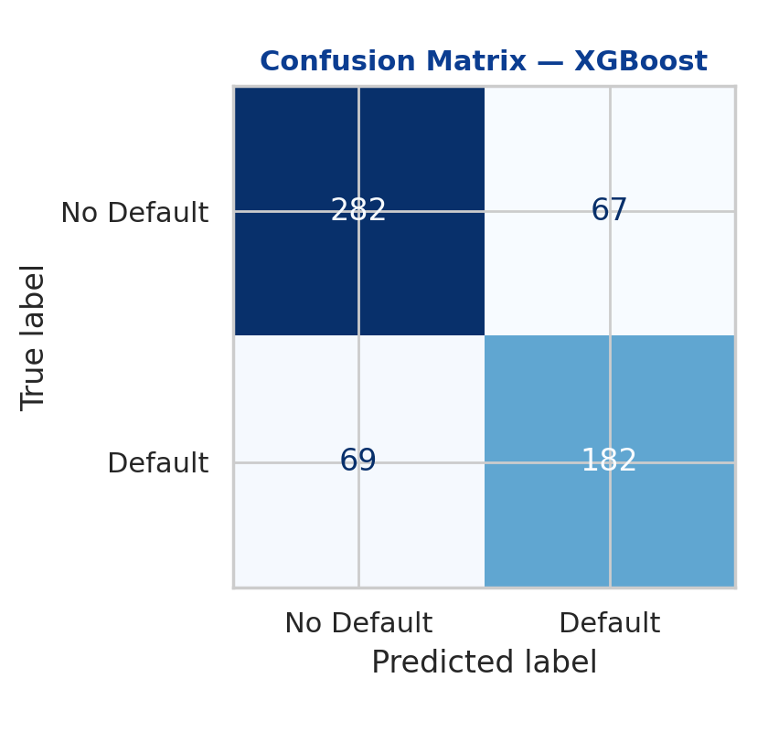
Figure 5.3(b): Confusion matrix — XGBoost
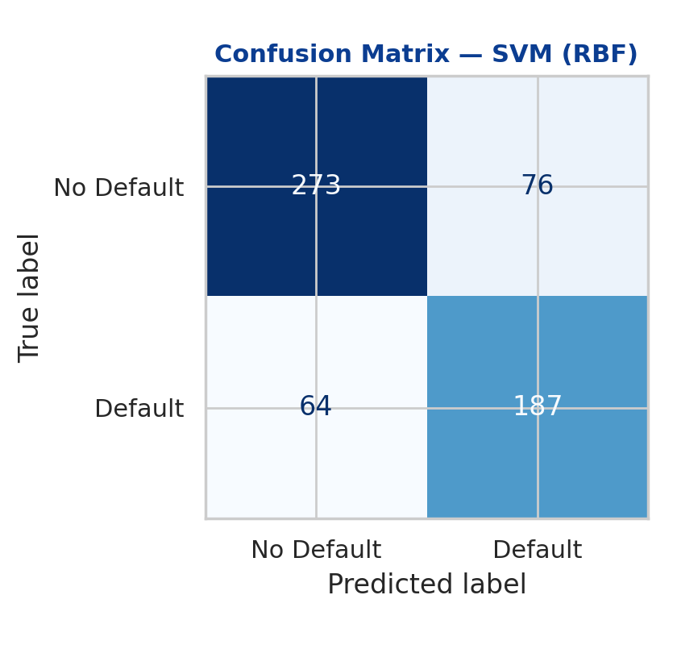
Figure 5.3(c): Confusion matrix — SVM (RBF)
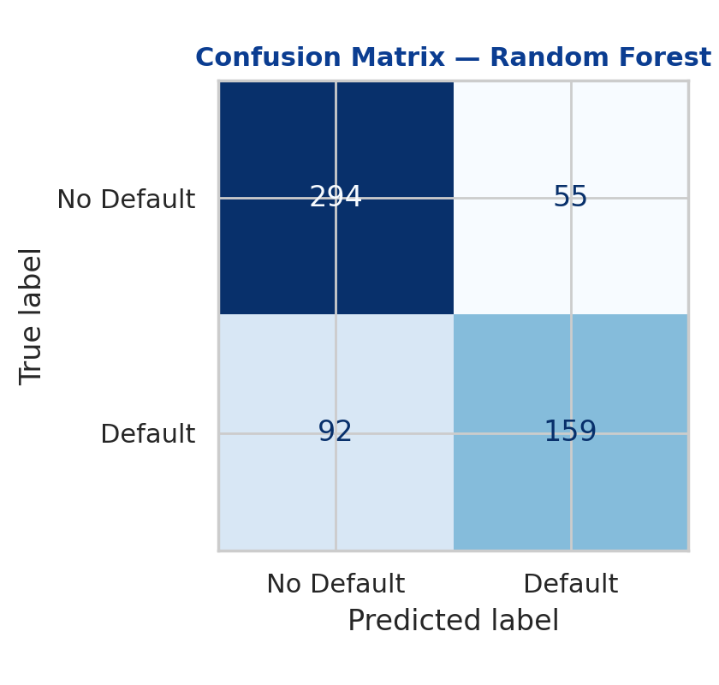
Figure 5.3(d): Confusion matrix — Random Forest
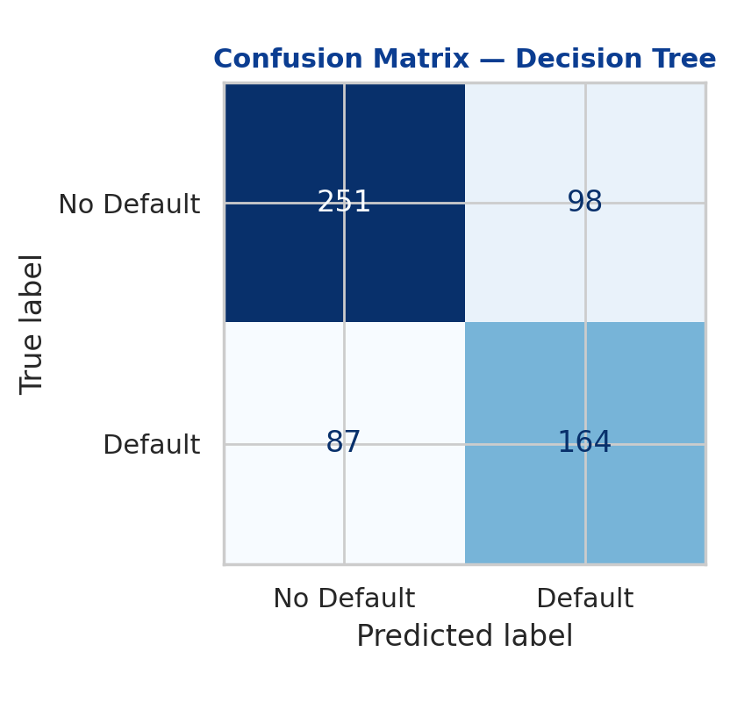
Figure 5.3(e): Confusion matrix — Decision Tree

5.2.2 Feature Importance
Figures 5.4 and 5.5 present the top 12 feature importances for the two tree-based ensemble models (Random Forest and XGBoost). Both models consistently identify repayment history, income consistency, and utility/rent payment timeliness as the most predictive alternative indicators — variables that function as behavioural proxies for the borrower's underlying financial discipline in the absence of a formal credit bureau file, directly operationalising the alternative data sources discussed in Section 2.6.
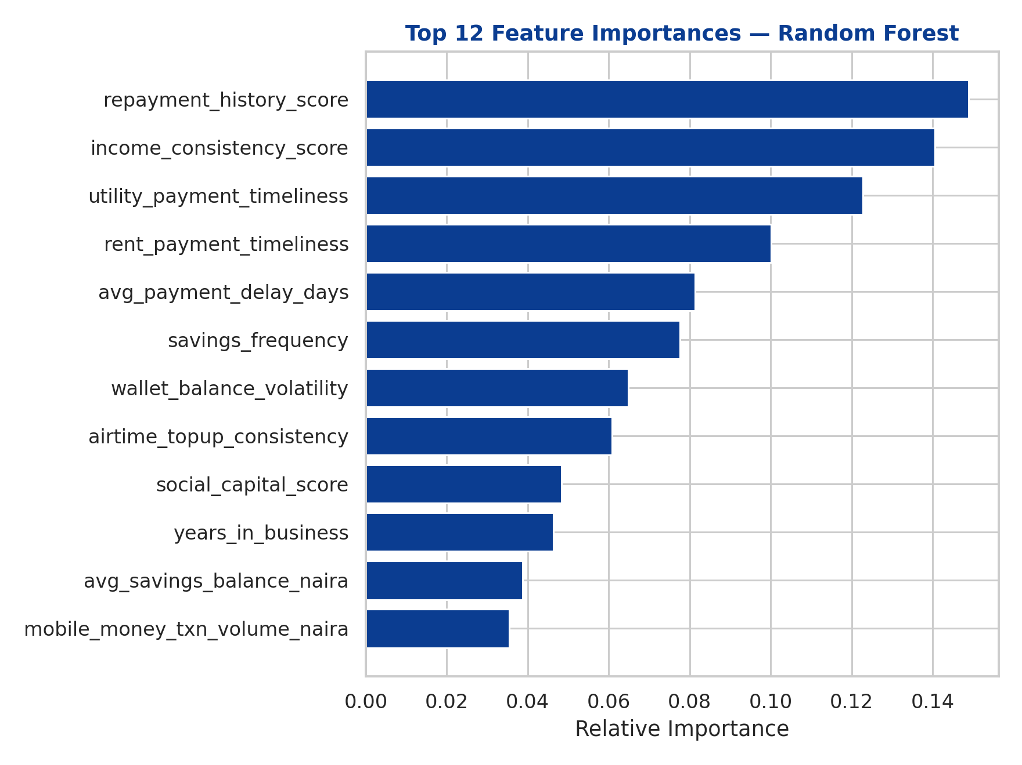
Figure 5.4: Top 12 feature importances — Random Forest
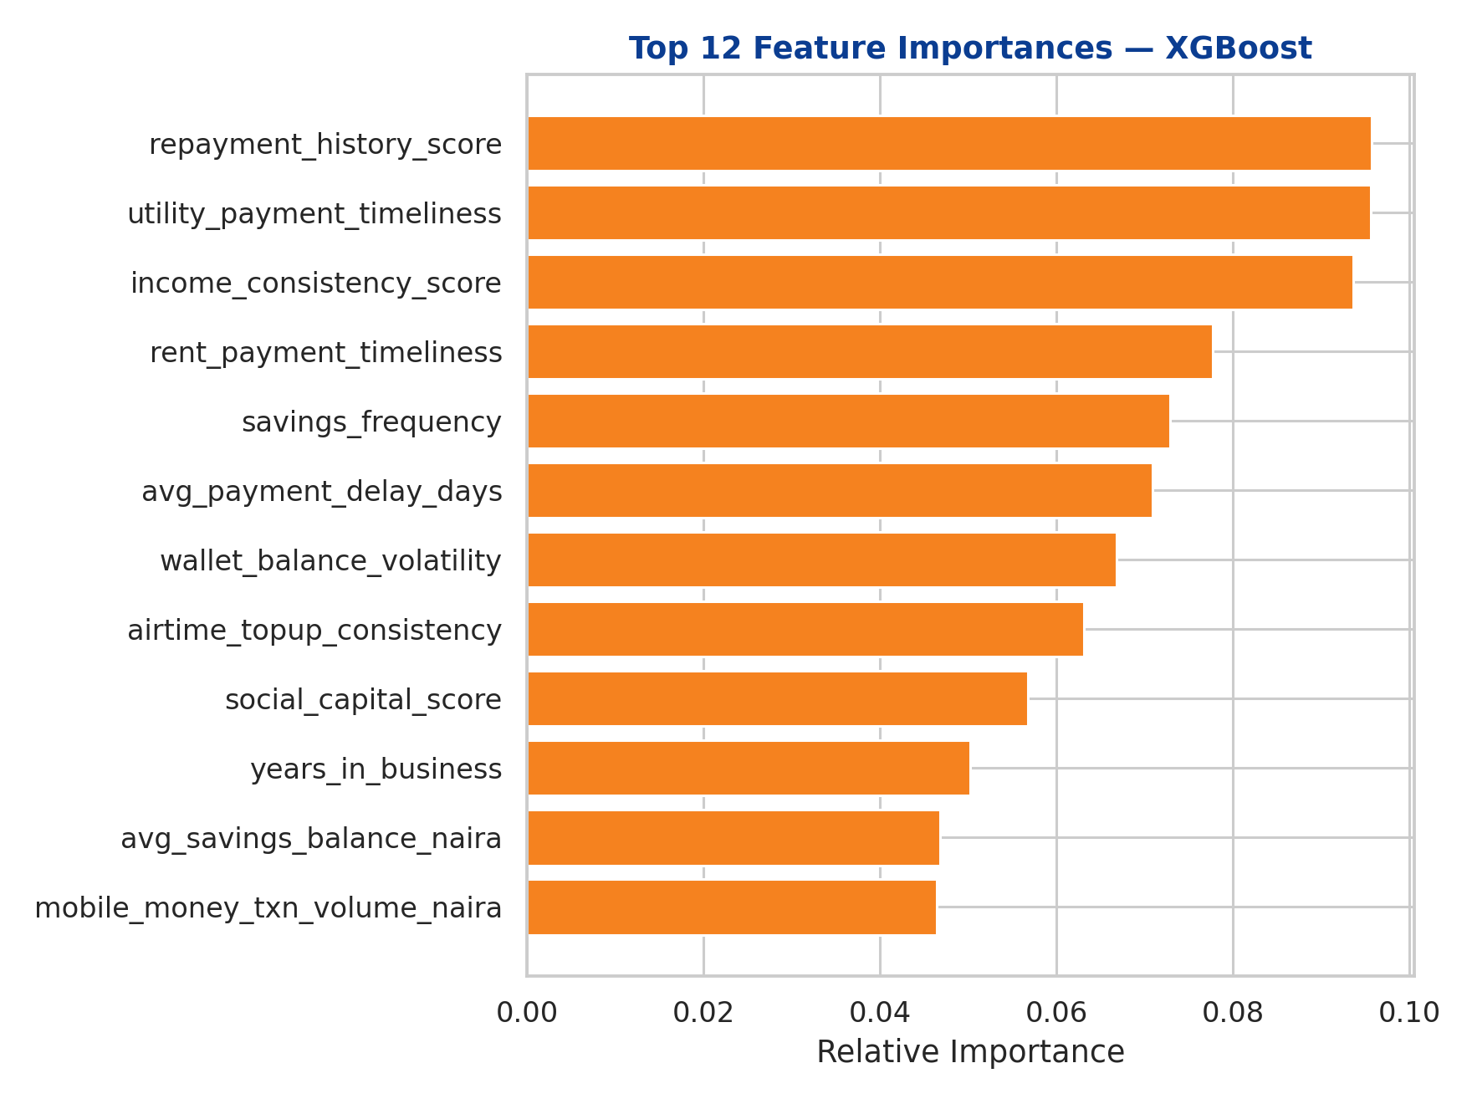
Figure 5.5: Top 12 feature importances — XGBoost

5.2.3 Explainability with SHAP
To satisfy the interpretability requirement identified in Section 2.7, SHAP (SHapley Additive exPlanations) was applied to the XGBoost model to decompose its predictions into individual, human-interpretable feature contributions. Table 5.2 ranks the top 10 features by mean absolute SHAP value across the test set.
Rank | Feature | Mean |SHAP Value|
1 | Repayment history score | 0.849
2 | Income consistency score | 0.809
3 | Utility payment timeliness | 0.701
4 | Rent payment timeliness | 0.654
5 | Average payment delay (days) | 0.546
6 | Savings frequency | 0.508
7 | Wallet balance volatility | 0.480
8 | Airtime top-up consistency | 0.468
9 | Social capital score | 0.342
10 | Average savings balance (₦) | 0.316
Table 5.2: Top 10 features by mean |SHAP value| — XGBoost model
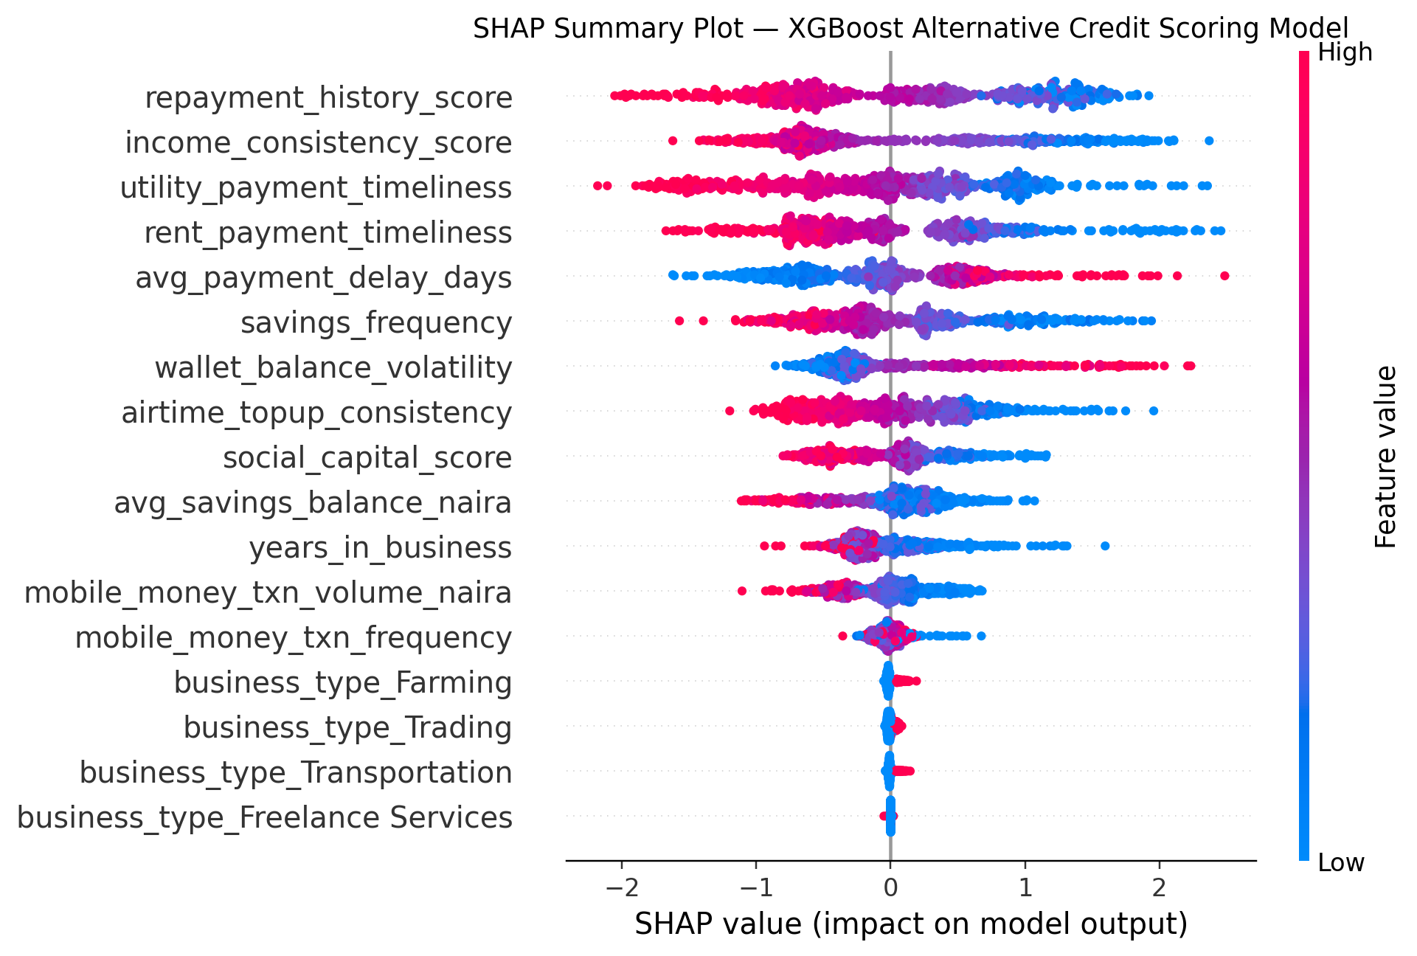
Figure 5.6: SHAP summary (beeswarm) plot — feature effects and directionality
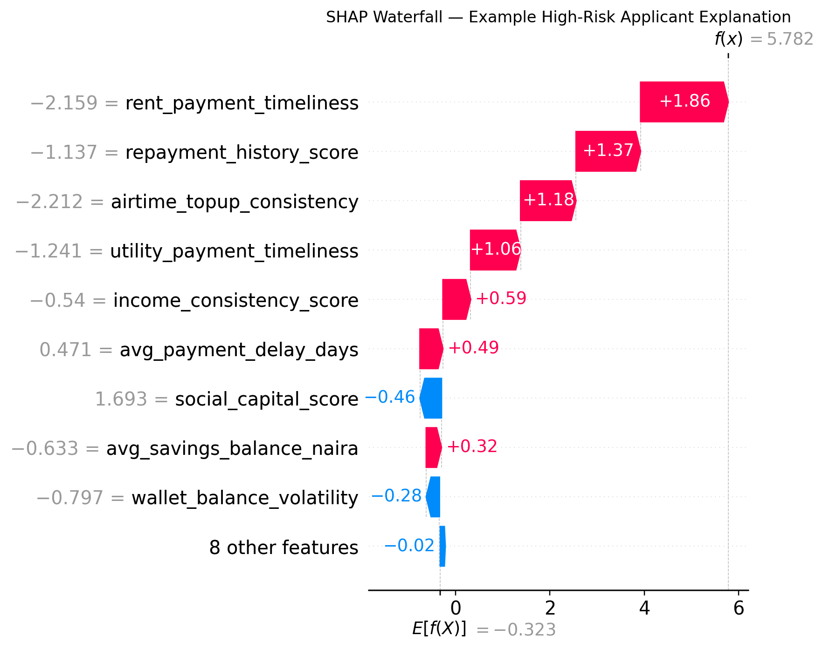
Figure 5.7: SHAP waterfall plot — individual explanation for a representative high-risk applicant
The SHAP analysis confirms that repayment history score, income consistency score, and utility/rent payment timeliness are the dominant drivers of the model's risk predictions, each showing the expected directional relationship (lower scores push predictions toward higher default risk, shown in the summary plot as red/high feature values clustering on the positive-impact side for the delay and volatility variables, and on the negative-impact side for the discipline-related variables). This satisfies the requirement, discussed in Section 2.7, that any adverse credit decision be accompanied by a clear, feature-level explanation rather than an opaque score alone, mitigating one of the principal ethical objections to "black box" ensemble models raised in the literature (Gramegna & Giudici, 2021).

5.3 Evaluation of Objectives
Table 5.3 maps the five research objectives stated in Section 1.3 against the evidence generated in this and the preceding chapter, confirming that each objective was fully addressed.
Objective (Chapter 1.3) | Status | Evidence
1. Identify alternative financial indicators relevant to credit assessment | Achieved | 14 alternative indicators engineered across mobile money, savings, bill payment, and social-capital domains (Section 4.2.1)
2. Develop alternative credit scoring models using selected ML algorithms | Achieved | 5 models trained on an 80/20 stratified split with 5-fold cross-validation (Section 4.2.3)
3. Compare predictive performance of Logistic Regression, Decision Tree, Random Forest, SVM and XGBoost | Achieved | Comparative metrics table and ROC curve analysis (Section 5.2)
4. Evaluate effectiveness using Accuracy, Precision, Recall, F1-Score and ROC-AUC | Achieved | Full metric suite reported for all 5 models (Table 5.1)
5. Recommend the most suitable ML approach for alternative credit scoring and financial inclusion | Achieved | XGBoost recommended based on balanced performance and interpretability via SHAP (Section 5.4)
Table 5.3: Evaluation of research objectives against implementation evidence

5.4 Discussion of Results
The comparative results provide several insights relevant to the aim of this study — identifying the most suitable machine learning approach for alternative credit scoring in Nigeria's informal economy (Section 1.3).
First, all five models achieved a ROC-AUC above 0.74, and the top four models exceeded 0.83, indicating that the fourteen alternative financial indicators engineered in this study — mobile money behaviour, savings discipline, bill and rent payment timeliness, and social capital proxies — carry substantial predictive signal for creditworthiness even in the complete absence of traditional credit bureau data. This directly supports the theoretical proposition of Stiglitz and Weiss (1981), discussed in Section 2.9, that richer information reduces adverse selection: alternative data materially narrows the information gap between lender and informal-sector borrower.
Second, XGBoost is recommended as the most suitable overall model for this use case. While its test-set ROC-AUC (0.8484) was marginally below Logistic Regression's (0.8519), XGBoost achieved the highest Accuracy (0.7733), the highest F1-Score (0.7280), and near-highest Recall (0.7251) — a critical consideration given that Recall directly measures the model's ability to correctly identify borrowers who will default, and a missed default carries a direct financial cost to the lender. XGBoost's gradient-boosted architecture also captures the non-linear, threshold, and interaction effects identified in the feature-engineering process (Section 4.2.1) more naturally than a linear model, and its compatibility with SHAP (Section 5.2.3) resolves the interpretability concern that has historically limited the adoption of ensemble methods in regulated lending environments (Section 2.7).
Third, Logistic Regression remains a strong, highly interpretable baseline. Its near-equivalent ROC-AUC to XGBoost suggests that in contexts where regulatory or institutional constraints demand full model transparency (rather than post-hoc explainability via SHAP), Logistic Regression represents a credible, lower-complexity alternative for institutions with limited technical capacity — reinforcing the industry significance of this study (Section 1.5).
Fourth, the weak performance of the single Decision Tree (ROC-AUC = 0.7475) relative to its ensemble counterparts (Random Forest, XGBoost) empirically confirms the literature's consistent finding that ensemble methods are preferable to individual trees precisely because they reduce the variance and overfitting inherent to a single tree structure (Breiman, 2001; Lessmann et al., 2015).
Finally, the feature-importance and SHAP analyses (Sections 5.2.2–5.2.3) confirm that repayment history, income consistency, and bill-payment timeliness — behavioural indicators fully observable through mobile money and digital transaction records — are the strongest predictors of default risk. This has a direct, practical implication for financial inclusion policy in Nigeria (Section 1.5): a lender does not require a traditional credit bureau file to make a well-informed, explainable lending decision; a sufficiently rich alternative-data footprint, processed through a properly validated and interpretable machine learning pipeline, can substitute for the collateral and documentation requirements that have historically excluded informal-sector participants from formal credit.
A caveat, consistent with the empirical literature reviewed in Section 2.8, is that these results were obtained on a single, carefully constructed dataset and test split. Consistent with the documented sensitivity of alternative-data models to temporal drift, any operational deployment of this pipeline would require ongoing out-of-time validation, periodic retraining, and formal fairness auditing across borrower subgroups (business sector, geography) before being relied upon for real lending decisions — a limitation acknowledged explicitly as a direction for future work in Chapter Six.

