Layout with rular and area:

1. inverter:4.51\*2.17=9.7867

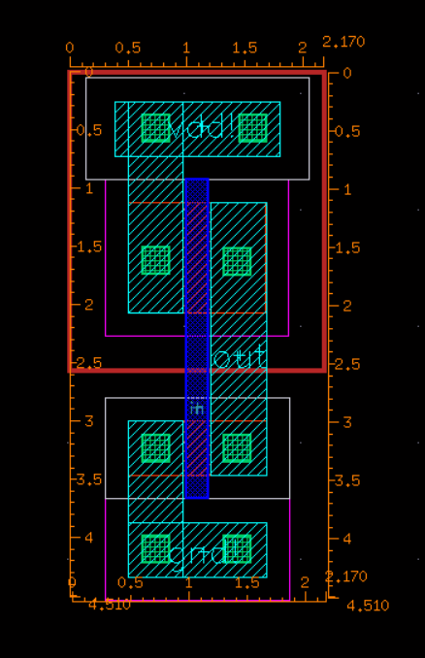

2.Oscillator:8.5\*64.0=544

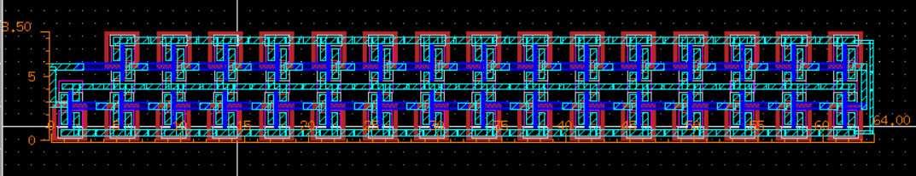

Questions of the lab

A. The pMOS transistor requires an n-type body region. However, we only have n-substrate wafers in fabrication process nowadays. How do we build pMOS on p-substrate wafers?

在p-substrate中加入As離子形成Nwell，然後在Nwell中加入p+即形成pMOS。

B. Why we set PMOS size: NMOS size = 2:1?

因為在相同大小下，NMOS的mobility為PMOS的兩倍，所以要設計PMOS size: NMOS size = 2:1他們才有大致一樣的mobility。