/*Explain the output of this C program. Why the wrong value is being displayed in the output?*/  
  
#include<stdio.h>

main(){

int testInteger=220000000000;

printf("the number is %d",testInteger);

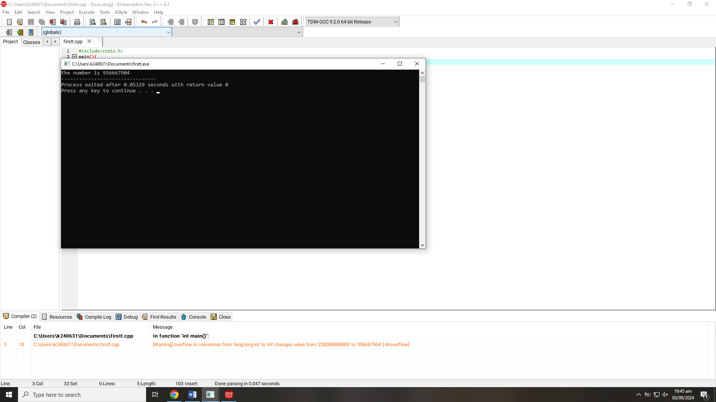}  
/* the error here is that int data type cannot store very large values

/*Write a C program that finds the largest of three numbers entered by the user.*/  
  
#include<stdio.h>

main()

{

int n1,n2,n3;

printf("enter any number n1 ");

scanf("%d",&n1);

printf("enter any number n2 ");

scanf("%d",&n2);

printf("enter any number n3 ");

scanf("%d",&n3);

if(n1>=n2&&n1>=n3) {

printf("n1 is largest number");

}

else if(n2>=n1&&n2>=n3){

printf("n2 is largest number");

}

else {

printf("n3 is largest number");

}

return 0;

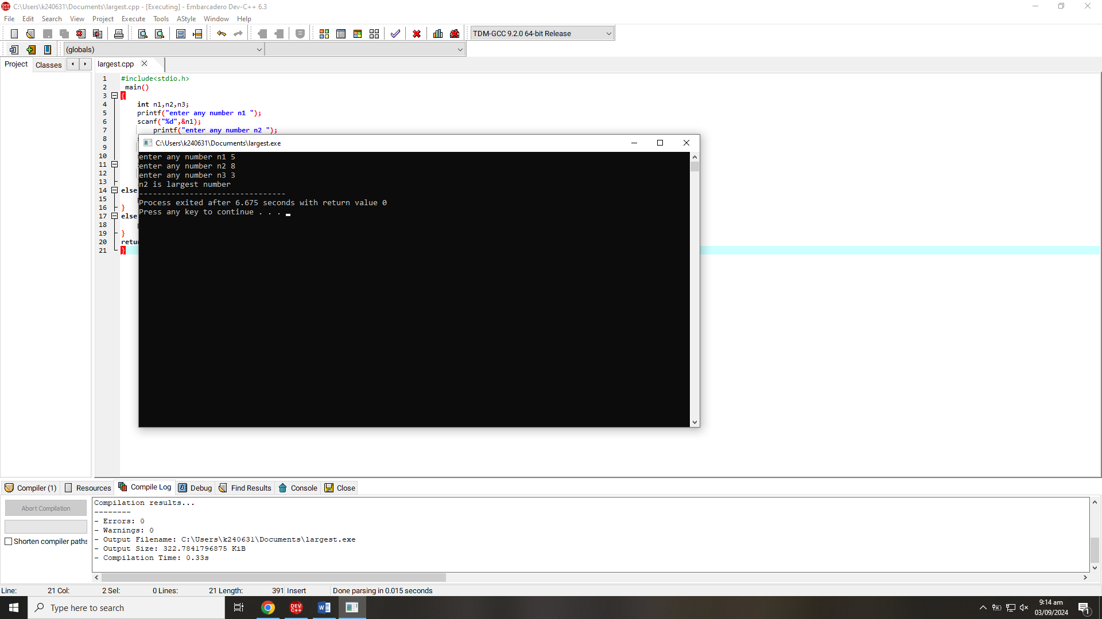}

/*A travel agency asks you to develop a program in C that can convert an amount from one

currency to another. The user should input the amount in their local currency and the

conversion rate for the desired foreign currency. The program should then output the

equivalent amount in the foreign currency.*/  
  
  
  
#include<stdio.h>

int main()

{

int pkr;

float euro, convert_rate=0.00333;

printf("enter value in your local currency ");

scanf("%d",&pkr);

(euro=pkr*convert_rate);

printf("the value of your local currency in euro is %.2f",euro);

}

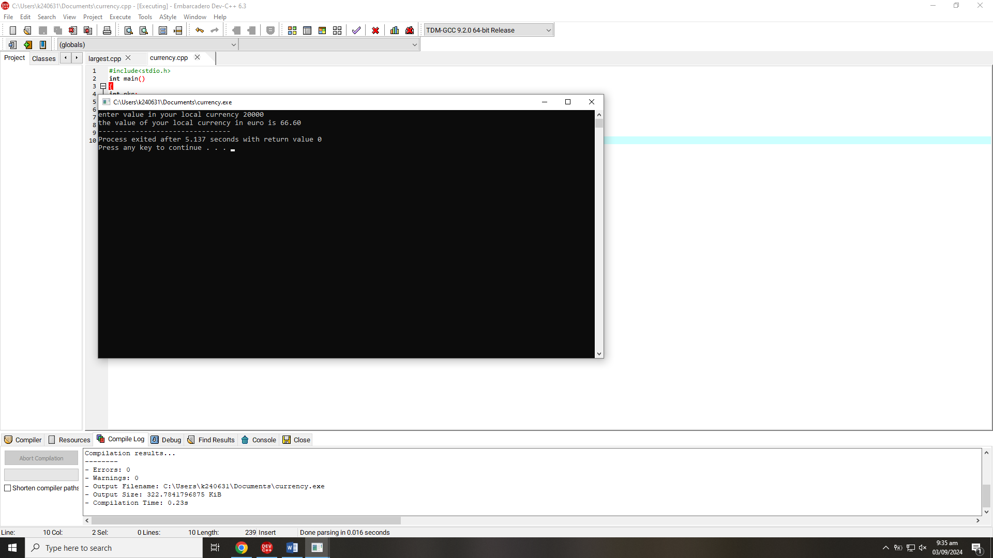

/*Write a C program that determines whether a number provided by the user is even or odd.*/  
#include<stdio.h>

int main()

{

int n;

printf("enter any number ");

scanf("%d",&n);

if(n%2==0)

{

printf("number is even");

}

else {

printf("number is odd");

}

return 0;

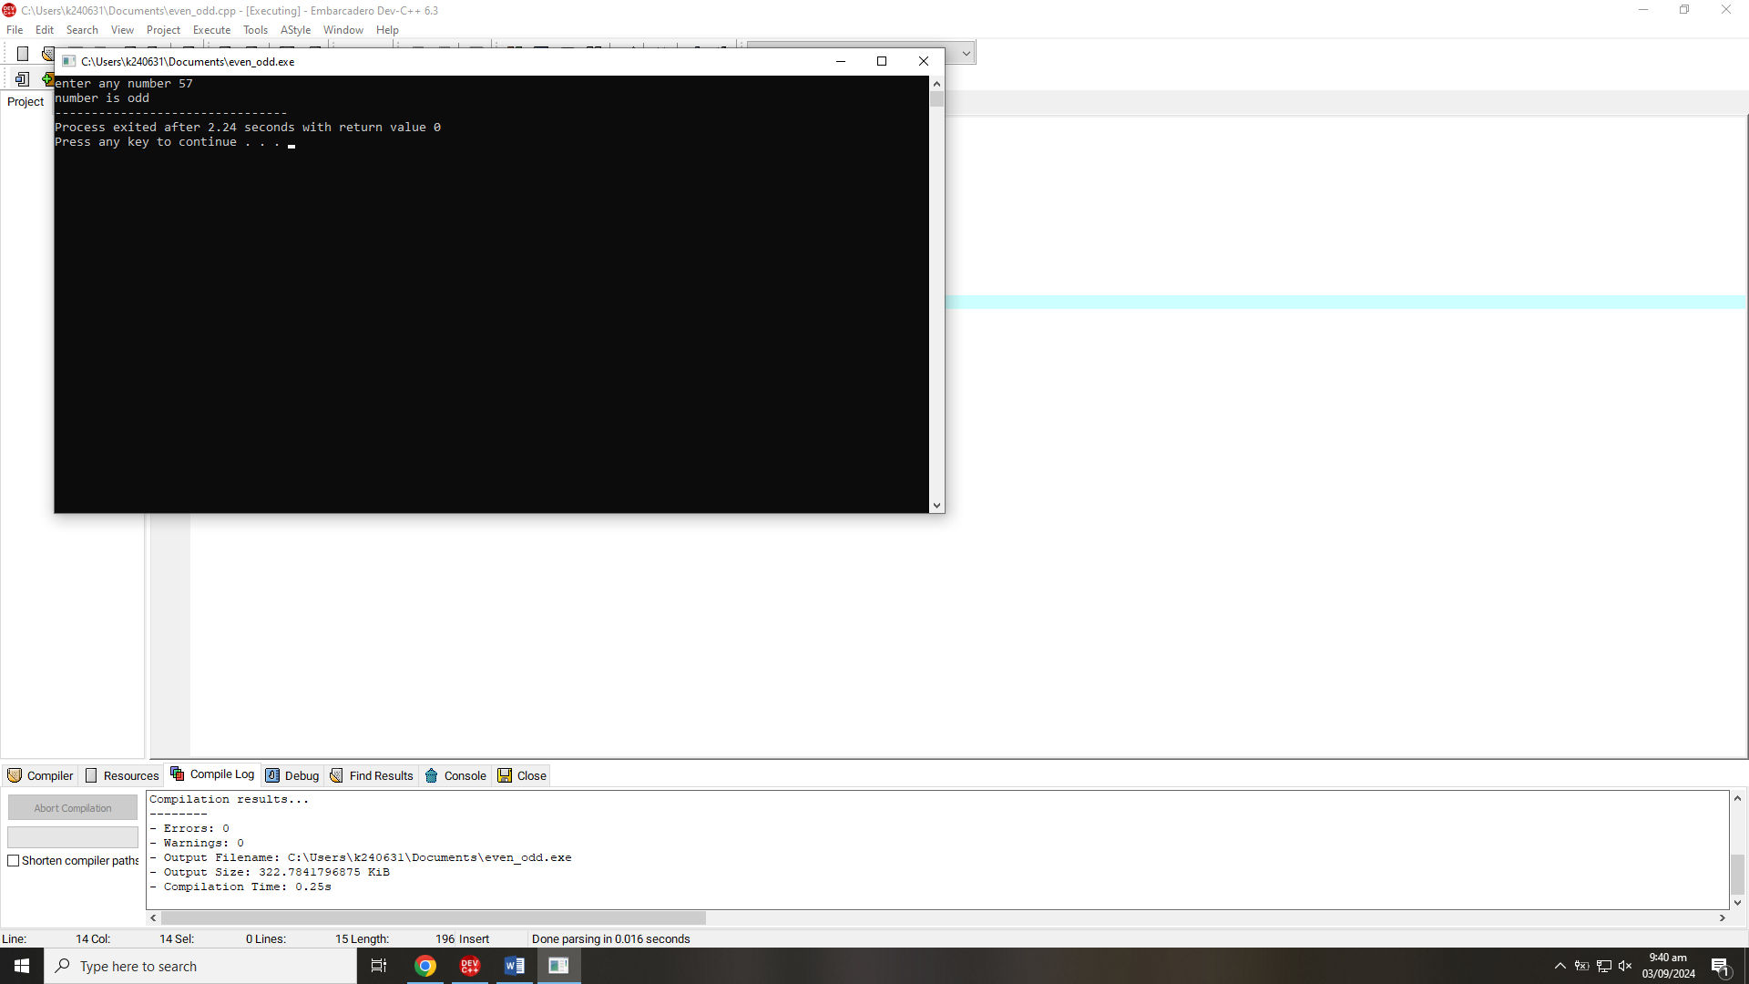}

/*Write a C program to calculate the volume of a cylinder given its radius and height. Use the

formula: Volume = π r^2 h where π is approximately 3.14159. Format the result to 3 decimal places.*/

#include<stdio.h>

int main()

{

int r,h;

float volume;

float pi=3.14159;

printf("enter the value of radius of cylinder ");

scanf("%d",&r);

printf("enter the value of height of cylinder ");

scanf("%d",&h);

volume=pi*r*r*h;

printf("the volume of cylinder is %.3f",volume);

return 0;

}

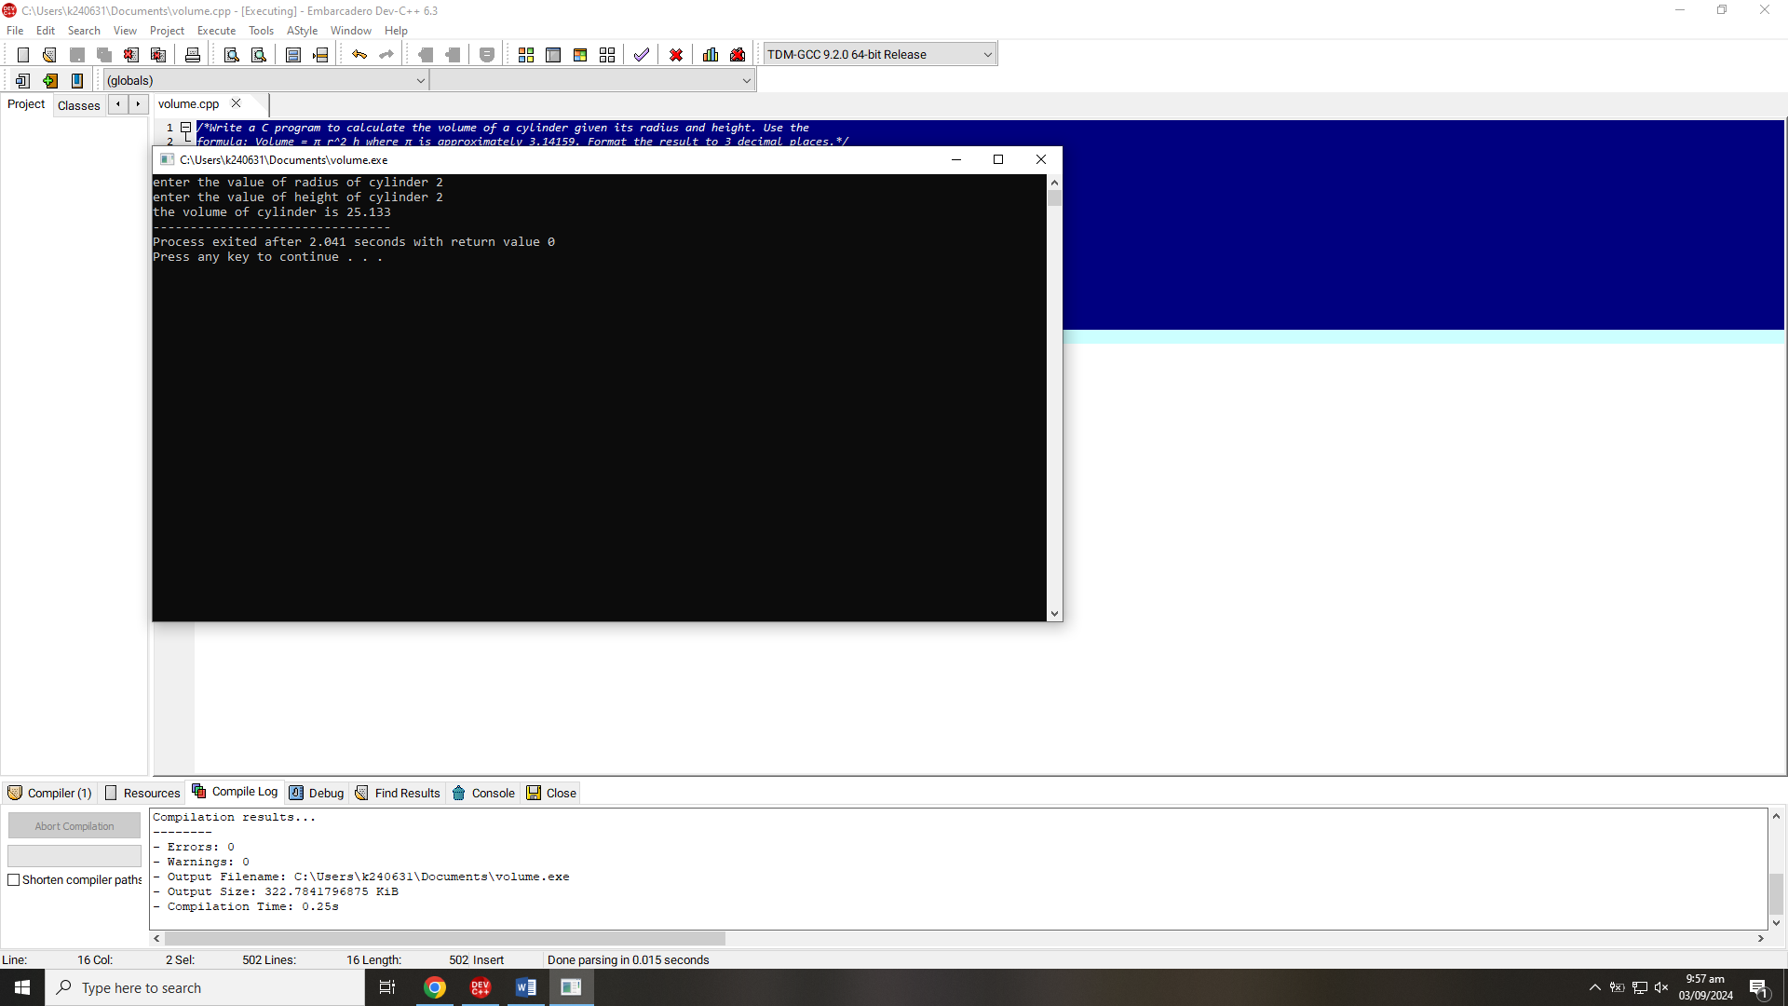

/*Write a C program to calculate the discounted price of an item based on original price between

Rs.100 and Rs. 50,000. Discount rate between 5% and 30%. Calculate the final price after

applying the discount. Validate inputs and provide error messages if they are out of range.

Display the final price after discount.

Final Price = Original Price * (1 – Discount Rate / 100)*/

#include<stdio.h>

int main()

{

int original_price;

float final_price, discount;

printf("enter the price of item ");

scanf("%d",&original_price);

printf("enter discount rate between 5 and 30 ");

scanf("%f",&discount);

if (original_price>=100&&original_price<=50000){

if(discount>=5&&discount<=30){

final_price = original_price * (1 - discount / 100.00);

printf("your final price after discount is %.2f",final_price);

}

}

else {

printf("enter price between the range of 100 and 50000");

}  
return 0;  
}

;

